**Metropolitan Branch Trail Design Build, South Segment**

**DC CONTRACT NO. DCKA-2016-C-0044**

**FAP No.: STP-2016 (060)**

CONSTRUCTION MANAGER’S

WEEKLY PROGRESS REPORT

12/19/2021 – 12/25/2021

Project Website: [www.metbranchtrail-forttotten.com](http://www.metbranchtrail-forttotten.com)

For Additional Trail Information Please see [www.metbranchtrail.com](http://www.metbranchtrail.com)

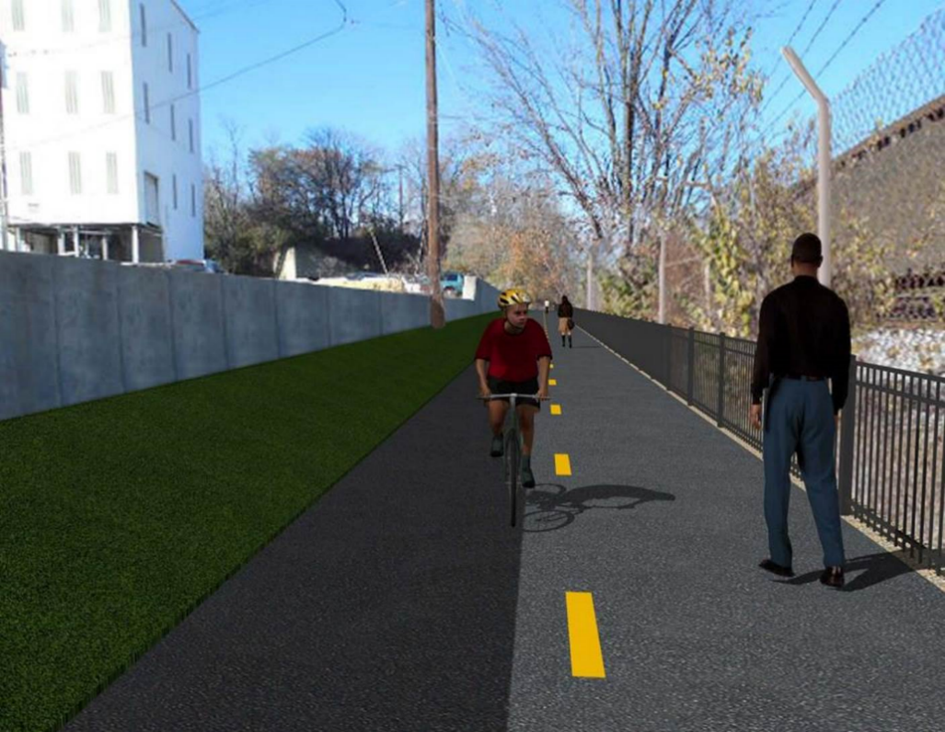

**Proposed Metropolitan Branch Trail**

**1. PROJECT DESCRIPTION**

The planned Metropolitan Branch Trail Project (“the Project”) consists of the design and construction of a new trail adjacent to CSX tracks and WMATA Red Line tracks along John McCormack Drive, adjacent to Fort Totten Metro Station, and on NPS property in NE, Washington D.C. The trail begins approximately 1500 feet south of Bates Road NE on the east side of John McCormack Drive NE, extending north along the WMATA and CSX tracks to the Fort Totten Metro Station tie in with First Place NE. An existing trail connection from Gallatin Road NE to the Fort Totten Metro Station will be reconstructed as a part of the Project.

The Project is 83.15% Federally-Funded and 16.85% District-Funded. Potomac Construction is the Design Build contractor.

Delon Hampton and Associates Chartered is providing Construction Management and Inspection services. Specific Construction Scope of Work includes:

* Provide mobilization and demobilization, provision and maintenance of Engineer’s field facilities, field layout, employee training, and other incidental work required for a quality, complete and finished product;
* Establishment and maintenance of vehicular and pedestrian traffic including signs, barricades and other transition devices; reconfiguring the devices in conjunction with changes in work areas; and their removal and disposal upon project completion, including restoration of disturbed areas;
* Clearing and grubbing, as required within the LOD;
* Removal of unsuitable material, excavation, and backfilling and pervious paving to construct a new trail;
* Protection of trees during construction;
* Provide ADA compliant trail connections and pedestrian ramps;
* Provide retaining walls as necessary to stay within the LOD and minimize property impacts following visual requirements specified for retaining walls on NPS property;
* Provide new permanent regulatory and wayfinding signs for the trail and all trail connection intersections;
* Provide road and trail pavement markings;
* Provide landscaping within the LOD for the Project including special requirements for landscaping on NPS property;
* Provide erosion and sediment control measures, storm water management facilities, including pervious asphalt pavement and bioretention facilities;
* Provide utility coordination, identification, locating, and protection of all utilities encountered during design and construction including relocation of Pepco poles along Aggregate Industries property; and
* Provide new WMATA security fencing between the trail and CSXT tracks.
* Remove existing sidewalk and widen sidewalk to 10’ along the west side of 1st place NE from Metropolitan Branch Trail to entrance to WMATA bus loop, on the west side.

**2. STATUS OF CONSTRUCTION / PROGRESS SUMMARY**

**Work performed this week:**

**Design**

* 100 % Complete

**Construction:**

**Phase D**

* Excavated drainage trench
* Installed drainage pipes
* Backfilled and compacted drainage trench
* Installed WMATA stair rebar
* Constructed WMATA stair formwork
* Excavated graded and compacted concrete ditch subgrade
* Compacted concrete ditch subgrade
* Placed concrete for concrete ditch located behind S3 wall
* Graded embankment slope area behind S3 wall
* Removed existing light pole foundation
* Installed electrical conduits for WMATA light pole
* Contractor safety tool box talk

**CM Consultant:**

* Monitored construction progress, make sure all applicable inspections and testing were performed
* Reviewed Project Schedule
* Attended Project Progress Meeting
* Prepared CM Weekly Report to post
* Prepared CM weekly report to DDOT
* Updated Project Files
* Updated Project Logs
* Updated Project Webpage
* Updated documents in DHA SharePoint site
* Updated DDOT Sharepoint site
* Communication with PCCI and stakeholders in terms of submittals

**3. MEETINGS / PROJECT COORDINATION**

Tue 12/21/2021 MBT Progress Meeting was held at 10:00 A.M.

**4. DAILY WORK PERFORMED**

Sun 12/19/21 No work performed.

Mon 12/20/21 Phase D – Excavated and compacted concrete ditch behind S3 wall. Placed

bedding stone at inlet base. Graded slope area behind S3 wall. Excavated drainage pipes trench.

Phase D – Electrical work – Excavated existing light pole foundation.

Tue 12/21/21 Phase D – Constructed WAMATA stair formwork. Placed concrete for ditch

behind wall S3. Excavated and graded slope area behind S3 wall. Graded concrete ditch subgrade. Constructed formwork for concrete ditch. Excavated drainage trench. Installed drainage pipes.

Phase D – Electrical work – Removed existing light pole foundation.

Wed 12/22/21 Phase D – Constructed WMATA stair formwork. Placed concrete for concrete ditch behind S3 wall. Excavated drainage trench. Installed drainage pipes. Backfilled and compacted drainage trench.

Phase D – Electrical work – Excavated and removed light pole foundation.

Thurs 12/23/21 Phase D – Excavated drainage trench. Constructed WMATA stair formwork.

Excavated and graded slope area behind S3. Placed concrete for ditch

concrete located behind S3 wall.

Phase D – Electrical Work – Installed electrical conduit at light pole foundation. Backfilled and compacted excavated light pole foundation pit.

Fri 12/24/21 Phase D – No work performed.

Phase D – Electrical Work – No work performed.

Sat 12/25/21 Phase D – No work scheduled.

**5. INSPECTION & MATERIAL TESTS PERFORMED**

|  |  |
| --- | --- |
| Jobsite Safety Inspection  Erosion and Sediment Control inspection  MOT Inspection  Compaction Test  Asphalt Material Testing  Concrete Material Testing – Results pending  **\*\* Note - Additional Material Test Results can be found on DDOT QA QC Material Division Tracking SharePoint website**. | Infiltration Tests  Dynamic Cone Penetration (DCP) Tests  Rebars Inspection - Ongoing |

**6. DBE PARTICIPATION SUMMARIES**

Potomac Construction Inc. (Contractor)

* DBE Goal for Contractor is 15%. To-date the Contractor has achieved 55% of their goal.

Delon Hampton & Associates (CM)

* DBE Goal for the CM is 10%. To-date the CM has achieved 97% of their goal.

**7. ACCIDENTS / INCIDENTS**

None occurred on-site during this week.

**8. PHOTOS OF THE WORK PERFORMED**

**12. PHOTOS OF WORK PERFORMED THIS PERIOD**

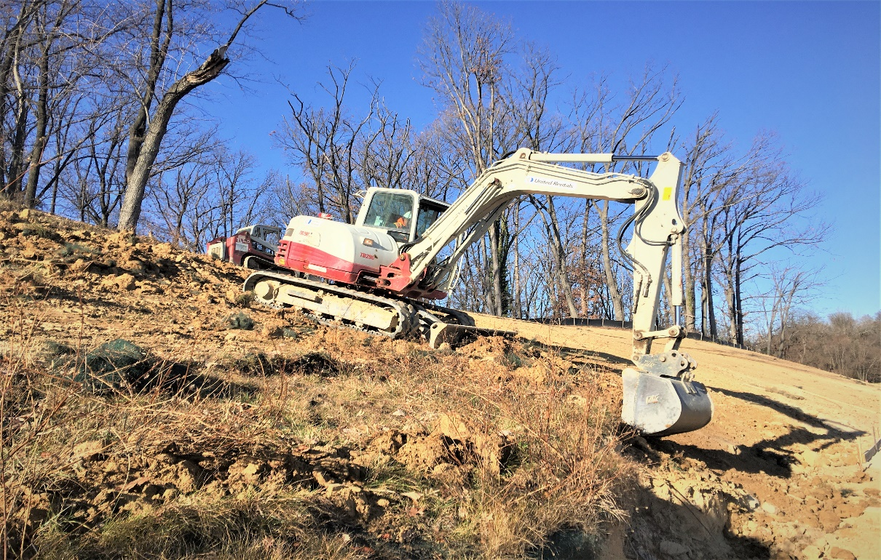

Phase D – Crew excavating slope area along the trail

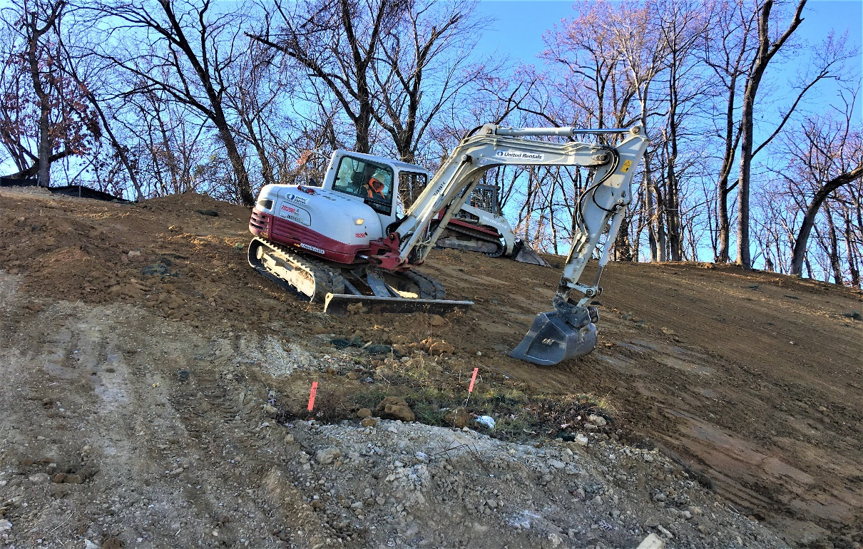

Phase D – Crew grading slope area along the trail

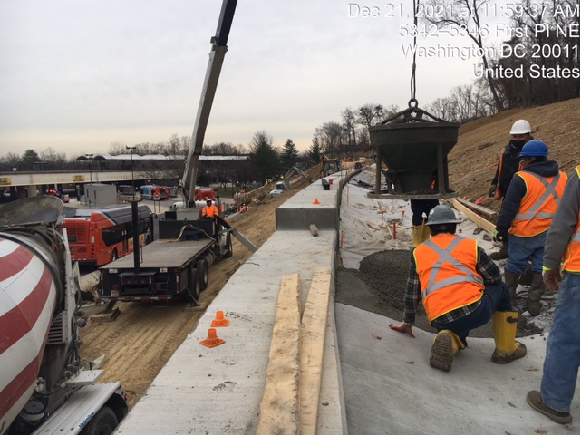

Phase D – Crew placing concrete at ditch behind S3 wall

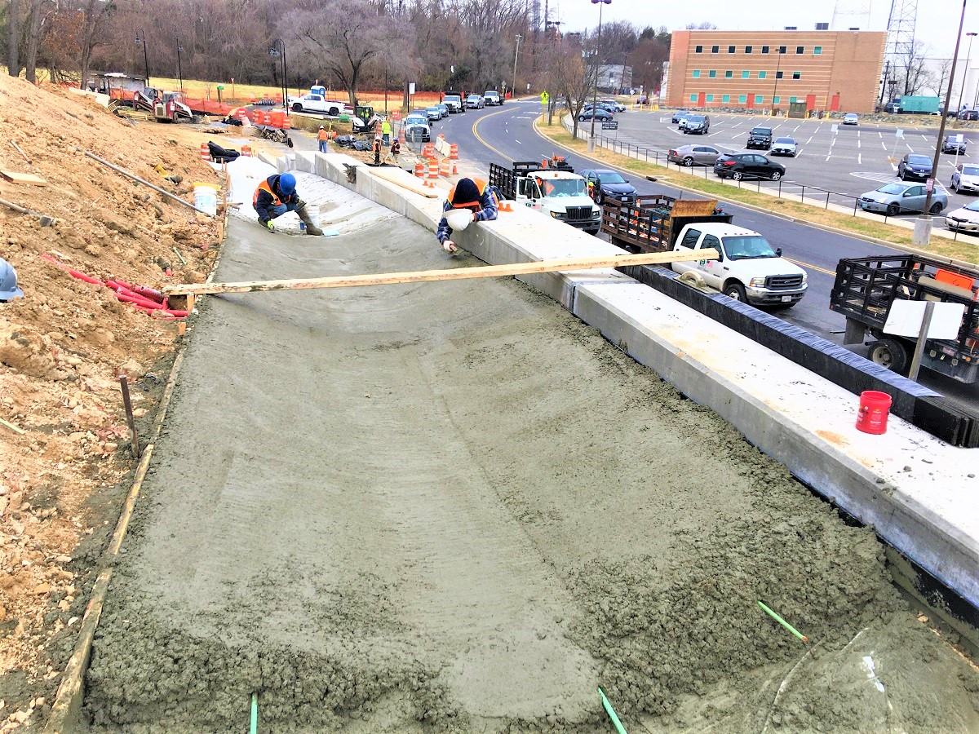

Phase D – Crew finishing ditch concrete behind S3 wall

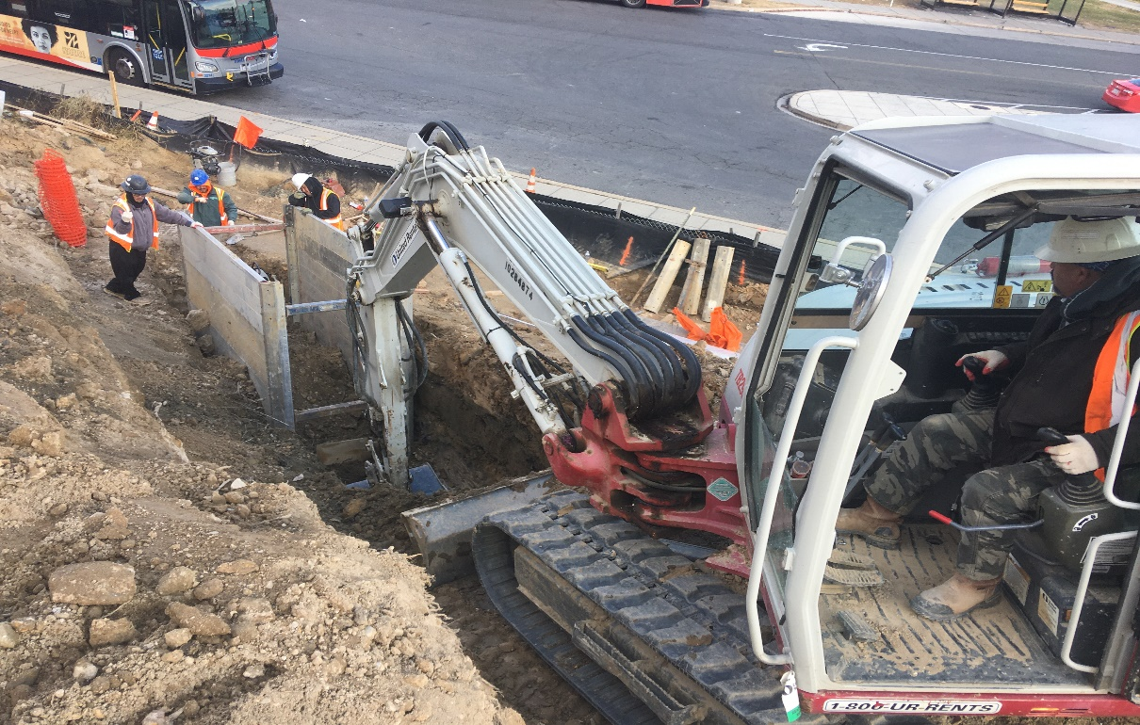

Phase D – Crew excavating drainage trench

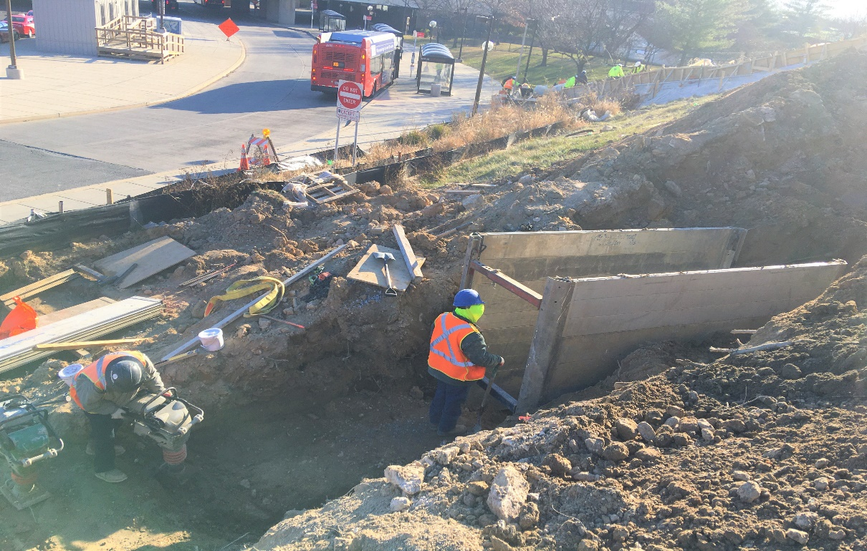

Phase D – Crew compacting drainage trench

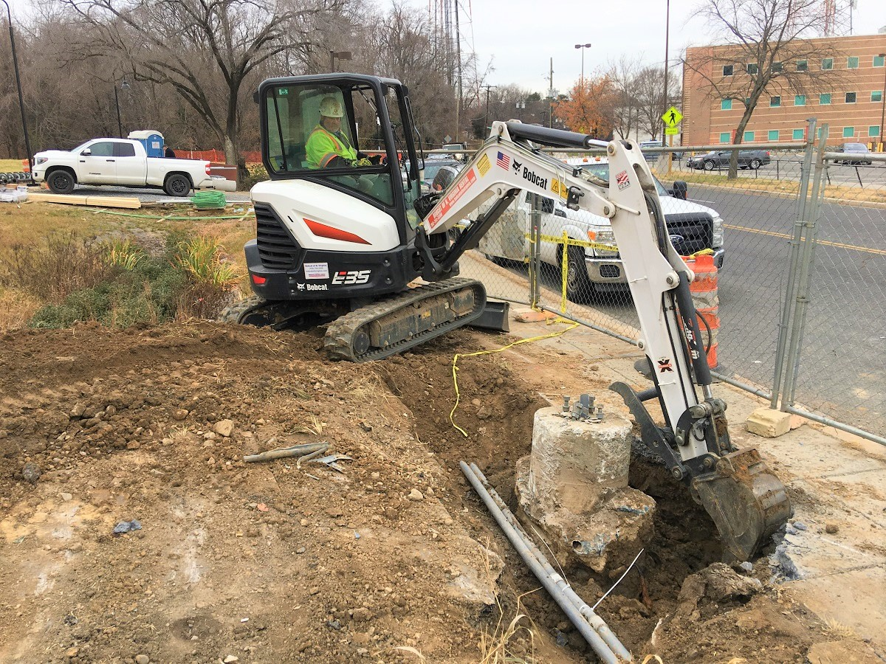

Phase D – Crew removing light pole foundation

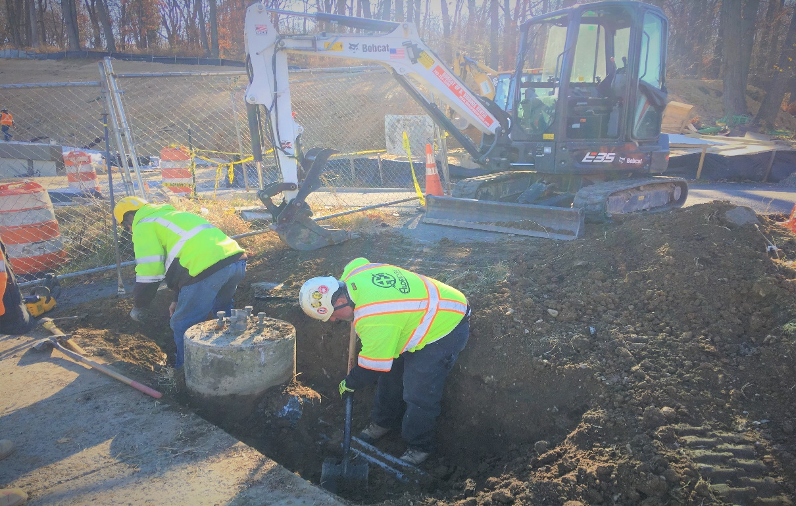

Phase D – Crew excavating WMATA Lightpole foundation

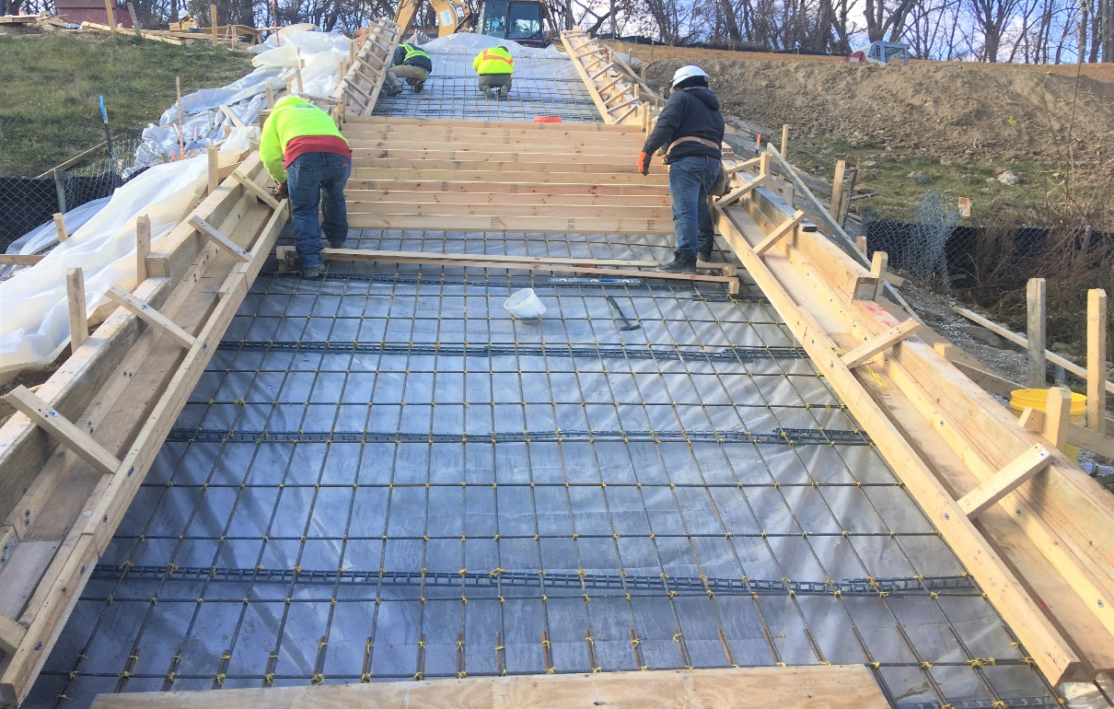

Phase D – Crew trying WMATA stair rebar

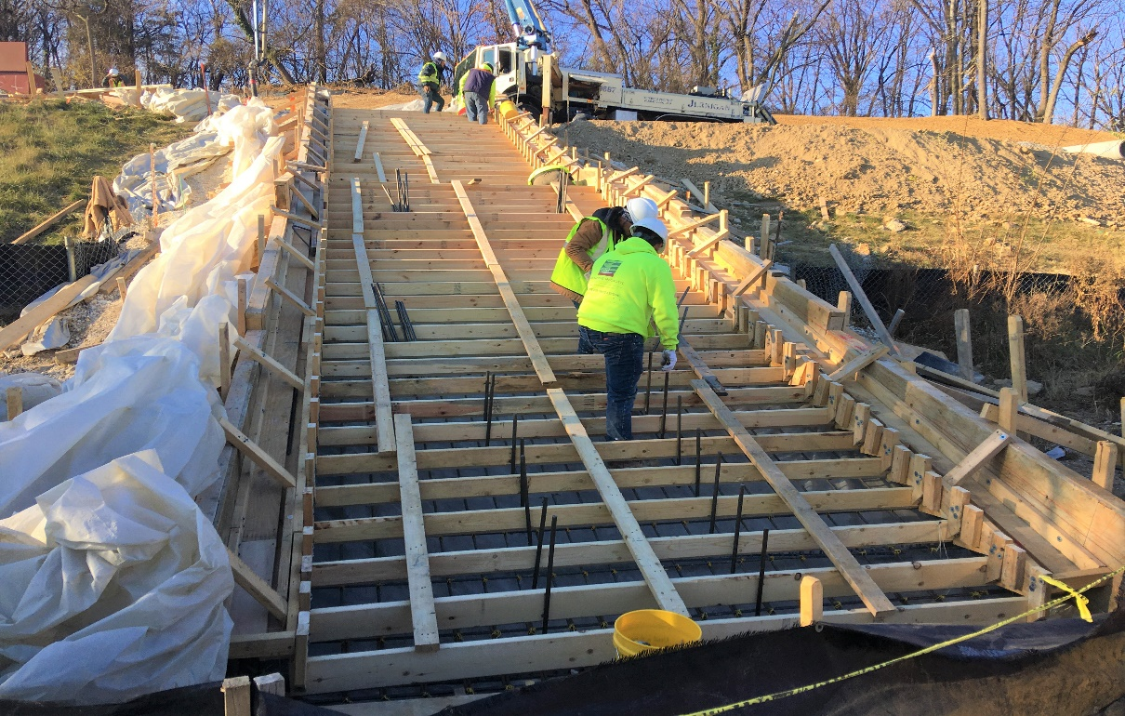

Phase D – Crew construction WMATA stair formwork