Metropolitan Branch Trail Design Build, South Segment
DC CONTRACT NO. DCKA-2016-C-0044
FAP No.: STP-2016 (060)

CONSTRUCTION MANAGER’S
WEEKLY PROGRESS REPORT

12/06/2020 – 12/12/2020

Project Website: www.metbranchtrail-forttotten.com
For Additional Trail Information Please see www.metbranchtrail.com

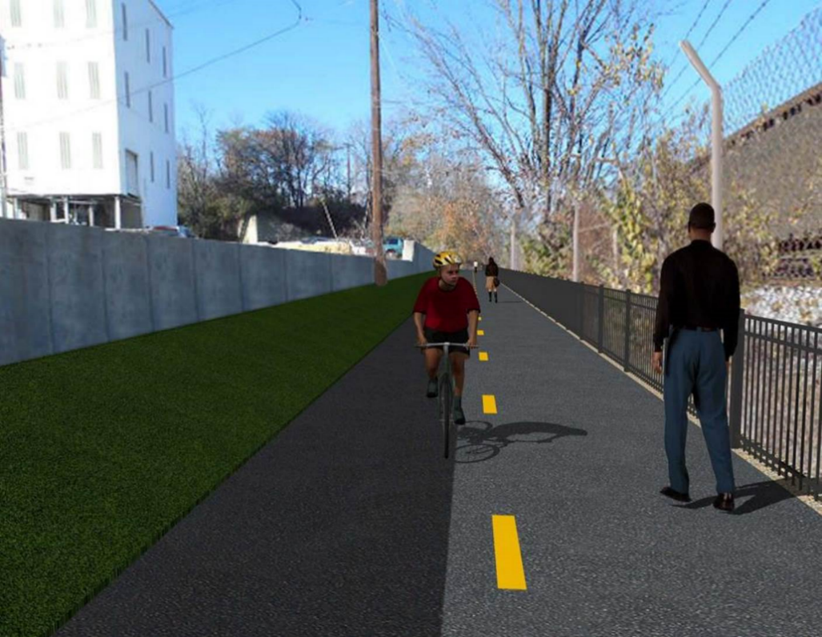

Proposed Metropolitan Branch Trail

1. PROJECT DESCRIPTION

The planned Metropolitan Branch Trail Project (“the Project”) consists of the design and construction of a new trail adjacent to CSX tracks and WMATA Red Line tracks along John McCormack Drive, adjacent to Fort Totten Metro Station, and on NPS property in NE, Washington D.C. The trail begins approximately 1500 feet south of Bates Road NE on the east side of John McCormack Drive NE, extending north along the WMATA and CSX tracks to the Fort Totten Metro Station tie in with First Place NE. An existing trail connection from Gallatin Road NE to the Fort Totten Metro Station will be reconstructed as a part of the Project.

The Project is 83.15% Federally-Funded and 16.85% District-Funded. Potomac Construction is the Design Build contractor.

Delon Hampton and Associates Chartered is providing Construction Management and Inspection services. Specific Construction Scope of Work includes:

- Provide mobilization and demobilization, provision and maintenance of Engineer’s field facilities, field layout, employee training, and other incidental work required for a quality, complete and finished product;
- Establishment and maintenance of vehicular and pedestrian traffic including signs, barricades and other transition devices; reconfiguring the devices in conjunction with changes in work areas; and their removal and disposal upon project completion, including restoration of disturbed areas;
- Clearing and grubbing, as required within the LOD;
- Removal of unsuitable material, excavation, and backfilling and pervious paving to construct a new trail;
- Protection of trees during construction;
- Provide ADA compliant trail connections and pedestrian ramps;
- Provide retaining walls as necessary to stay within the LOD and minimize property impacts following visual requirements specified for retaining walls on NPS property;
- Provide new permanent regulatory and wayfinding signs for the trail and all trail connection intersections;
- Provide road and trail pavement markings;
- Provide landscaping within the LOD for the Project including special requirements for landscaping on NPS property;
- Provide erosion and sediment control measures, storm water management facilities, including pervious asphalt pavement and bioretention facilities;
- Provide utility coordination, identification, locating, and protection of all utilities encountered during design and construction including relocation of Pepco poles along Aggregate Industries property; and
- Provide new WMATA security fencing between the trail and CSXT tracks.
- Remove existing sidewalk and widen sidewalk to 10’ along the west side of 1st place NE from Metropolitan Branch Trail to entrance to WMATA bus loop, on the west side.

2. STATUS OF CONSTRUCTION / PROGRESS SUMMARY

Work performed this week:

Design

- MBT Designer submitted Phase D 3-ring binder and 100% Plans to DDOT
- Stakeholders acceptance for Phase D Final Design Plans
- CSX is reviewing Phase D Means and Methods

Construction:

Phase B

- Cleaned inlets
- Cut exposed filter fabric along the trail edge

Phase D

- Excavated drainage trench
- Installed and backfilled drainage pipes
- Demolished and removed existing concrete ditch
- Stripped retaining wall footings formwork
- Constructed retaining wall footings formwork
- Installed retaining wall footings rebars
- Painted anti-graffiti coating on retaining wall S1 outer face
- Installed temporary drainage pipes
- Installed silt fence
- CSX flagger’s operation and safety tool box talk

CM Consultant:

- Monitored construction progress, make sure all applicable inspections and testing were
Performed
- Reviewed Inspector Daily Reports
- Attended MBT Progress Meeting conference call
- Attended Field Meeting with DDOT Designer and Potomac Construction, Inc.
- Attended DDOT Aggregate Industries Meeting conference call
- Attended MBT QAQC Meeting
- Reviewed Contractor’s Monthly Payment Invoice
- Prepared Change Order packages
- Prepared CM Weekly Reports
- Updated Project Files
- Updated Project Webpage
- Updated documents in SharePoint
- Communication with the stakeholder in terms of submittals

3. MEETINGS / PROJECT COORDINATION

Mon 12/07/20 MBT Field Meeting was held between DDOT CM Designer and Potomac
Construction, Inc. at 9:00 A.M.
Tue 12/08/20 MBT Progress Meeting conference call was held at 10:00 A.M
Wed 12/09/20 MBT DDOT CM Aggregate Industries meeting conference call was held
at 2:30 P.M.
Fri 12/11/20 MBT QAQC Meeting conference call was held at 10:00 A.M.

4. DAILY WORK PERFORMED

Sun 12/06/20 No work performed.
Mon 12/07/20 Phase B – Cleaned drainage inlets.
Phase B - Electrical Work – No work scheduled.
Phase D – Excavated retaining wall footing. Stripped retaining wall footing formwork. Constructed retaining wall footings formwork. Painted anti-graffiti coating on the outer face of retaining wall. Excavated test pits. Demolished and removed existing concrete ditch. Excavated drainage trench, placed bedding stone, and installed pipes. Backfilled drainage pipe trench. Installed temporary drainage pipes.
Tue 12/08/20 Phase B – Cut exposed geotextile fabric along the trail edge.
Phase B – Electrical Work – No work scheduled.
Phase D – Demolished and removed existing underground concrete structure. Installed retaining wall footings formwork. Installed retaining wall footings rebars. Excavated drainage trench, placed bedding stone, and installed pipes. Backfilled drainage pipe trench.
Wed 12/09/20 Phase B – No work performed
Phase B – Electrical Work – No work scheduled
Phase D – Demolished and removed existing underground concrete structure. Installed retaining wall footings formwork. Installed retaining wall footings rebars. Excavated drainage trench, placed bedding stone, and installed pipes. Backfilled drainage pipe trench. Installed temporary drainage pipes. Installed silt fence.
Thurs 12/10/20 Phase B – No work performed.
Phase B – Electrical Work – No work scheduled
Phase D – Demolished and removed existing underground concrete
structure. Installed retaining wall footings formwork. Installed retaining wall footings rebars. Excavated drainage trench, placed bedding stone, and installed pipes. Backfilled drainage pipe trench. Installed temporary drainage pipes.
Fri 12/11/20 Phase B – No work performed
Phase B – Electrical work – No work scheduled
Phase D – Prepared retaining wall footings for final inspection. Excavated drainage trench, placed bedding stone, and installed pipes. Backfilled drainage trench.
Sat 12/13/20 No work scheduled

5. INSPECTION & MATERIAL TESTS PERFORMED

Jobsite Safety Inspection  Erosion and Sediment Control inspection  MOT Inspection  Compaction Test - Passed  Asphalt Material Testing  Concrete Material Testing – Pending results  ** Note - Additional Material Test Results can be found on DDOT QA QC Material Division Tracking SharePoint website. | Infiltration Tests  Dynamic Cone Penetration (DCP) Tests - Passed  Rebars Inspection - Ongoing
6. DBE PARTICIPATION SUMMARIES

Potomac Construction (Contractor)
- DBE Goal for Contractor is 15%. To-date the Contractor has achieved 46% of their goal.

Delon Hampton & Associates (CM)
- DBE Goal for the CM is 10%. To-date the CM has achieved 58% of their Goal.

7. ACCIDENTS / INCIDENTS

None occurred on-site during this week.

8. PHOTOS OF THE WORK PERFORMED

12. PHOTOS OF WORK PERFORMED THIS PERIOD

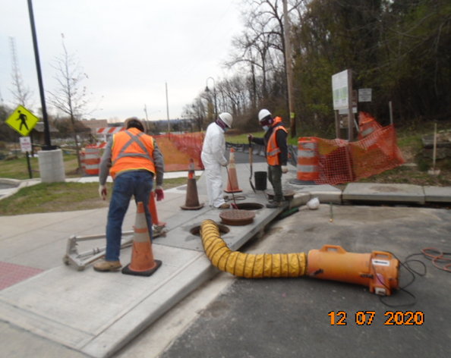
Phase B – Crew cleaning catch basin located at Gallatin Street

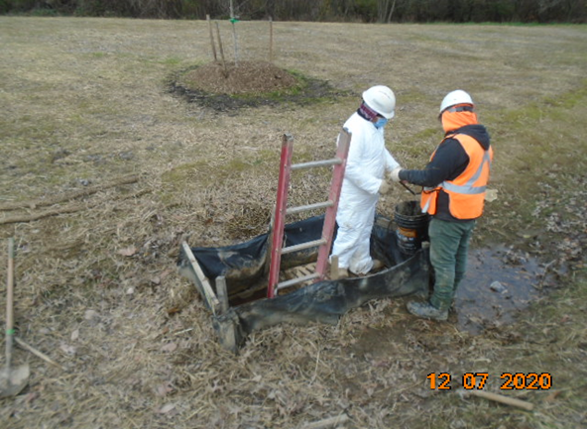
Phase B – Crew cleaning drainage inlet
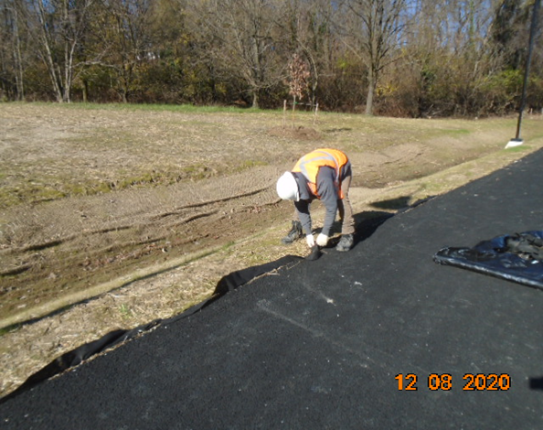
Phase B – Crew cutting exposed geotextile fabric

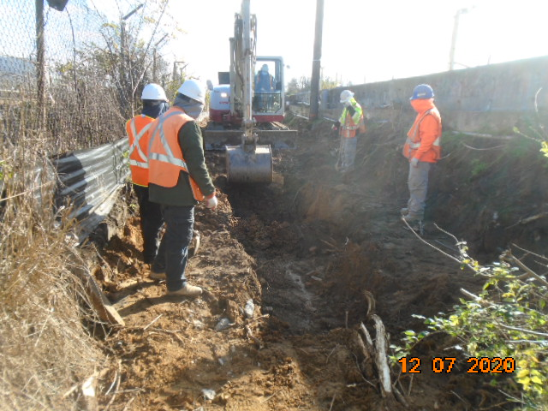
Phase D – Crew excavating drainage trench

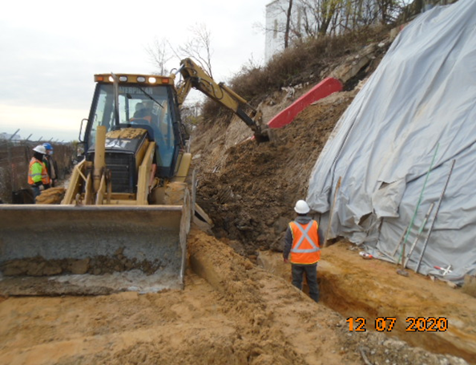
Phase D – Crew excavating retaining wall footing

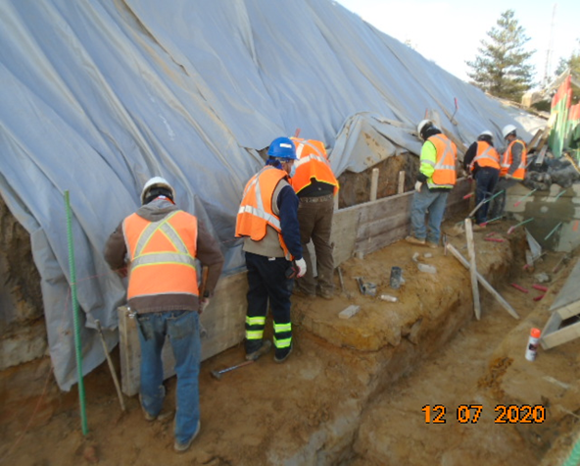
Phase D – Crew installing retaining wall footings formwork

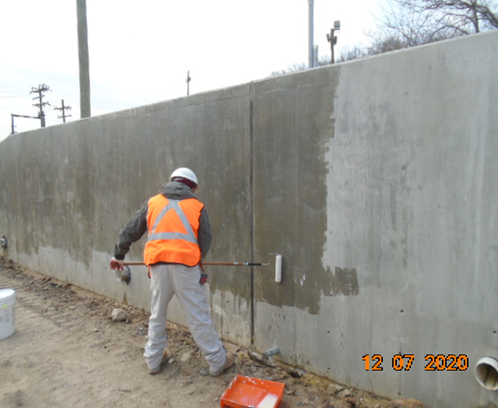
Phase D – Crew painting anti-graffiti coating on retaining wall outer face

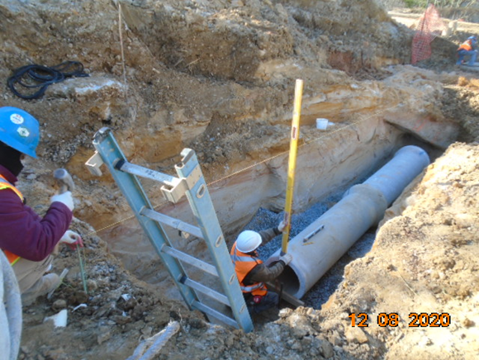
Phase D – Crew installing drainage pipes

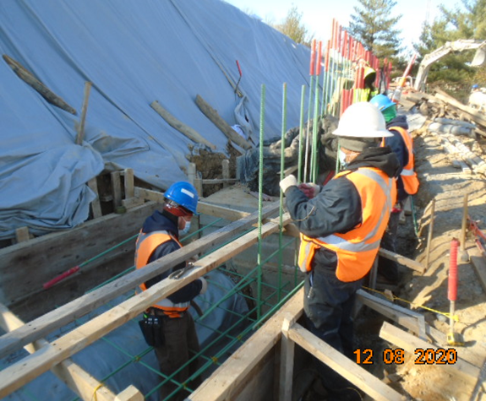
Phase D – Crew installing retaining wall footing rebars

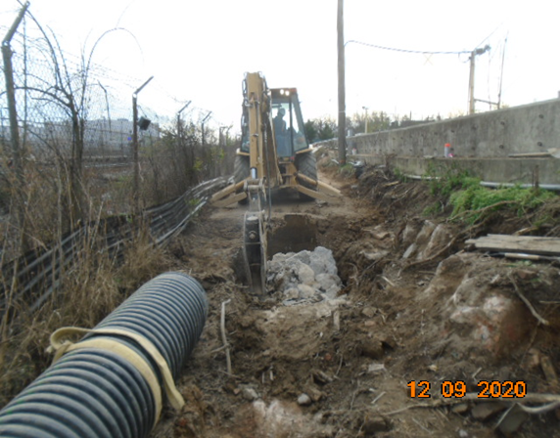
Phase D – Crew demolishing existing underground concrete

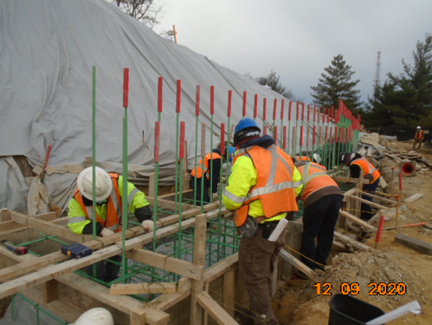
Phase D – Crew installing retaining footings wall rebars

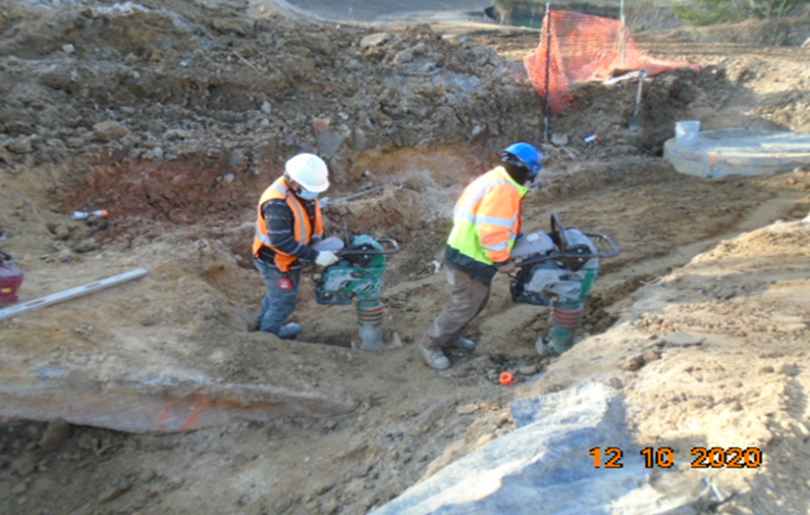
Phase D – Crew compacting drainage trench

