Metropolitan Branch Trail Design Build, South Segment
DC CONTRACT NO. DCKA-2016-C-0044
FAP No.: STP-2016 (060)

CONSTRUCTION MANAGER’S
WEEKLY PROGRESS REPORT

12/05/2021 – 12/11/2021

Project Website: www.metbranchtrail-forttotten.com
For Additional Trail Information Please see www.metbranchtrail.com
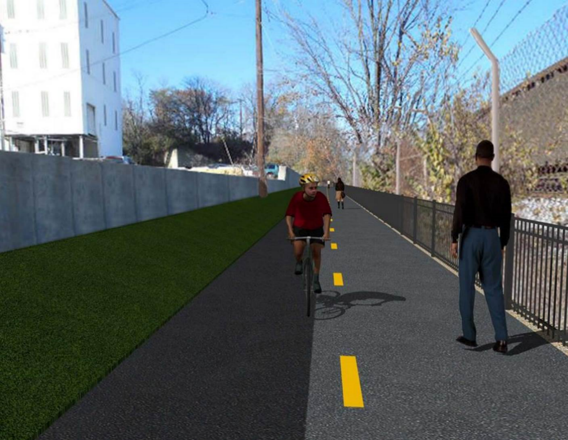

Proposed Metropolitan Branch Trail

1. PROJECT DESCRIPTION

The planned Metropolitan Branch Trail Project (“the Project”) consists of the design and construction of a new trail adjacent to CSX tracks and WMATA Red Line tracks along John McCormack Drive, adjacent to Fort Totten Metro Station, and on NPS property in NE, Washington D.C. The trail begins approximately 1500 feet south of Bates Road NE on the east side of John McCormack Drive NE, extending north along the WMATA and CSX tracks to the Fort Totten Metro Station tie in with First Place NE. An existing trail connection from Gallatin Road NE to the Fort Totten Metro Station will be reconstructed as a part of the Project.

The Project is 83.15% Federally-Funded and 16.85% District-Funded. Potomac Construction is the Design Build contractor.

Delon Hampton and Associates Chartered is providing Construction Management and Inspection services. Specific Construction Scope of Work includes:

- Provide mobilization and demobilization, provision and maintenance of Engineer’s field facilities, field layout, employee training, and other incidental work required for a quality, complete and finished product;
- Establishment and maintenance of vehicular and pedestrian traffic including signs, barricades and other transition devices; reconfiguring the devices in conjunction with changes in work areas; and their removal and disposal upon project completion, including restoration of disturbed areas;
- Clearing and grubbing, as required within the LOD;
- Removal of unsuitable material, excavation, and backfilling and pervious paving to construct a new trail;
- Protection of trees during construction;
- Provide ADA compliant trail connections and pedestrian ramps;
- Provide retaining walls as necessary to stay within the LOD and minimize property impacts following visual requirements specified for retaining walls on NPS property;
- Provide new permanent regulatory and wayfinding signs for the trail and all trail connection intersections;
- Provide road and trail pavement markings;
- Provide landscaping within the LOD for the Project including special requirements for landscaping on NPS property;
- Provide erosion and sediment control measures, storm water management facilities, including pervious asphalt pavement and bioretention facilities;
- Provide utility coordination, identification, locating, and protection of all utilities encountered during design and construction including relocation of Pepco poles along Aggregate Industries property; and
- Provide new WMATA security fencing between the trail and CSXT tracks.
- Remove existing sidewalk and widen sidewalk to 10’ along the west side of 1st place NE from Metropolitan Branch Trail to entrance to WMATA bus loop, on the west side.

2. STATUS OF CONSTRUCTION / PROGRESS SUMMARY

Work performed this week:

Design

- 100 % Complete

Construction:

Phase D

- Set precast inlet
- Excavated drainage trench
- Installed drainage pipes
- Backfilled drainage trench
- Placed and compacted stone at WMATA stairs subgrade
- Performed layout for WMATA stairs
- Painted S3 wall panels, pilasters, and coping wall
- Excavated and prepared subgrade for sidewalk
- Excavated and prepared subgrade for concrete ditch behind S3 wall
- Constructed formwork for sidewalk
- Constructed formwork for concrete ditch
- Graded slope area behind S3 wall
- Cleaned and fine graded slope area in AI lot between S1 and S2 wall
- Contractor safety tool box talk

CM Consultant:

- Monitored construction progress, make sure all applicable inspections and testing were performed
- Reviewed Project Schedule
- Reviewed Monthly payment invoice
- Attended site walk-thru inspection with NPS
- Attended Project Progress Meeting
- Prepared CM Weekly Report to post
- Prepared CM weekly report to DDOT
- Updated Project Files
- Updated Project Logs
- Updated Project Webpage
- Updated documents in DHA SharePoint site
- Updated DDOT Sharepoint site
- Communication with PCCI and stakeholders in terms of submittals

3. MEETINGS / PROJECT COORDINATION

Mon 12/06/21 NPS DHA and PCCI site walk-thru meeting was held at 1:00 A.M.
Tue 12/07/21 MBT Progress Meeting was held at 10:00 A.M.

4. DAILY WORK PERFORMED

Sun 12/05/21 No work performed.
Mon 12/06/21 Phase D – Placed stone for WMATA stairs subgrade. Performed excavation
for precast inlet. Excavated drainage pipes trench. Graded slope area behind S3 wall. Painted S3 wall panels and pilasters.
Phase D – Electrical work – No work performed.
Tue 12/07/21 Phase D – Placed bedding stone for WMATA stairs subgrade. Performed
excavation for precast inlet. Installed drainage pipes. Graded slope area behind S3 wall. Painted S3 wall panels and pilasters.
Phase D – Electrical work – No work performed.
Wed 12/08/21 Phase D – Compacted bedding stone at WMATA stairs subgrade. Backfilled and compacted drainage trench. Installed precast drainage inlet. Cleaned and fine graded slope behind curb between S1 and S2 walls. Painted S3 wall panels and pilasters.
Phase D – Electrical work – No work performed
Thurs 12/09/21 Phase D – Compacted bedding stone at WMATA stairs subgrade.
Performed layout for WMATA stairs. Backfilled and compacted drainage trench. Backfilled drainage inlet. Excavated and graded concrete ditch behind S3 wall. Construct formwork for concrete ditch behind S3 wall.
Phase D – Electrical Work – No work performed.
Fri 12/10/21 Phase D – Backfilled drainage inlet. Graded slope area behind S3 wall.
Compacted WMATA stairs bedding stone and covered with plastic. Graded
sidewalk subgrade. Constructed sidewalk formwork. Compacted concrete
ditch subgrade. Constructed formwork for concrete ditch behind S3 wall.
Phase D – Electrical Work – No work performed.
Sat 12/11/21 Phase D – No work scheduled.

5. INSPECTION & MATERIAL TESTS PERFORMED

Jobsite Safety Inspection  Erosion and Sediment Control inspection  MOT Inspection  Compaction Test  Asphalt Material Testing  Concrete Material Testing  ** Note - Additional Material Test Results can be found on DDOT QA QC Material Division Tracking SharePoint website. | Infiltration Tests  Dynamic Cone Penetration (DCP) Tests  Rebars Inspection
6. DBE PARTICIPATION SUMMARIES

Potomac Construction Inc. (Contractor)

- DBE Goal for Contractor is 15%. To-date the Contractor has achieved 55% of their goal.

Delon Hampton & Associates (CM)

- DBE Goal for the CM is 10%. To-date the CM has achieved 97% of their goal.

7. ACCIDENTS / INCIDENTS

None occurred on-site during this week.

8. PHOTOS OF THE WORK PERFORMED

12. PHOTOS OF WORK PERFORMED THIS PERIOD

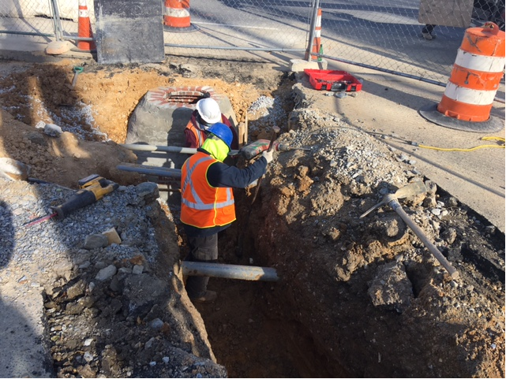
Phase D – Crew excavating drainage trench

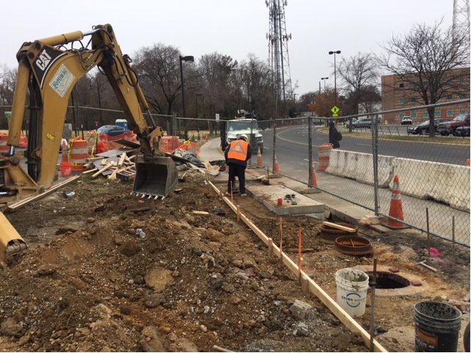
Phase D – Crew compacting backfill around inlet

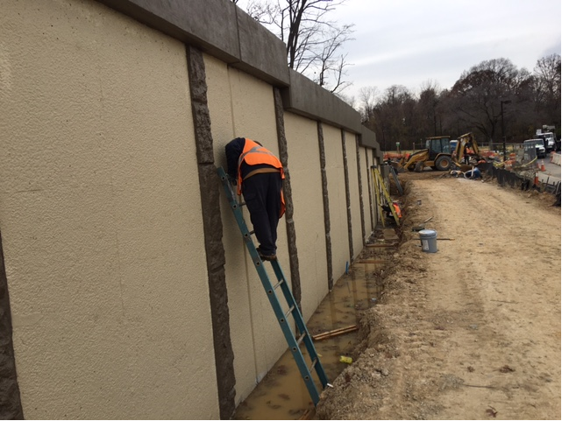
Phase D – Crew paining S3 wall panel

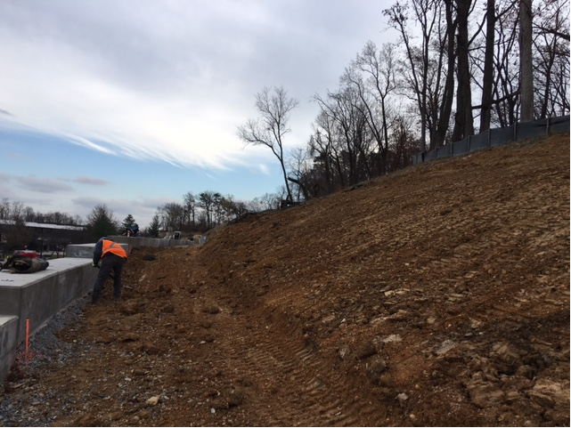
Phase D – Crew cleaning and fine grading slope area behind S3 wall

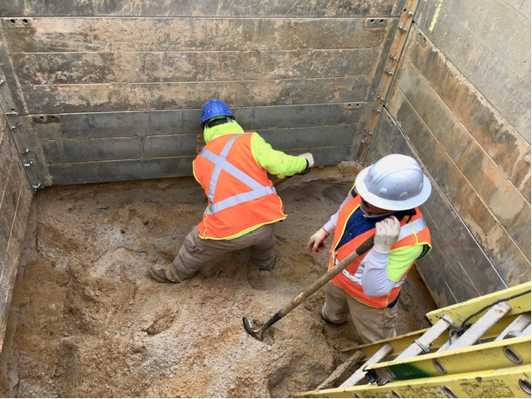
Phase D – Crew excavating precast inlet

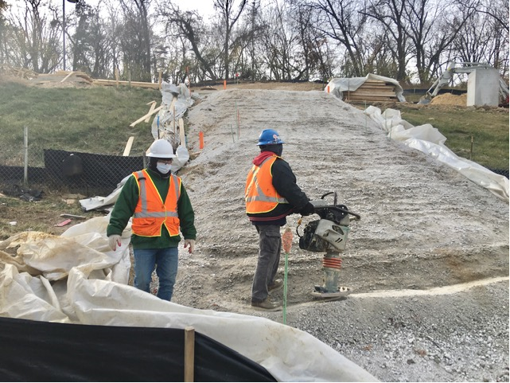
Phase D – Crew compacting bedding stone WMATA stairs subgrade

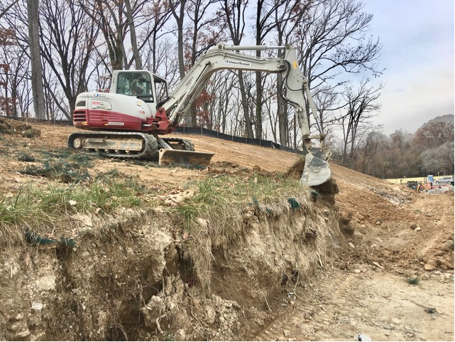
Phase D – Crew grading slope area behind S3 wall

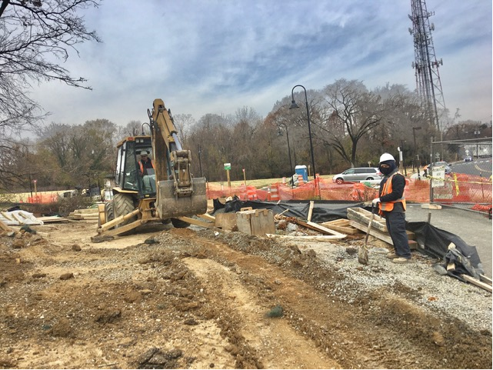
Phase D – Phase D crew excavating the trail path

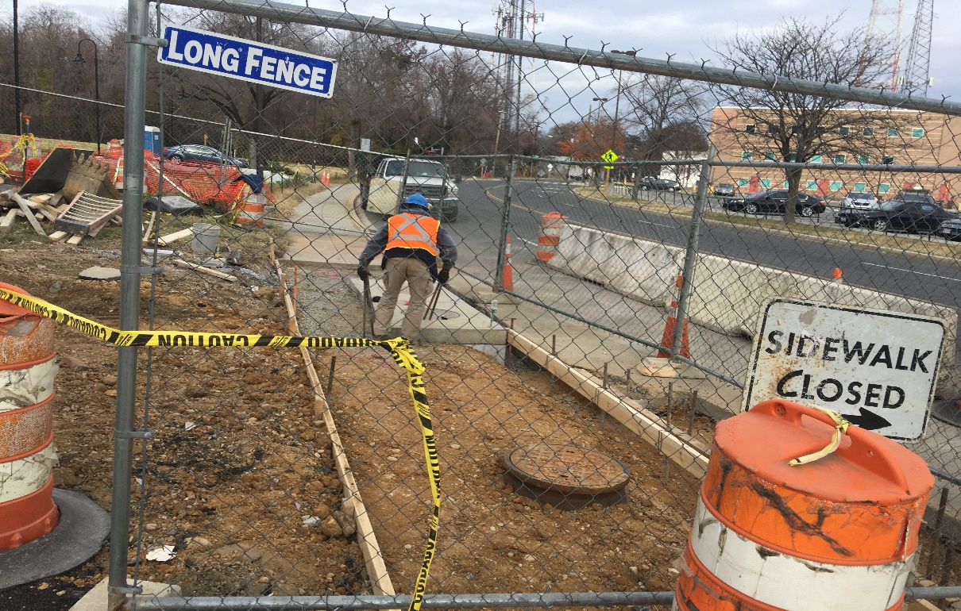
Phase D – Crew constructing sidewalk formwork

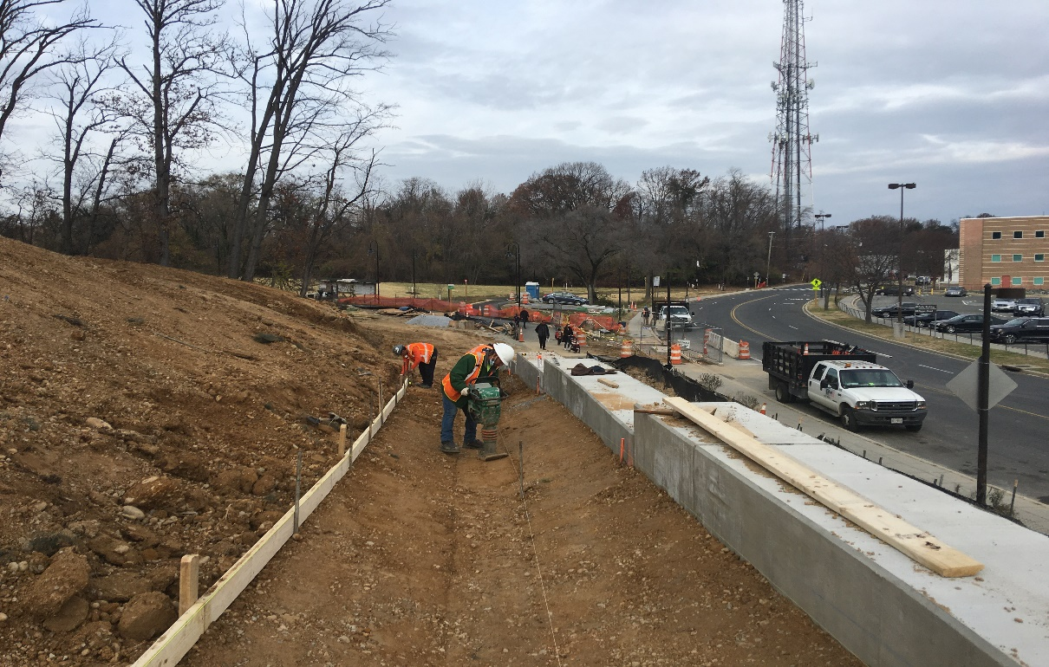
Phase D – Crew compacting concrete ditch subgrade behind S3 wall.

