Metropolitan Branch Trail Design Build, South Segment
DC CONTRACT NO. DCKA-2016-C-0044
FAP No.: STP-2016 (060)

CONSTRUCTION MANAGER’S
WEEKLY PROGRESS REPORT

11/28/2021 – 12/04/2021

Project Website: www.metbranchtrail-forttotten.com
For Additional Trail Information Please see www.metbranchtrail.com
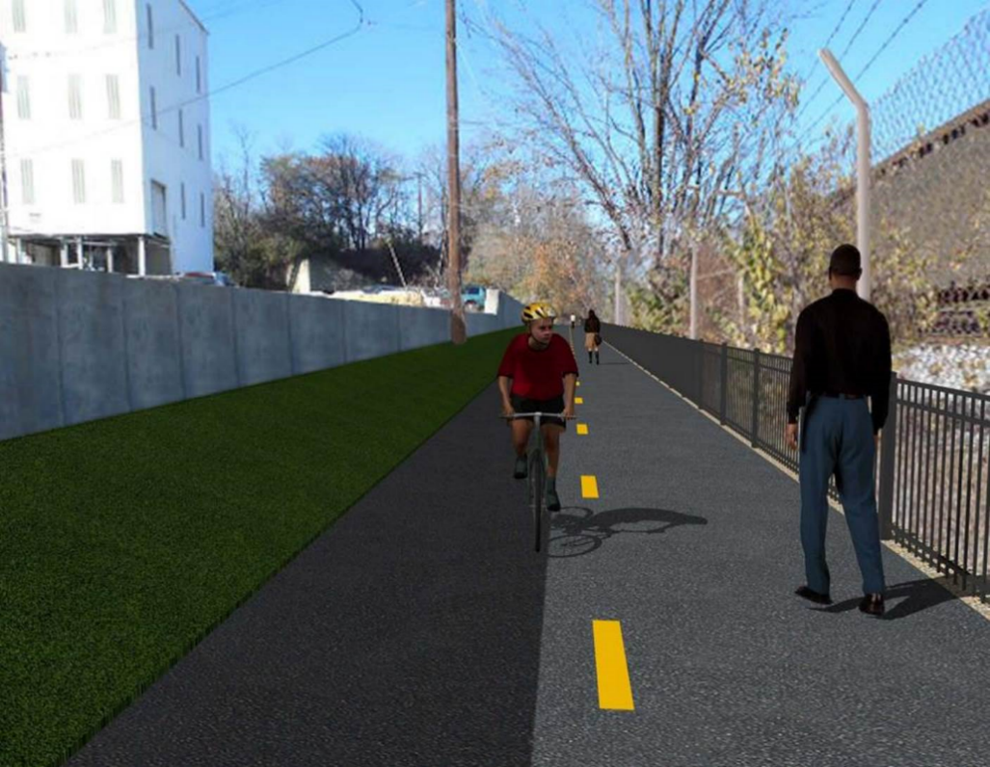

Proposed Metropolitan Branch Trail

1. PROJECT DESCRIPTION

The planned Metropolitan Branch Trail Project (“the Project”) consists of the design and construction of a new trail adjacent to CSX tracks and WMATA Red Line tracks along John McCormack Drive, adjacent to Fort Totten Metro Station, and on NPS property in NE, Washington D.C. The trail begins approximately 1500 feet south of Bates Road NE on the east side of John McCormack Drive NE, extending north along the WMATA and CSX tracks to the Fort Totten Metro Station tie in with First Place NE. An existing trail connection from Gallatin Road NE to the Fort Totten Metro Station will be reconstructed as a part of the Project.

The Project is 83.15% Federally-Funded and 16.85% District-Funded. Potomac Construction is the Design Build contractor.

Delon Hampton and Associates Chartered is providing Construction Management and Inspection services. Specific Construction Scope of Work includes:

- Provide mobilization and demobilization, provision and maintenance of Engineer’s field facilities, field layout, employee training, and other incidental work required for a quality, complete and finished product;
- Establishment and maintenance of vehicular and pedestrian traffic including signs, barricades and other transition devices; reconfiguring the devices in conjunction with changes in work areas; and their removal and disposal upon project completion, including restoration of disturbed areas;
- Clearing and grubbing, as required within the LOD;
- Removal of unsuitable material, excavation, and backfilling and pervious paving to construct a new trail;
- Protection of trees during construction;
- Provide ADA compliant trail connections and pedestrian ramps;
- Provide retaining walls as necessary to stay within the LOD and minimize property impacts following visual requirements specified for retaining walls on NPS property;
- Provide new permanent regulatory and wayfinding signs for the trail and all trail connection intersections;
- Provide road and trail pavement markings;
- Provide landscaping within the LOD for the Project including special requirements for landscaping on NPS property;
- Provide erosion and sediment control measures, storm water management facilities, including pervious asphalt pavement and bioretention facilities;
- Provide utility coordination, identification, locating, and protection of all utilities encountered during design and construction including relocation of Pepco poles along Aggregate Industries property; and
- Provide new WMATA security fencing between the trail and CSXT tracks.
- Remove existing sidewalk and widen sidewalk to 10’ along the west side of 1st place NE from Metropolitan Branch Trail to entrance to WMATA bus loop, on the west side.

2. STATUS OF CONSTRUCTION / PROGRESS SUMMARY

Work performed this week:

Design

- 100 % Complete

Construction:

Phase D

- Placed concrete for manhole base
- Constructed brick manhole
- Set precast manhole
- Constructed formwork for drainage manhole
- Performed excavation for WMATA stairs
- Compacted WMATA stairs subgrade
- Constructed formwork for WMATA stairs
- Painted S3 wall panels and ashlar pattern pilasters
- Parged S3 wall front and back face
- Drilled street lightpole foundation
- Constructed lightpole foundation formwork
- Place lightpole foundation concrete
- Pulled conductors from electrical manhole to light pole foundation
- Contractor safety tool box talk

CM Consultant:

- Monitored construction progress, make sure all applicable inspections and testing were performed
- Reviewed Project Schedule
- Reviewed Monthly payment invoice
- Prepared CM Weekly Report to post
- Prepared CM weekly report to DDOT
- Updated Project Files
- Updated Project Logs
- Updated Project Webpage
- Updated documents in DHA SharePoint site
- Updated DDOT Sharepoint site
- Communication with PCCI and stakeholders in terms of submittals

3. MEETINGS / PROJECT COORDINATION

None during this week.

4. DAILY WORK PERFORMED

Sun 11/28/21 No work performed.
Mon 11/29/21 Phase D – Performed excavation for WMATA stairs. Constructed formwork
for WMATA stairs. Performed excavation for drainage trench. Assembled
rebar for manhole base. Placed concrete for manhole base.
Painted S3 wall panels and pilasters.
Phase D – Electrical work – Drilled streetlight pole foundation. Installed lightpole foundation rebar.
Tue 11/30/21 Phase D – Compacted WMATA stair subgrade. Constructed formwork for
WMATA stairs. Removed manhole formwork. Construct brick manhole.
Performed excavation for recast drainage inlet.
Painted S3 wall panels and pilasters.
Phase D – Electrical work – Drilled streetlight pole foundation. Installed lightpole foundation rebar. Placed concrete for lightpole foundation.
Wed 12/01/21 Phase D – Constructed formwork for WMATA stairs. Constructed brick manhole. Painted S3 wall panels and pilasters.
Phase D – Electrical work – Drilled streetlight pole foundation. Installed lightpole foundation rebar and anchor bolts.
Thurs 12/02/21 Phase D – Backfilled and regraded WMATA stairs. Painted S3 wall panels
and pilasters. Constructed brick manhole. Installed connection pipe between precast inlet and drainage manhole. Excavated and graded the trail path.
Phase D – Electrical Work – Installed ground rod at lightpole foundation. Pre-assembled light poles.
Fri 12/03/21 Phase D – Backfilled and regraded WMATA stairs. Painted S3 wall panels
and pilasters. Constructed brick manhole. Excavated the trail path.
Phase D – Electrical Work – Pulled electrical wires from manhole to light pole foundation.
Sat 12/04/21 Phase D – No work scheduled.

5. INSPECTION & MATERIAL TESTS PERFORMED

Jobsite Safety Inspection  Erosion and Sediment Control inspection  MOT Inspection  Compaction Test  Asphalt Material Testing  Concrete Material Testing – Pending results  ** Note - Additional Material Test Results can be found on DDOT QA QC Material Division Tracking SharePoint website. | Infiltration Tests  Dynamic Cone Penetration (DCP) Tests  Rebars Inspection - Passed
6. DBE PARTICIPATION SUMMARIES

Potomac Construction Inc. (Contractor)

- DBE Goal for Contractor is 15%. To-date the Contractor has achieved 55% of their goal.

Delon Hampton & Associates (CM)

- DBE Goal for the CM is 10%. To-date the CM has achieved 97% of their goal.

7. ACCIDENTS / INCIDENTS

None occurred on-site during this week.

8. PHOTOS OF THE WORK PERFORMED

12. PHOTOS OF WORK PERFORMED THIS PERIOD

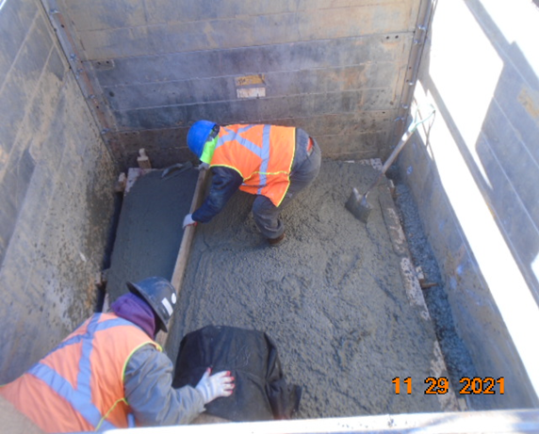
Phase D – Crew placing concrete for manhole base

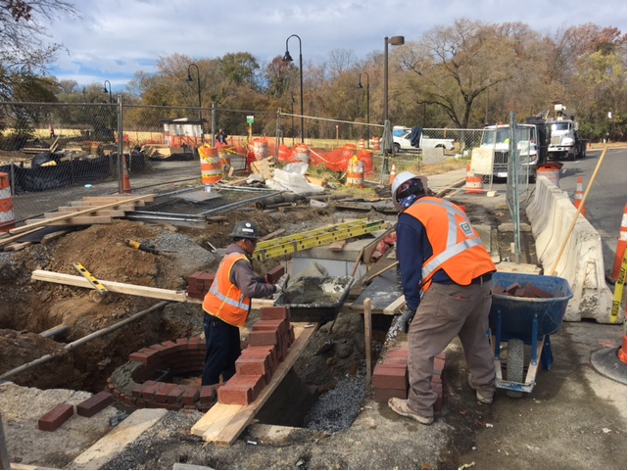
Phase D – Crew constructing brick manhole
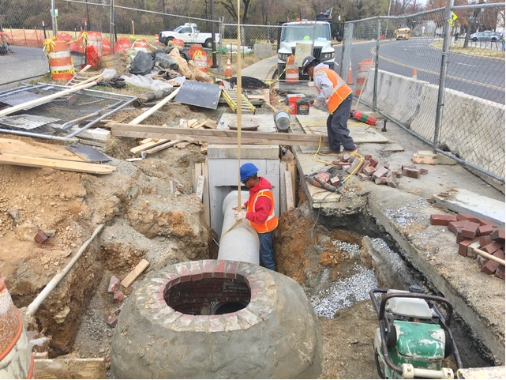
Phase D – Crew installing connection pipe between manhole and inlet

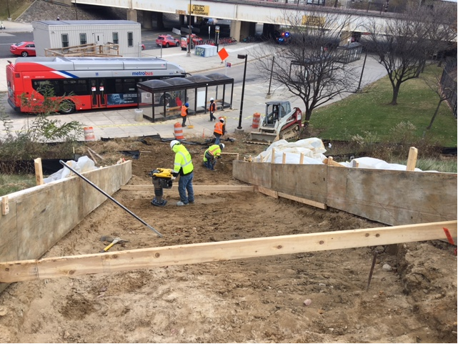
Phase D – Crew compacting WMATA stairs subgrade

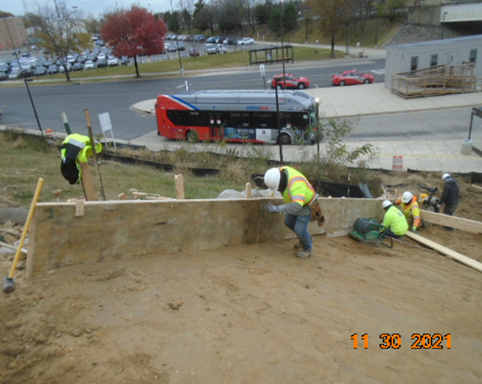
Phase D – Crew constructing WMATA stairs formwork

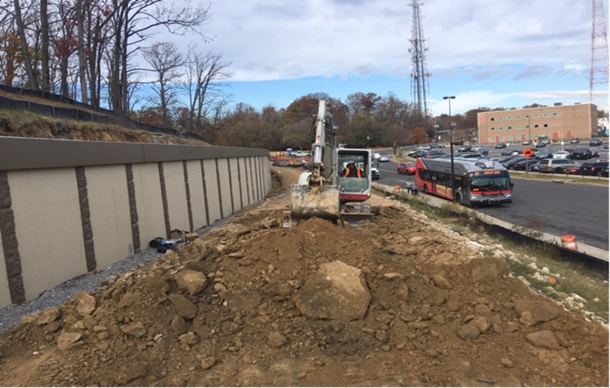
Phase D – Crew excavating the trail path

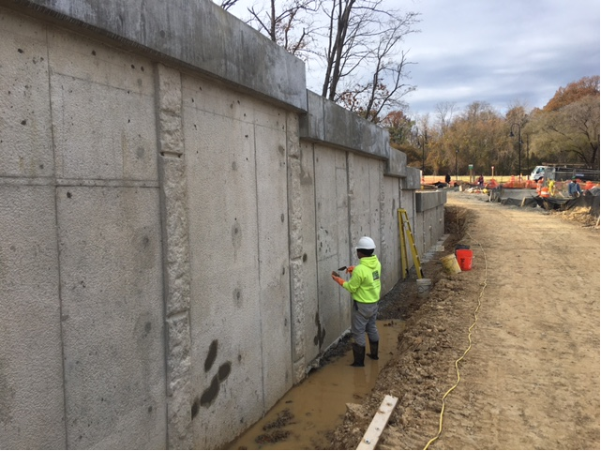
Phase D – Crew parging S3 wall front face

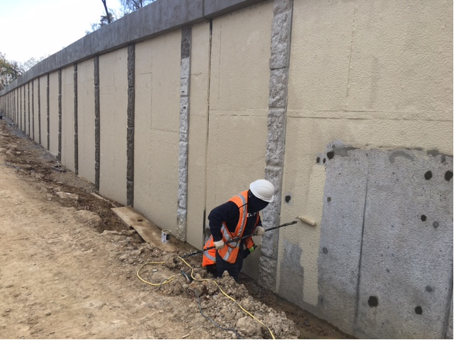
Phase D – Crew painting S3 wall panel

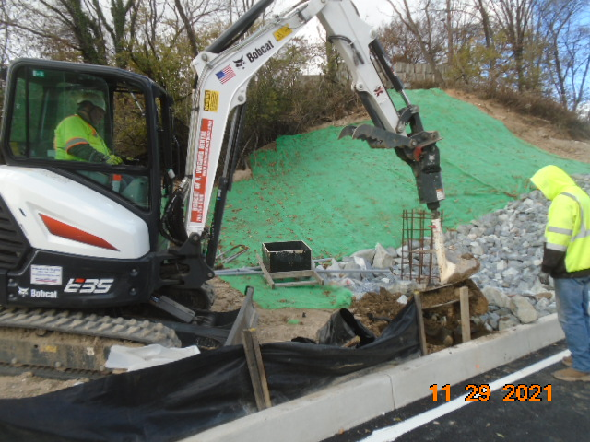
Phase D – Crew shaft drilling street lightpole foundation

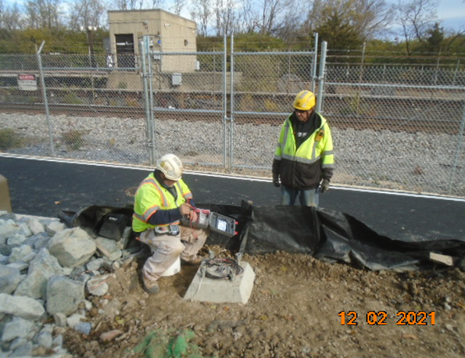
Phase D – Crew pulling electrical wires

