Metropolitan Branch Trail Design Build, South Segment
DC CONTRACT NO. DCKA-2016-C-0044
FAP No.: STP-2016 (060)

CONSTRUCTION MANAGER’S
WEEKLY PROGRESS REPORT

11/14/2021 – 11/20/2021

Project Website: www.metbranchtrail-forttotten.com
For Additional Trail Information Please see www.metbranchtrail.com
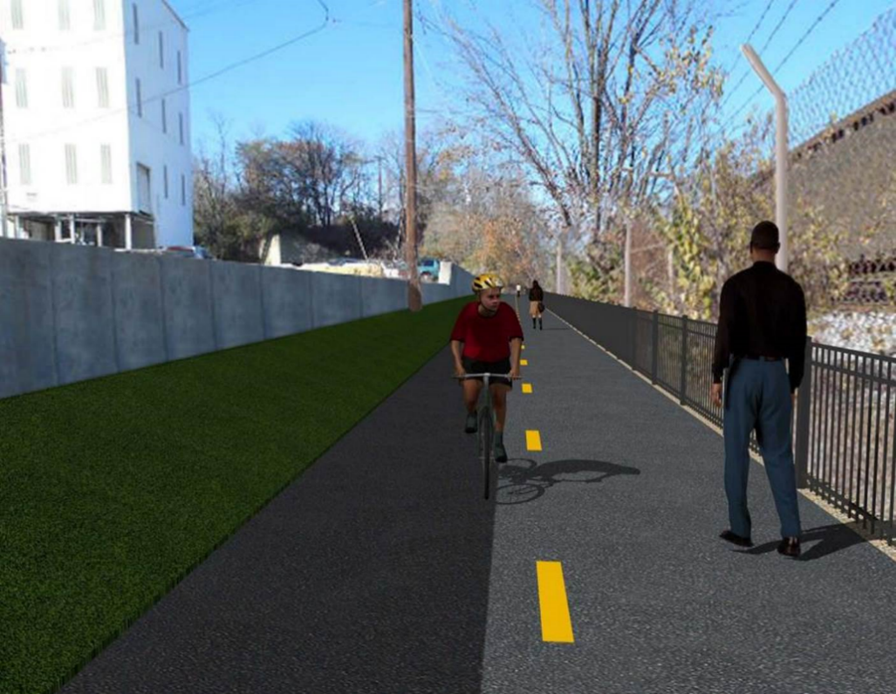

Proposed Metropolitan Branch Trail

1. PROJECT DESCRIPTION

The planned Metropolitan Branch Trail Project (“the Project”) consists of the design and construction of a new trail adjacent to CSX tracks and WMATA Red Line tracks along John McCormack Drive, adjacent to Fort Totten Metro Station, and on NPS property in NE, Washington D.C. The trail begins approximately 1500 feet south of Bates Road NE on the east side of John McCormack Drive NE, extending north along the WMATA and CSX tracks to the Fort Totten Metro Station tie in with First Place NE. An existing trail connection from Gallatin Road NE to the Fort Totten Metro Station will be reconstructed as a part of the Project.

The Project is 83.15% Federally-Funded and 16.85% District-Funded. Potomac Construction is the Design Build contractor.

Delon Hampton and Associates Chartered is providing Construction Management and Inspection services. Specific Construction Scope of Work includes:

- Provide mobilization and demobilization, provision and maintenance of Engineer’s field facilities, field layout, employee training, and other incidental work required for a quality, complete and finished product;
- Establishment and maintenance of vehicular and pedestrian traffic including signs, barricades and other transition devices; reconfiguring the devices in conjunction with changes in work areas; and their removal and disposal upon project completion, including restoration of disturbed areas;
- Clearing and grubbing, as required within the LOD;
- Removal of unsuitable material, excavation, and backfilling and pervious paving to construct a new trail;
- Protection of trees during construction;
- Provide ADA compliant trail connections and pedestrian ramps;
- Provide retaining walls as necessary to stay within the LOD and minimize property impacts following visual requirements specified for retaining walls on NPS property;
- Provide new permanent regulatory and wayfinding signs for the trail and all trail connection intersections;
- Provide road and trail pavement markings;
- Provide landscaping within the LOD for the Project including special requirements for landscaping on NPS property;
- Provide erosion and sediment control measures, storm water management facilities, including pervious asphalt pavement and bioretention facilities;
- Provide utility coordination, identification, locating, and protection of all utilities encountered during design and construction including relocation of Pepco poles along Aggregate Industries property; and
- Provide new WMATA security fencing between the trail and CSXT tracks.
- Remove existing sidewalk and widen sidewalk to 10’ along the west side of 1st place NE from Metropolitan Branch Trail to entrance to WMATA bus loop, on the west side.

2. STATUS OF CONSTRUCTION / PROGRESS SUMMARY

Work performed this week:

Design

- 100 % Complete

Construction:

Phase D

- Constructed S3 coping wall formwork
- Installed S3 coping wall rebar
- Placed S3 coping wall concrete
- Parged retaining walls S0 and S2 front and back faces
- Graded embankment slope along the trail
- Planted trees at the planting area along the trail path
- Installed chain link fence along Aggregate Industries
- Painted S3 wall panels and pilasters
- Placed and graded stone along the trail in front of S2 wall
- Graded embankment slope along the trail
- Excavated and graded the trail path
- Excavated drainage manhole
- Excavated WMATA steps
- Raised drainage manhole
- Constructed manhole parapet wall formwork
- Contractor safety tool box talk

CM Consultant:

- Monitored construction progress, make sure all applicable inspections and testing were performed
- Reviewed Project Schedule
- Reviewed Monthly payment invoice
- Reviewed CSX Invoice
- Attended DDOT and PEPCO field meeting
- Attended DDOT and PCCI field meeting
- Prepared CM Weekly Report to post
- Prepared CM weekly report to DDOT
- Updated Project Files
- Updated Project Logs
- Updated Project Webpage
- Updated documents in DHA SharePoint site
- Updated DDOT Sharepoint site
- Communication with PCCI and stakeholders in terms of submittals

3. MEETINGS / PROJECT COORDINATION

11/17/2021 DDOT DHA and PEPCO field meeting was held at 1:00 P.M.
11/17/2021 DDOT DHA and PCCI field walk-thru meeting was held at 2:00 P.M.

4. DAILY WORK PERFORMED

Sun 11/14/21 No work performed.
Mon 11/15/21 Phase D – Parged front face of S0 wall. Painted S2 wall. Installed
coping wall rebars. Constructed S3 coping wall formwork. Placed and graded stone along the trail in front of S2 wall. Installed chain link fence along Aggregate Industries. Planted trees.
Phase D – Electrical work – No work performed.
Tue 11/16/21 Phase D – Parged back side of S0 wall. Painted S2 wall. Installed coping
wall rebar. Constructed coping wall formwork. Installed chain link fence along Aggregate Industries. Placed and graded stone along the trail edge in front of S2 wall. Planted trees.
Phase D – Electrical work – No work performed.
Wed 11/17/21 Phase D – Installed retaining coping wall rebar. Constructed retaining wall S3 formwork. Removed exiting manhole. Excavated drainage manhole. Graded embankment slope along the trail. Planted trees.
Thurs 11/18/21 Phase D – Placed concrete for S3 coping wall. Excavated drainage
manhole. Parged front face of S3 wall. Painted S3 wall. Excavated drainage manhole. Installed chain link fence privacy slates.
Phase D – Electrical Work – No work performed.
Fri 11/19/21 Phase D – Excavated WMATA stairs. Excavated drainage manhole. Graded embankment slope. Parged front face of S3 wall. Painted S3 wall. excavated and graded the trail path. Constructed formwork for drainage manhole parapet wall.
Phase D – Electrical Work – No work performed.
Sat 11/20/21 Phase D – No work scheduled.

5. INSPECTION & MATERIAL TESTS PERFORMED

Jobsite Safety Inspection  Erosion and Sediment Control inspection  MOT Inspection  Compaction Test  Asphalt Material Testing – Pending results  Concrete Material Testing – Pending results  ** Note - Additional Material Test Results can be found on DDOT QA QC Material Division Tracking SharePoint website. | Infiltration Tests  Dynamic Cone Penetration (DCP) Tests  Rebars Inspection – Passed
6. DBE PARTICIPATION SUMMARIES

Potomac Construction Inc. (Contractor)

- DBE Goal for Contractor is 15%. To-date the Contractor has achieved 55% of their goal.

Delon Hampton & Associates (CM)

- DBE Goal for the CM is 10%. To-date the CM has achieved 97% of their goal.

7. ACCIDENTS / INCIDENTS

None occurred on-site during this week.

8. PHOTOS OF THE WORK PERFORMED

12. PHOTOS OF WORK PERFORMED THIS PERIOD

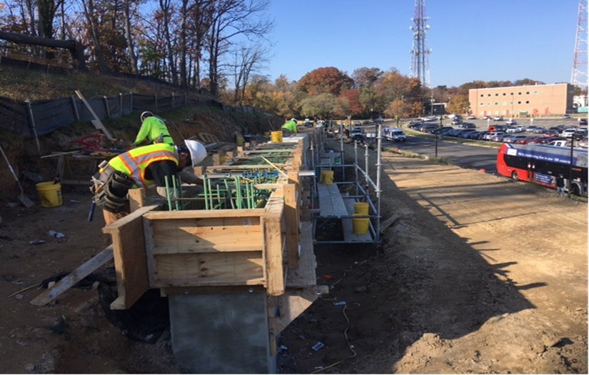
Phase D – Crew constructing S3 formwork

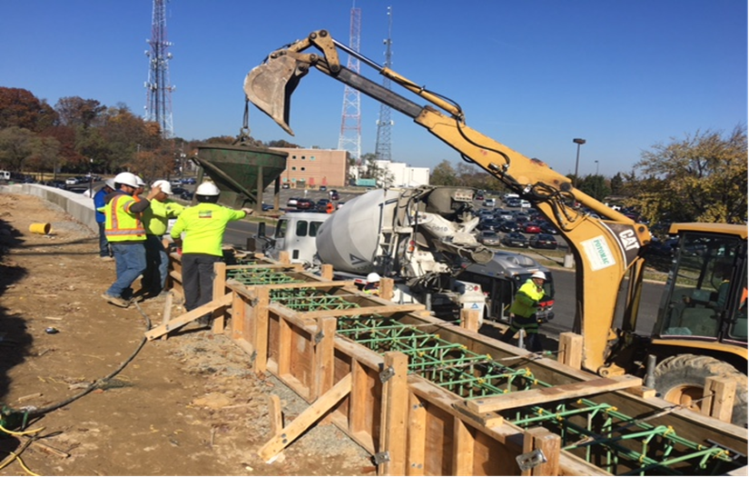
Phase D – Crew placing coping wall concrete

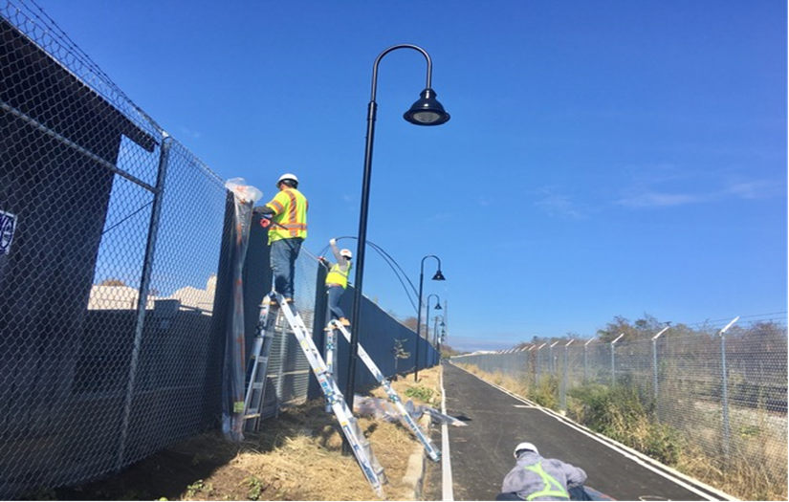
Phase D – Crew installing chain link fence privacy slates

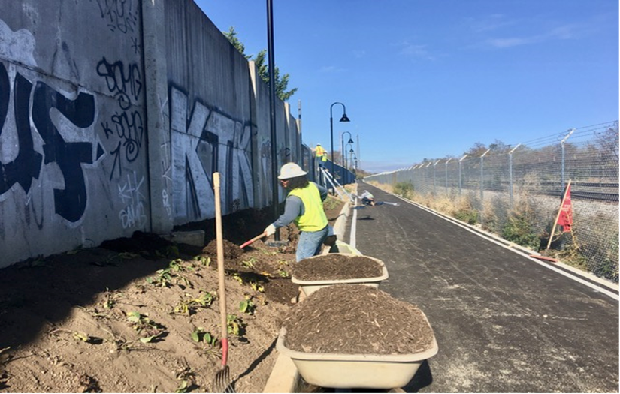
Phase D – Crew placing mulch around the planting area

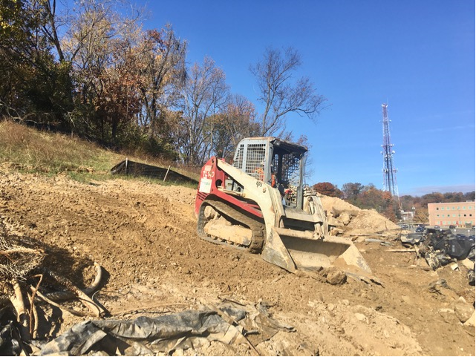
Phase D – Crew grading slope area along the trail

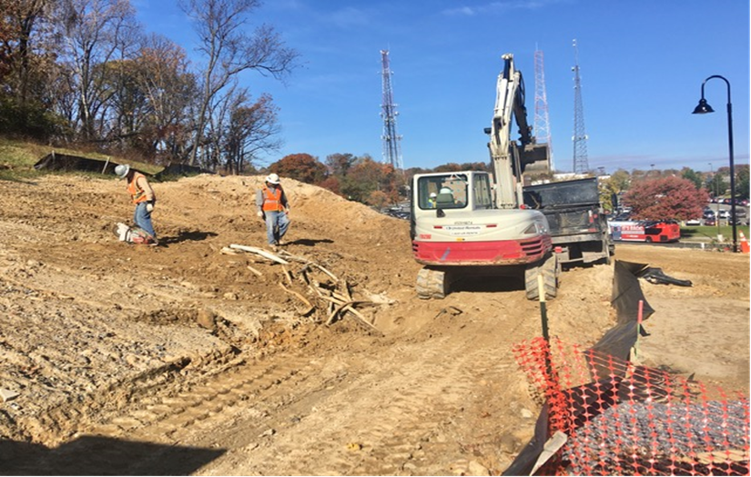
Phase D – Crew excavating trail path

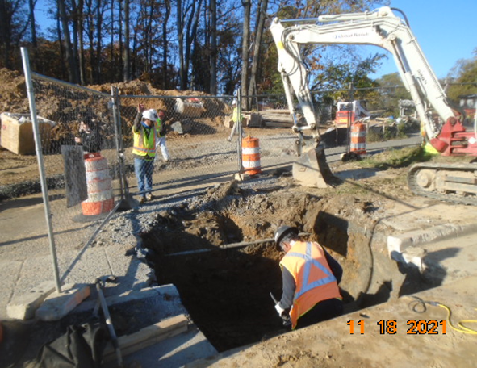
Phase D – Crew excavating drainage manhole

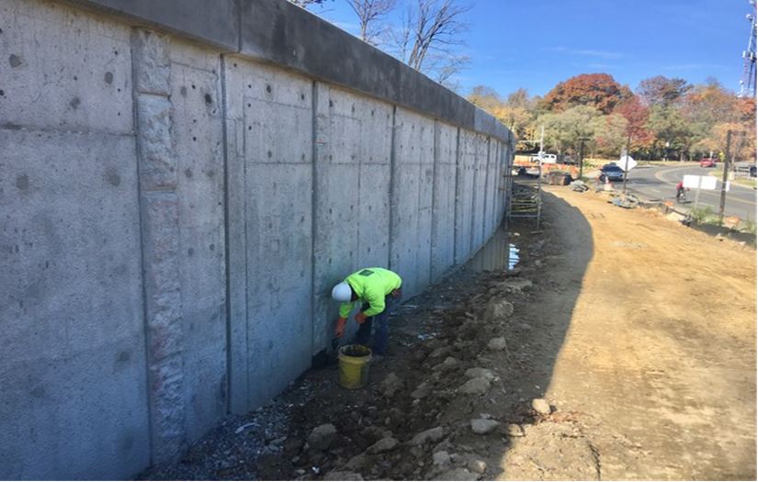
Phase D – Crew paring S3 wall

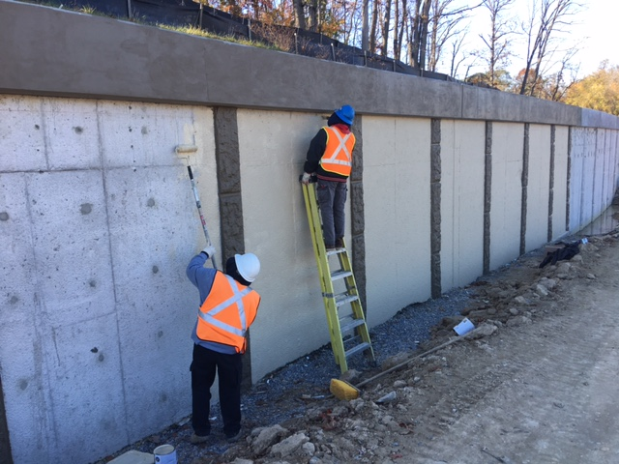Phase D – Crew painting S3 wall

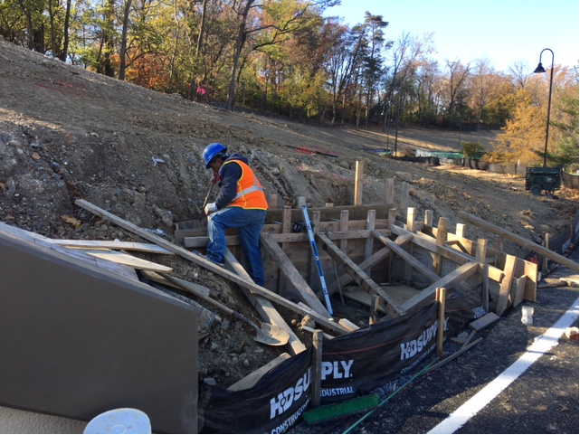
Phase D – Crew constructing manhole parapet wall formwork
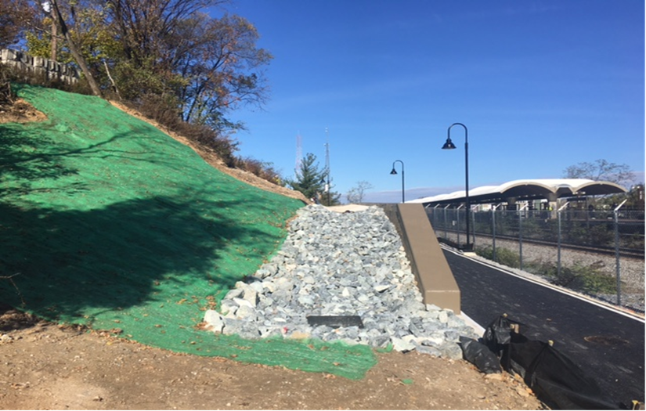
Phase D – Gabion structure and erosion control mat installed behind S3 wall

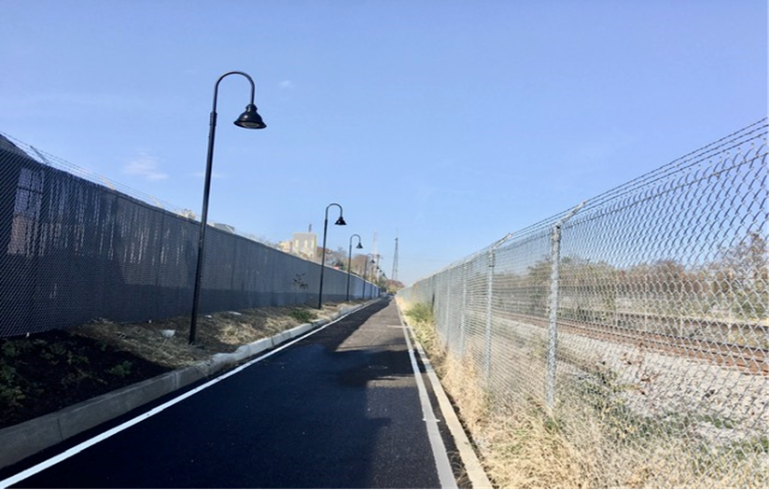
Phase D – Chain link fence with privacy slates installed

