Metropolitan Branch Trail Design Build, South Segment
DC CONTRACT NO. DCKA-2016-C-0044
FAP No.: STP-2016 (060)

CONSTRUCTION MANAGER’S
WEEKLY PROGRESS REPORT

11/07/2021 – 11/13/2021

Project Website: www.metbranchtrail-forttotten.com
For Additional Trail Information Please see www.metbranchtrail.com
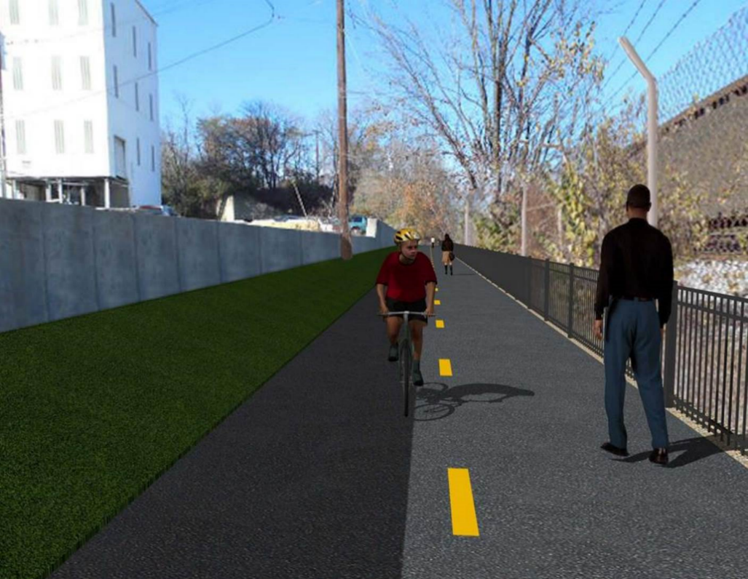

Proposed Metropolitan Branch Trail

1. PROJECT DESCRIPTION

The planned Metropolitan Branch Trail Project (“the Project”) consists of the design and construction of a new trail adjacent to CSX tracks and WMATA Red Line tracks along John McCormack Drive, adjacent to Fort Totten Metro Station, and on NPS property in NE, Washington D.C. The trail begins approximately 1500 feet south of Bates Road NE on the east side of John McCormack Drive NE, extending north along the WMATA and CSX tracks to the Fort Totten Metro Station tie in with First Place NE. An existing trail connection from Gallatin Road NE to the Fort Totten Metro Station will be reconstructed as a part of the Project.

The Project is 83.15% Federally-Funded and 16.85% District-Funded. Potomac Construction is the Design Build contractor.

Delon Hampton and Associates Chartered is providing Construction Management and Inspection services. Specific Construction Scope of Work includes:

- Provide mobilization and demobilization, provision and maintenance of Engineer’s field facilities, field layout, employee training, and other incidental work required for a quality, complete and finished product;
- Establishment and maintenance of vehicular and pedestrian traffic including signs, barricades and other transition devices; reconfiguring the devices in conjunction with changes in work areas; and their removal and disposal upon project completion, including restoration of disturbed areas;
- Clearing and grubbing, as required within the LOD;
- Removal of unsuitable material, excavation, and backfilling and pervious paving to construct a new trail;
- Protection of trees during construction;
- Provide ADA compliant trail connections and pedestrian ramps;
- Provide retaining walls as necessary to stay within the LOD and minimize property impacts following visual requirements specified for retaining walls on NPS property;
- Provide new permanent regulatory and wayfinding signs for the trail and all trail connection intersections;
- Provide road and trail pavement markings;
- Provide landscaping within the LOD for the Project including special requirements for landscaping on NPS property;
- Provide erosion and sediment control measures, storm water management facilities, including pervious asphalt pavement and bioretention facilities;
- Provide utility coordination, identification, locating, and protection of all utilities encountered during design and construction including relocation of Pepco poles along Aggregate Industries property; and
- Provide new WMATA security fencing between the trail and CSXT tracks.
- Remove existing sidewalk and widen sidewalk to 10’ along the west side of 1st place NE from Metropolitan Branch Trail to entrance to WMATA bus loop, on the west side.

2. STATUS OF CONSTRUCTION / PROGRESS SUMMARY

Work performed this week:

Design

- 100 % Complete

Construction:

Phase D

- Constructed retaining wall S3 formwork
- Installed S3 wall rebar
- Placed S3 wall concrete
- Constructed S3 coping wall formwork
- Installed S3 coping wall rebar
- Placed S3 coping wall concrete
- Parged retaining walls S0 and S2 front and back faces
- Graded embankment slope along the trail
- Performed cleanup and prepared embankment slope for plants installation
- Planted tress at along the trail path
- Painted thermoplastic pavement markings.
- Installed chain link fence along Aggregate Industries
- Constructed gabion structure located behind S2 wall
- Parged S0 wall back face
- Painted S2 wall panels and S2 wall pilasters
- Graded, seeded and installed erosion control mat on slope behind S2 wall
- Contractor safety tool box talk

CM Consultant:

- Monitored construction progress, make sure all applicable inspections and testing were performed
- Reviewed Project Schedule
- Reviewed Monthly payment invoice
- Prepared CM Weekly Report to post
- Prepared CM weekly report to DDOT
- Updated Project Files
- Updated Project Logs
- Updated Project Webpage
- Updated documents in DHA SharePoint site
- Updated DDOT Sharepoint site
- Communication with PCCI and stakeholders in terms of submittals

3. MEETINGS / PROJECT COORDINATION

None during this week.

4. DAILY WORK PERFORMED

Sun 11/07/21 No work performed.
Mon 11/08/21 Phase D – Parged back face of S0 wall. Installed retaining wall S3 rebar.
Constructed retaining wall S3 formwork. Placed S3 wall concrete. Installed fence posts at S0 wall. Planted trees. Constructed gabion structure located behind S2 wall.
Phase D – Electrical work – No work performed.
Tue 11/09/21 Phase D – Parged retaining wall S0 and S2 wall. Installed retaining wall S3
rebar. Constructed retaining wall S3 formwork. Installed chain link fence along Aggregate Industries. Constructed gabion structure located behind S2 wall. Backfilled and compacted area behind S3 wall. Planted trees. Painted thermoplastic pavement markings. Painter S2 wall panels and pilasters.
Phase D – Electrical work – No work performed.
Wed 11/10/21 Phase D – Parged back face of retaining wall S0. Installed retaining
wall S3 rebar. Constructed retaining wall S3 formwork. Tied S3 coping wall
rebar. Constructed S3 coping wall formwork. Installed chain link fence along Aggregate Industries. Graded, seeded and installed erosion control mat behind S2 wall. Backfilled and compacted area behind S3 wall. Planted trees.
Phase D – Electrical Work – No work performed.
Thurs 11/11/21 Phase D – Parged back face of retaining wall S0. Installed retaining wall S3
formwork. Constructed retaining wall S3 formwork. Installed S3 coping wall
rebar. Constructed S3 coping wall formwork. Placed S3 wall concrete.
Installed chain link fence along Aggregate Industries. Graded,
seeded and installed erosion control mat behind S2 wall. Backfilled and
compacted area behind S3 wall. Planted trees. Graded trail path in front of S3 wall.
Phase D – Electrical Work – No work performed.
Fri 11/12/21 Phase D – Contractor canceled work due to rain. Fence installation crew Installed chain link along Aggregate Industries.
Phase D – Electrical Work – No work performed.
Sat 11/13/21 Phase D – No work scheduled.

5. INSPECTION & MATERIAL TESTS PERFORMED

Jobsite Safety Inspection  Erosion and Sediment Control inspection  MOT Inspection  Compaction Test  Asphalt Material Testing – Pending results  Concrete Material Testing – Pending results  ** Note - Additional Material Test Results can be found on DDOT QA QC Material Division Tracking SharePoint website. | Infiltration Tests  Dynamic Cone Penetration (DCP) Tests  Rebars Inspection – Passed
6. DBE PARTICIPATION SUMMARIES

Potomac Construction (Contractor)

- DBE Goal for Contractor is 15%. To-date the Contractor has achieved 54.4% of their goal.

Delon Hampton & Associates (CM)

- DBE Goal for the CM is 10%. To-date the CM has achieved 96.6% of their Goal.

7. ACCIDENTS / INCIDENTS

None occurred on-site during this week.

8. PHOTOS OF THE WORK PERFORMED

12. PHOTOS OF WORK PERFORMED THIS PERIOD

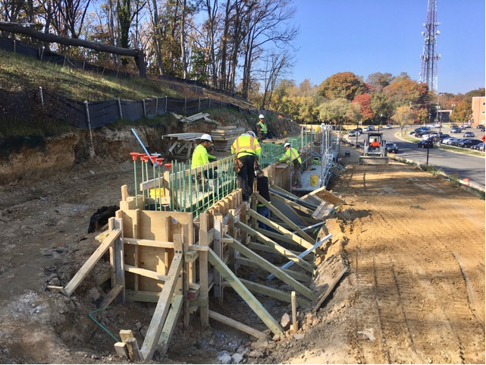
Phase D Crew tying S3 wall rebar

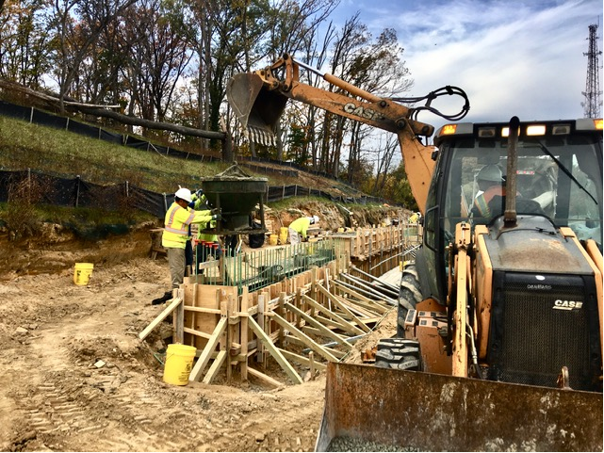
Phase D – Crew placing S3 wall concrete

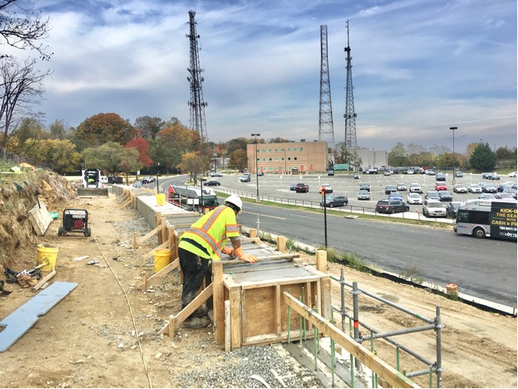
Phase D – Crew finishing S3 coping wall concrete

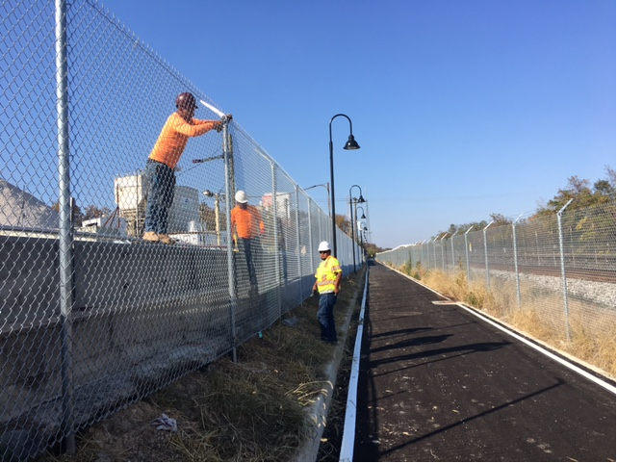
Phase D – Crew installing chain link fence along Aggregate Industries

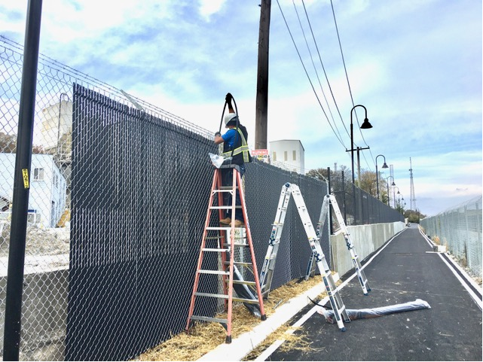
Phase D – Crew installing chain link fence privacy slats

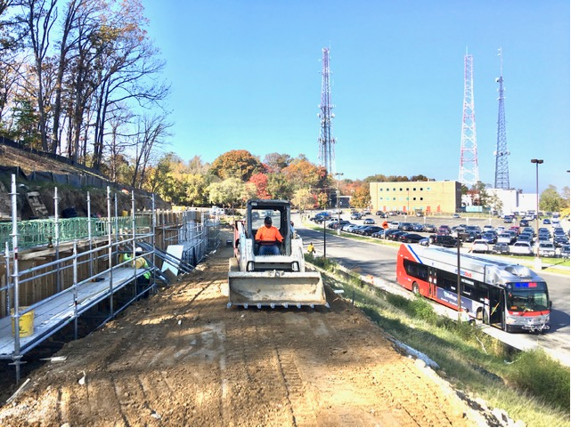
Phase D – Crew grading the trail path

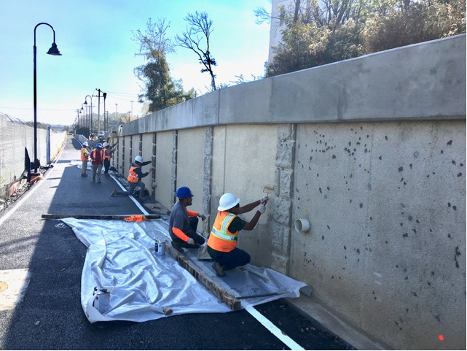
Phase D – Crew painting S2 wall

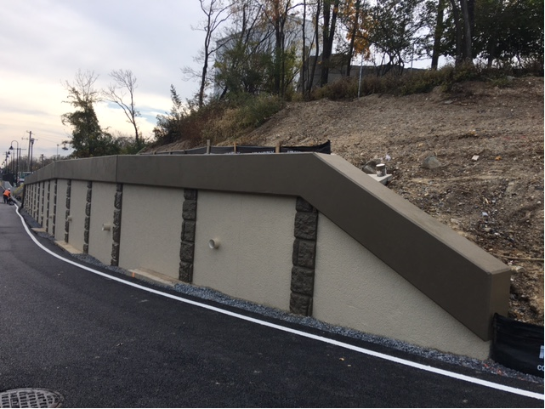
Phase D – Retaining wall S2 wall panels and pilasters painted

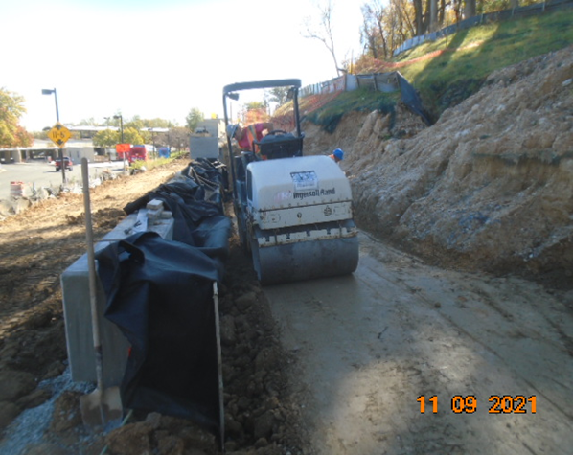
Phase D – Crew compacting backfill behind S3 wall

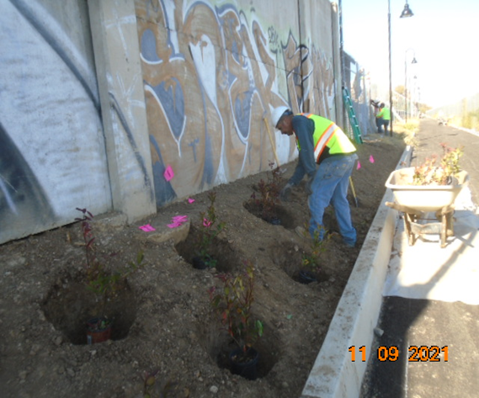
Phase D – Crew planting trees

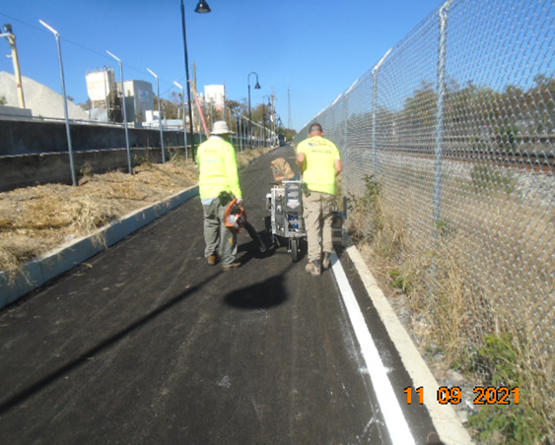
Phase D – Crew painting thermoplastic pavement markings

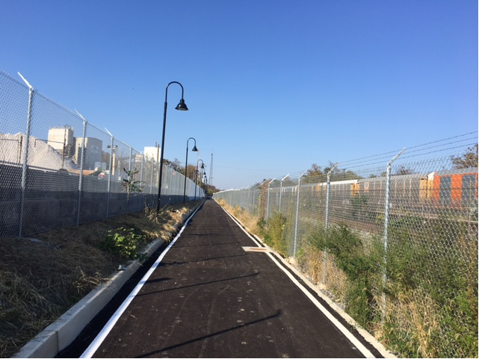
Phase D – Thermoplastic pavement markings and chain link fence installed

