Metropolitan Branch Trail Design Build, South Segment
DC CONTRACT NO. DCKA-2016-C-0044
FAP No.: STP-2016 (060)

CONSTRUCTION MANAGER’S
WEEKLY PROGRESS REPORT

11/01/2020 – 11/07/2020

Project Website: www.metbranchtrail-forttotten.com
For Additional Trail Information Please see www.metbranchtrail.com

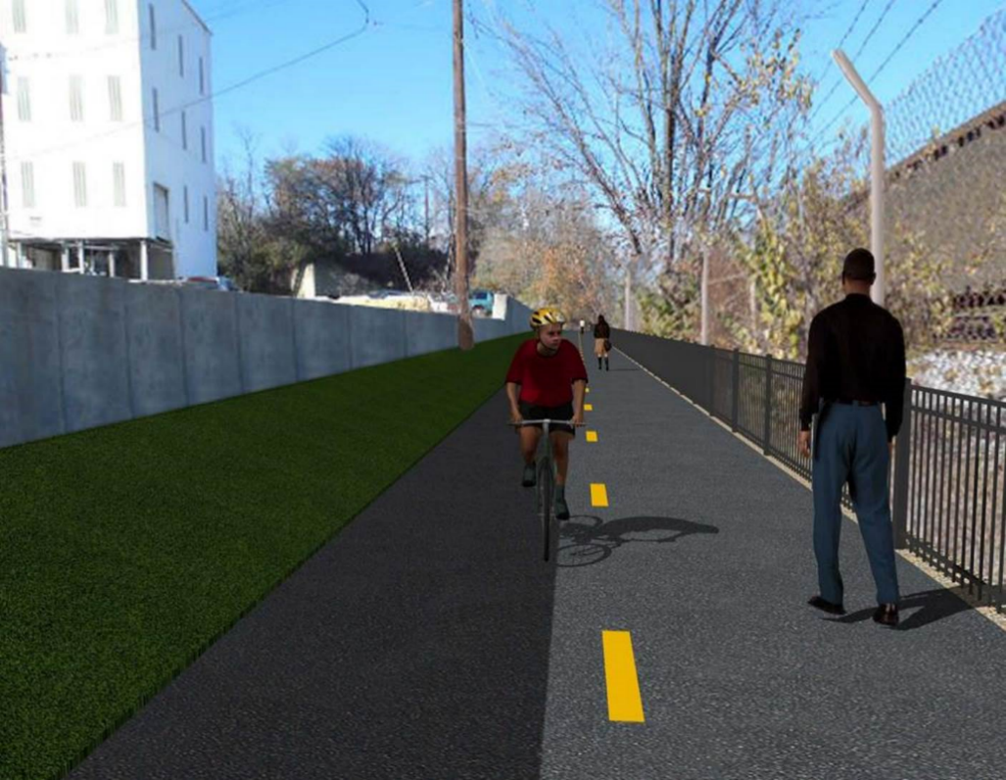

Proposed Metropolitan Branch Trail

1. PROJECT DESCRIPTION

The planned Metropolitan Branch Trail Project (“the Project”) consists of the design and construction of a new trail adjacent to CSX tracks and WMATA Red Line tracks along John McCormack Drive, adjacent to Fort Totten Metro Station, and on NPS property in NE, Washington D.C. The trail begins approximately 1500 feet south of Bates Road NE on the east side of John McCormack Drive NE, extending north along the WMATA and CSX tracks to the Fort Totten Metro Station tie in with First Place NE. An existing trail connection from Gallatin Road NE to the Fort Totten Metro Station will be reconstructed as a part of the Project.

The Project is 83.15% Federally-Funded and 16.85% District-Funded. Potomac Construction is the Design Build contractor.

Delon Hampton and Associates Chartered is providing Construction Management and Inspection services. Specific Construction Scope of Work includes:

- Provide mobilization and demobilization, provision and maintenance of Engineer’s field facilities, field layout, employee training, and other incidental work required for a quality, complete and finished product;
- Establishment and maintenance of vehicular and pedestrian traffic including signs, barricades and other transition devices; reconfiguring the devices in conjunction with changes in work areas; and their removal and disposal upon project completion, including restoration of disturbed areas;
- Clearing and grubbing, as required within the LOD;
- Removal of unsuitable material, excavation, and backfilling and pervious paving to construct a new trail;
- Protection of trees during construction;
- Provide ADA compliant trail connections and pedestrian ramps;
- Provide retaining walls as necessary to stay within the LOD and minimize property impacts following visual requirements specified for retaining walls on NPS property;
- Provide new permanent regulatory and wayfinding signs for the trail and all trail connection intersections;
- Provide road and trail pavement markings;
- Provide landscaping within the LOD for the Project including special requirements for landscaping on NPS property;
- Provide erosion and sediment control measures, storm water management facilities, including pervious asphalt pavement and bioretention facilities;
- Provide utility coordination, identification, locating, and protection of all utilities encountered during design and construction including relocation of Pepco poles along Aggregate Industries property; and
- Provide new WMATA security fencing between the trail and CSXT tracks.
- Remove existing sidewalk and widen sidewalk to 10’ along the west side of 1st place NE from Metropolitan Branch Trail to entrance to WMATA bus loop, on the west side.

2. STATUS OF CONSTRUCTION / PROGRESS SUMMARY

Work performed this week:

Design

- MBT Designer submitted Phase D 3-ring binder and 100% Plans to DDOT
- Stakeholders acceptance for Phase D Final Design Plans
- CSX is reviewing Phase D Means and Methods
- Redesign of Retaining Wall S2 under review

Construction:

Phase B

- Plant trees
- Spread mulch at biorention pond
- Applied grass seeding
- Installed erosion control matting
- Installed silt fence
- Cleaned site

Phase D

- Stripped retaining wall formwork
- Performed backfilling and compaction behind retaining wall
- Excavated drainage trench
- Installed and backfilled drainage pipes
- Constructed manholes
- Installed temporary drainage pipes
- Constructed manhole base formwork
- Installed manhole base rebars
- CSX flagger’s operation and safety tool box talk

CM Consultant:

- Monitored construction progress, make sure all applicable inspections and testing were
performed
- Reviewed Inspector Daily Reports
- Attended NPS CM and PCCI retaining wall pilaster mock-up review sample meeting
- Prepared CM Weekly Reports
- Updated Project Files
- Update Project Webpage
- Updated documents in SharePoint
- Communication with the stakeholder in terms of submittals

3. MEETINGS / PROJECT COORDINATION

Thurs 11/05/20 NPS DHA and PCCI meeting was held in PCCI yard at 1:00 P.M. to review retaining wall mockup sample

4. DAILY WORK PERFORMED

Sun 11/01/20 No work performed.
Mon 11/02/20 Phase B – Plant trees. Installed silt fence. Cleaned site.
Phase B – Electrical Work – No work scheduled.
Phase D –Performed backfilling and compaction behind retaining wall. Excavated drainage trench, placed bedding stone, and installed pipes. Backfilled drainage pipe trench. Constructed manhole.
Tue 11/03/20 Phase B – Spread mulch at bioretention pond. Planted trees at bioretention
pond. Cleaned site.
Phase B – Electrical Work – No work scheduled
Phase D – Performed rough grading the trail path. Performed backfilling and compaction behind retaining wall. Excavated drainage trench, placed bedding stone, and installed pipes. Backfilled drainage pipe trench. Installed temporary drainage pipes. Installed silt fence.
Wed 11/04/20 Phase B – Spread mulch at bioretention pond. Planted trees. Hauled away
unsuitable materials from the site.
Phase B - Electrical Work – No work scheduled.
Phase D – Performed rough grading the trail. Performed backfilling and compaction behind retaining wall. Excavated drainage trench, placed bedding stone, and installed pipes. Backfilled drainage pipe trench. Installed temporary drainage pipes. Installed silt fence.
Thurs 11/05/20 Phase B – Planted trees and spread mulch around the planted trees inside
biorention pond.
Phase B – Electrical work – No work scheduled
Phase D – Performed rough grading the trail path. Hauled away excavated
Materials from the site. Performed compaction behind retaining wall. Excavated drainage trench, placed bedding stone, and installed pipes. Backfilled drainage pipe trench.
Fri 11/06/20 Phase B – Planted trees. Applied grass seeding and installed erosion
Phase B – Electrical Work – No work scheduled
Phase D – Performed rough grading the trail path. Hauled away excavated
Materials from the site. Performed compaction behind retaining wall. Excavated drainage trench, placed bedding stone, and installed pipes. Backfilled drainage pipe trench. Constructed manhole base formwork and installed rebars. Installed manhole top slab.
Sat 11/07/20 No work scheduled

5. INSPECTION & MATERIAL TESTS PERFORMED

Jobsite Safety Inspection  Erosion and Sediment Control inspection  MOT Inspection  Compaction Test - Passed  Asphalt Material Testing  Concrete Material Testing – Pending results  ** Note - Additional Material Test Results can be found on DDOT QA QC Material Division Tracking SharePoint website. | Infiltration Tests – Pending results  Dynamic Cone Penetration (DCP) Tests  Rebars Inspection - Passed
6. DBE PARTICIPATION SUMMARIES

Potomac Construction (Contractor)
- DBE Goal for Contractor is 15%. To-date the Contractor has achieved 40% of their goal.

Delon Hampton & Associates (CM)
- DBE Goal for the CM is 10%. To-date the CM has achieved 18% of their Goal.

7. ACCIDENTS / INCIDENTS

None occurred on-site during this week.

8. PHOTOS OF THE WORK PERFORMED

12. PHOTOS OF WORK PERFORMED THIS PERIOD

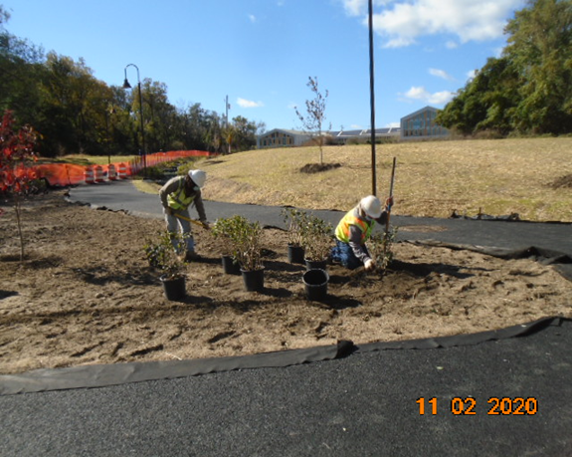
Phase B – Crew planting tree

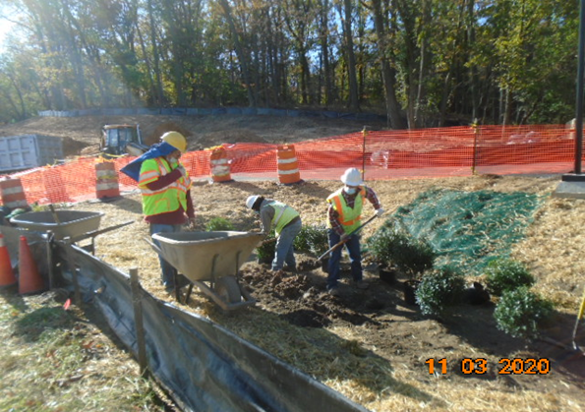
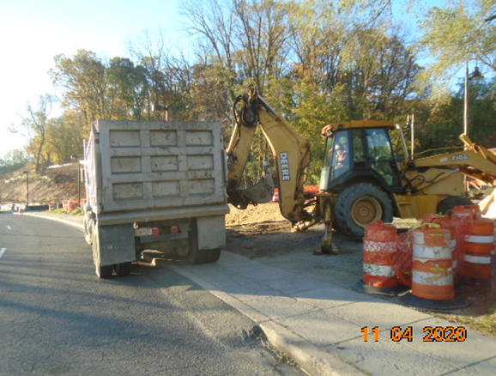
Phase B – Crew hauling away unsuitable materials from the site

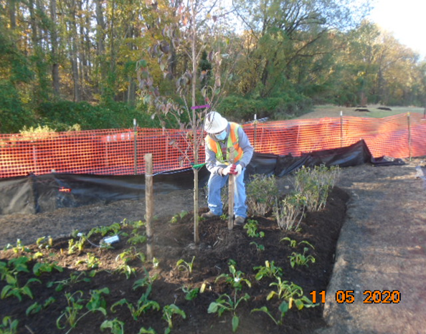
Phase B – Crew planting trees

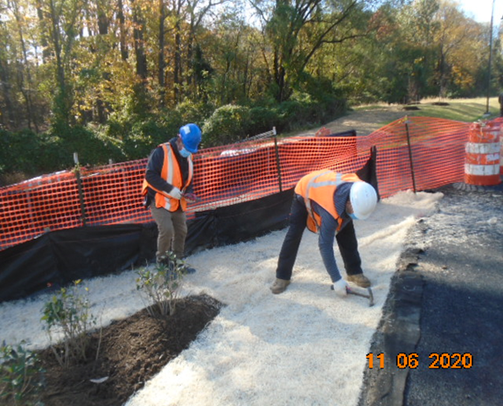
Phase B – Crew installing erosion matting

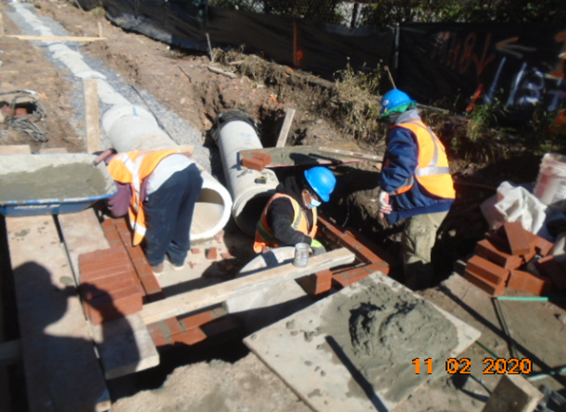
Phase D – Crew constructing drainage manhole

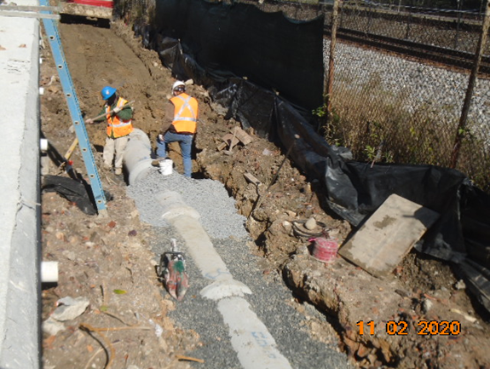
Phase D – Crew installing drainage pipes

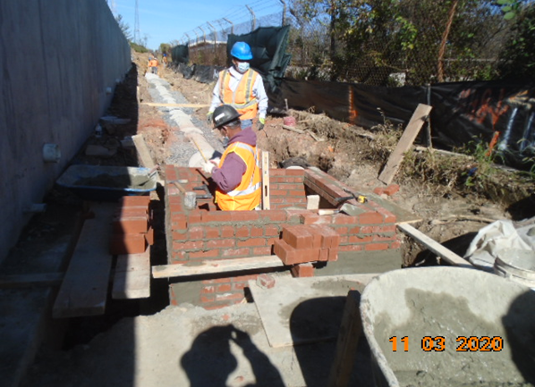
Phase D – Crew constructing drainage manhole

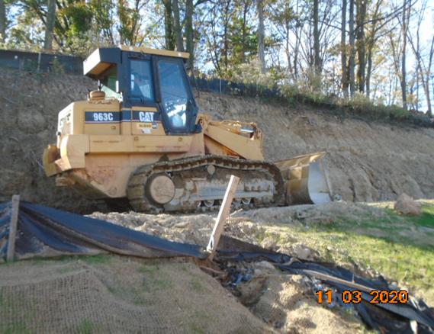
Phase D – Crew rough grading the trail path

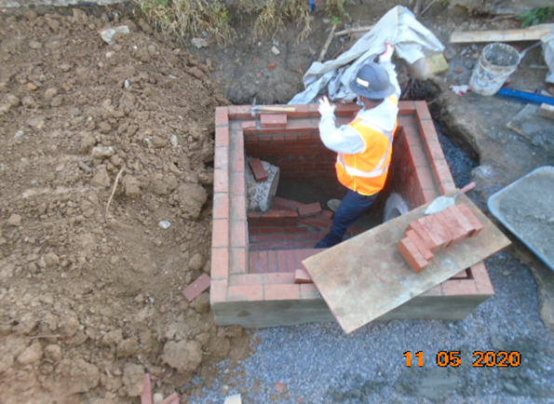
Phase D – Crew constructing drainage manhole

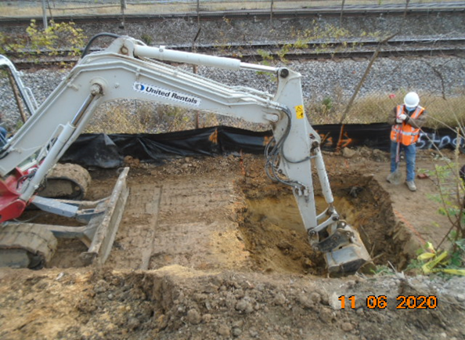
Phase D – Crew performing excavation for manhole base

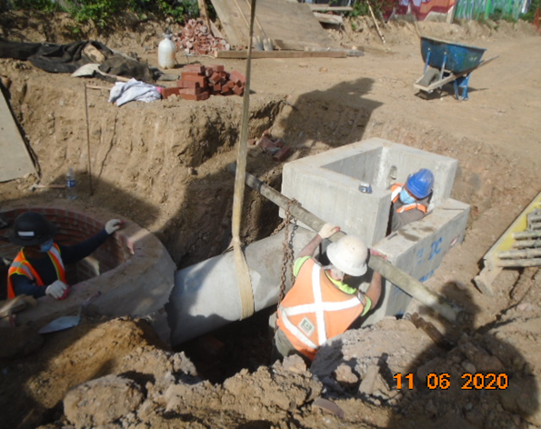
Phase D – Crew installing drainage pipes

