**Metropolitan Branch Trail Design Build, South Segment**

**DC CONTRACT NO. DCKA-2016-C-0044**

**FAP No.: STP-2016 (060)**

CONSTRUCTION MANAGER’S

WEEKLY PROGRESS REPORT

10/31/2021 – 11/06/2021

Project Website: [www.metbranchtrail-forttotten.com](http://www.metbranchtrail-forttotten.com)

For Additional Trail Information Please see [www.metbranchtrail.com](http://www.metbranchtrail.com)

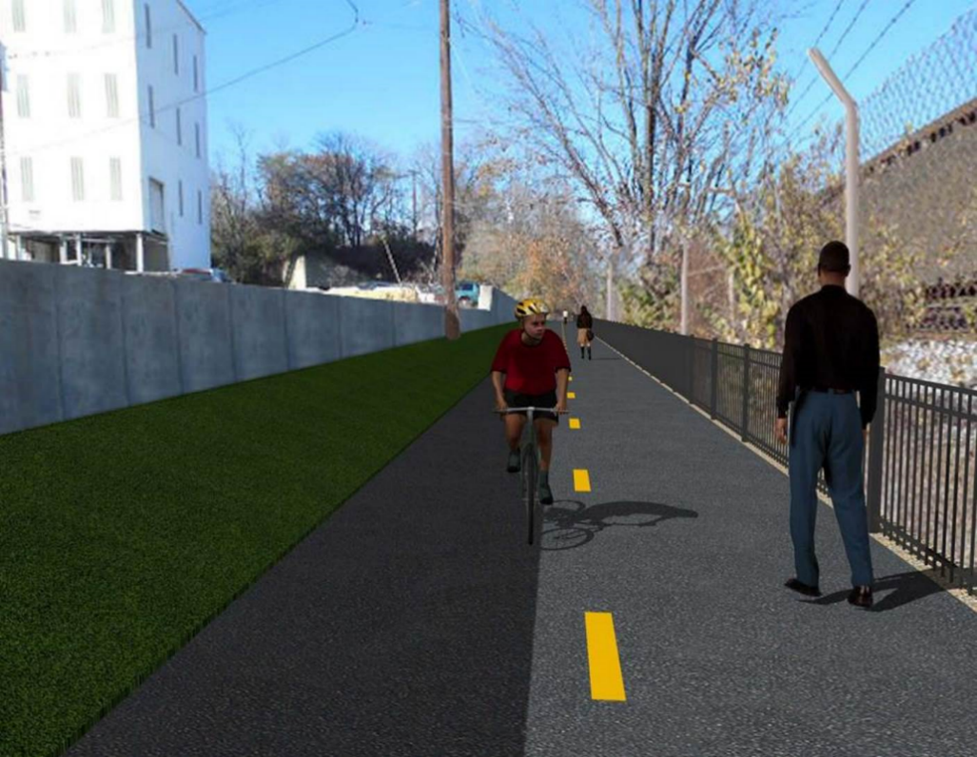

**Proposed Metropolitan Branch Trail**

**1. PROJECT DESCRIPTION**

The planned Metropolitan Branch Trail Project (“the Project”) consists of the design and construction of a new trail adjacent to CSX tracks and WMATA Red Line tracks along John McCormack Drive, adjacent to Fort Totten Metro Station, and on NPS property in NE, Washington D.C. The trail begins approximately 1500 feet south of Bates Road NE on the east side of John McCormack Drive NE, extending north along the WMATA and CSX tracks to the Fort Totten Metro Station tie in with First Place NE. An existing trail connection from Gallatin Road NE to the Fort Totten Metro Station will be reconstructed as a part of the Project.

The Project is 83.15% Federally-Funded and 16.85% District-Funded. Potomac Construction is the Design Build contractor.

Delon Hampton and Associates Chartered is providing Construction Management and Inspection services. Specific Construction Scope of Work includes:

* Provide mobilization and demobilization, provision and maintenance of Engineer’s field facilities, field layout, employee training, and other incidental work required for a quality, complete and finished product;
* Establishment and maintenance of vehicular and pedestrian traffic including signs, barricades and other transition devices; reconfiguring the devices in conjunction with changes in work areas; and their removal and disposal upon project completion, including restoration of disturbed areas;
* Clearing and grubbing, as required within the LOD;
* Removal of unsuitable material, excavation, and backfilling and pervious paving to construct a new trail;
* Protection of trees during construction;
* Provide ADA compliant trail connections and pedestrian ramps;
* Provide retaining walls as necessary to stay within the LOD and minimize property impacts following visual requirements specified for retaining walls on NPS property;
* Provide new permanent regulatory and wayfinding signs for the trail and all trail connection intersections;
* Provide road and trail pavement markings;
* Provide landscaping within the LOD for the Project including special requirements for landscaping on NPS property;
* Provide erosion and sediment control measures, storm water management facilities, including pervious asphalt pavement and bioretention facilities;
* Provide utility coordination, identification, locating, and protection of all utilities encountered during design and construction including relocation of Pepco poles along Aggregate Industries property; and
* Provide new WMATA security fencing between the trail and CSXT tracks.
* Remove existing sidewalk and widen sidewalk to 10’ along the west side of 1st place NE from Metropolitan Branch Trail to entrance to WMATA bus loop, on the west side.

**2. STATUS OF CONSTRUCTION / PROGRESS SUMMARY**

**Work performed this week:**

**Design**

* 100 % Complete

**Construction:**

**Phase D**

* Placed base and surface asphalt at the trail
* Constructed retaining wall S3 formwork
* Installed S3 wall rebar
* Constructed S3 coping wall formwork
* Installed S3 coping wall rebar
* Placed retaining wall S3 concrete
* Parged retaining walls S0 and S2 front and back faces
* Placed bedding stone at the trail path
* Installed perforated underdrain at S3 wall footing
* Graded embankment slope along the trail
* Performed cleanup and prepared embankment slope for plants installation
* Planted plants at embankment slope along the trail
* Excavated chain link fence post footing
* Placed concrete for fence post footing.
* Contractor safety tool box talk

**CM Consultant:**

* Monitored construction progress, make sure all applicable inspections and testing were performed
* Reviewed Project Schedule
* Reviewed Monthly payment invoice
* Prepared CM Weekly Report to post
* Prepared CM weekly report to DDOT
* Updated Project Files
* Updated Project Logs
* Updated Project Webpage
* Updated documents in DHA SharePoint site
* Updated DDOT Sharepoint site
* Communication with PCCI and stakeholders in terms of submittals

**3. MEETINGS / PROJECT COORDINATION**

None during this week.

**4. DAILY WORK PERFORMED**

Sun 10/31/21 No work performed.

Mon 11/01/21 Phase D – Parged back face of S0 wall. Installed retaining wall S3 rebar.

Constructed retaining wall S3 formwork. Placed base and surface asphalt. Placed bedding pad stone in front of S3 wall footing. Installed 6” perforated PVC pipe as underdrain in front of in front of S3 wall. Excavated fence post footing. Graded embankment slope along the trail.

Phase D – Electrical work – No work performed.

Tue 11/02/21 Phase D – Parged retaining wall S0 and S2 wall. Installed retaining wall S3

rebar. Constructed retaining wall S3 formwork. Graded embankment slope along the trail. Performed cleanup, re-grading and preparing embankment slope for plants. Excavated fence post footing.

Phase D – Electrical work – No work performed.

Wed 11/03/21 Phase D – Parged back face of retaining wall S0. Installed retaining

wall S3 rebar. Constructed retaining wall S3 formwork. Tied S3 coping wall

rebar. Constructed S3 coping wall formwork. Installed perforated underdrain pipe. Placed bedding stone for S3 wall. Graded slope area along the trail. Performed cleanup and grading for plants along the trail. Excavated chain link fence post footing.

Phase D – Electrical Work – No work performed.

Thurs 11/04/21 Phase D – Parged back face of retaining wall S0. Installed retaining wall S3 formwork. Constructed retaining wall S3 formwork. Installed S3 coping wall rebar. Constructed S3 coping wall formwork. Graded embankment slope along the trail. Prepared sloped area along the trail for plants. Placed concrete for fence post footing.

Phase D – Electrical Work – No work performed.

Fri 11/05/21 Phase D – Parged back face of retaining wall S0. Parged front face of S2 wall. Installed retaining wall S3 formwork. Constructed retaining wall S3 formwork. Installed S3 coping wall rebar. Constructed S3 coping wall formwork. Graded embankment slope along the trail. Planted plants along the trail.

Phase D – Electrical Work – No work performed.

Sat 11/06/21 Phase D – No work scheduled.

**5. INSPECTION & MATERIAL TESTS PERFORMED**

|  |  |
| --- | --- |
| Jobsite Safety Inspection  Erosion and Sediment Control inspection  MOT Inspection  Compaction Test  Asphalt Material Testing – Pending results  Concrete Material Testing – Pending results  **\*\* Note - Additional Material Test Results can be found on DDOT QA QC Material Division Tracking SharePoint website**. | Infiltration Tests  Dynamic Cone Penetration (DCP) Tests  Rebars Inspection – Ongoing |

**6. DBE PARTICIPATION SUMMARIES**

Potomac Construction (Contractor)

* DBE Goal for Contractor is 15%. To-date the Contractor has achieved 54.4% of their goal.

Delon Hampton & Associates (CM)

* DBE Goal for the CM is 10%. To-date the CM has achieved 96.6% of their Goal.

**7. ACCIDENTS / INCIDENTS**

None occurred on-site during this week.

**8. PHOTOS OF THE WORK PERFORMED**

**12. PHOTOS OF WORK PERFORMED THIS PERIOD**

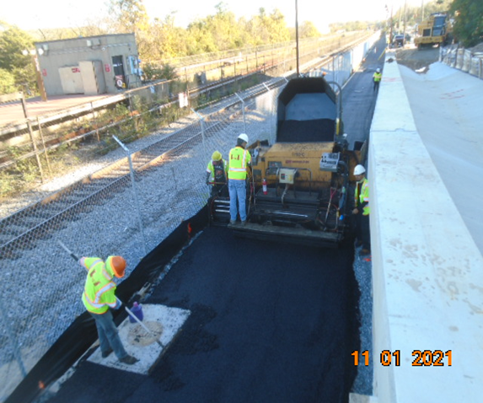

Phase D – Crew placing asphalt

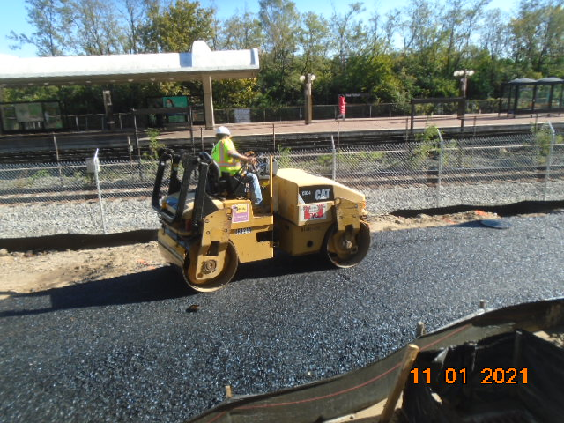

Phase D – Crew compacting surface asphalt

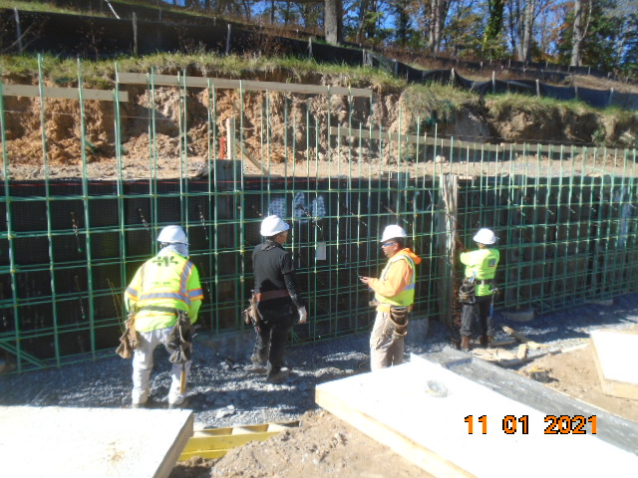

Phase D – Crew installing S3 wall rebar

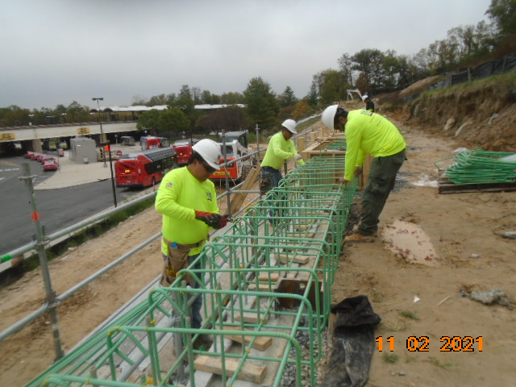

Phase D – Crew tying S3 coping wall rebar

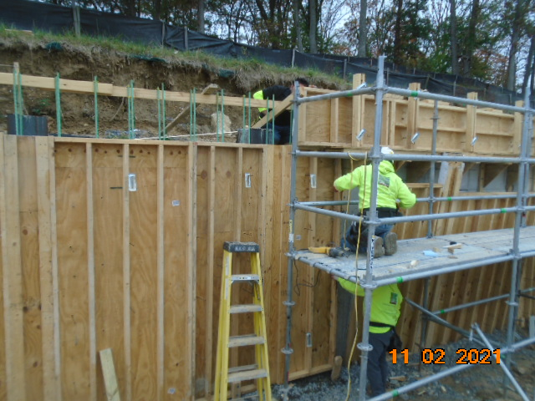

Phase D – Crew constructing S3 wall formwork

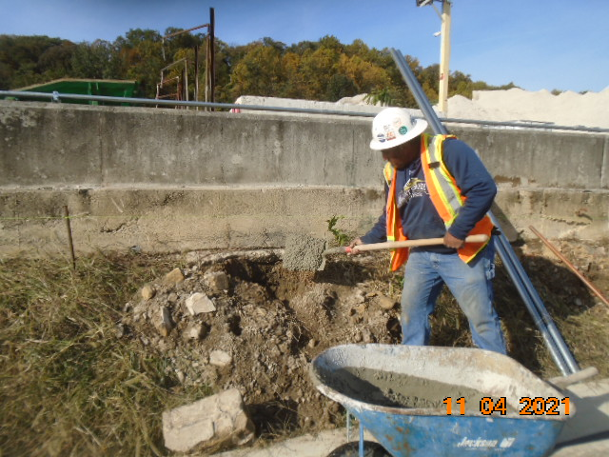

Phase D – Crew placing fence post concrete

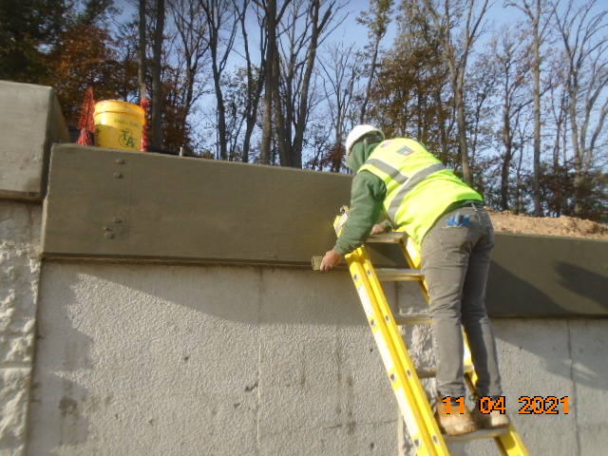

Phase D – Crew parging S3 wall

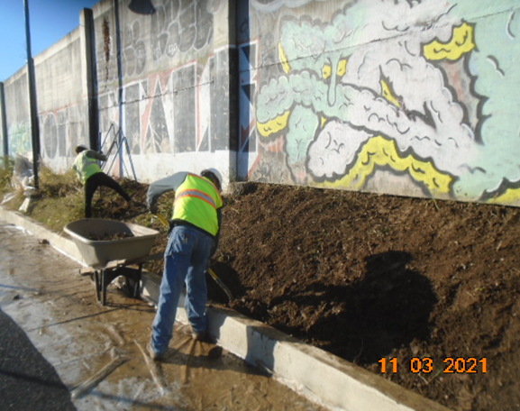

Phase D – Crew grading the embankment slope along the trail

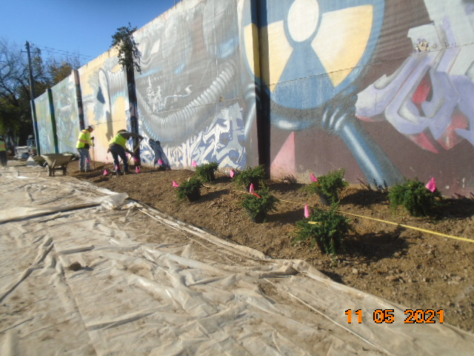

Phase D – Crew planting plants

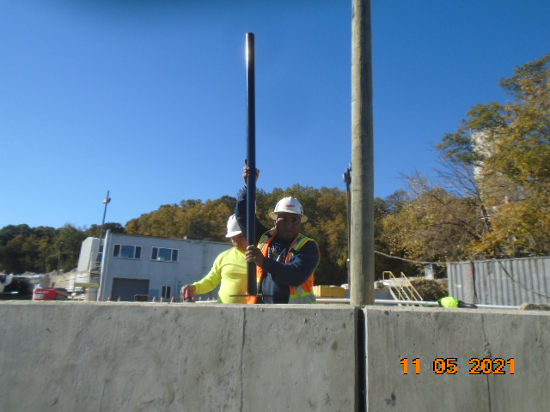

Phase D – Crew installing fence post at S0 wall