Metropolitan Branch Trail Design Build, South Segment
DC CONTRACT NO. DCKA-2016-C-0044
FAP No.: STP-2016 (060)

CONSTRUCTION MANAGER’S
WEEKLY PROGRESS REPORT

10/25/2020 – 10/31/2020

Project Website: www.metbranchtrail-forttotten.com
For Additional Trail Information Please see www.metbranchtrail.com

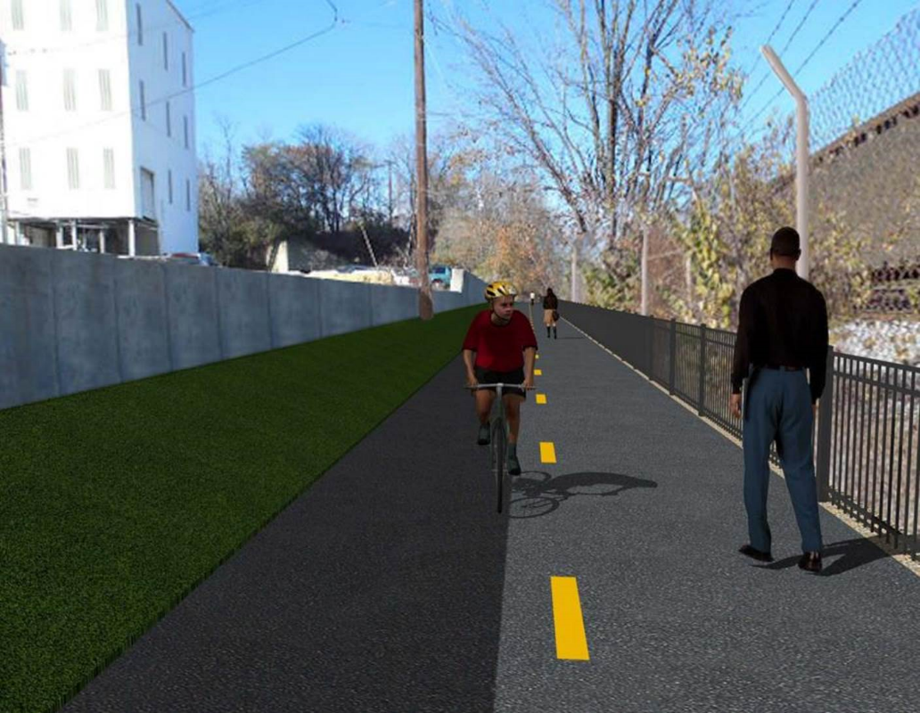

Proposed Metropolitan Branch Trail

1. PROJECT DESCRIPTION

The planned Metropolitan Branch Trail Project (“the Project”) consists of the design and construction of a new trail adjacent to CSX tracks and WMATA Red Line tracks along John McCormack Drive, adjacent to Fort Totten Metro Station, and on NPS property in NE, Washington D.C. The trail begins approximately 1500 feet south of Bates Road NE on the east side of John McCormack Drive NE, extending north along the WMATA and CSX tracks to the Fort Totten Metro Station tie in with First Place NE. An existing trail connection from Gallatin Road NE to the Fort Totten Metro Station will be reconstructed as a part of the Project.

The Project is 83.15% Federally-Funded and 16.85% District-Funded. Potomac Construction is the Design Build contractor.

Delon Hampton and Associates Chartered is providing Construction Management and Inspection services. Specific Construction Scope of Work includes:

- Provide mobilization and demobilization, provision and maintenance of Engineer’s field facilities, field layout, employee training, and other incidental work required for a quality, complete and finished product;
- Establishment and maintenance of vehicular and pedestrian traffic including signs, barricades and other transition devices; reconfiguring the devices in conjunction with changes in work areas; and their removal and disposal upon project completion, including restoration of disturbed areas;
- Clearing and grubbing, as required within the LOD;
- Removal of unsuitable material, excavation, and backfilling and pervious paving to construct a new trail;
- Protection of trees during construction;
- Provide ADA compliant trail connections and pedestrian ramps;
- Provide retaining walls as necessary to stay within the LOD and minimize property impacts following visual requirements specified for retaining walls on NPS property;
- Provide new permanent regulatory and wayfinding signs for the trail and all trail connection intersections;
- Provide road and trail pavement markings;
- Provide landscaping within the LOD for the Project including special requirements for landscaping on NPS property;
- Provide erosion and sediment control measures, storm water management facilities, including pervious asphalt pavement and bioretention facilities;
- Provide utility coordination, identification, locating, and protection of all utilities encountered during design and construction including relocation of Pepco poles along Aggregate Industries property; and
- Provide new WMATA security fencing between the trail and CSXT tracks.
- Remove existing sidewalk and widen sidewalk to 10’ along the west side of 1st place NE from Metropolitan Branch Trail to entrance to WMATA bus loop, on the west side.

2. STATUS OF CONSTRUCTION / PROGRESS SUMMARY

Work performed this week:

Design

- MBT Designer submitted Phase D 3-ring binder and 100% Plans to DDOT
- Stakeholders acceptance for Phase D Final Design Plans
- CSX is reviewing Phase D Means and Methods
- Redesign of Retaining Wall S2 under review

Construction:

Phase B

- Constructed bioretention pond
- Construct bioretention pond
- Placed stone at biorention pond
- Excavated tree pits
- Planted trees

Phase D

- Stripped retaining wall formwork
- Performed backfilling and compaction behind retaining wall
- Excavated drainage trench
- Installed and backfilled drainage pipes
- Constructed manholes
- CSX flagger’s operation and safety tool box talk

CM Consultant:

- Monitored construction progress, make sure all applicable inspections and testing were
performed
- Attended Progress Meeting conference call
- Attended QAQC Meeting conference call
- Reviewed Inspector Daily Reports
- Prepared CM Weekly Reports
- Updated Project Files
- Update Project Webpage
- Updated documents in SharePoint
- Communication with the stakeholder in terms of submittals

3. MEETINGS / PROJECT COORDINATION

Tue 10/27/20 MBT Progress meeting conference call was held at 10:00 A.M.

4. DAILY WORK PERFORMED

Sun 10/25/20 No work performed.
Mon 10/26/20 Phase B – Constructed bioretention pond. Placed stone and bioretention
soil at the bioretention pond.
Phase B – Electrical Work – No work scheduled.
Phase D – Sawcut and demolished existing Aggregate Industries concrete pavement. Placed wedge wall concrete. Installed drainage pipes. Backfilled drainage trench.
Tue 10/27/20 Phase B – Constructed bioretention pond. Placed stone and bioretention
soil at the bioretention pond. Placed planting soil in tree pits.
Phase B – Electrical Work – No work scheduled
Phase D – Performed rough grading the trail. Performed backfilling and compaction behind retaining wall. Excavated drainage trench, installed pipes, placed bedding stone, and installed pipes. Backfilled drainage pipe trench. Constructed drainage manhole.
Wed 10/28/20 Phase B – Constructed bioretention pond. Spread straw bale all around
the bioretention slope. Planted trees.
Phase B - Electrical Work – No work scheduled.
Phase D – Perform rough grading the trail. Performed backfilling and compaction behind retaining wall. Installed drainage pipes. Backfilled drainage trench. Demolished the existing concrete ditch and installed temporary drainage pipe. Installed silt fence.
Thurs 10/29/20 Phase B – No work performed due to rain.
Phase D – No work performed due to rain
Fri 10/30/20 Phase B – Planted trees
Phase B – Electrical Work – No work scheduled
Phase D – No work performed due to rain
Sat 10/31/20 No work scheduled

5. INSPECTION & MATERIAL TESTS PERFORMED

Jobsite Safety Inspection  Erosion and Sediment Control inspection  MOT Inspection  Compaction Test - Passed  Asphalt Material Testing  Concrete Material Testing – Pending results  ** Note - Additional Material Test Results can be found on DDOT QA QC Material Division Tracking SharePoint website. | Infiltration Tests – Pending results  Dynamic Cone Penetration (DCP) Tests  Rebars Inspection - Passed
6. DBE PARTICIPATION SUMMARIES

Potomac Construction (Contractor)
- DBE Goal for Contractor is 15%. To-date the Contractor has achieved 40% of their goal.

Delon Hampton & Associates (CM)
- DBE Goal for the CM is 10%. To-date the CM has achieved 18% of their Goal.

7. ACCIDENTS / INCIDENTS

None occurred on-site during this week.

8. PHOTOS OF THE WORK PERFORMED

12. PHOTOS OF WORK PERFORMED THIS PERIOD

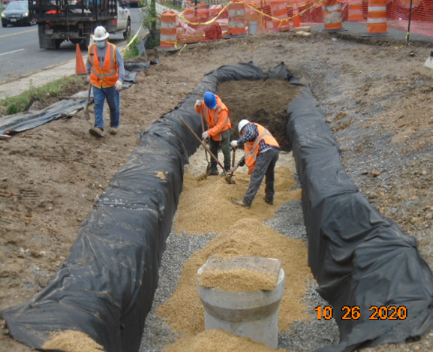
Phase B – Crew placing stone at biorention pond

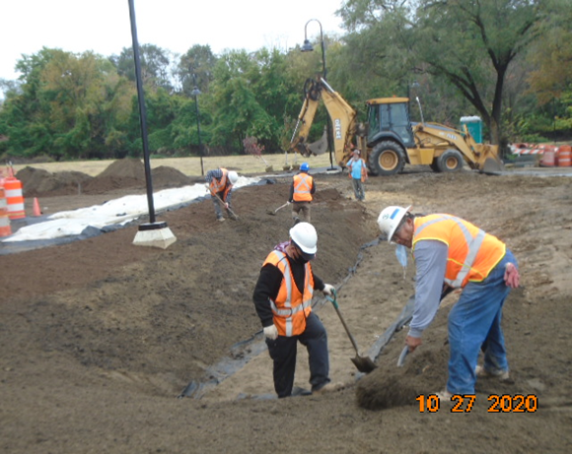
Phase B – Crew constructing bioretention pond
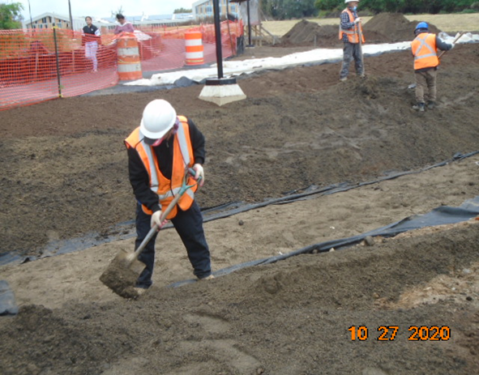
Phase B – Crew constructing biorention pond

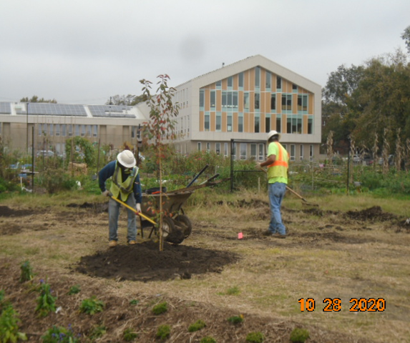
Phase D – Crew planting trees

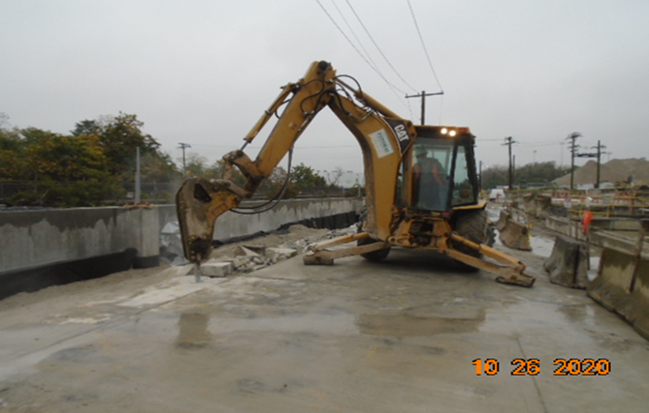
Phase D – Crew demolishing existing concrete slab

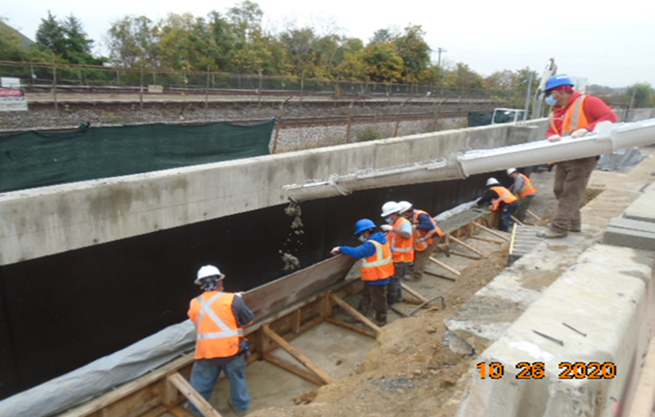
Phase D – Crew placing wedge wall concrete

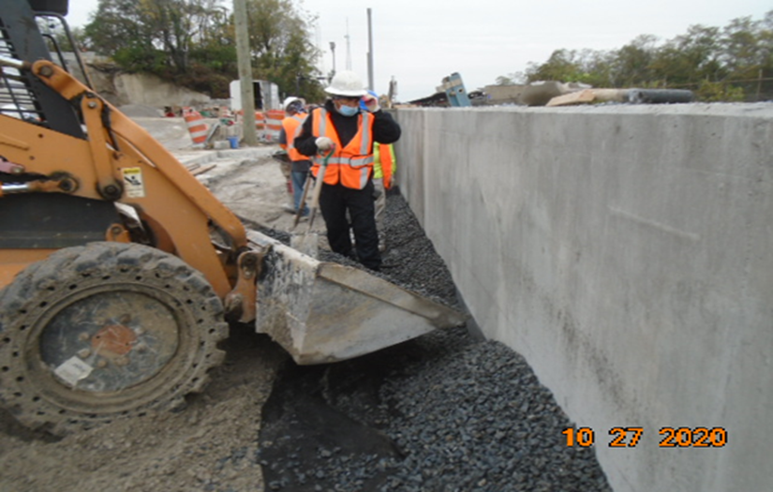
Phase D – Crew backfilling behind retaining wall

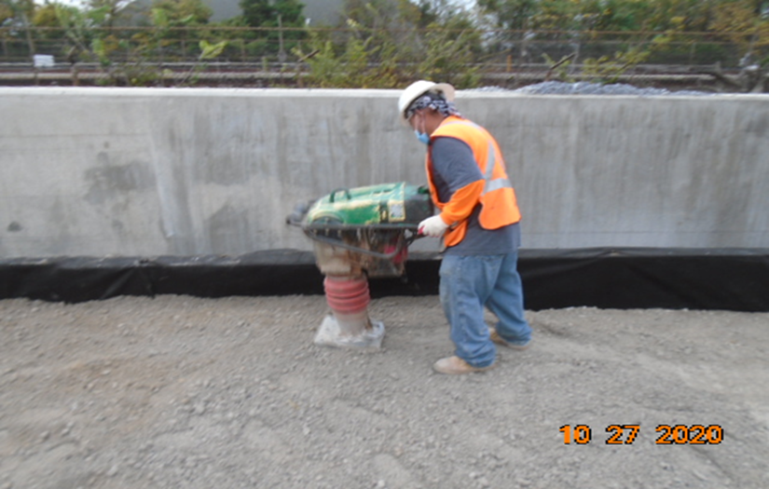
Phase D – Crew compacting backfill behind retaining wall

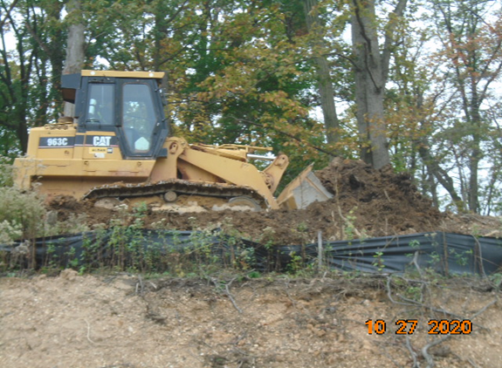
Phase D – Crew rough grading the trail

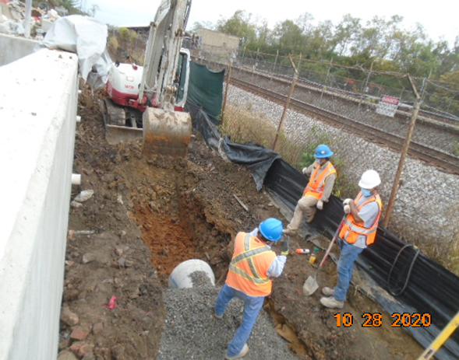
Phase D – Crew excavating drainage pipe trench

