Metropolitan Branch Trail Design Build, South Segment
DC CONTRACT NO. DCKA-2016-C-0044
FAP No.: STP-2016 (060)

CONSTRUCTION MANAGER’S
WEEKLY PROGRESS REPORT

10/24/2021 – 10/30/2021

Project Website: www.metbranchtrail-forttotten.com
For Additional Trail Information Please see www.metbranchtrail.com
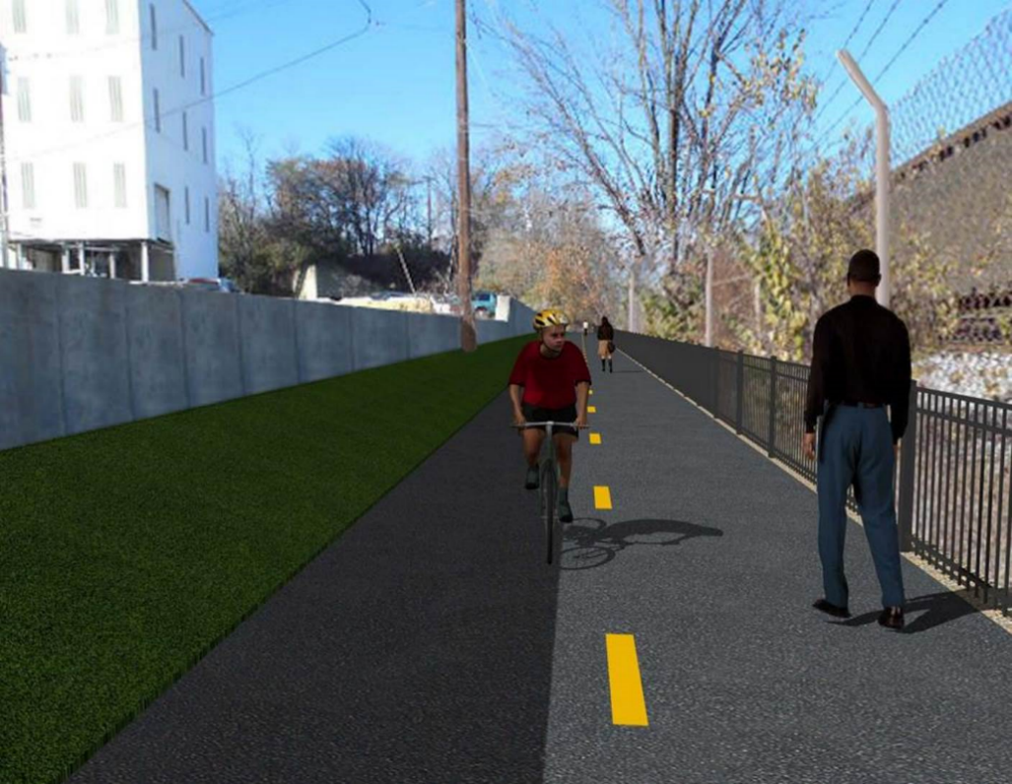

Proposed Metropolitan Branch Trail

1. PROJECT DESCRIPTION

The planned Metropolitan Branch Trail Project (“the Project”) consists of the design and construction of a new trail adjacent to CSX tracks and WMATA Red Line tracks along John McCormack Drive, adjacent to Fort Totten Metro Station, and on NPS property in NE, Washington D.C. The trail begins approximately 1500 feet south of Bates Road NE on the east side of John McCormack Drive NE, extending north along the WMATA and CSX tracks to the Fort Totten Metro Station tie in with First Place NE. An existing trail connection from Gallatin Road NE to the Fort Totten Metro Station will be reconstructed as a part of the Project.

The Project is 83.15% Federally-Funded and 16.85% District-Funded. Potomac Construction is the Design Build contractor.

Delon Hampton and Associates Chartered is providing Construction Management and Inspection services. Specific Construction Scope of Work includes:

- Provide mobilization and demobilization, provision and maintenance of Engineer’s field facilities, field layout, employee training, and other incidental work required for a quality, complete and finished product;
- Establishment and maintenance of vehicular and pedestrian traffic including signs, barricades and other transition devices; reconfiguring the devices in conjunction with changes in work areas; and their removal and disposal upon project completion, including restoration of disturbed areas;
- Clearing and grubbing, as required within the LOD;
- Removal of unsuitable material, excavation, and backfilling and pervious paving to construct a new trail;
- Protection of trees during construction;
- Provide ADA compliant trail connections and pedestrian ramps;
- Provide retaining walls as necessary to stay within the LOD and minimize property impacts following visual requirements specified for retaining walls on NPS property;
- Provide new permanent regulatory and wayfinding signs for the trail and all trail connection intersections;
- Provide road and trail pavement markings;
- Provide landscaping within the LOD for the Project including special requirements for landscaping on NPS property;
- Provide erosion and sediment control measures, storm water management facilities, including pervious asphalt pavement and bioretention facilities;
- Provide utility coordination, identification, locating, and protection of all utilities encountered during design and construction including relocation of Pepco poles along Aggregate Industries property; and
- Provide new WMATA security fencing between the trail and CSXT tracks.
- Remove existing sidewalk and widen sidewalk to 10’ along the west side of 1st place NE from Metropolitan Branch Trail to entrance to WMATA bus loop, on the west side.

2. STATUS OF CONSTRUCTION / PROGRESS SUMMARY

Work performed this week:

Design

- 100 % Complete

Construction:

Phase B

- Placed and graded topsoil. Hydroseeded the landscaping. Placed mulch over seeded area.

Phase D

- Parged retaining walls S0 and S1 front face
- Constructed retaining wall S3 formwork
- Installed S3 wall rebar
- Constructed S3 coping wall formwork
- Installed S3 coping wall rebar
- Placed retaining wall S3 concrete
- Excavated and fine graded the trail subgrade
- Placed bedding stone at the trail path
- Installed geotextile fabric at the trail
- Installed perforated underdrain at the trail
- Graded embankment slope along the trail
- Seeded embankment slope along the trail
- Raised drainage manholes
- Installed erosion control matt over the embankment slope along the trail
- Contractor safety tool box talk

CM Consultant:

- Monitored construction progress, make sure all applicable inspections and testing were performed
- Reviewed Project Schedule
- Prepared CM Weekly Report to post
- Prepared CM weekly report to DDOT
- Updated Project Files
- Updated Project Logs
- Updated Project Webpage
- Updated documents in DHA SharePoint site
- Updated DDOT Sharepoint site
- Communication with PCCI and stakeholders in terms of submittals

3. MEETINGS / PROJECT COORDINATION

Mon 10/25/21 DHA PCCI and Century Fence Construction site meeting was held at 9:30
A.M.

4. DAILY WORK PERFORMED

Sun 10/24/21 No work performed.
Mon 10/25/21 Phase B – Placed and graded topsoil.
Phase D – Parged retaining wall S0 and S2 wall. Installed retaining wall S3 rebar. Constructed retaining wall S3 formwork. Installed perforate underdrain in front of retaining wall S3. Excavated and fine graded the trail path.
Phase D – Electrical work – No work performed.
Tue 10/26/21 Phase B – No work performed.
Phase D – Parged retaining wall S0 and S2 wall. Installed retaining wall S3 rebar. Constructed retaining wall S3 formwork. Stripped retaining wall S3 formwork. Excavated and fine graded the trail path. Place bedding stone at the trail trench. Installed geotextile fabric over the trail path. Installed perforated underdrain pipe. Raised drainage manholes.
Phase D – Electrical work – No work performed.
Wed 10/27/21 Phase B – Hydroseeded the landscape
Phase D – Parged retaining wall S0 and S1 concrete. Installed retaining wall S3 rebar. Constructed retaining wall S3 formwork. Tied S3 coping wall rebar. Constructed S3 coping wall formwork. Installed geotextile fabric over the trail path. Installed perforated underdrain pipe. Seeded and installed erosion control matt over the embankment slope area along the trail.
Phase D – Electrical Work – No work performed.
Thurs 10/28/21 Phase B – Spread mulch over hydoseeded area.
Phase D – Parged retaining wall S0 and S2 concrete. Installed retaining wall S3 formwork. Constructed retaining wall S3 formwork. Placed concrete for retaining wall S3 wall section. Placed concrete for S3 coping wall. Placed and graded bedding stone at the trail path.
Phase D – Electrical Work – No work performed.
Fri 10/29/21 Phase B – No work performed due to rain
Phase D – No work performed due to rain
Phase D – Electrical Work – No work performed due to rain
Sat 10/30/21 Phase D – No work scheduled.

5. INSPECTION & MATERIAL TESTS PERFORMED

Jobsite Safety Inspection  Erosion and Sediment Control inspection  MOT Inspection  Compaction Test  Asphalt Material Testing – Pending results  Concrete Material Testing – Pending results  ** Note - Additional Material Test Results can be found on DDOT QA QC Material Division Tracking SharePoint website. | Infiltration Tests - Passed  Dynamic Cone Penetration (DCP) Tests  Rebars Inspection – Passed
6. DBE PARTICIPATION SUMMARIES

Potomac Construction (Contractor)

- DBE Goal for Contractor is 15%. To-date the Contractor has achieved 54.4% of their goal.

Delon Hampton & Associates (CM)

- DBE Goal for the CM is 10%. To-date the CM has achieved 96.6% of their Goal.

7. ACCIDENTS / INCIDENTS

None occurred on-site during this week.

8. PHOTOS OF THE WORK PERFORMED

12. PHOTOS OF WORK PERFORMED THIS PERIOD
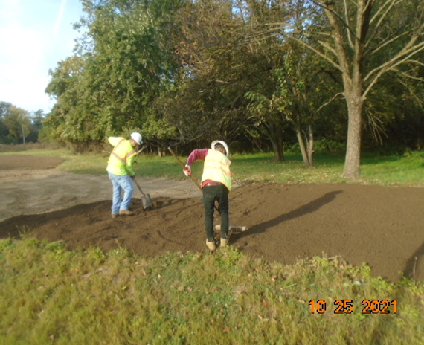
Phase B – Crew placing and grading topsoil

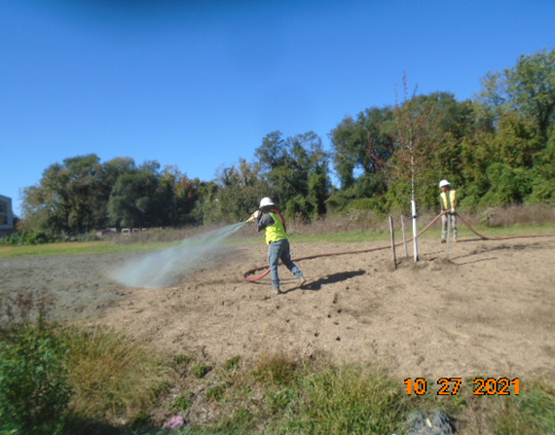
Phase B – Crew hydroseeding the landscape
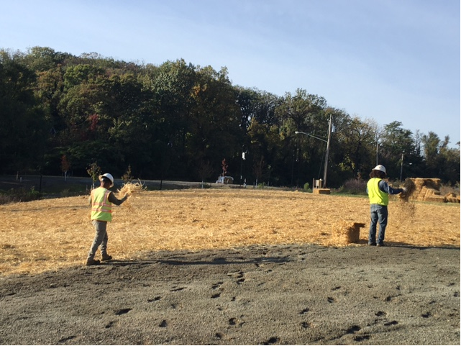
Phase D – Crew placing mulch over seeded area

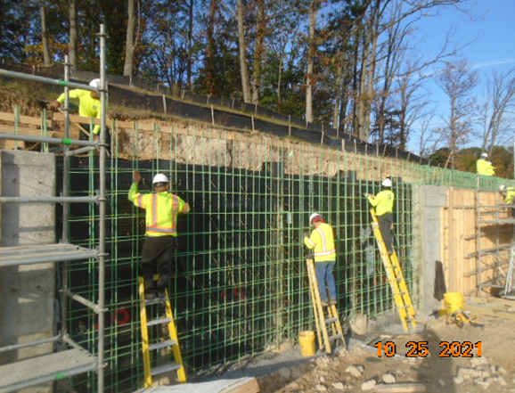
Phase D – Crew tying S3 wall rebar

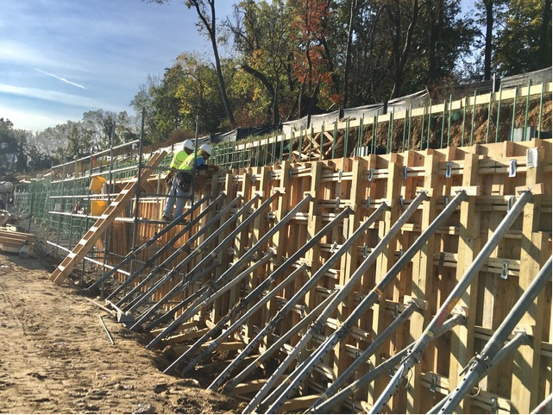
Phase D – Crew constructing retaining wall formwork

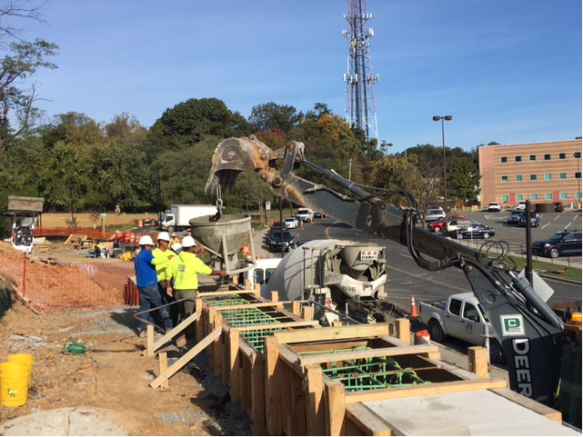
Phase D – Crew placing concrete for S3 wall

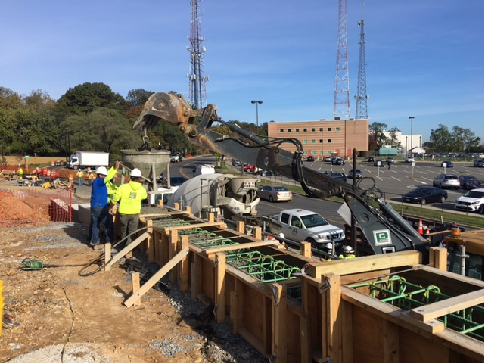
Phase D – Crew placing coping wall concrete

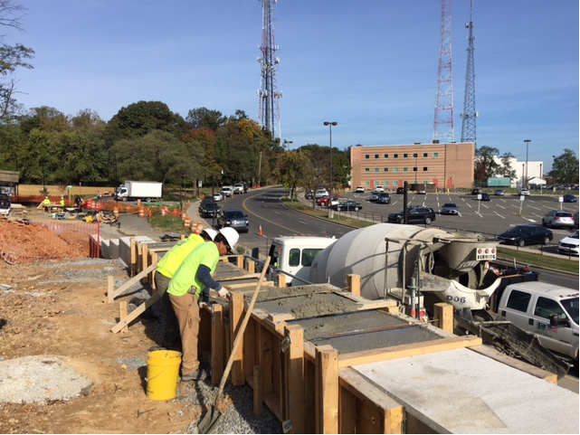
Phase D – Crew finishing coping wall concrete

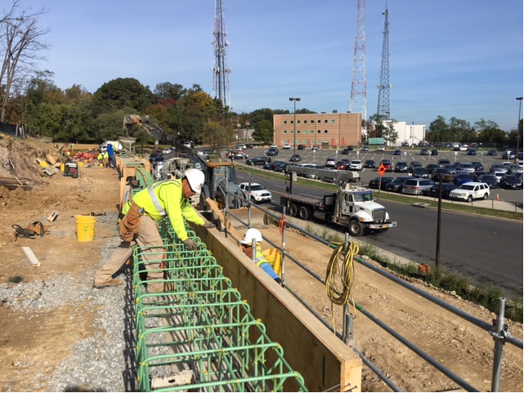
Phase D – Crew constructing S3 coping wall formwork

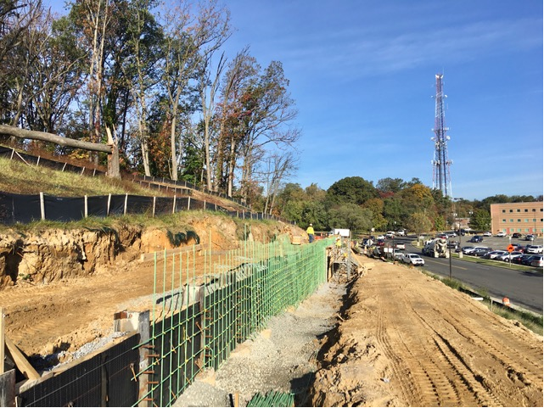
Phase D – Retaining wall S3 rebars installed

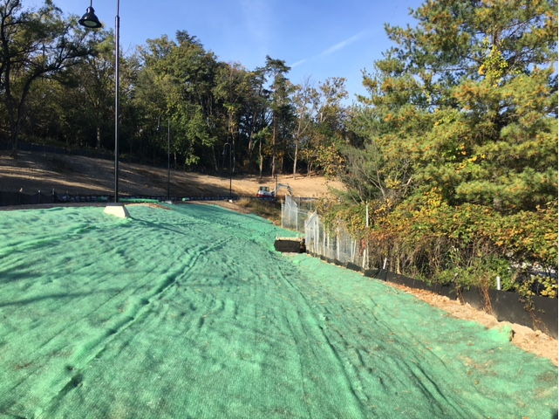
Phase D – Erosion control matt installed over sloped area along the trail

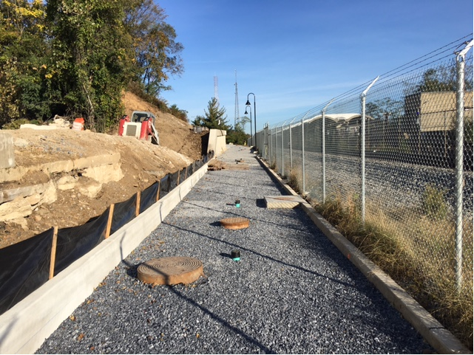
Phase D – Bedding stone placed and graded at the trail path

