Metropolitan Branch Trail Design Build, South Segment
DC CONTRACT NO. DCKA-2016-C-0044
FAP No.: STP-2016 (060)

CONSTRUCTION MANAGER’S
WEEKLY PROGRESS REPORT

10/04/2020 – 10/10/2020

Project Website: www.metbranchtrail-forttotten.com
For Additional Trail Information Please see www.metbranchtrail.com

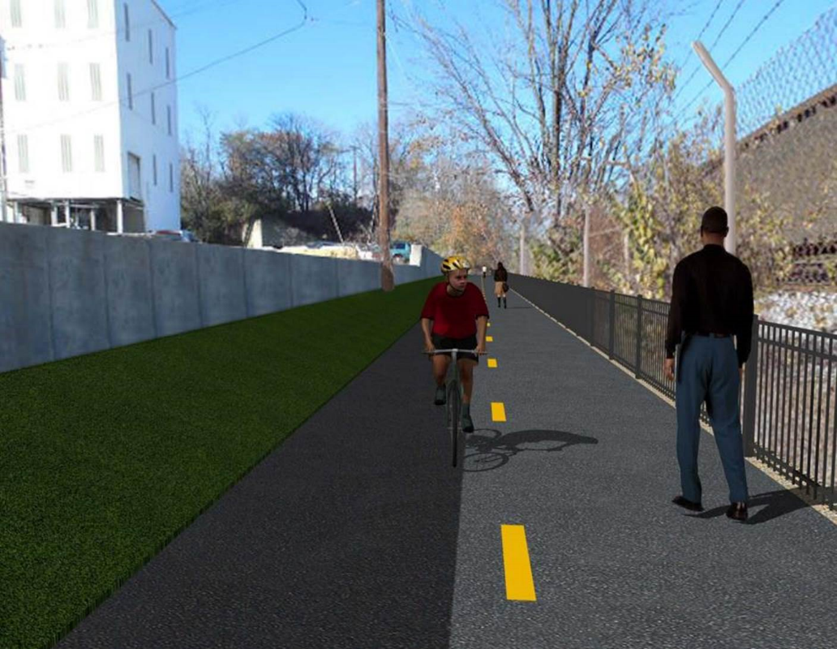

Proposed Metropolitan Branch Trail

1. PROJECT DESCRIPTION

The planned Metropolitan Branch Trail Project (“the Project”) consists of the design and construction of a new trail adjacent to CSX tracks and WMATA Red Line tracks along John McCormack Drive, adjacent to Fort Totten Metro Station, and on NPS property in NE, Washington D.C. The trail begins approximately 1500 feet south of Bates Road NE on the east side of John McCormack Drive NE, extending north along the WMATA and CSX tracks to the Fort Totten Metro Station tie in with First Place NE. An existing trail connection from Gallatin Road NE to the Fort Totten Metro Station will be reconstructed as a part of the Project.

The Project is 83.15% Federally-Funded and 16.85% District-Funded. Potomac Construction is the Design Build contractor.

Delon Hampton and Associates Chartered is providing Construction Management and Inspection services. Specific Construction Scope of Work includes:

- Provide mobilization and demobilization, provision and maintenance of Engineer’s field facilities, field layout, employee training, and other incidental work required for a quality, complete and finished product;
- Establishment and maintenance of vehicular and pedestrian traffic including signs, barricades and other transition devices; reconfiguring the devices in conjunction with changes in work areas; and their removal and disposal upon project completion, including restoration of disturbed areas;
- Clearing and grubbing, as required within the LOD;
- Removal of unsuitable material, excavation, and backfilling and pervious paving to construct a new trail;
- Protection of trees during construction;
- Provide ADA compliant trail connections and pedestrian ramps;
- Provide retaining walls as necessary to stay within the LOD and minimize property impacts following visual requirements specified for retaining walls on NPS property;
- Provide new permanent regulatory and wayfinding signs for the trail and all trail connection intersections;
- Provide road and trail pavement markings;
- Provide landscaping within the LOD for the Project including special requirements for landscaping on NPS property;
- Provide erosion and sediment control measures, storm water management facilities, including pervious asphalt pavement and bioretention facilities;
- Provide utility coordination, identification, locating, and protection of all utilities encountered during design and construction including relocation of Pepco poles along Aggregate Industries property; and
- Provide new WMATA security fencing between the trail and CSXT tracks.
- Remove existing sidewalk and widen sidewalk to 10’ along the west side of 1st place NE from Metropolitan Branch Trail to entrance to WMATA bus loop, on the west side.

2. STATUS OF CONSTRUCTION / PROGRESS SUMMARY

Work performed this week:

Design

- MBT Designer submitted Phase D 3-ring binder and 100% Plans to DDOT
- Stakeholders acceptance for Phase D Final Design Plans
- CSX is reviewing Phase D Means and Methods

Construction:

Phase B

- Planted Bioswale plants
- Hauled away unsuitable soil from the site
- Cleaned site

Phase D

- Installed retaining wall footings formwork and rebars
- Placed retaining wall footings concrete
- Excavated drainage trench
- Installed and backfilled drainage pipes
- Constructed manhole base formwork
- Installed manhole base rebars
- Placed manhole base concrete
- Demolished existing concrete ditch
- CSX flagger’s operation and safety tool box talk

CM Consultant:

- Monitored construction progress, make sure all applicable inspections and testing were
Performed
- Attended MBT Progress Meeting conference call
- Attended QAQC Meeting conference call
- Reviewed Inspection Daily Reports
- Prepared CM Weekly Reports
- Updated Project Files
- Update Project Webpage
- Updated documents in SharePoint
- Communication with the stakeholder in terms of submittals

3. MEETINGS / PROJECT COORDINATION

Fri 10/09/20 QAQC Meeting conference call was held at 10:00 A.M.

4. DAILY WORK PERFORMED

Sun 10/04/20 No work performed.
Mon 10/05/20 Phase B – Planted Bioswale trees
Phase B – No Electrical work scheduled
Phase D – Excavated and rough graded the trail. Installed retaining wall rebars. Excavated drainage trench, placed drainage pipes bedding material. Installed drainage pipes. Compacted and backfilled drainage pipes trench. Constructed drainage manhole base and top slab forms. Installed rebars and poured base and top slab concrete. Cut trees.
Tue 10/06/20 Phase B – Planted Bioswale plants. Hauled away unsuitable soil for the
site. Cleaned site.
Electrical Work – Electrical work – No work scheduled
Phase D – Excavated and rough graded the trail. Installed retaining wall rebars. Excavated drainage trench, placed drainage pipes bedding material. Installed drainage pipes. Compacted and backfilled drainage pipes trench. Constructed drainage manhole. Graded and stabilized the slope line along the trail. Cut trees.
Wed 10/07/20 Phase B – Planted Bioswale plants. Cleaned site.
Phase B - Electrical Work – No work scheduled.
Phase D – Excavated and rough graded the trail. Installed retaining wall rebars. Excavated drainage trench, placed drainage pipes bedding material. Installed drainage pipes. Compacted and backfilled drainage pipes trench. Constructed drainage manhole. Cleared cut trees, roots and stumps.
Thurs 10/08/20 Phase B – No work performed. Surveyor marked bioretention pond.
Phase B – Electrical – No work scheduled
Phase D – Excavated and rough graded the trail. Installed retaining wall rebars. Excavated drainage trench, placed drainage pipes bedding material. Installed drainage pipes. Compacted and backfilled drainage pipes trench. Constructed drainage manhole. Cleared cut trees, roots and stumps.
Phase D – Electrical Work – Installed light pole conduits for retaining wall light pole.
Fri 10/09/20 Phase B – No work performed
Phase B – Electrical – No work scheduled
Phase D – Placed retaining wall concrete. Backfilled drainage pipes
Sat 10/10/20 No work scheduled

5. INSPECTION & MATERIAL TESTS PERFORMED

Jobsite Safety Inspection  Erosion and Sediment Control inspection  MOT Inspection  Compaction Test  Asphalt Material Testing  Concrete Material Testing – Pending results  ** Note - Additional Material Test Results can be found on DDOT QA QC Material Division Tracking SharePoint website. | Infiltration Tests – Pending results  Dynamic Cone Penetration (DCP) Tests  Rebars Inspection - Passed
6. DBE PARTICIPATION SUMMARIES

Potomac Construction (Contractor)
- DBE Goal for Contractor is 15%. To-date the Contractor has achieved 40% of their goal.

Delon Hampton & Associates (CM)
- DBE Goal for the CM is 10%. To-date the CM has achieved 18% of their Goal.

7. ACCIDENTS / INCIDENTS

None occurred on-site during this week.

8. PHOTOS OF THE WORK PERFORMED

12. PHOTOS OF WORK PERFORMED THIS PERIOD

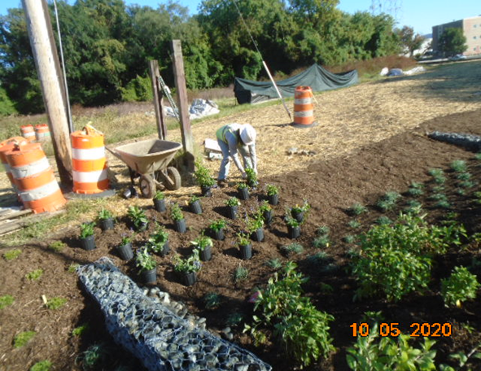
Phase B – Crew planting bioswale trees

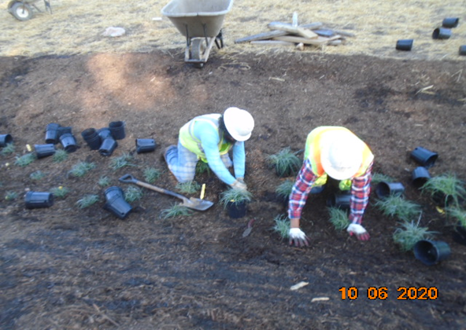
Phase B – Crew planting bio swale plants
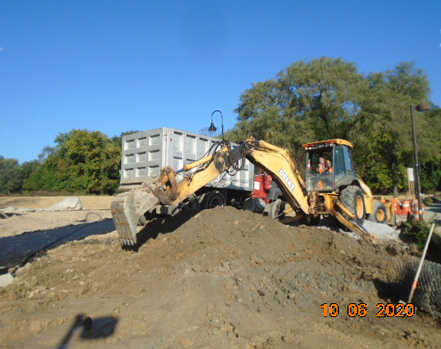
Phase B – Crew hauling away unsuitable soil

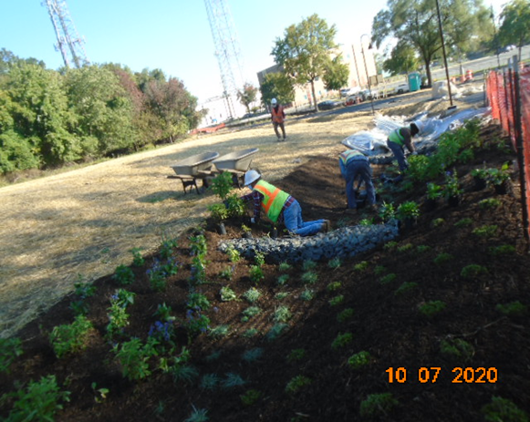
Phase D – Crew planting Bioswale plants

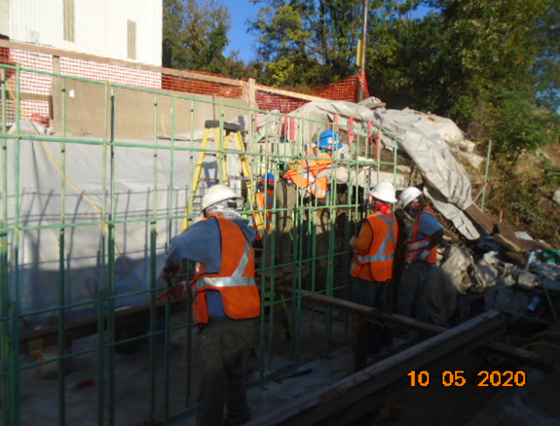
Phase D – Crew installing retaining wall rebars

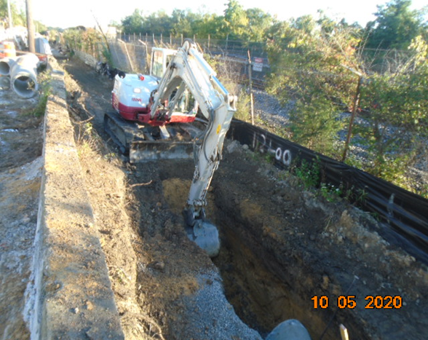
Phase D – Crew excavating drainage pipes trench

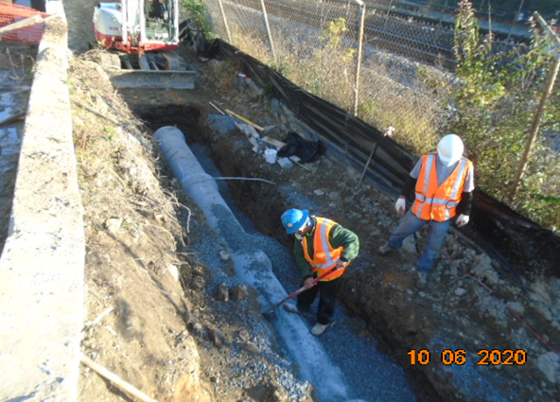
Phase D – Crew installing drainage pipes

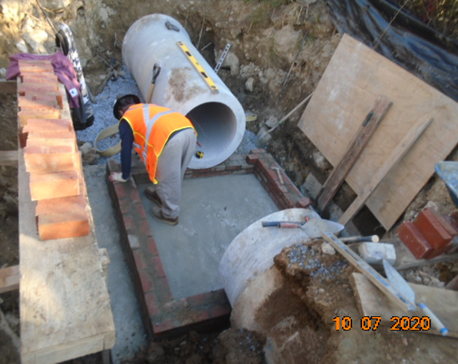
Phase D – Crew constructing drainage manhole

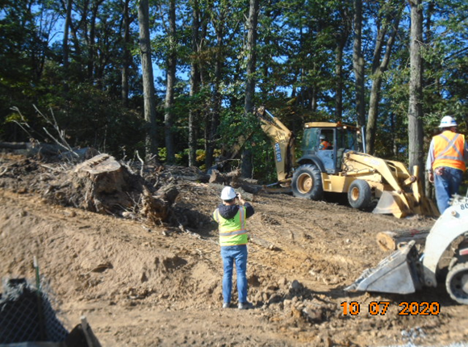
Phase D – Crew clearing the cut trees

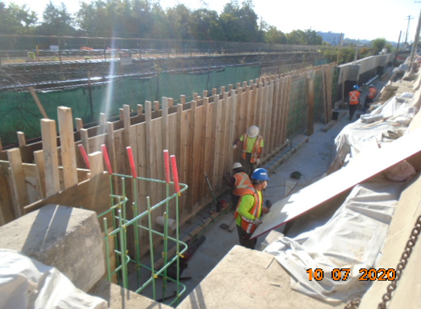
Phase D – Crew installing retaining wall formwork

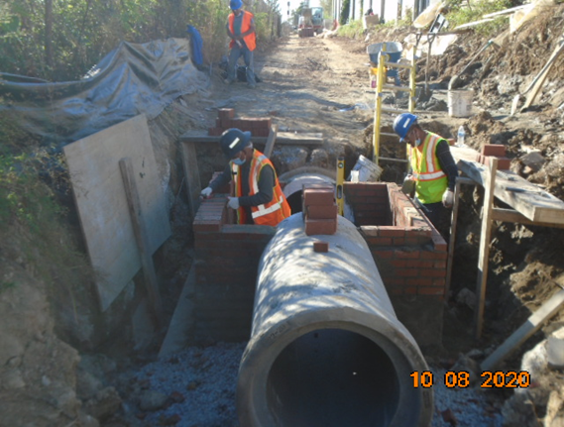
Phase D – Crew constructing brick manhole

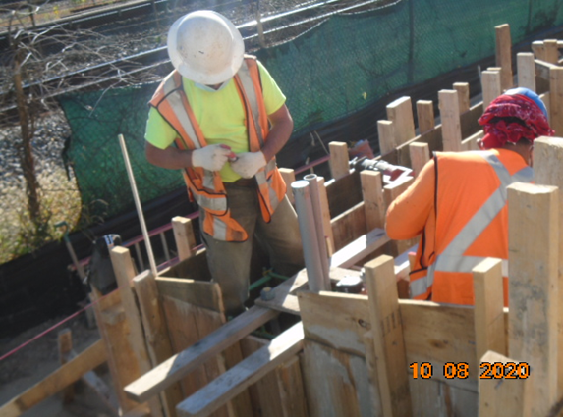
Phase D – Crew installing light pole conduits

