Metropolitan Branch Trail Design Build, South Segment
DC CONTRACT NO. DCKA-2016-C-0044
FAP No.: STP-2016 (060)

CONSTRUCTION MANAGER’S
WEEKLY PROGRESS REPORT

10/03/2021 – 10/09/2021

Project Website: www.metbranchtrail-forttotten.com
For Additional Trail Information Please see www.metbranchtrail.com
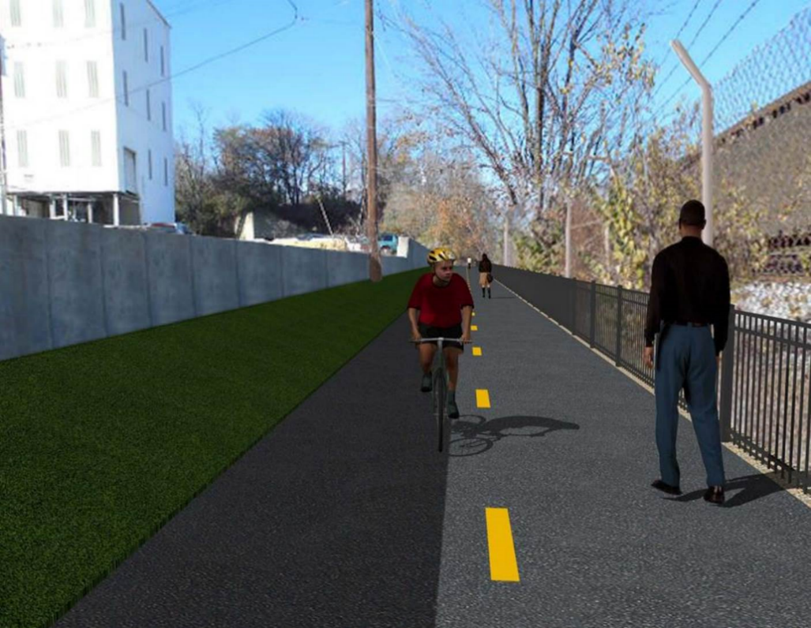

Proposed Metropolitan Branch Trail

1. PROJECT DESCRIPTION

The planned Metropolitan Branch Trail Project (“the Project”) consists of the design and construction of a new trail adjacent to CSX tracks and WMATA Red Line tracks along John McCormack Drive, adjacent to Fort Totten Metro Station, and on NPS property in NE, Washington D.C. The trail begins approximately 1500 feet south of Bates Road NE on the east side of John McCormack Drive NE, extending north along the WMATA and CSX tracks to the Fort Totten Metro Station tie in with First Place NE. An existing trail connection from Gallatin Road NE to the Fort Totten Metro Station will be reconstructed as a part of the Project.

The Project is 83.15% Federally-Funded and 16.85% District-Funded. Potomac Construction is the Design Build contractor.

Delon Hampton and Associates Chartered is providing Construction Management and Inspection services. Specific Construction Scope of Work includes:

- Provide mobilization and demobilization, provision and maintenance of Engineer’s field facilities, field layout, employee training, and other incidental work required for a quality, complete and finished product;
- Establishment and maintenance of vehicular and pedestrian traffic including signs, barricades and other transition devices; reconfiguring the devices in conjunction with changes in work areas; and their removal and disposal upon project completion, including restoration of disturbed areas;
- Clearing and grubbing, as required within the LOD;
- Removal of unsuitable material, excavation, and backfilling and pervious paving to construct a new trail;
- Protection of trees during construction;
- Provide ADA compliant trail connections and pedestrian ramps;
- Provide retaining walls as necessary to stay within the LOD and minimize property impacts following visual requirements specified for retaining walls on NPS property;
- Provide new permanent regulatory and wayfinding signs for the trail and all trail connection intersections;
- Provide road and trail pavement markings;
- Provide landscaping within the LOD for the Project including special requirements for landscaping on NPS property;
- Provide erosion and sediment control measures, storm water management facilities, including pervious asphalt pavement and bioretention facilities;
- Provide utility coordination, identification, locating, and protection of all utilities encountered during design and construction including relocation of Pepco poles along Aggregate Industries property; and
- Provide new WMATA security fencing between the trail and CSXT tracks.
- Remove existing sidewalk and widen sidewalk to 10’ along the west side of 1st place NE from Metropolitan Branch Trail to entrance to WMATA bus loop, on the west side.

2. STATUS OF CONSTRUCTION / PROGRESS SUMMARY

Work performed this week:

Design

- 100 % Complete

Construction:

Phase B

- Tilted soil at the north side of the trail

Phase D

- Parged retaining walls S0 and S1 front face
- Constructed retaining wall S3 formwork
- Installed retaining wall S3 wall section rebar
- Excavated and graded the trail subgrade
- Installed dowels and grouted inlets top
- Graded embankment slope area along the trail
- Pulled conductors for electrical manholes
- Excavated in front of retaining wall S3
- Placed bedding stone in front retaining wall S3
- Tilted soil at the north side of the trail
- Installed grounding rod for light pole foundation
- Proofed electrical conduits and pulled mule tape in the electrical manholes
- Contractor safety tool box talk

CM Consultant:

- Monitored construction progress, make sure all applicable inspections and testing were performed
- Reviewed PCCI Monthly Pay Estimate
- Reviewed Project Schedule
- Prepared CM Weekly Report to post
- Prepared CM weekly report to DDOT
- Updated Project Files
- Updated Project Logs
- Updated Project Webpage
- Updated documents in DHA SharePoint site
- Updated DDOT Sharepoint site
- Communication with PCCI and stakeholders in terms of submittals

3. MEETINGS / PROJECT COORDINATION

10/06/21 PCCI and DHA field meeting at Phase B was held at 10:00 A.M.
10/07/21 PCCI Landscaper and DHA site meeting at Phase B was held at 11:30 A.M.

4. DAILY WORK PERFORMED

Sun 10/03/21 No work performed.
Mon 10/04/21 Phase D – Parged retaining wall S0 and S1 wall. Installed retaining wall S3
wall section rebar. Constructed retaining wall S3 formwork. Secured Drilled dowels and grouted inlets top.
Phase D – Electrical work – Pulled conductors for the electrical manholes.
Tue 10/05/21 Phase D – Parged retaining wall S0 and S1 wall. Installed retaining wall S3
wall section rebar. Constructed retaining wall S3 formwork. Secured Drilled dowels and grouted inlets top.
Phase D – Electrical work – No work performed.
Wed 10/06/21 Phase D – Parged retaining wall S0 and S1 wall. Installed retaining wall S3
wall section rebar. Constructed retaining wall S3 formwork. Secured Drilled dowels and grouted inlets top. Graded slope area along the trail path. Raised drainage manholes.
Phase D – Electrical Work – No work performed.
Thurs 10/07/21 Phase B – Tilted soil at the north side of the trail.
Phase D – Installed rebars for S3 wall section. Constructed retaining wall S3 formwork. Performed excavation in front of retaining wall S3 bedding pad. Placed bedding stone in front of RW S3 footing. Placed No 57 stone for S3 wall bedding pad.
Phase D – Electrical Work – Installed ground rods of electrical poles. Megger test ground rods. Proof the installed conduits and pulled mule tape in the conduits.
Fri 10/08/21 Phase B – Tilted soil at the north side of the trail.
Phase D – Installed retaining wall S3 rebar. Constructed retaining wall S3 formwork. Graded embankment slope area along the trail.
Phase D – Electrical Work – Installed ground rods of electrical poles. Megger test ground rods. Proof the installed conduits and pulled mule tape in the conduits.
Sat 10/09/21 Phase D – No work scheduled.

5. INSPECTION & MATERIAL TESTS PERFORMED

Jobsite Safety Inspection  Erosion and Sediment Control inspection  MOT Inspection  Compaction Test  Asphalt Material Testing – Pending results  Concrete Material Testing – Pending results  ** Note - Additional Material Test Results can be found on DDOT QA QC Material Division Tracking SharePoint website. | Infiltration Tests - Passed  Dynamic Cone Penetration (DCP) Tests  Rebars Inspection – Ongoing
6. DBE PARTICIPATION SUMMARIES

Potomac Construction (Contractor)

- DBE Goal for Contractor is 15%. To-date the Contractor has achieved 54.4% of their goal.

Delon Hampton & Associates (CM)

- DBE Goal for the CM is 10%. To-date the CM has achieved 96.6% of their Goal.

7. ACCIDENTS / INCIDENTS

None occurred on-site during this week.

8. PHOTOS OF THE WORK PERFORMED

12. PHOTOS OF WORK PERFORMED THIS PERIOD

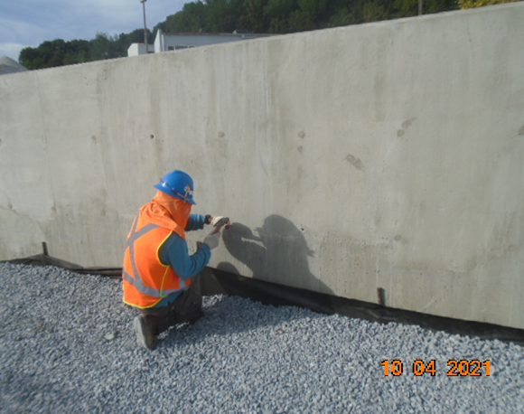
Phase D – Crew parging the S0 wall

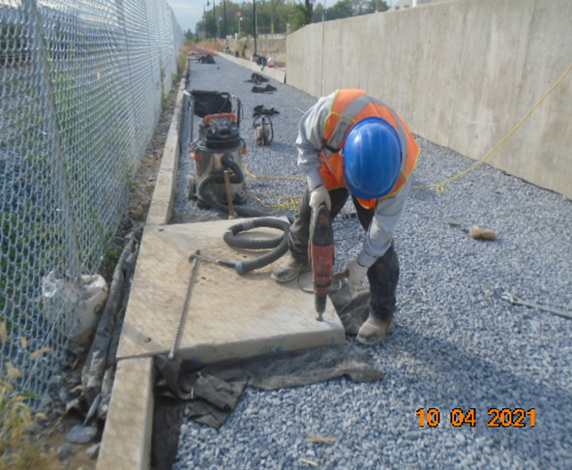
Phase D – Crew drilling dowels for the catch basin top
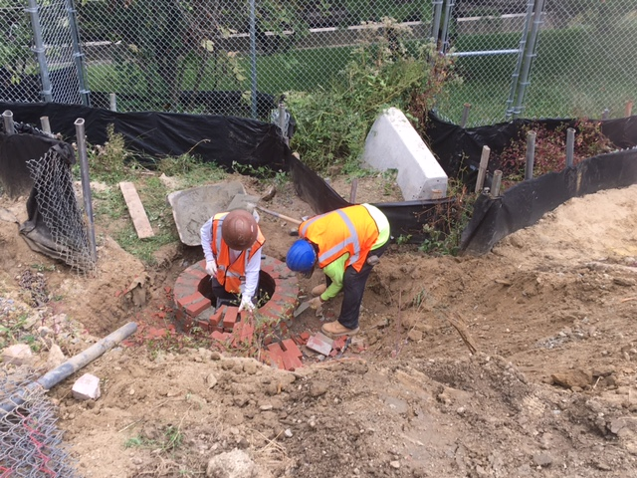
Phase D – Crew raising drainage manhole

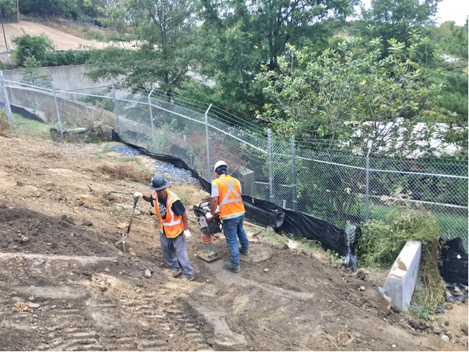
Phase D – Crew compacting backfill around the drainage manhole

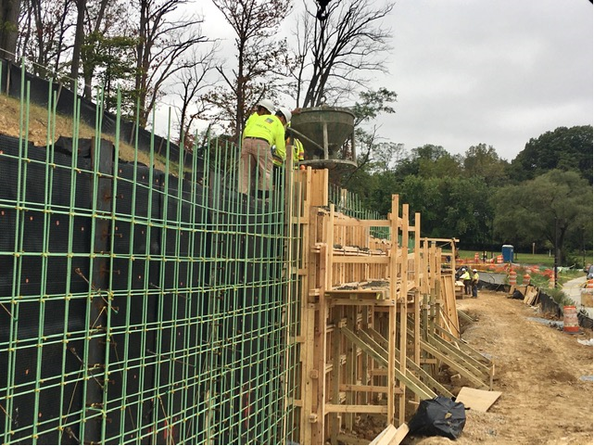
Phase D – Crew placing retaining wall S3 concrete

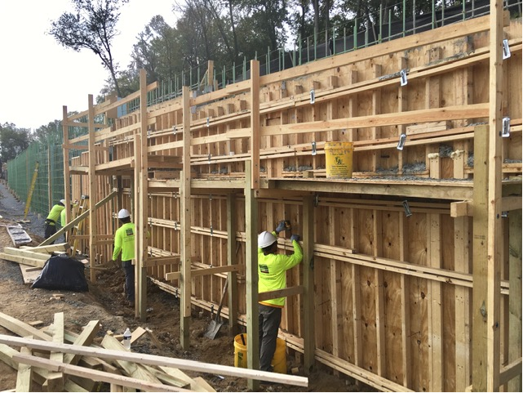
Phase D – Crew constructing retaining wall S3 formwork

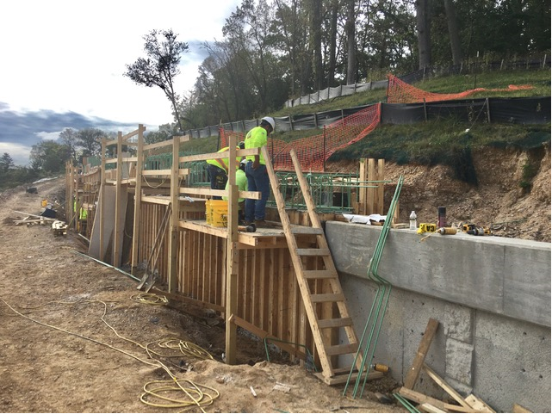
Phase D – Crew tying retaining wall S3 coping rebar

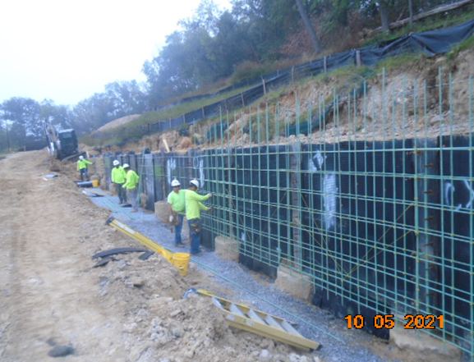
Phase D – Crew installing retaining wall S3 rebar

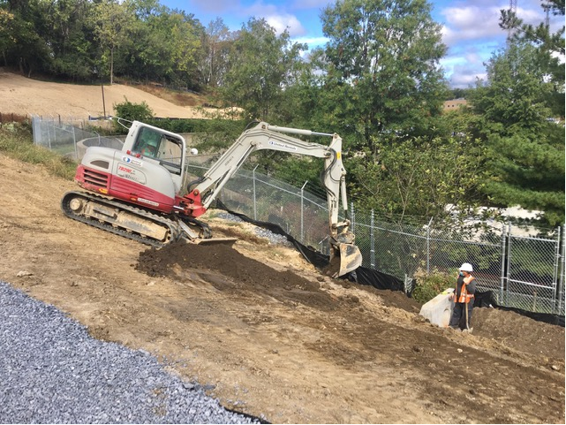
Phase D – Crew grading slope along the trail path

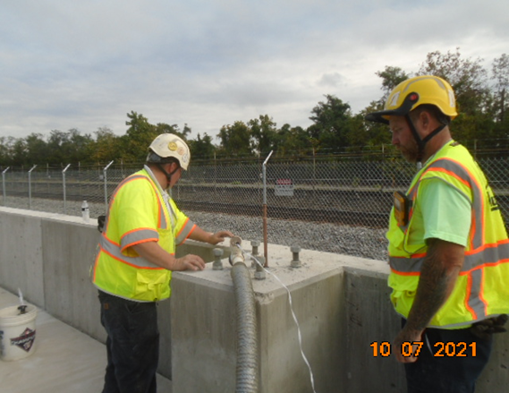
Phase D – Crew installing lightpole ground rod for light pole

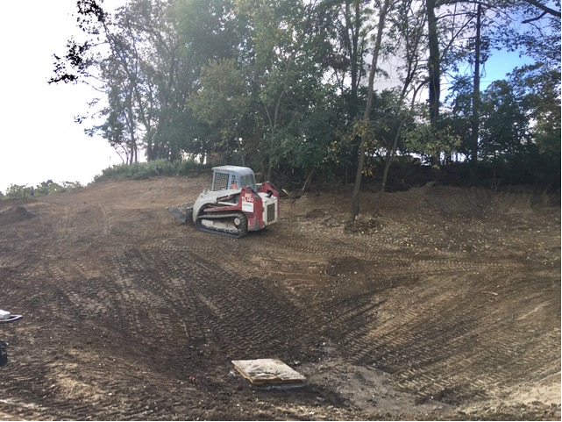
Phase D – Crew grading embankment slope area

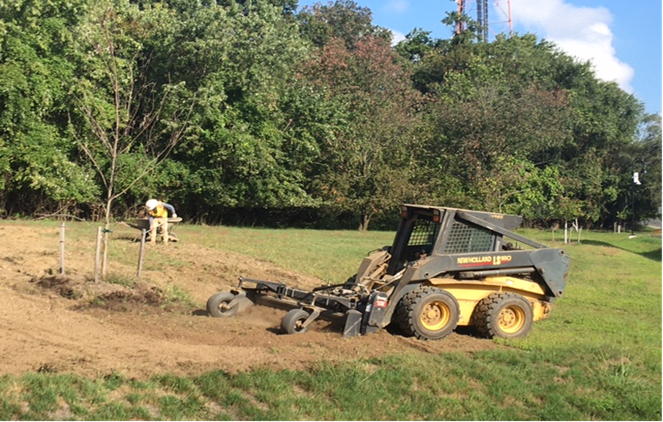
Phase B – Crew tilting soil at north side of the trail

