Metropolitan Branch Trail Design Build, South Segment
DC CONTRACT NO. DCKA-2016-C-0044
FAP No.: STP-2016 (060)

CONSTRUCTION MANAGER’S
WEEKLY PROGRESS REPORT

09/27/2020 – 10/03/2020

Project Website: www.metbranchtrail-forttotten.com
For Additional Trail Information Please see www.metbranchtrail.com

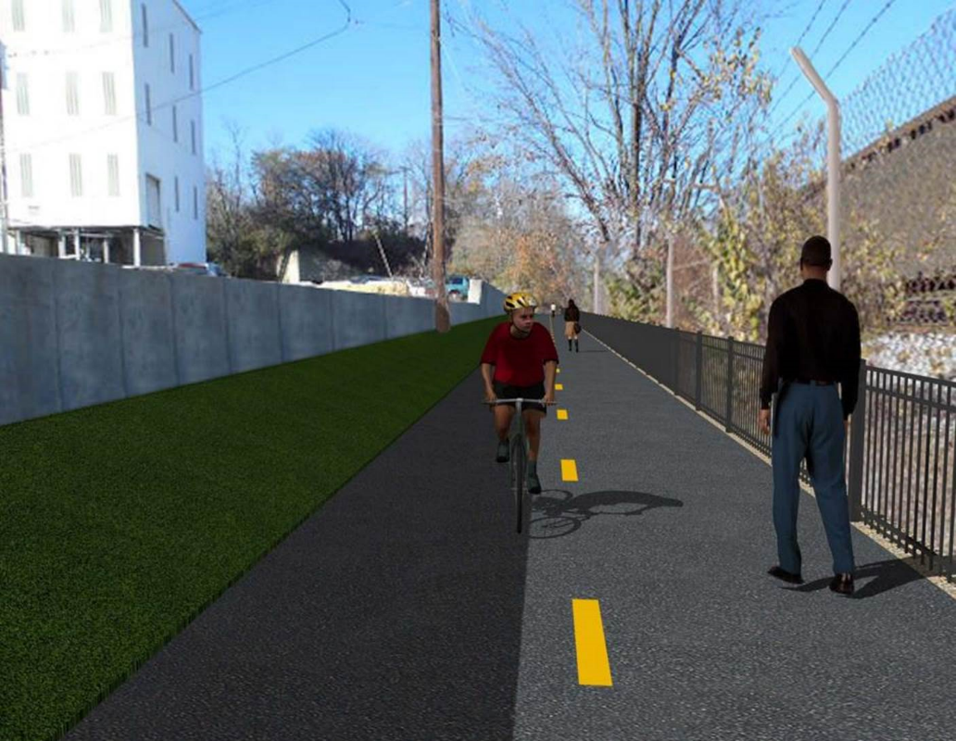

Proposed Metropolitan Branch Trail

1. PROJECT DESCRIPTION

The planned Metropolitan Branch Trail Project (“the Project”) consists of the design and construction of a new trail adjacent to CSX tracks and WMATA Red Line tracks along John McCormack Drive, adjacent to Fort Totten Metro Station, and on NPS property in NE, Washington D.C. The trail begins approximately 1500 feet south of Bates Road NE on the east side of John McCormack Drive NE, extending north along the WMATA and CSX tracks to the Fort Totten Metro Station tie in with First Place NE. An existing trail connection from Gallatin Road NE to the Fort Totten Metro Station will be reconstructed as a part of the Project.

The Project is 83.15% Federally-Funded and 16.85% District-Funded. Potomac Construction is the Design Build contractor.

Delon Hampton and Associates Chartered is providing Construction Management and Inspection services. Specific Construction Scope of Work includes:

- Provide mobilization and demobilization, provision and maintenance of Engineer’s field facilities, field layout, employee training, and other incidental work required for a quality, complete and finished product;
- Establishment and maintenance of vehicular and pedestrian traffic including signs, barricades and other transition devices; reconfiguring the devices in conjunction with changes in work areas; and their removal and disposal upon project completion, including restoration of disturbed areas;
- Clearing and grubbing, as required within the LOD;
- Removal of unsuitable material, excavation, and backfilling and pervious paving to construct a new trail;
- Protection of trees during construction;
- Provide ADA compliant trail connections and pedestrian ramps;
- Provide retaining walls as necessary to stay within the LOD and minimize property impacts following visual requirements specified for retaining walls on NPS property;
- Provide new permanent regulatory and wayfinding signs for the trail and all trail connection intersections;
- Provide road and trail pavement markings;
- Provide landscaping within the LOD for the Project including special requirements for landscaping on NPS property;
- Provide erosion and sediment control measures, storm water management facilities, including pervious asphalt pavement and bioretention facilities;
- Provide utility coordination, identification, locating, and protection of all utilities encountered during design and construction including relocation of Pepco poles along Aggregate Industries property; and
- Provide new WMATA security fencing between the trail and CSXT tracks.
- Remove existing sidewalk and widen sidewalk to 10’ along the west side of 1st place NE from Metropolitan Branch Trail to entrance to WMATA bus loop, on the west side.

2. STATUS OF CONSTRUCTION / PROGRESS SUMMARY

Work performed this week:

Design

- MBT Designer submitted Phase D 3-ring binder and 100% Plans to DDOT
- Stakeholders acceptance for Phase D Final Design Plans
- CSX is reviewing Phase D Means and Methods

Construction:

Phase B

- Restored disturbed area along the North side of the trail
- Regraded disturbed area
- Applied topsoil, seed and straw Fine graded trail trench
- Delivered Bioswale plants
- Planted Bioswale plants

Phase D

- Installed retaining wall footings formwork and rebars
- Placed retaining wall footings concrete
- Excavated drainage trench
- Installed and backfilled drainage pipes
- Constructed manhole base formwork
- Installed manhole base rebars
- Placed manhole base concrete
- Demolished existing concrete ditch
- CSX flagger’s operation and safety tool box talk

CM Consultant:

- Monitored construction progress, make sure all applicable inspections and testing were
Performed
- Attended MBT Progress Meeting conference call
- Attended QAQC Meeting conference call
- Reviewed Inspection Daily Reports
- Prepared CM Weekly Reports
- Updated Project Files
- Update Project Webpage
- Updated documents in SharePoint
- Communication with the stakeholder in terms of submittals

3. MEETINGS / PROJECT COORDINATION

Tue 09/29/20 MBT Progress Meeting conference call was held at 10:00 A.M.
Fri 10/02/20 QAQC Meeting conference call was held at 10:00 A.M.

4. DAILY WORK PERFORMED

Sun 09/27/20 No work performed.
Mon 09/28/20 Phase B – Regraded disturbed area, applied topsoil, seeded and placed
straw along the North side of the trail.
Phase B – No Electrical work scheduled
Phase D – Installed retaining wall footings rebars. Excavated drainage trench, placed drainage pipes bedding material. Installed drainage pipes. Compacted and backfilled drainage pipes trench. Installed temporary drainage pipes and tied into the installed drainage pipes.
Tue 09/29/20 Phase B – Regraded disturbed area, applied topsoil, seeded and placed
straw along the North side of the trail.
Electrical Work – Electrical work – No work scheduled
Phase D – Demolished existing concrete ditch. Installed retaining wall rebars. Excavated a drainage trench, placed drainage pipes bedding material. Installed drainage pipes. Compacted and backfilled drainage trench. Installed temporary drainage pipes and tied into the installed drainage pipe. Placed bedding stone for manhole base. Constructed manhole base formwork.
Wed 09/30/20 Phase B – Delivered Bioswale plants and stored them on site.
Core drilled surface and base asphalt samples. Patched cores with geofabric and approved asphalt mix.
Phase B - Electrical Work – No work scheduled.
Phase D – Demolished and removed existing concrete ditch. Installed retaining wall footings rebars. Installed perforated underdrain pipe along retaining wall. Pre-assembled manhole rebars. Installed formwork for manhole base.
Thurs 10/01/20 Phase B – Regraded disturbed area, applied topsoil, seeded and placed
straw along the North side of the trail. Planted Bioswale plants.
Phase B – Electrical – Disconnect and removed NPS solar lights.
Phase D – Placed retaining wall footing concrete. Poured concrete at manhole base.
Fri 10/02/20 Phase B – Graded slope area, applied topsoil, seeded and placed
straw along the North side of the trail.
Phase B – Electrical – Electric crew picked up NPS light poles
Phase D – Install retaining wall formwork. Install retaining wall rebars. Excavate drainage pipes trench. Place bedding materials for drainage pipes. Install drainage pipes and backfill drainage trench. Construct manhole base. Demolished existing concrete. Cleaned retaining wall area.
Sat 10/03/20 No work scheduled

5. INSPECTION & MATERIAL TESTS PERFORMED

Jobsite Safety Inspection  Erosion and Sediment Control inspection  MOT Inspection  Compaction Test  Asphalt Material Testing  Concrete Material Testing – Pending results  ** Note - Additional Material Test Results can be found on DDOT QA QC Material Division Tracking SharePoint website. | Infiltration Tests – Pending results  Dynamic Cone Penetration (DCP) Tests  Rebars Inspection - Passed
6. DBE PARTICIPATION SUMMARIES

Potomac Construction (Contractor)
- DBE Goal for Contractor is 15%. To-date the Contractor has achieved 40% of their goal.

Delon Hampton & Associates (CM)
- DBE Goal for the CM is 10%. To-date the CM has achieved 18% of their Goal.

7. ACCIDENTS / INCIDENTS

None occurred on-site during this week.

8. PHOTOS OF THE WORK PERFORMED

12. PHOTOS OF WORK PERFORMED THIS PERIOD

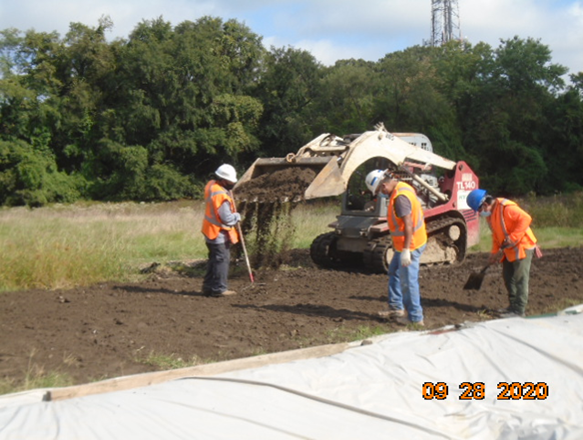
Phase B – Crew applying topsoil along the North side of the trail

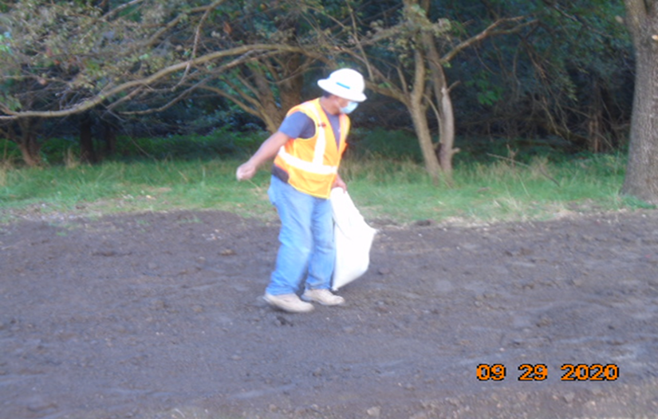
Phase B – Crew seeding the regraded area along the North side of the trail

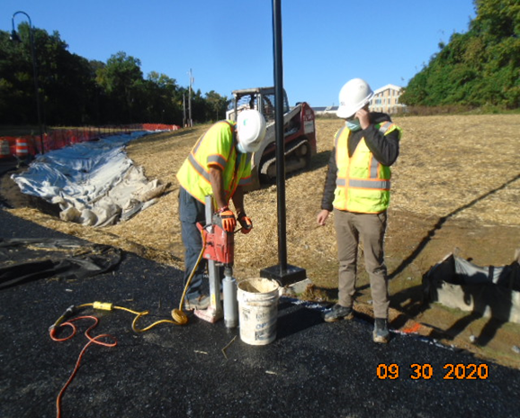
Phase B – Crew core drilling asphalt samples

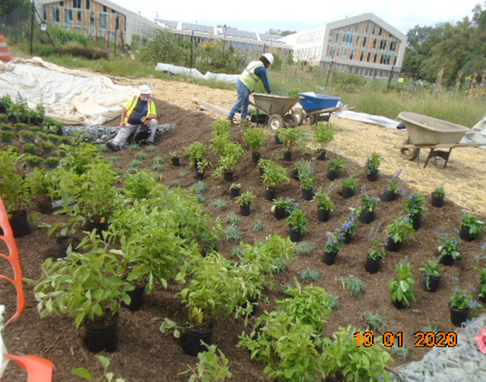
Phase B – Crew planting Bioswale trees

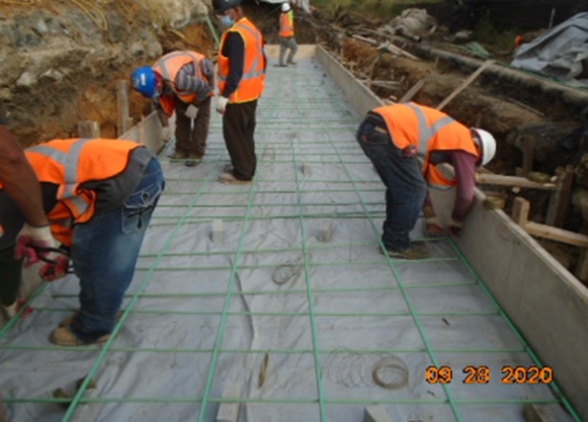
Phase D – Crew installing retaining wall footing rebars

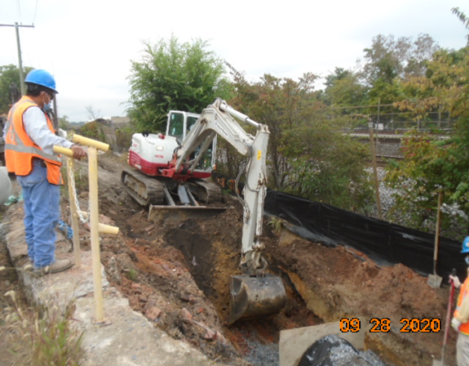
Phase D – Crew excavating drainage pipes trench
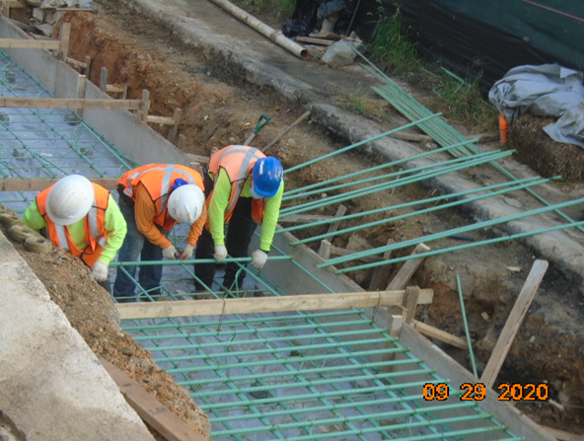
Phase B – Crew installing retaining wall footing rebars

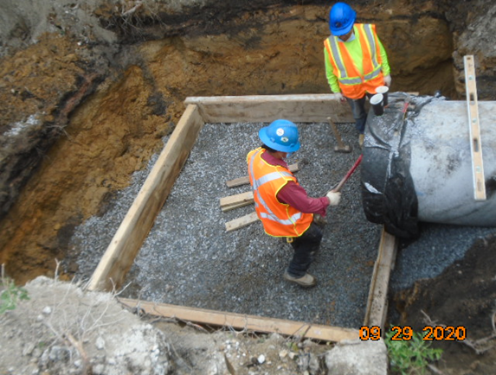
Phase D – Crew constructing manhole base formwork
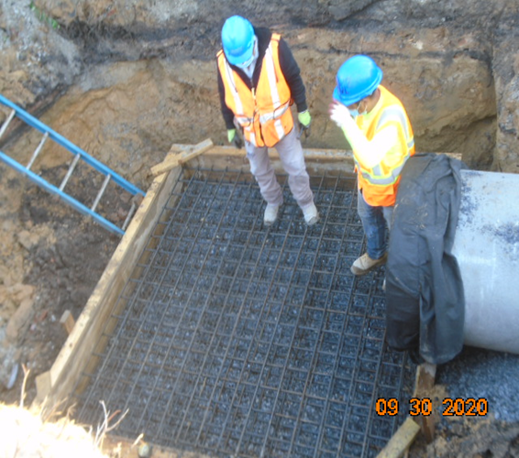
Phase D – Crew installing manhole base rebars

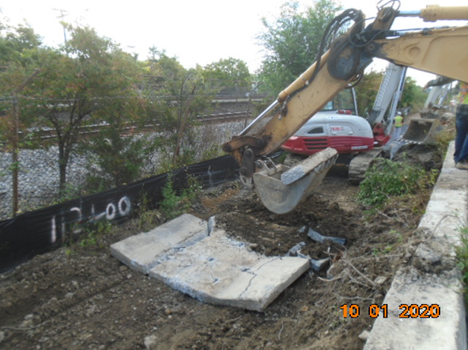
Phase D – Crew demolishing existing concrete ditch

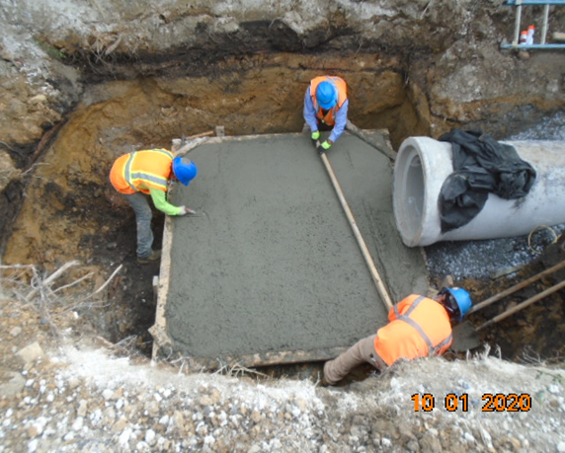
Phase D – Crew placing concrete at manhole base

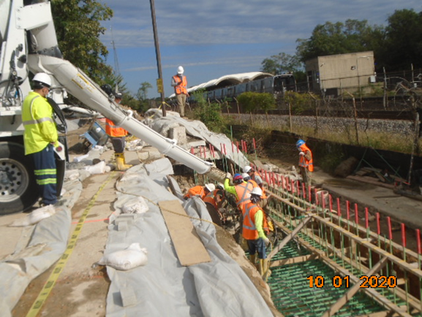
Phase D – Crew placing retaining wall footing concrete

