Metropolitan Branch Trail Design Build, South Segment
DC CONTRACT NO. DCKA-2016-C-0044
FAP No.: STP-2016 (060)

CONSTRUCTION MANAGER’S
WEEKLY PROGRESS REPORT

09/26/2021 – 10/02/2021

Project Website: www.metbranchtrail-forttotten.com
For Additional Trail Information Please see www.metbranchtrail.com
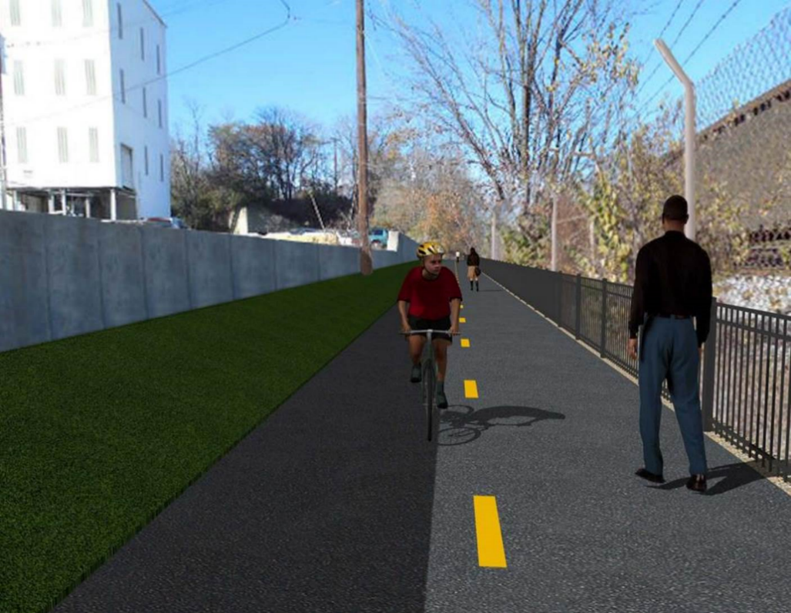

Proposed Metropolitan Branch Trail

1. PROJECT DESCRIPTION

The planned Metropolitan Branch Trail Project (“the Project”) consists of the design and construction of a new trail adjacent to CSX tracks and WMATA Red Line tracks along John McCormack Drive, adjacent to Fort Totten Metro Station, and on NPS property in NE, Washington D.C. The trail begins approximately 1500 feet south of Bates Road NE on the east side of John McCormack Drive NE, extending north along the WMATA and CSX tracks to the Fort Totten Metro Station tie in with First Place NE. An existing trail connection from Gallatin Road NE to the Fort Totten Metro Station will be reconstructed as a part of the Project.

The Project is 83.15% Federally-Funded and 16.85% District-Funded. Potomac Construction is the Design Build contractor.

Delon Hampton and Associates Chartered is providing Construction Management and Inspection services. Specific Construction Scope of Work includes:

- Provide mobilization and demobilization, provision and maintenance of Engineer’s field facilities, field layout, employee training, and other incidental work required for a quality, complete and finished product;
- Establishment and maintenance of vehicular and pedestrian traffic including signs, barricades and other transition devices; reconfiguring the devices in conjunction with changes in work areas; and their removal and disposal upon project completion, including restoration of disturbed areas;
- Clearing and grubbing, as required within the LOD;
- Removal of unsuitable material, excavation, and backfilling and pervious paving to construct a new trail;
- Protection of trees during construction;
- Provide ADA compliant trail connections and pedestrian ramps;
- Provide retaining walls as necessary to stay within the LOD and minimize property impacts following visual requirements specified for retaining walls on NPS property;
- Provide new permanent regulatory and wayfinding signs for the trail and all trail connection intersections;
- Provide road and trail pavement markings;
- Provide landscaping within the LOD for the Project including special requirements for landscaping on NPS property;
- Provide erosion and sediment control measures, storm water management facilities, including pervious asphalt pavement and bioretention facilities;
- Provide utility coordination, identification, locating, and protection of all utilities encountered during design and construction including relocation of Pepco poles along Aggregate Industries property; and
- Provide new WMATA security fencing between the trail and CSXT tracks.
- Remove existing sidewalk and widen sidewalk to 10’ along the west side of 1st place NE from Metropolitan Branch Trail to entrance to WMATA bus loop, on the west side.

2. STATUS OF CONSTRUCTION / PROGRESS SUMMARY

Work performed this week:

Design

- 100 % Complete

Construction:

Phase D

- Drilled dowels through the exiting concrete pavement
- Placed concrete for concrete pavement
- Constructed retaining wall S3 formwork
- Installed retaining wall S3 wall section rebar
- Performed excavation in front of retaining wall S3 for bedding pad
- Place bedding stone at retaining wall S3 footing
- Installed retaining wall S3 drainage pipes
- Excavated and graded the trail subgrade
- Compacted the trail subgrade
- Installed underdrain at the trail
- Installed geotextile fabric at the trail
- Placed and graded the trail bedding stone
- Pulled conductors for the electrical manholes
- Spliced conductors in the electrical manhole
- Installed security cameras
- Repaired silt fence site wide
- Performed site clean up
- Contractor safety tool box talk

CM Consultant:

- Monitored construction progress, make sure all applicable inspections and testing were performed
- Reviewed PCCI Monthly Pay Estimate
- Reviewed Project Schedule
- Prepared CM Weekly Report to post
- Prepared CM weekly report to DDOT
- Updated Project Files
- Updated Project Logs
- Updated Project Webpage
- Updated documents in DHA SharePoint site
- Updated DDOT Sharepoint site
- Communication with PCCI and stakeholders in terms of submittals

3. MEETINGS / PROJECT COORDINATION

10/28/21 Tue MBT Progress Meeting conference call was held at 10:00 A.M.

4. DAILY WORK PERFORMED

Sun 09/26/21 No work performed.
Mon 09/27/21 Phase D – Drilled dowels through existing concrete pavement. Pavement Install retaining wall S3 wall section rebar. Excavated the trail path. Placed
and graded the trail bedding stone. Installed geotextile fabric at the trail. Installed perforated underdrain at the trail path.
Phase D – Electrical work – Pulled conductors for the electrical manholes. Spliced electrical wires in the electrical manhole. Installed security cameras.
Tue 09/28/21 Phase D – Placed concrete Installed retaining wall S3 wall section rebar.
Placed concrete for parking lot pavement behind S0 wall. Excavated and graded the trail subgrade. Placed and graded the trail bedding stone. Installed geotextile fabric at the trail path. Installed underdrain.
Phase D – Electrical work – Spliced electrical wires in the electrical manhole. Installed security cameras.
Wed 09/29/21 Phase D – Installed rebars for S3 wall section. Constructed retaining wall S3 formwork. Performed excavation in front of retaining wall S3 bedding pad. Placed No 57 stone for S3 wall bedding pad. Excavated and graded the trail path. Installed under drain pipe at the trail. Install geotextile fabric at the trail. Placed and graded bedding stone at the trail.
Phase D – Electrical Work – No work performed.
Thurs 09/30/21 Phase D – Installed rebars for S3 wall section. Constructed retaining wall S3 formwork. Performed excavation in front of retaining wall S3 bedding pad. Placed No 57 stone for S3 wall bedding pad. Excavated and graded trail subgrade. Installed under drain pipe at the trail. Install geotextile fabric at the trail. Placed and graded bedding stone at the trail.
Phase D – Electrical Work – Pull conductors for the electrical manholes.
Fri 10/01/21 Phase D – Installed retaining wall S3 rebar. Constructed retaining wall S3 formwork. Performed excavation in front of retaining wall S3 bedding pad. Placed No 57 stone for S3 wall bedding pad. Excavated and graded trail subgrade. Installed under drain pipe at the trail. Install geotextile fabric at the trail. Placed and graded bedding stone at the trail. Performed clearing and grubbing at embankment sloped area behind S2 Wall.
Phase D – Electrical Work – Spliced conductors for electrical manholes.
Sat 10/02/21 Phase D – Constructed retaining wall S3 formwork. Installed retaining wall S3 rebar.

5. INSPECTION & MATERIAL TESTS PERFORMED

Jobsite Safety Inspection  Erosion and Sediment Control inspection  MOT Inspection  Compaction Test - Passed  Asphalt Material Testing – Pending results  Concrete Material Testing – Pending results  ** Note - Additional Material Test Results can be found on DDOT QA QC Material Division Tracking SharePoint website. | Infiltration Tests - Passed  Dynamic Cone Penetration (DCP) Tests  Rebars Inspection – Ongoing
6. DBE PARTICIPATION SUMMARIES

Potomac Construction (Contractor)

- DBE Goal for Contractor is 15%. To-date the Contractor has achieved 54.4% of their goal.

Delon Hampton & Associates (CM)

- DBE Goal for the CM is 10%. To-date the CM has achieved 96.6% of their Goal.

7. ACCIDENTS / INCIDENTS

None occurred on-site during this week.

8. PHOTOS OF THE WORK PERFORMED

12. PHOTOS OF WORK PERFORMED THIS PERIOD

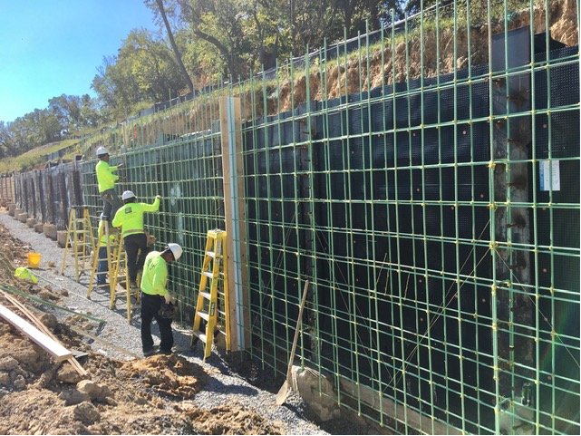
Phase D – Crew tying retaining wall S3 rebar

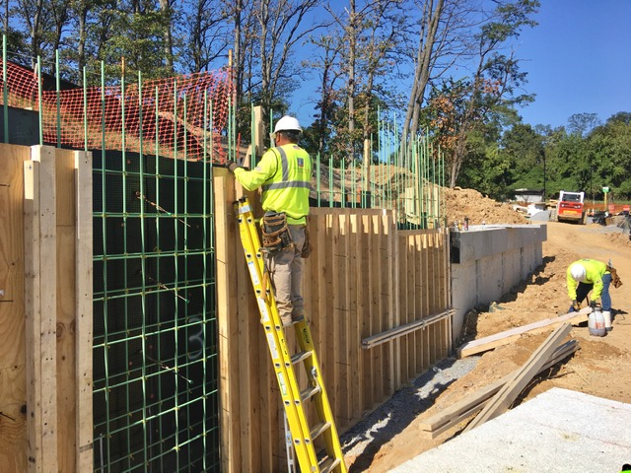
Phase D – Crew constructing retaining wall S3 formwork

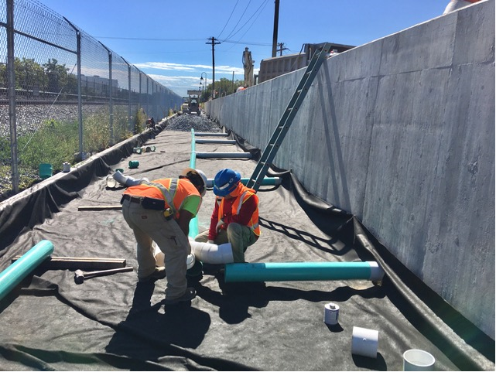
Phase D – Crew installing underdrain pipe in front of S1 wall

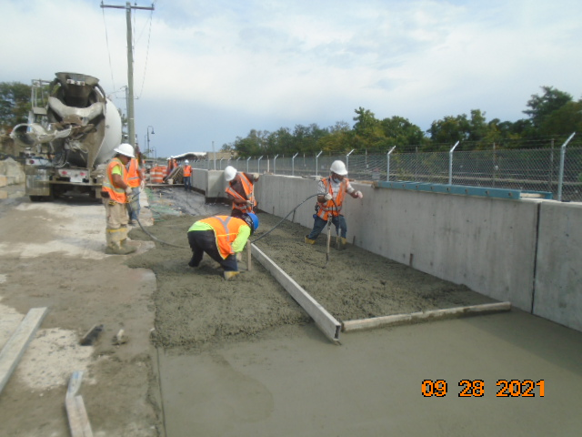
Phase D – Concrete pavement placement at Aggregate Industries parking lot

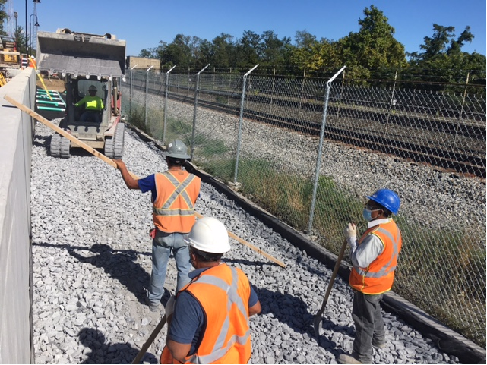
Phase D – Crew placing and grading stone at the trail path

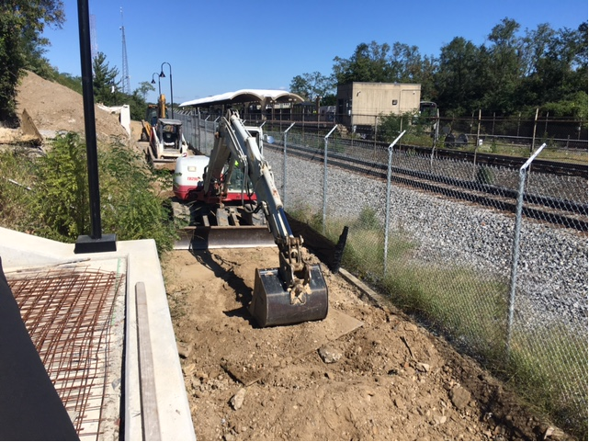
Phase D – Crew excavating the trail path

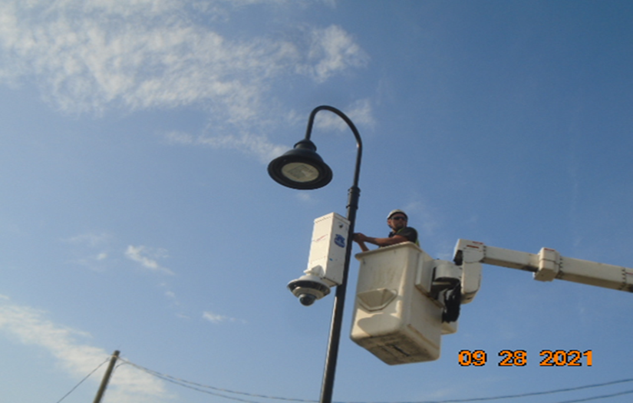
Phase D – Crew installing security camera

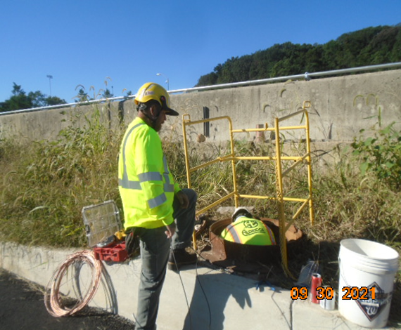
Phase D – Electrical crew splicing cables inside electrical manhole

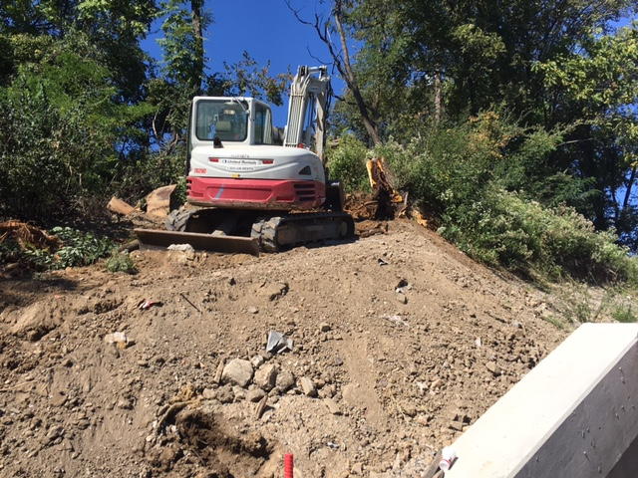
Phase D – Crew clearing trees from embanked behind S2 wall

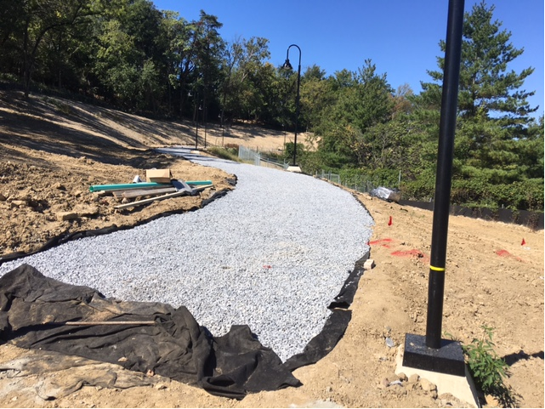
Phase D – Trail bedding stone placed and graded

