Metropolitan Branch Trail Design Build, South Segment
DC CONTRACT NO. DCKA-2016-C-0044
FAP No.: STP-2016 (060)

CONSTRUCTION MANAGER’S
WEEKLY PROGRESS REPORT

09/20/2020 – 09/26/2020

Project Website: www.metbranchtrail-forttotten.com
For Additional Trail Information Please see www.metbranchtrail.com

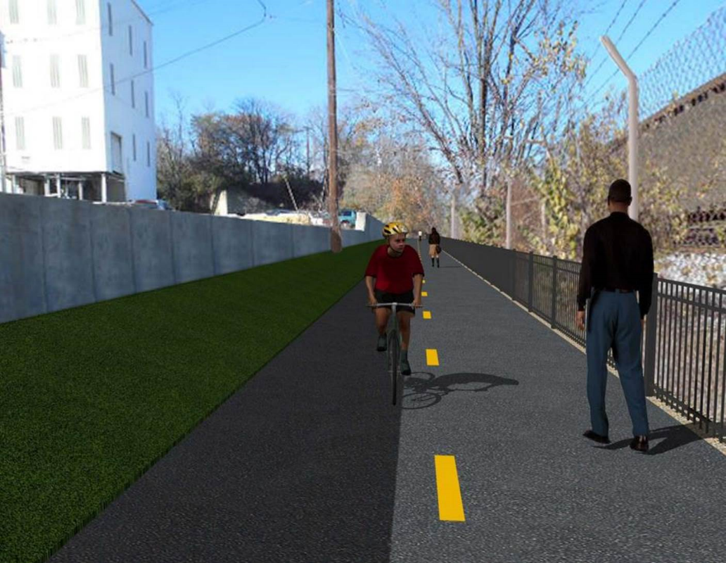

Proposed Metropolitan Branch Trail

1. PROJECT DESCRIPTION

The planned Metropolitan Branch Trail Project (“the Project”) consists of the design and construction of a new trail adjacent to CSX tracks and WMATA Red Line tracks along John McCormack Drive, adjacent to Fort Totten Metro Station, and on NPS property in NE, Washington D.C. The trail begins approximately 1500 feet south of Bates Road NE on the east side of John McCormack Drive NE, extending north along the WMATA and CSX tracks to the Fort Totten Metro Station tie in with First Place NE. An existing trail connection from Gallatin Road NE to the Fort Totten Metro Station will be reconstructed as a part of the Project.

The Project is 83.15% Federally-Funded and 16.85% District-Funded. Potomac Construction is the Design Build contractor.

Delon Hampton and Associates Chartered is providing Construction Management and Inspection services. Specific Construction Scope of Work includes:

- Provide mobilization and demobilization, provision and maintenance of Engineer’s field facilities, field layout, employee training, and other incidental work required for a quality, complete and finished product;
- Establishment and maintenance of vehicular and pedestrian traffic including signs, barricades and other transition devices; reconfiguring the devices in conjunction with changes in work areas; and their removal and disposal upon project completion, including restoration of disturbed areas;
- Clearing and grubbing, as required within the LOD;
- Removal of unsuitable material, excavation, and backfilling and pervious paving to construct a new trail;
- Protection of trees during construction;
- Provide ADA compliant trail connections and pedestrian ramps;
- Provide retaining walls as necessary to stay within the LOD and minimize property impacts following visual requirements specified for retaining walls on NPS property;
- Provide new permanent regulatory and wayfinding signs for the trail and all trail connection intersections;
- Provide road and trail pavement markings;
- Provide landscaping within the LOD for the Project including special requirements for landscaping on NPS property;
- Provide erosion and sediment control measures, storm water management facilities, including pervious asphalt pavement and bioretention facilities;
- Provide utility coordination, identification, locating, and protection of all utilities encountered during design and construction including relocation of Pepco poles along Aggregate Industries property; and
- Provide new WMATA security fencing between the trail and CSXT tracks.
- Remove existing sidewalk and widen sidewalk to 10’ along the west side of 1st place NE from Metropolitan Branch Trail to entrance to WMATA bus loop, on the west side.

2. STATUS OF CONSTRUCTION / PROGRESS SUMMARY

Work performed this week:

Design

- MBT Designer submitted Phase D 3-ring binder and 100% Plans to DDOT
- Stakeholders acceptance for Phase D Final Design Plans
- CSX is reviewing Phase D Means and Methods

Construction:

Phase B

- Excavated trail trench.
- Placed stone at the trail
- Fine graded trail trench
- Placed geotextile fabric
- Installed perforated under drain
- Placed base and surface asphalt over the trail
- Removed NPS solar light panel poles

Phase D

- Placed retaining wall concrete
- Stripped retaining wall formwork
- Excavated retaining wall footings
- Installed retaining wall footing forms
- Installed retaining wall rebars
- Demolished and removed existing concrete slab
- Installed and backfilled drainage pipes
- Demolished and removed existing concrete ditch
- Demolished and removed existing concrete slab
- Hauled away excavated materials from the site
- CSX flagger’s operation and safety tool box talk

CM Consultant:

- Monitored construction progress, make sure all applicable inspections and testing were
Performed
- Attended QAQC Meeting conference call
- Reviewed Inspection Daily Reports
- Prepared CM Weekly Reports
- Updated Project Files
- Update Project Webpage
- Updated documents in SharePoint
- Communication with the stakeholder in terms of submittals

3. MEETINGS / PROJECT COORDINATION

Fri 09/26/20 QAQC Meeting conference call was held at 10:00 A.M.

4. DAILY WORK PERFORMED

Sun 09/21/20 No work performed.
Mon 09/21/20 Phase B – Excavated trail trench. Leveled to fine grade trail trench.
Placed geotextile fabric, installed perforated under drain and placed
stone. Crew covered trail with plastic. Applied and graded mulch over the Bioswale.
Phase B – No Electrical work scheduled
Phase D – Placed retaining wall concrete. Excavated a trench, placed drainage pipes bedding material. Installed drainage pipes. Compacted and backfilled drainage pipes trench.
Tue 09/22/20 Phase B – Excavated trail trench. Leveled to fine grade trail trench.
Placed geotextile fabric. Installed perforated under drain pipe and placed
stone.
Electrical Work – Electrical work – No work scheduled
Phase D – Demolished existing concrete and existing concrete ditch. Performed wet curing of retaining wall concrete. Purged retaining wall face. Applied water proofing paint over the inner face of retaining wall. Excavated a trench, placed drainage pipes bedding material. Installed drainage pipes. Compacted and backfilled drainage pipes trench.
Wed 09/23/20 Phase B – Placed stone and fine graded trail.
Phase B - Electrical Work – No work scheduled.
Phase D – Demolished and removed existing concrete slab located inside AI property. Placed bedding stone at retaining wall footing. Installed drainage pipes. Compacted and backfilled drainage pipes trench. Installed drainage pipes. Compacted and backfilled drainage pipes trench.
Installed temporary drainage pipes.
Thurs 09/24/20 Phase B – Placed base and surface asphalt at the trail. Removed
temporary asphalt inside the core holes and patched with mix porous asphalt.
Phase B – Electrical – Disconnect and removed NPS solar lights.
Phase D – Stripped retaining wall forms. Placed bedding stone at retaining wall footings. Cleaned the area around retaining wall. Compacted and backfilled drainage pipes trench. Installed temporary drainage pipes.
Fri 09/25/20 Phase B – Performed site cleanup. Performed infiltration tests.
Phase B – Electrical – Electric crew picked up NPS light poles
Phase D – Install retaining wall footings forms. Install retaining wall footings rebars. Installed drainage pipes. Compacted and backfilled drainage pipes trench. Installed drainage pipes. Compacted and backfilled drainage pipes trench.
Sat 09/27/20 No work scheduled

5. INSPECTION & MATERIAL TESTS PERFORMED

Jobsite Safety Inspection  Erosion and Sediment Control inspection  MOT Inspection  Compaction Test - Passed  Asphalt Material Testing – Pending results  Concrete Material Testing – Pending results  ** Note - Additional Material Test Results can be found on DDOT QA QC Material Division Tracking SharePoint website. | Infiltration Tests – Pending results  Dynamic Cone Penetration (DCP) Tests - Passed  Rebars Inspection - Passed
6. DBE PARTICIPATION SUMMARIES

Potomac Construction (Contractor)
- DBE Goal for Contractor is 15%. To-date the Contractor has achieved 40% of their goal.

Delon Hampton & Associates (CM)
- DBE Goal for the CM is 10%. To-date the CM has achieved 18% of their Goal.

7. ACCIDENTS / INCIDENTS

None occurred on-site during this week.

8. PHOTOS OF THE WORK PERFORMED

12. PHOTOS OF WORK PERFORMED THIS PERIOD

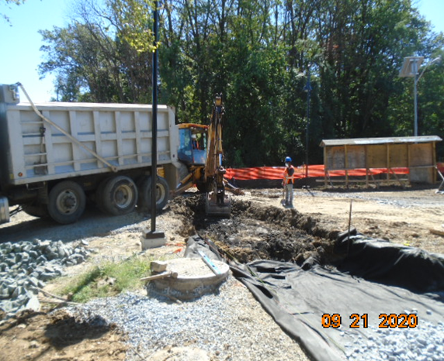
Phase B – Crew excavating trail trench

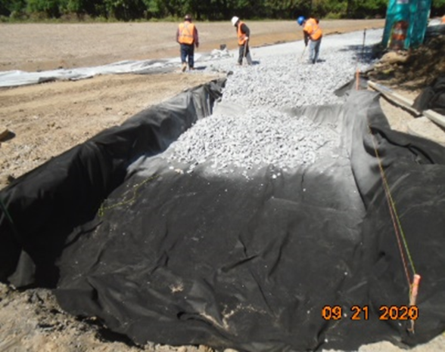
Phase B – Crew installed geotextile fabric at the trail

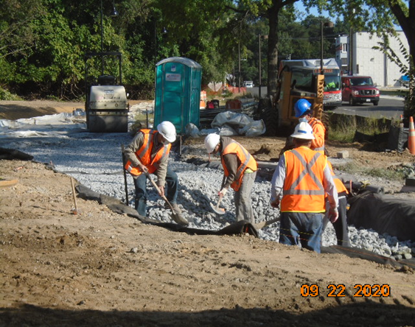
Phase D – Crew placing and grading stone at the trail

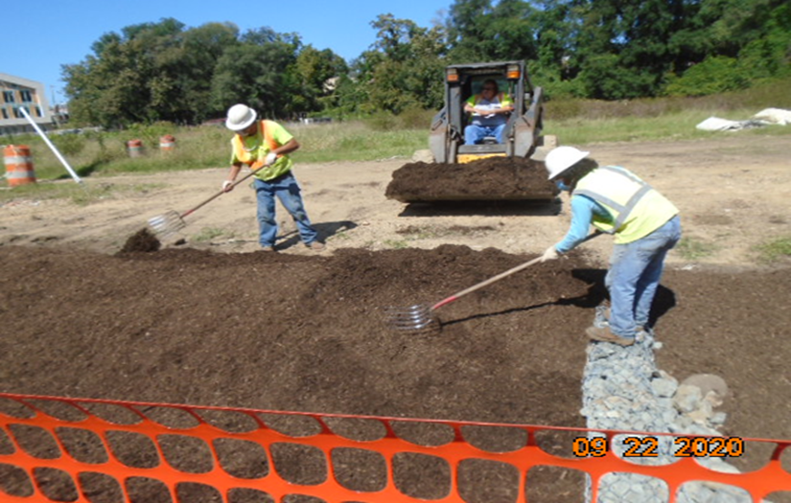
Phase B – Crew applying mulch at the Bioswale

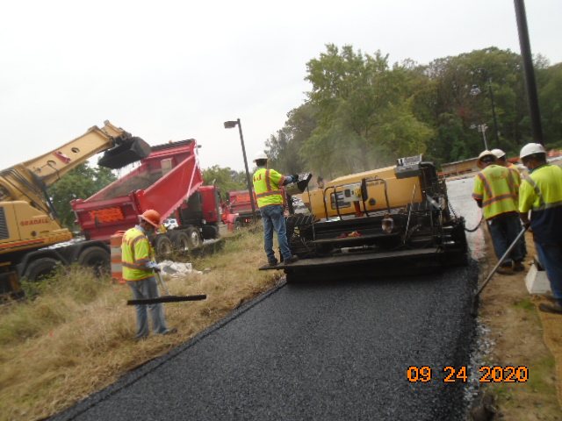
Phase B – Crew placing asphalt at the trail

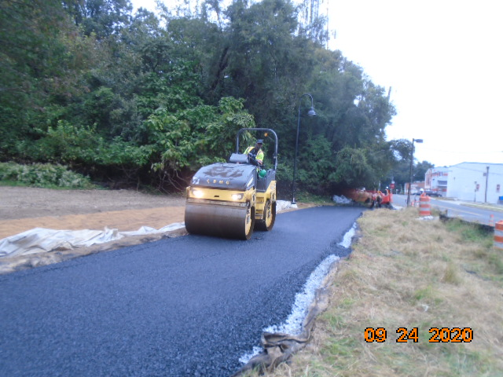
Phase B – Crew performing asphalt compaction

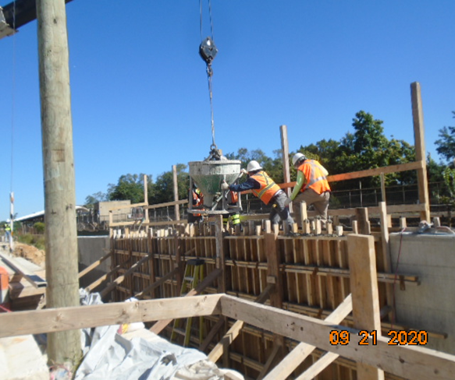
Phase D – Crew placing retaining wall concrete

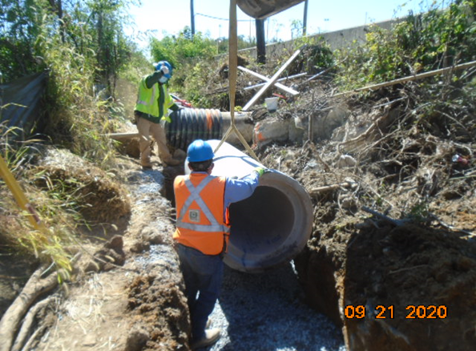
Phase D – Crew installing drainage pipes

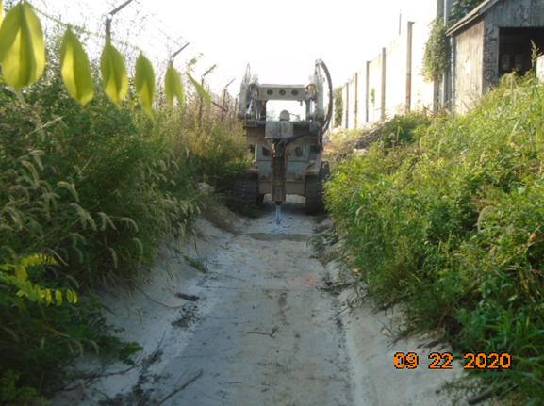
Phase D – Crew demolishing existing concrete ditch

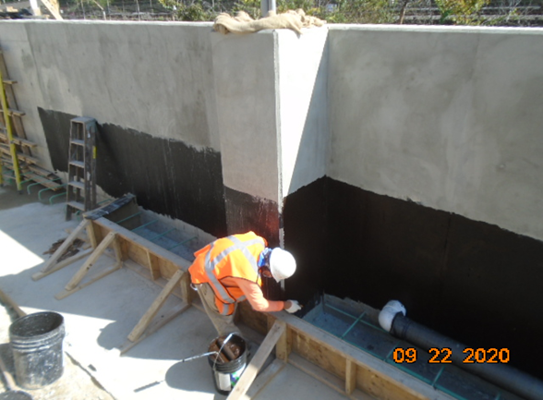
Phase D – Crew applying water proofing over retaining fall face

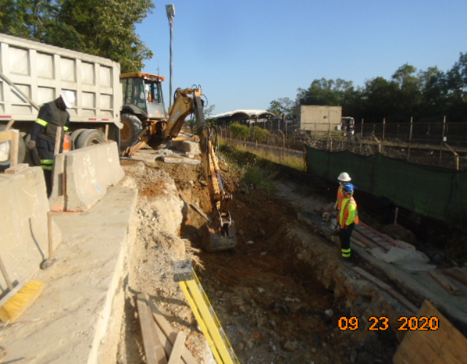
Phase D – Crew excavating retaining wall footings

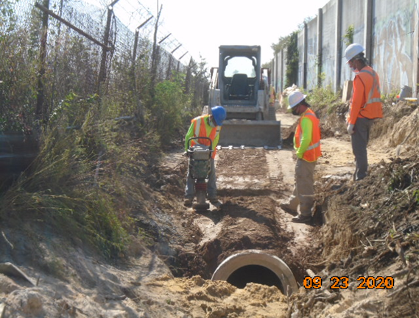
Phase D – Crew compacting drainage pipes trench

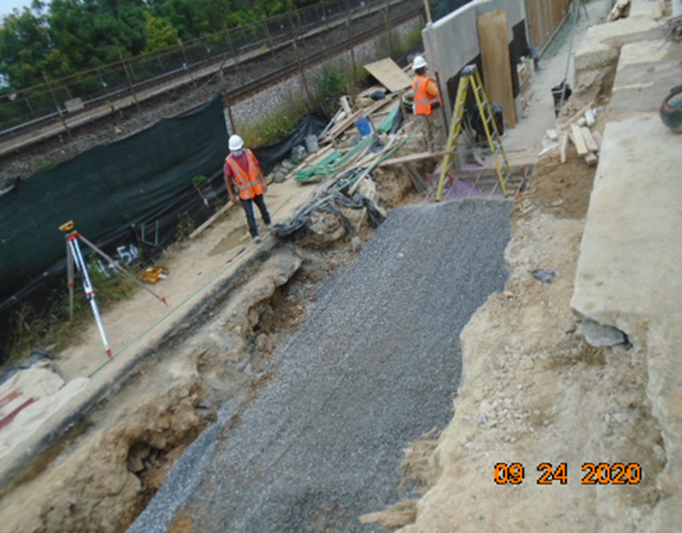
Phase D – Crew placing and grading bedding stone at retaining wall footings

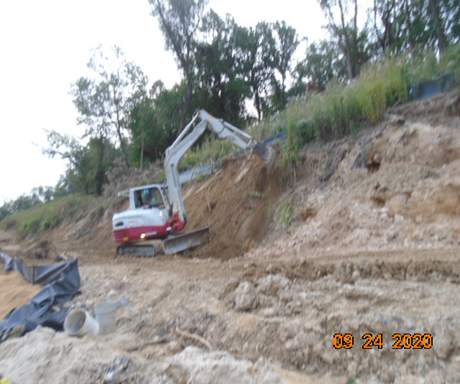
Phase D – Crew grading the slope

