Metropolitan Branch Trail Design Build, South Segment
DC CONTRACT NO. DCKA-2016-C-0044
FAP No.: STP-2016 (060)

CONSTRUCTION MANAGER’S
WEEKLY PROGRESS REPORT

09/13/2020 – 09/19/2020

Project Website: www.metbranchtrail-forttotten.com
For Additional Trail Information Please see www.metbranchtrail.com

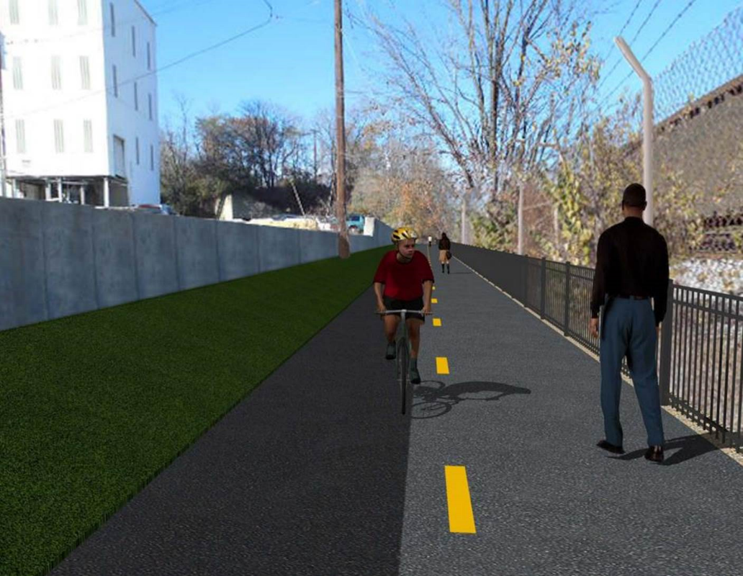

Proposed Metropolitan Branch Trail

1. PROJECT DESCRIPTION

The planned Metropolitan Branch Trail Project (“the Project”) consists of the design and construction of a new trail adjacent to CSX tracks and WMATA Red Line tracks along John McCormack Drive, adjacent to Fort Totten Metro Station, and on NPS property in NE, Washington D.C. The trail begins approximately 1500 feet south of Bates Road NE on the east side of John McCormack Drive NE, extending north along the WMATA and CSX tracks to the Fort Totten Metro Station tie in with First Place NE. An existing trail connection from Gallatin Road NE to the Fort Totten Metro Station will be reconstructed as a part of the Project.

The Project is 83.15% Federally-Funded and 16.85% District-Funded. Potomac Construction is the Design Build contractor.

Delon Hampton and Associates Chartered is providing Construction Management and Inspection services. Specific Construction Scope of Work includes:

- Provide mobilization and demobilization, provision and maintenance of Engineer’s field facilities, field layout, employee training, and other incidental work required for a quality, complete and finished product;
- Establishment and maintenance of vehicular and pedestrian traffic including signs, barricades and other transition devices; reconfiguring the devices in conjunction with changes in work areas; and their removal and disposal upon project completion, including restoration of disturbed areas;
- Clearing and grubbing, as required within the LOD;
- Removal of unsuitable material, excavation, and backfilling and pervious paving to construct a new trail;
- Protection of trees during construction;
- Provide ADA compliant trail connections and pedestrian ramps;
- Provide retaining walls as necessary to stay within the LOD and minimize property impacts following visual requirements specified for retaining walls on NPS property;
- Provide new permanent regulatory and wayfinding signs for the trail and all trail connection intersections;
- Provide road and trail pavement markings;
- Provide landscaping within the LOD for the Project including special requirements for landscaping on NPS property;
- Provide erosion and sediment control measures, storm water management facilities, including pervious asphalt pavement and bioretention facilities;
- Provide utility coordination, identification, locating, and protection of all utilities encountered during design and construction including relocation of Pepco poles along Aggregate Industries property; and
- Provide new WMATA security fencing between the trail and CSXT tracks.
- Remove existing sidewalk and widen sidewalk to 10’ along the west side of 1st place NE from Metropolitan Branch Trail to entrance to WMATA bus loop, on the west side.

2. STATUS OF CONSTRUCTION / PROGRESS SUMMARY

Work performed this week:

Design

- MBT Designer submitted Phase D 3-ring binder and 100% Plans to DDOT
- Stakeholders acceptance for Phase D Final Design Plans
- CSX is reviewing Phase D Means and Methods

Construction:

Phase B

- Removed and replaced contaminated Bioswale topsoil
- Applied bioretention and topsoil over the ditch line
- Excavated trail trench. Leveled to fine grade trail trench.
- Placed geotextile fabric.
- Installed perforated under drain and placed
- Hauled away excavated materials from site to for Phase D drainage trench backfill

Phase D

- Stripped retaining wall formwork
- Installed retaining wall formwork
- Demolished and removed existing concrete slab
- Excavated retaining wall footings
- Installed and backfilled drainage pipes
- Demolished and removed existing concrete ditch
- Installed temporary drainage pipes
- Removed temporary drainage pipes
- Installed super silt fence
- Stabilized sloped area along the trail
- Cut trees
- Hauled away excavated materials from site
- Stockpiled materials excavated from the sloped area
- Delivered drainage pipes to the site
- DOEE performed site inspection
- CSX flagger’s operation and safety tool box talk

CM Consultant:

- Monitored construction progress, make sure all applicable inspections and testing were
Performed
- Attended Project Progress Meeting conference call
- Attended QAQC Meeting conference call
- Reviewed Contractor’s Monthly Payment Invoice
- Reviewed Inspection Daily Reports
- Prepared CW weekly reports
- Updated Project Files
- Update Project Webpage
- Updated documents in SharePoint
- Communication with the stakeholder in terms of submittals

3. MEETINGS / PROJECT COORDINATION

Tue 09/15/20 MBT Progress Meeting conference call was led at 10:00A.M.
Fri 09/18/20 QAQC Meeting conference call was held at 10:00 A.M.

4. DAILY WORK PERFORMED

Sun 09/13/20 No work performed.
Mon 09/14/20 Phase B – Cleaned and replaced contaminated Bioswale top soil along
the North side of the trail.
Phase B – No Electrical work scheduled
Phase D – Excavated retaining wall footings. Stripped retaining wall formwork. Demolished and removed existing concrete slab inside Aggregate Industries property. Demolished and removed existing concrete ditch. Removed wet soil from drainage pipes trench. Backfilled and compacted drainage pipes trench. Demolished and removed existing concrete ditch. Installed temporary drainage pipes. Cut trees. Replaced super silt fence. Stabilized side slope along the slope. Cut trees.
Tue 09/15/20 Phase B – Cleaned and removed contaminated Bioswale top soil
along the north side of the trail
Electrical Work – Electrical work – No work scheduled
Phase D – Stripped retaining wall formwork. Installed retaining wall formwork. Demolished and removed existing concrete ditch. Removed wet soil from drainage pipes trench. Backfilled and compacted drainage pipes trench. Cut trees. DOEE inspector performed site inspections
Wed 09/16/20 Phase B – Cleaned and replaced contaminated Bioswale topsoil. Re-
seeded Bioswale and installed erosion control matting.
Phase B - Electrical Work – No work scheduled.
Phase D – Installed retaining wall formwork. Excavated retaining wall footings. Demolished and removed existing concrete slab located inside Aggregate Industries property. Removed temporary drainage pipes from the ditch. Backfilled and compacted the ditch. Installed super silt fence. Stabilized sloped area along the trail and stock piled excavated materials. Delivered drainage pipes to the site.
Phase D – Electrical Work – No work scheduled.
Thurs 09/17/20 Phase B – Excavated trail trench. Leveled to fine grade trail trench.
Placed geotextile fabric, installed perforated under drain and placed
stone. Crew covered trail with plastic.
Phase B – Electrical – No work scheduled.
Phase D – Installed retaining wall formwork. Installed and backfilled drainage pipes. Installed temporary drainage pipe. Installed silt fence.
Fri 09/18/20 Phase B – Excavated trail trench. Leveled to fine grade trail trench.
Placed geotextile fabric, installed perforated under drain and placed
Phase B – Electrical – No work scheduled.
Phase D – Installed and backfilled drainage pipes. Installed silt fence.
Sat 09/19/20 No work scheduled

5. INSPECTION & MATERIAL TESTS PERFORMED

Jobsite Safety Inspection  Erosion and Sediment Control inspection  MOT Inspection  Compaction Test - Passed  Asphalt Material Testing  Concrete Material Testing – Pending results  ** Note - Additional Material Test Results can be found on DDOT QA QC Material Division Tracking SharePoint website. | Infiltration Tests  Dynamic Cone Penetration (DCP) Tests  Rebars Inspection - Ongoing
6. DBE PARTICIPATION SUMMARIES

Potomac Construction (Contractor)
- DBE Goal for Contractor is 15%. To-date the Contractor has achieved 40% of their goal.

Delon Hampton & Associates (CM)
- DBE Goal for the CM is 10%. To-date the CM has achieved 18% of their Goal.

7. ACCIDENTS / INCIDENTS

None occurred on-site during this week.

8. PHOTOS OF THE WORK PERFORMED

12. PHOTOS OF WORK PERFORMED THIS PERIOD

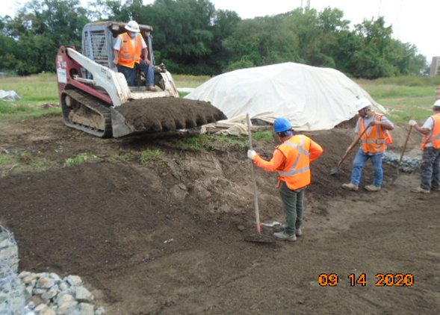
Phase D – Crew replacing Bioswale top soil

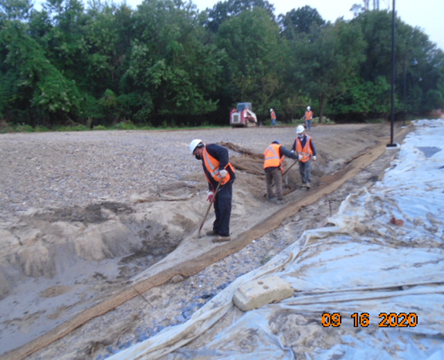
Phase B – Crew repairing Bioswale topsoil
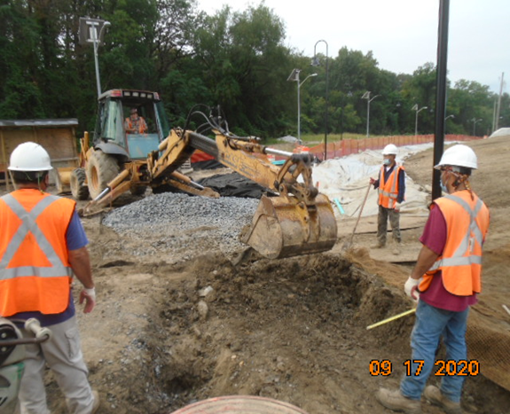
Phase B – Crew excavting trail trench

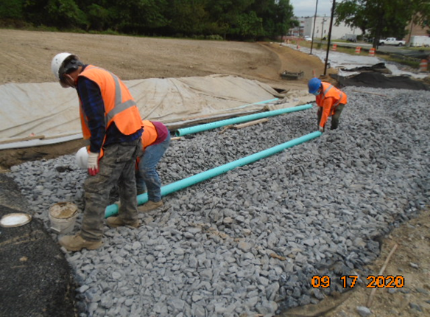
Phase B – Crew insatlling perforated under drain pipes

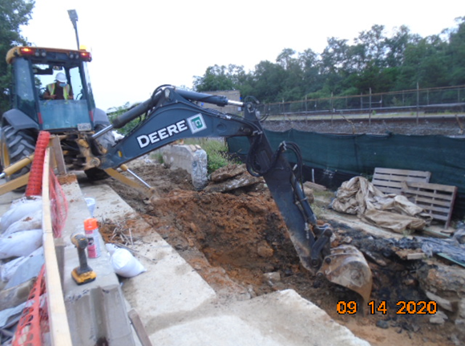
Phase D – Crew excavating retaining wall footings

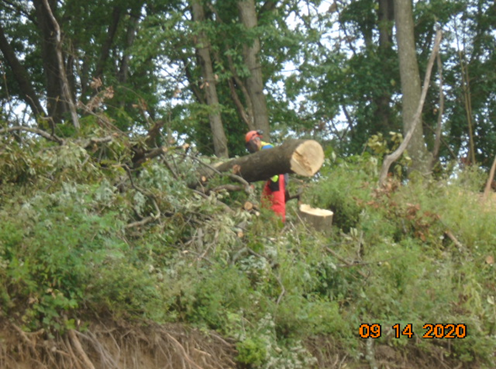
Phase D – Crew cutting trees

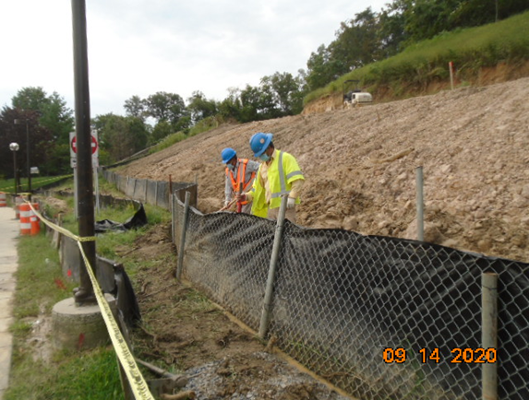
Phase D – Crew repairing super silt fence

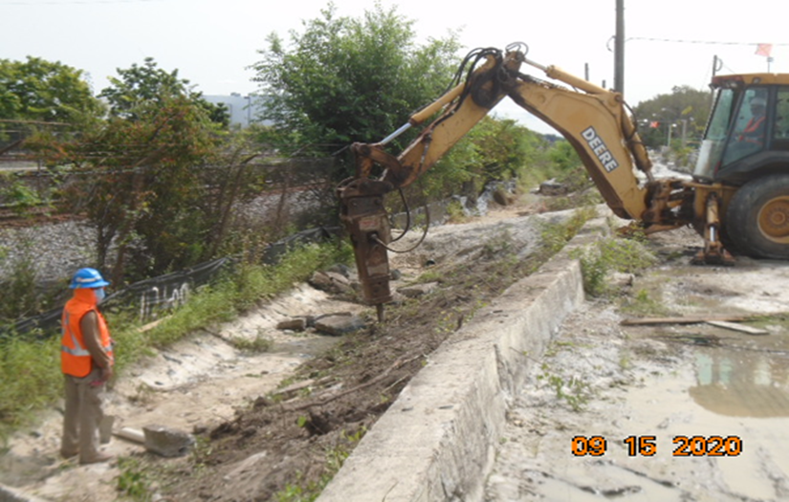
Phase D – Crew demolishing existing concrete ditch

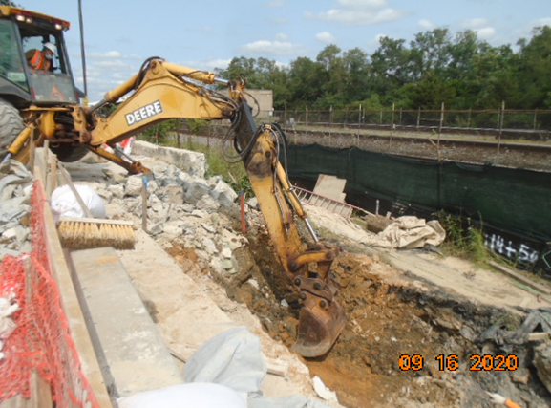
Phase D – Crew excavating retaining wall footings

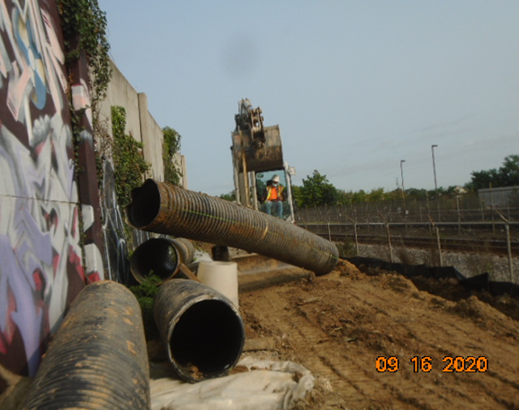
Phase D – Crew removing temporary drainage pipes
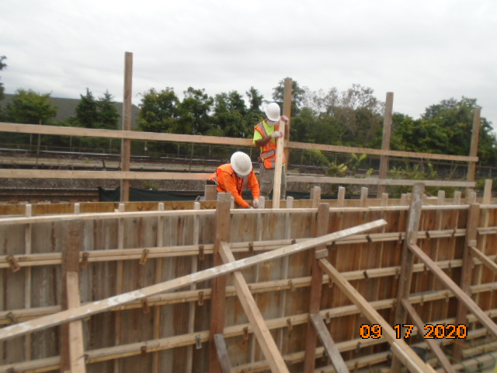
Phase D – Crew installing retaining wall formwork

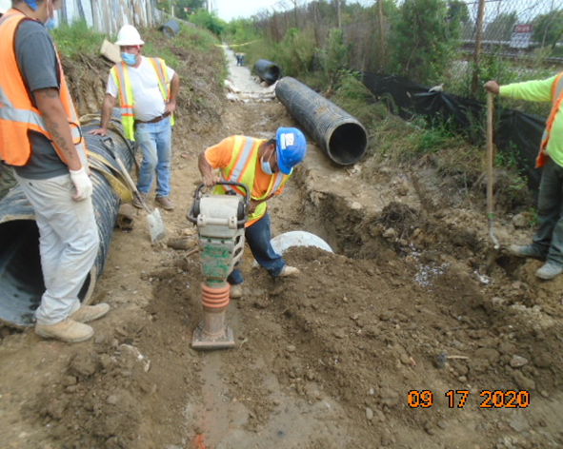
Phase D – Crew compacting drainage pipes trench

