Metropolitan Branch Trail Design Build, South Segment
DC CONTRACT NO. DCKA-2016-C-0044
FAP No.: STP-2016 (060)

CONSTRUCTION MANAGER’S
WEEKLY PROGRESS REPORT

09/06/2020 – 09/12/2020

Project Website: www.metbranchtrail-forttotten.com
For Additional Trail Information Please see www.metbranchtrail.com

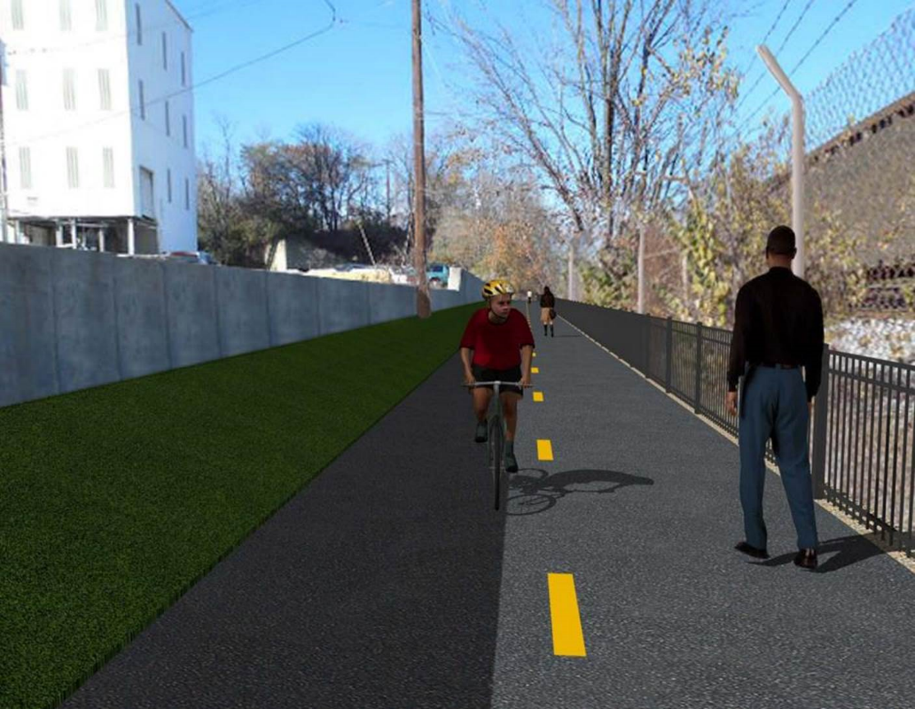

Proposed Metropolitan Branch Trail

1. PROJECT DESCRIPTION

The planned Metropolitan Branch Trail Project (“the Project”) consists of the design and construction of a new trail adjacent to CSX tracks and WMATA Red Line tracks along John McCormack Drive, adjacent to Fort Totten Metro Station, and on NPS property in NE, Washington D.C. The trail begins approximately 1500 feet south of Bates Road NE on the east side of John McCormack Drive NE, extending north along the WMATA and CSX tracks to the Fort Totten Metro Station tie in with First Place NE. An existing trail connection from Gallatin Road NE to the Fort Totten Metro Station will be reconstructed as a part of the Project.

The Project is 83.15% Federally-Funded and 16.85% District-Funded. Potomac Construction is the Design Build contractor.

Delon Hampton and Associates Chartered is providing Construction Management and Inspection services. Specific Construction Scope of Work includes:

- Provide mobilization and demobilization, provision and maintenance of Engineer’s field facilities, field layout, employee training, and other incidental work required for a quality, complete and finished product;
- Establishment and maintenance of vehicular and pedestrian traffic including signs, barricades and other transition devices; reconfiguring the devices in conjunction with changes in work areas; and their removal and disposal upon project completion, including restoration of disturbed areas;
- Clearing and grubbing, as required within the LOD;
- Removal of unsuitable material, excavation, and backfilling and pervious paving to construct a new trail;
- Protection of trees during construction;
- Provide ADA compliant trail connections and pedestrian ramps;
- Provide retaining walls as necessary to stay within the LOD and minimize property impacts following visual requirements specified for retaining walls on NPS property;
- Provide new permanent regulatory and wayfinding signs for the trail and all trail connection intersections;
- Provide road and trail pavement markings;
- Provide landscaping within the LOD for the Project including special requirements for landscaping on NPS property;
- Provide erosion and sediment control measures, storm water management facilities, including pervious asphalt pavement and bioretention facilities;
- Provide utility coordination, identification, locating, and protection of all utilities encountered during design and construction including relocation of Pepco poles along Aggregate Industries property; and
- Provide new WMATA security fencing between the trail and CSXT tracks.
- Remove existing sidewalk and widen sidewalk to 10’ along the west side of 1st place NE from Metropolitan Branch Trail to entrance to WMATA bus loop, on the west side.

2. STATUS OF CONSTRUCTION / PROGRESS SUMMARY

Work performed this week:

Design

- MBT Designer submitted Phase D 3-ring binder and 100% Plans to DDOT
- Stakeholders acceptance for Phase D Final Design Plans
- CSX is reviewing Phase D Means and Methods

Construction:

Phase B

- Excavated and graded ditch along the North side of the trail
- Constructed Bioswale along the North side of the trail
- Applied bioretention and topsoil over the ditch line
- Hauled away excavated materials from site

Phase D

- Constructed retaining wall forms
- Installed retaining wall rebars
- Placed retaining wall concrete
- Backfilled drainage manhole
- Installed and backfilled drainage pipes
- Installed drainage manhole frame and cover
- Rough graded trail pathway
- Installed super silt fence
- PEPCO crew repaired damaged wires
- Demolished and removed existing concrete ditch
- CSX flagger’s operation and safety tool box talk

CM Consultant:

- Monitored construction progress, make sure all applicable inspections and testing were
Performed
- Attended DDOT Aggregate Industries Meeting conference
- Attended QAQC Meeting conference call
- Reviewed Inspection Daily Reports
- Prepared CW weekly reports
- Updated Project Files
- Update Project Webpage
- Updated documents in SharePoint
- Communication with the stakeholder in terms of submittals

3. MEETINGS / PROJECT COORDINATION

Thurs 09/10/20 DDOT DHA and Aggregate Industries meeting conference call was held
at 8:00A.M.
Thurs 09/10/20 DDOT DHA and PCCI field meeting was held at 10:00A.M.
Fri 09/11/20 QAQC Meeting conference call was held at 10:00 A.M.

4. DAILY WORK PERFORMED

Sun 09/06/20 No work performed.
Mon 09/07/20 Holiday
Tue 09/08/20 Phase B – Constructed Bioswale along the North side of the trail. Placed
bioretention soil over the swale. Applied topsoil over the swale. Fine graded topsoil.
Electrical Work – Electrical work – No work scheduled
Phase D – Constructed retaining wall forms. Backfilled drainage manhole. Reformed rough grading. Installed super silt fence. PEPCO crew was onsite to repair the damaged wires
Wed 09/09/20 Phase B – Constructed swale along the North side of the trail. Applied
seeds and placed erosion control matting over the ditch line. Excavated trail trench. Installed geotextile fabric and placed stone at trail trench.
Phase B - Electrical Work – No work scheduled.
Phase D – Constructed retaining wall formwork. Installed solid PVC drain pipe. Constructed drainage manhole and installed manhole top. Excavated and performed rough grading pathway for the rail. Graded the slope area along the trail. Installed super silt fence. PEPCO crew was onsite to repair the damaged wires.
Phase D – Electrical Work – No work scheduled.
Thurs 09/10/20 Phase B – Relocated project posting board to the North side of the trail.
Due to rain work activities cancelled.
Phase B – Electrical – No work scheduled.
Phase D – Placed retaining wall concrete. Excavated drainage pipes trench. Placed drainage pipes bedding materials. Installed drainage pipes. Backfilled drainage pipes. PEPCO crew onsite to repair cut wires.
Fri 09/11/20 Phase B – Work activities cancelled due to wet site conditions
Phase B – Electrical – No work scheduled.
Phase D – Saw cut existing concrete. Cut trees. Repaired super silt fence. Cleaned site.
Sat 09/12/20 No work scheduled

5. INSPECTION & MATERIAL TESTS PERFORMED

Jobsite Safety Inspection  Erosion and Sediment Control inspection  MOT Inspection  Compaction Test - Passed  Asphalt Material Testing  Concrete Material Testing – Pending results  ** Note - Additional Material Test Results can be found on DDOT QA QC Material Division Tracking SharePoint website. | Infiltration Tests  Dynamic Cone Penetration (DCP) Tests  Rebars Inspection - Passed
6. DBE PARTICIPATION SUMMARIES

Potomac Construction (Contractor)
- DBE Goal for Contractor is 15%. To-date the Contractor has achieved 40% of their goal.

Delon Hampton & Associates (CM)
- DBE Goal for the CM is 10%. To-date the CM has achieved 18% of their Goal.

7. ACCIDENTS / INCIDENTS

None occurred on-site during this week.

8. PHOTOS OF THE WORK PERFORMED

12. PHOTOS OF WORK PERFORMED THIS PERIOD

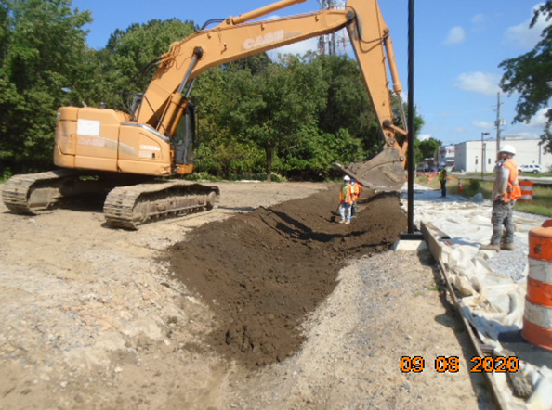
Phase B – Crew placing topsoil over the ditch

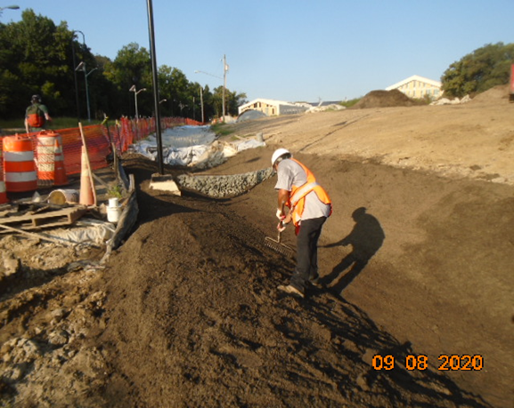
Phase B – Crew fine grading topsoil over the ditch
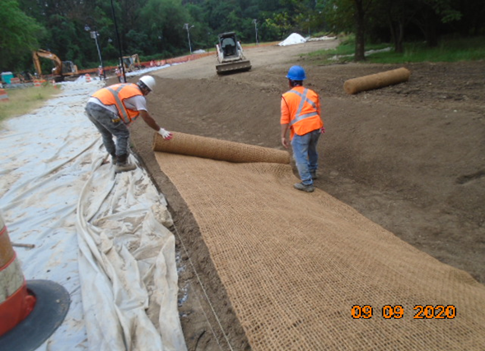
Phase B – Crew placing erosion control matting at the ditch along the trail

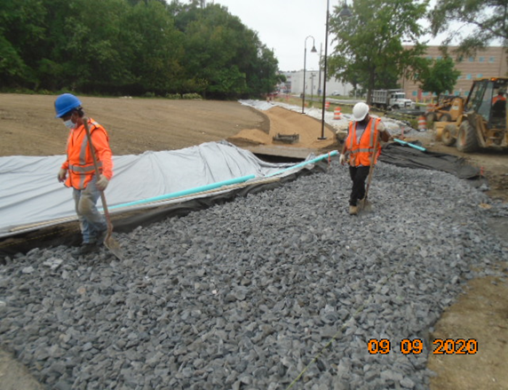
Phase B – Crew placing stone at the trail trench

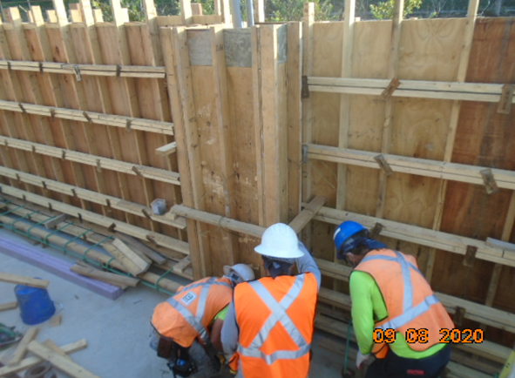
Phase D – Crew constructing retaining wall formwork

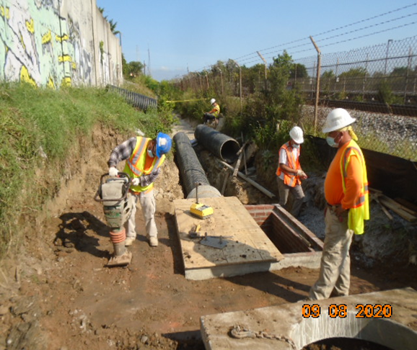
Phase D – Crew backfilling drainage manhole

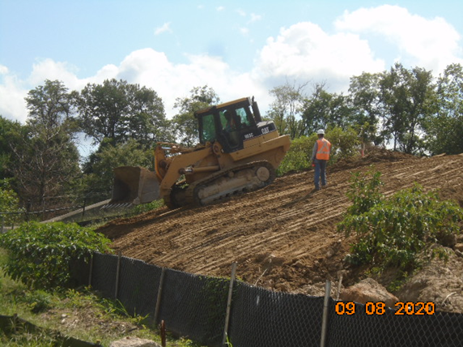
Phase D – Crew grading the slope area along the trail

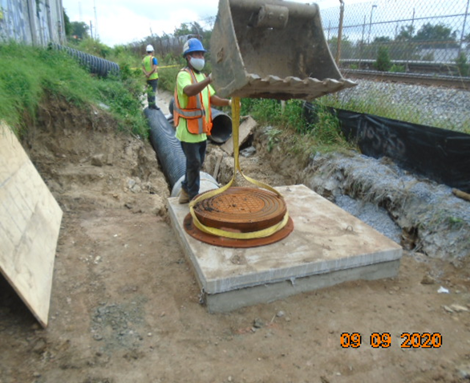
Phase D – Crew setting manhole frame and cover

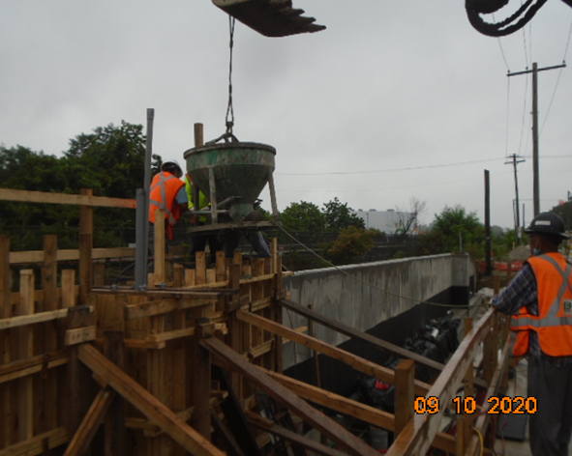
Phase D – Crew placing retaining wall concrete

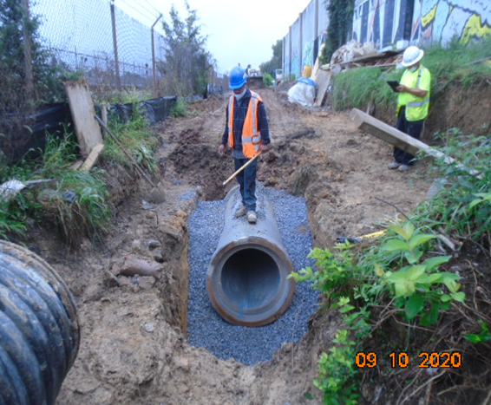
Phase D – Crew installing drainage pipe

