Metropolitan Branch Trail Design Build, South Segment
DC CONTRACT NO. DCKA-2016-C-0044
FAP No.: STP-2016 (060)

CONSTRUCTION MANAGER’S
WEEKLY PROGRESS REPORT

08/30/2020 – 09/05/2020

Project Website: www.metbranchtrail-forttotten.com
For Additional Trail Information Please see www.metbranchtrail.com

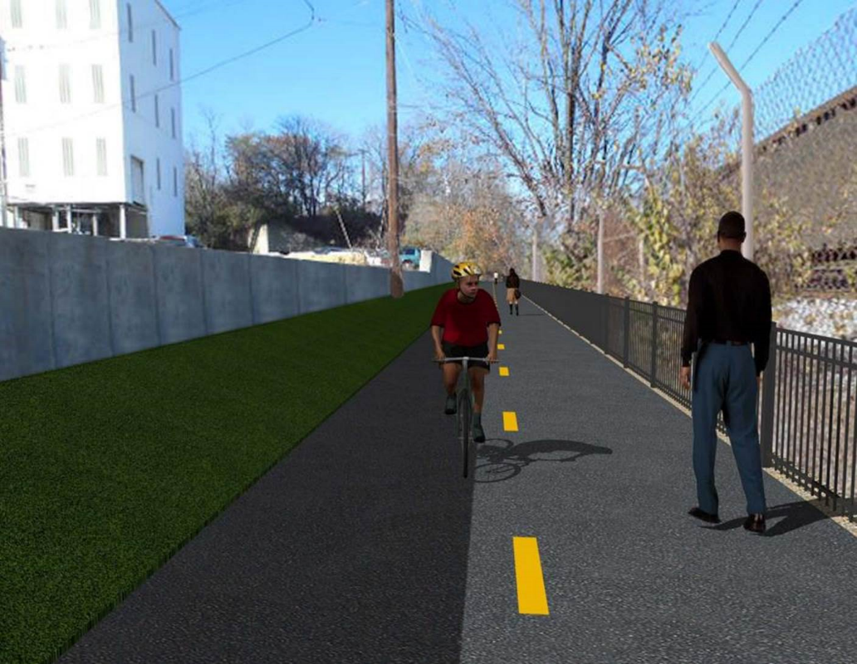

Proposed Metropolitan Branch Trail

1. PROJECT DESCRIPTION

The planned Metropolitan Branch Trail Project (“the Project”) consists of the design and construction of a new trail adjacent to CSX tracks and WMATA Red Line tracks along John McCormack Drive, adjacent to Fort Totten Metro Station, and on NPS property in NE, Washington D.C. The trail begins approximately 1500 feet south of Bates Road NE on the east side of John McCormack Drive NE, extending north along the WMATA and CSX tracks to the Fort Totten Metro Station tie in with First Place NE. An existing trail connection from Gallatin Road NE to the Fort Totten Metro Station will be reconstructed as a part of the Project.

The Project is 83.15% Federally-Funded and 16.85% District-Funded. Potomac Construction is the Design Build contractor.

Delon Hampton and Associates Chartered is providing Construction Management and Inspection services. Specific Construction Scope of Work includes:

- Provide mobilization and demobilization, provision and maintenance of Engineer’s field facilities, field layout, employee training, and other incidental work required for a quality, complete and finished product;
- Establishment and maintenance of vehicular and pedestrian traffic including signs, barricades and other transition devices; reconfiguring the devices in conjunction with changes in work areas; and their removal and disposal upon project completion, including restoration of disturbed areas;
- Clearing and grubbing, as required within the LOD;
- Removal of unsuitable material, excavation, and backfilling and pervious paving to construct a new trail;
- Protection of trees during construction;
- Provide ADA compliant trail connections and pedestrian ramps;
- Provide retaining walls as necessary to stay within the LOD and minimize property impacts following visual requirements specified for retaining walls on NPS property;
- Provide new permanent regulatory and wayfinding signs for the trail and all trail connection intersections;
- Provide road and trail pavement markings;
- Provide landscaping within the LOD for the Project including special requirements for landscaping on NPS property;
- Provide erosion and sediment control measures, storm water management facilities, including pervious asphalt pavement and bioretention facilities;
- Provide utility coordination, identification, locating, and protection of all utilities encountered during design and construction including relocation of Pepco poles along Aggregate Industries property; and
- Provide new WMATA security fencing between the trail and CSXT tracks.
- Remove existing sidewalk and widen sidewalk to 10’ along the west side of 1st place NE from Metropolitan Branch Trail to entrance to WMATA bus loop, on the west side.

2. STATUS OF CONSTRUCTION / PROGRESS SUMMARY

Work performed this week:

Design

- MBT Designer submitted Phase D 3-ring binder and 100% Plans to DDOT
- Stakeholders acceptance for Phase D Final Design Plans
- CSX is reviewing Phase D Means and Methods

Construction:

Phase B

- Excavated and graded ditch along the North side of the trail
- Constructed Bioswale along the North side of the trail.
- Installed geo-fabric in the trench.
- Installed perforated underdrain and placed stone.
- Hauled away excavated materials from site

Phase D

- Installed retaining wall rebars
- Constructed retaining wall forms
- Rough graded trail pathway
- Constructed drainage manhole
- Installed super silt fence
- Installed light poles foundation conduits
- Demolished and removed existing concrete ditch
- CSX flagger’s operation and safety tool box talk

CM Consultant:

- Monitored construction progress, make sure all applicable inspections and testing were
Performed
- Attended DDOT Aggregate Industries Meeting conference
- Attended MBT Project Progress Meeting
- Attended QAQC Meeting conference call
- Reviewed Inspection Daily Reports
- Prepared weekly CM reports
- Updated Project Files
- Update Project Webpage
- Updated documents in SharePoint
- Communication with the stakeholder in terms of submittals

3. MEETINGS / PROJECT COORDINATION

Tue 09/01/20 MBT Progress Meeting conference call was held at 10:00 A.M.
Tue 09/02/20 DDOT DHA Designer and PCCI conference call meeting to discuss
Aggregate Industries Items was held at 11:00A.M.
Thurs 09/03/20 DDOT DHA and Aggregate Industries meeting conference call was held
at 8:00A.M

4. DAILY WORK PERFORMED

Sun 08/30/20 No work performed.
Mon 08/31/20 Phase B – Excavated and graded ditch along the North side of the
trail. Removed excavated materials from site.
Phase B – Electrical work – No work scheduled.
Phase D – Installed retaining wall rebars. Rough graded trail pathway.
Tue 09/01/20 Phase B – No work performed due to wet site conditions
Electrical Work – Electrical work – No work scheduled
Phase D – Constructed retaining wall forms. Constructed drainage manhole. Demolished and removed existing concrete ditch.
Wed 09/02/20 Phase B – Constructed Bioswale along the North side of the trail. Installed
geo-fabric in the trench. Installed perforated underdrain and placed stone.
Phase B - Electrical Work – No work scheduled.
Phase D – Constructed retaining wall formwork. Constructed brick manhole. Demolished existing and removed concrete ditch. Installed super silt fence.
Phase D – Electrical Work – Installed light pole foundations conduits.
Thurs 09/03/20 Phase B – Constructed Bioswale along the North side of the trail. Installed
geo-fabric in the trench. Installed perforated underdrain and placed stone.
Phase B – Electrical – No work scheduled.
Phase D – Constructed retaining wall formwork. Excavated and rough graded pathway for the trail. Installed super silt fence.
Fri 09/04/20 Phase B – Constructed Bioswale along the North side of the trail. Installed
geo-fabric in the trench. Installed perforated underdrain and placed stone.
Phase B – Electrical – No work scheduled.
Phase D – Constructed retaining wall formwork. Excavated and rough graded pathway for the trail. Installed super silt fence.
Sat 09/05/20 No work scheduled

5. INSPECTION & MATERIAL TESTS PERFORMED

Jobsite Safety Inspection  Erosion and Sediment Control inspection  MOT Inspection  Compaction Test - Passed  Asphalt Material Testing  Concrete Material Testing  ** Note - Additional Material Test Results can be found on DDOT QA QC Material Division Tracking SharePoint website. | Infiltration Tests  Dynamic Cone Penetration (DCP) Tests  Rebars Inspection - ongoing
6. DBE PARTICIPATION SUMMARIES

Potomac Construction (Contractor)
- DBE Goal for Contractor is 15%. To-date the Contractor has achieved 40% of their goal.

Delon Hampton & Associates (CM)
- DBE Goal for the CM is 10%. To-date the CM has achieved 18% of their Goal.

7. ACCIDENTS / INCIDENTS

None occurred on-site during this week.

8. PHOTOS OF THE WORK PERFORMED

12. PHOTOS OF WORK PERFORMED THIS PERIOD

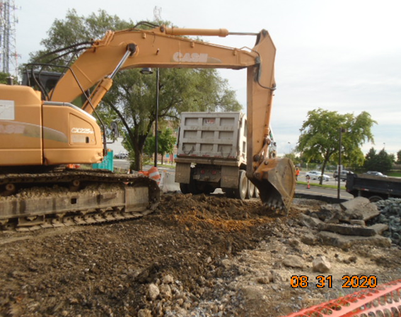
Phase B – Crew grading ditch along the North side of the trail
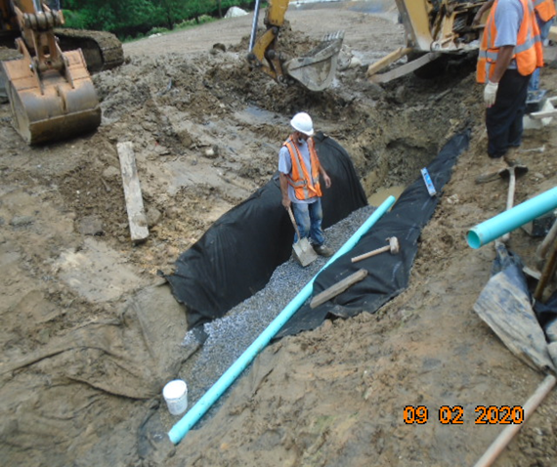
Phase B – Crew installing underdrain at the Bioswale along the trail

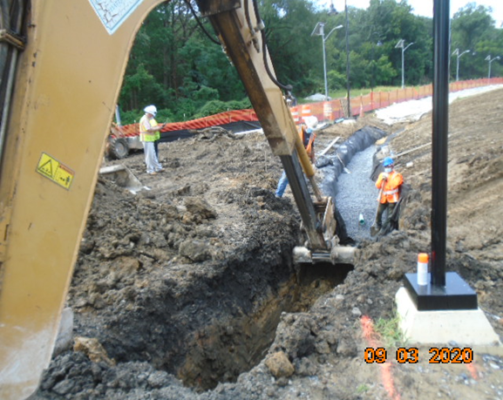
Phase B – Crew excavating bio swale

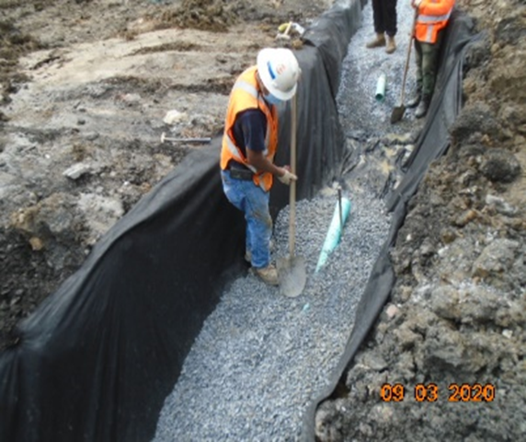
Phase B – Crew placing stone at Bioswale

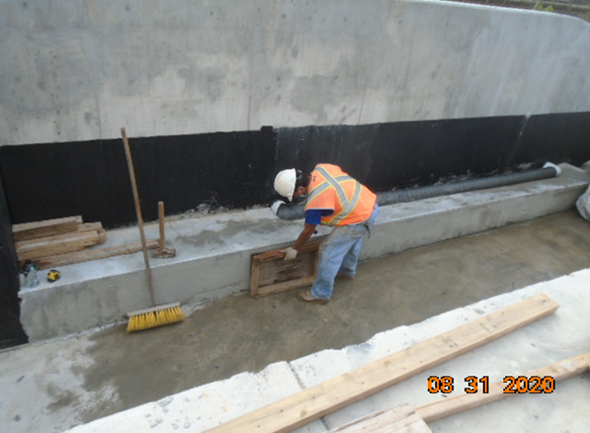
Phase B – Crew removing edge wall forms

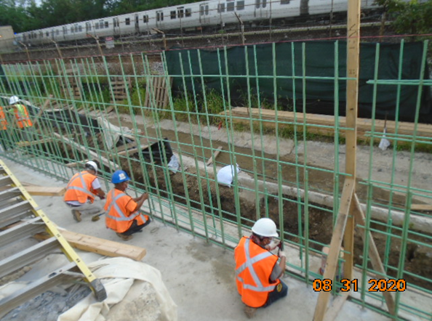
Phase D – Crew installing retaining wall rebars

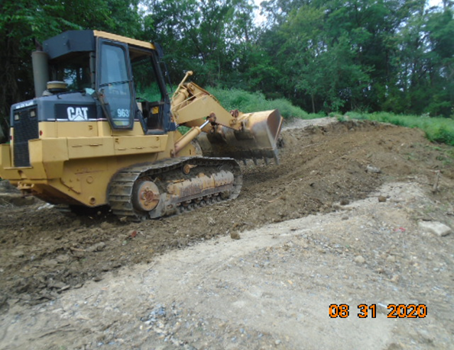
Phase D – Crew rough grading trail pathway

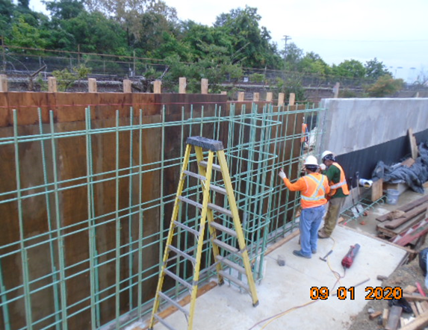
Phase D – Crew constructing retaining wall forms

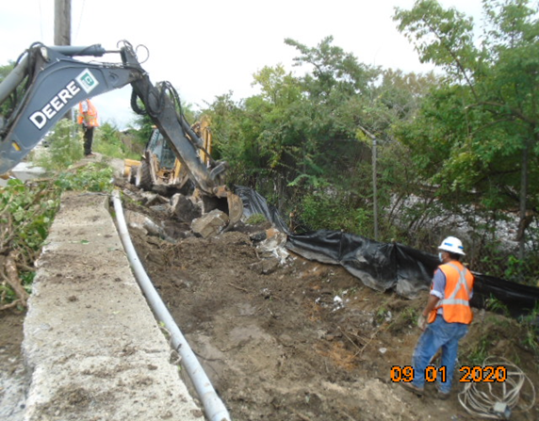
Phase D – Crew demolishing existing concrete ditch

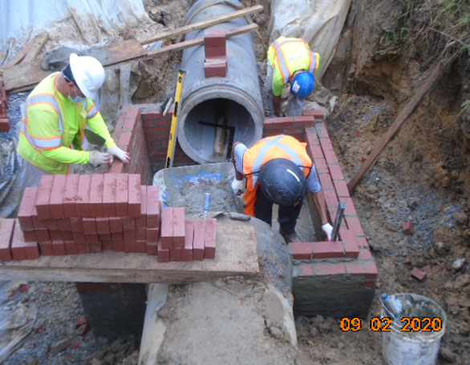
Phase D – Crew constructing brick manhole
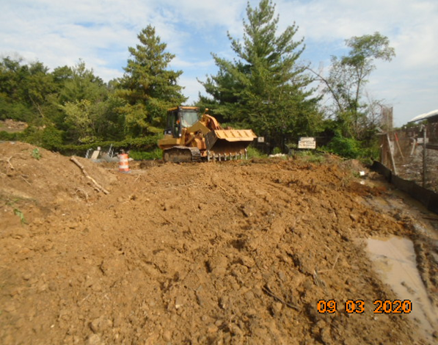
Phase D – Crew rough grading trail pathway

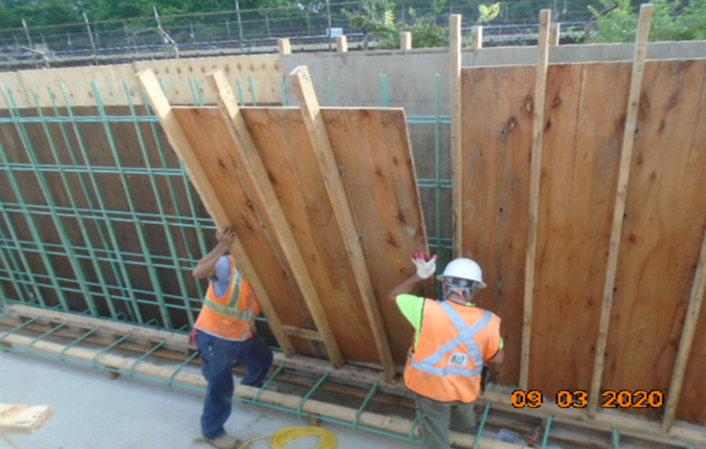
Phase D – Crew constructing retaining wall formwork.

