Metropolitan Branch Trail Design Build, South Segment
DC CONTRACT NO. DCKA-2016-C-0044
FAP No.: STP-2016 (060)

CONSTRUCTION MANAGER’S
WEEKLY PROGRESS REPORT

08/29/2021 – 09/04/2021

Project Website: www.metbranchtrail-forttotten.com
For Additional Trail Information Please see www.metbranchtrail.com
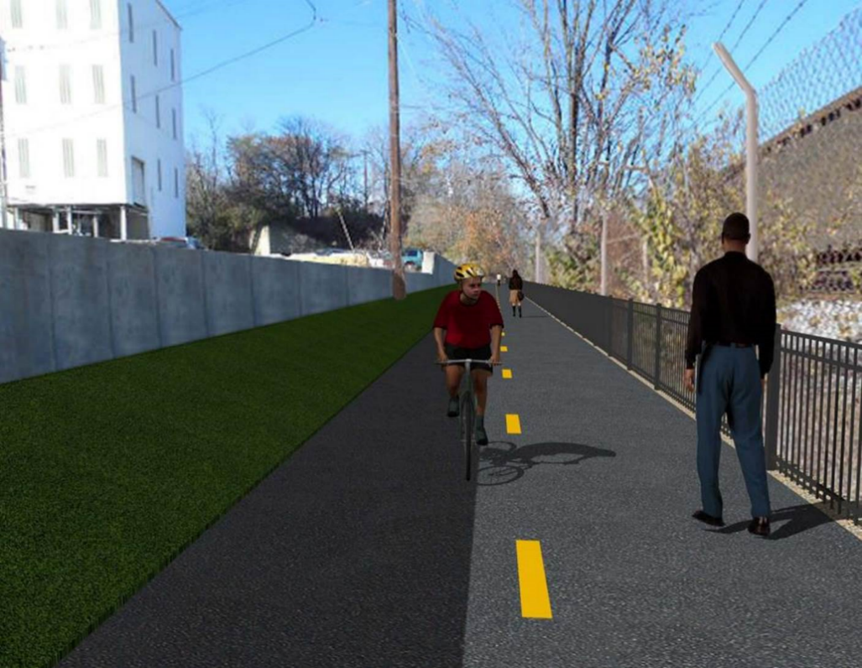

Proposed Metropolitan Branch Trail

1. PROJECT DESCRIPTION

The planned Metropolitan Branch Trail Project (“the Project”) consists of the design and construction of a new trail adjacent to CSX tracks and WMATA Red Line tracks along John McCormack Drive, adjacent to Fort Totten Metro Station, and on NPS property in NE, Washington D.C. The trail begins approximately 1500 feet south of Bates Road NE on the east side of John McCormack Drive NE, extending north along the WMATA and CSX tracks to the Fort Totten Metro Station tie in with First Place NE. An existing trail connection from Gallatin Road NE to the Fort Totten Metro Station will be reconstructed as a part of the Project.

The Project is 83.15% Federally-Funded and 16.85% District-Funded. Potomac Construction is the Design Build contractor.

Delon Hampton and Associates Chartered is providing Construction Management and Inspection services. Specific Construction Scope of Work includes:

- Provide mobilization and demobilization, provision and maintenance of Engineer’s field facilities, field layout, employee training, and other incidental work required for a quality, complete and finished product;
- Establishment and maintenance of vehicular and pedestrian traffic including signs, barricades and other transition devices; reconfiguring the devices in conjunction with changes in work areas; and their removal and disposal upon project completion, including restoration of disturbed areas;
- Clearing and grubbing, as required within the LOD;
- Removal of unsuitable material, excavation, and backfilling and pervious paving to construct a new trail;
- Protection of trees during construction;
- Provide ADA compliant trail connections and pedestrian ramps;
- Provide retaining walls as necessary to stay within the LOD and minimize property impacts following visual requirements specified for retaining walls on NPS property;
- Provide new permanent regulatory and wayfinding signs for the trail and all trail connection intersections;
- Provide road and trail pavement markings;
- Provide landscaping within the LOD for the Project including special requirements for landscaping on NPS property;
- Provide erosion and sediment control measures, storm water management facilities, including pervious asphalt pavement and bioretention facilities;
- Provide utility coordination, identification, locating, and protection of all utilities encountered during design and construction including relocation of Pepco poles along Aggregate Industries property; and
- Provide new WMATA security fencing between the trail and CSXT tracks.
- Remove existing sidewalk and widen sidewalk to 10’ along the west side of 1st place NE from Metropolitan Branch Trail to entrance to WMATA bus loop, on the west side.

2. STATUS OF CONSTRUCTION / PROGRESS SUMMARY

Work performed this week:

Design

- 100 % Complete

Construction:

Phase D

- Removed S0 wall section formwork
- Constructed retaining wall S3 formwork
- Installed retaining wall S3 wall section rebar
- Dewatered and cleaned retaining wall S3 footing area
- Removed retaining wall S3 footing formwork
- Excavated the trail path
- Graded the trail path
- Graded the embankment slope along the trail
- Installed silt fence
- Performed site clean up
- Pulled conductors for the trail light poles
- Contractor safety tool box talk

CM Consultant:

- Monitored construction progress, make sure all applicable inspections and testing were performed
- Reviewed CSX invoice
- Reviewed Project Schedule
- Attended MBT Progress Meeting
- Attended MBT Project Field Meeting with PCCI
- Prepared CM Weekly Report to post
- Prepared CM weekly report to DDOT
- Updated Project Files
- Updated Project Logs
- Updated Project Webpage
- Updated documents in DHA SharePoint site
- Updated DDOT Sharepoint site
- Communication with PCCI and stakeholders in terms of submittals

3. MEETINGS / PROJECT COORDINATION

Mon 08/30/21 DHA PCCI site meeting was held at 9:00 A.M.
Tue 08/31/21 MBT Progress Meeting conference call was held at 10:00 A.M.

4. DAILY WORK PERFORMED

Sun 08/29/21 No work performed.
Mon 08/30/21 Phase D – Removed retaining wall S0 wall section formwork. Constructed
retaining wall S3 wall section formwork. Installed retaining wall S3 rebars.
retaining wall S wedge wall rebars. Dewatered and cleaned retaining wall S0 footing. Cleaned up the surrounding area S0 wall.
Phase D – Electrical Work – Pulled conductors for trail light poles.
Tue 08/31/21 Phase D – Removed retaining wall S0 wall formwork. Constructed retaining
wall S3 formwork. Installed retaining wall S3 wall section rebars.
wall S3. Dewatered and cleaned retaining wall S3 footing. Placed and graded No. 57 stone at the trail.
Phase D – Electrical Work – Pulled conductors for trail light poles.
Wed 09/01/21 Phase D – Constructed retaining wall S3 formwork. Installed retaining wall
S3 wall section rebars.
Phase D – Electrical Work – Pulled conductors for trail light poles.
Thurs 09/02/21 Phase D – Removed retaining wall S3 footing formwork. Constructed
retaining wall S3 formwork. Installed retaining wall S3 wall section rebars.
wall S3. Dewatered and cleaned retaining wall S3 footing. Placed and graded No. 57 stone at the trail.
Phase D – Electrical Work – No work performed.
Fri 09/03/21 Phase D – Removed retaining wall S3 footing formwork. Constructed
retaining wall S3 formwork. Installed retaining wall S3 wall section rebars.
wall S3. Excavated and graded the trail path. Graded embankment slope along the trail.
Phase D – Electrical Work – No work performed.
Sat 09/04/21 Phase D – No work scheduled

5. INSPECTION & MATERIAL TESTS PERFORMED

Jobsite Safety Inspection  Erosion and Sediment Control inspection  MOT Inspection  Compaction Test  Asphalt Material Testing  Concrete Material Testing – Pending results  ** Note - Additional Material Test Results can be found on DDOT QA QC Material Division Tracking SharePoint website. | Infiltration Tests  Dynamic Cone Penetration (DCP) Tests  Rebars Inspection – Ongoing
6. DBE PARTICIPATION SUMMARIES

Potomac Construction (Contractor)

- DBE Goal for Contractor is 15%. To-date the Contractor has achieved 54.4% of their goal.

Delon Hampton & Associates (CM)

- DBE Goal for the CM is 10%. To-date the CM has achieved 96.6% of their Goal.

7. ACCIDENTS / INCIDENTS

None occurred on-site during this week.

8. PHOTOS OF THE WORK PERFORMED

12. PHOTOS OF WORK PERFORMED THIS PERIOD

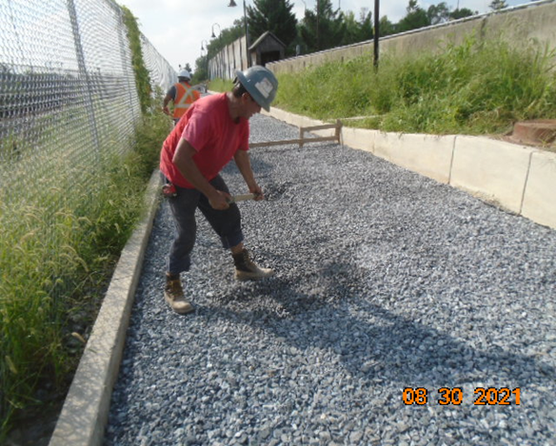
Phase D – Crew grading the trail stone
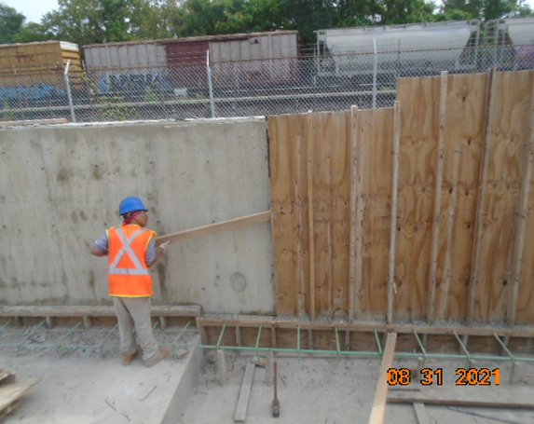
Phase D – Crew removing retaining wall S0 formwork
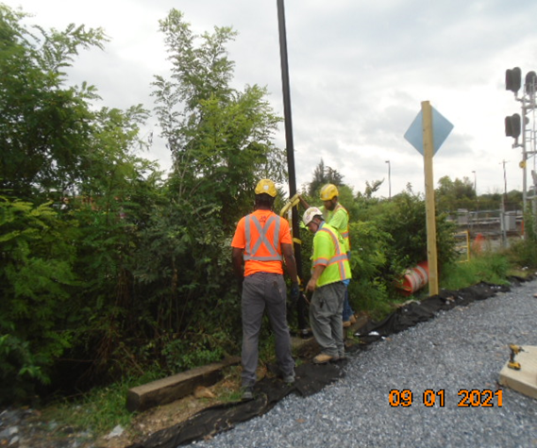
Phase D – Crew pulling conductors for trail light pole

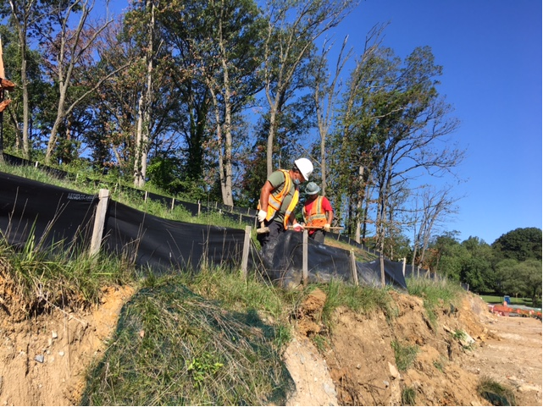
Phase D – Crew installing silt fence

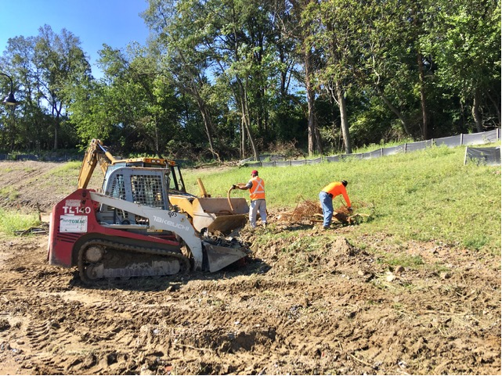
Phase D – Crew cleaning site

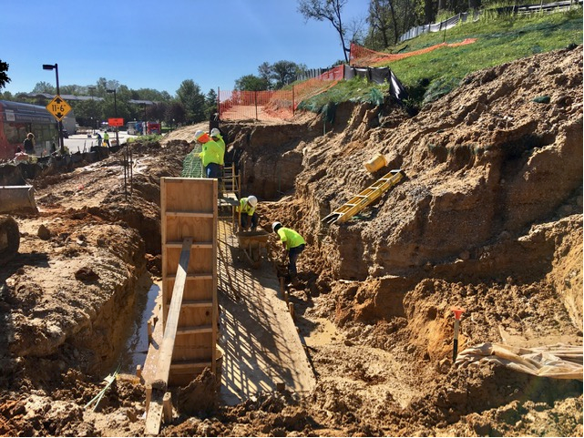
Phase D – Crew cleaning retaining wall S3 footing area

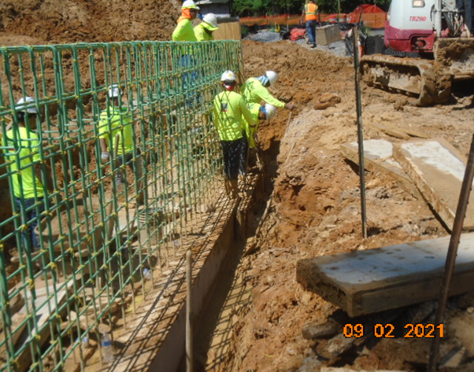
Phase D – Crew removing retaining wall S3 footing formwork

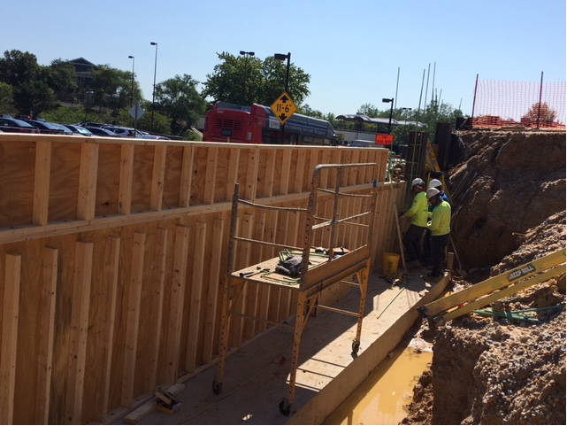
Phase D – Crew constructing retaining wall S3 formwork

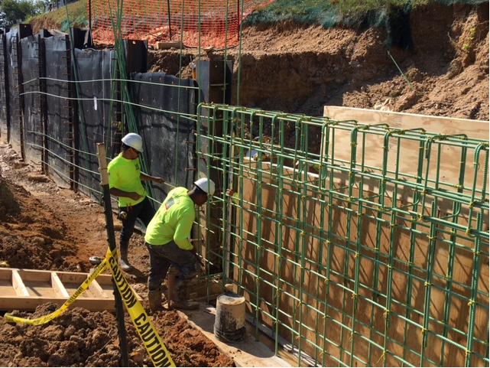
Phase D – Crew installing retaining wall S3 rebar

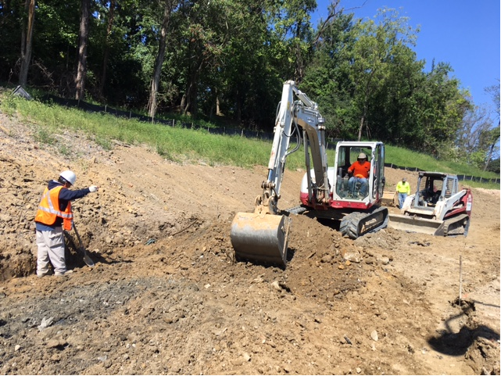
Phase D – Crew excavating the trail path

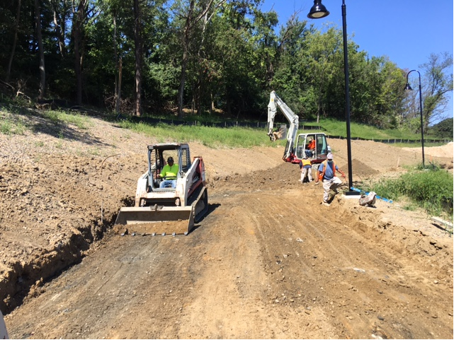
Phase D – Crew grading the trail path

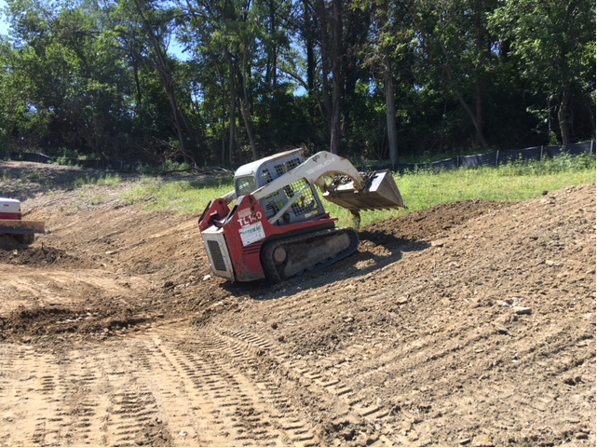
Phase D – Crew grading embankment slope along the trail path

