**Metropolitan Branch Trail Design Build, South Segment**

**DC CONTRACT NO. DCKA-2016-C-0044**

**FAP No.: STP-2016 (060)**

CONSTRUCTION MANAGER’S

WEEKLY PROGRESS REPORT

08/23/2020 – 08/29/2020

Project Website: [www.metbranchtrail-forttotten.com](http://www.metbranchtrail-forttotten.com)

For Additional Trail Information Please see [www.metbranchtrail.com](http://www.metbranchtrail.com)

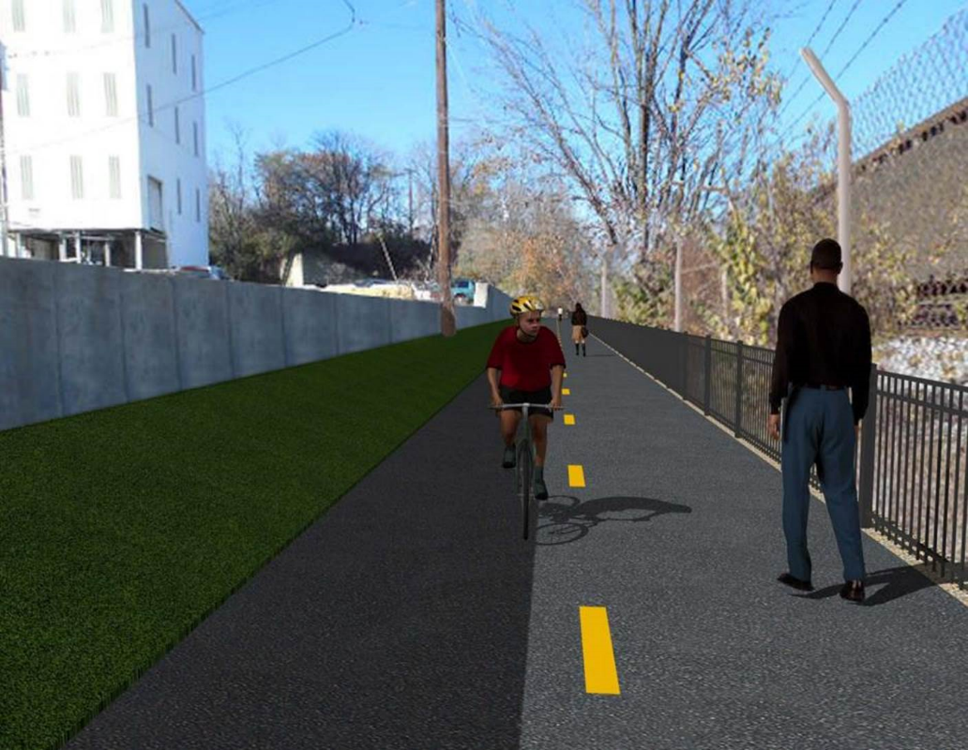

**Proposed Metropolitan Branch Trail**

**1. PROJECT DESCRIPTION**

The planned Metropolitan Branch Trail Project (“the Project”) consists of the design and construction of a new trail adjacent to CSX tracks and WMATA Red Line tracks along John McCormack Drive, adjacent to Fort Totten Metro Station, and on NPS property in NE, Washington D.C. The trail begins approximately 1500 feet south of Bates Road NE on the east side of John McCormack Drive NE, extending north along the WMATA and CSX tracks to the Fort Totten Metro Station tie in with First Place NE. An existing trail connection from Gallatin Road NE to the Fort Totten Metro Station will be reconstructed as a part of the Project.

The Project is 83.15% Federally-Funded and 16.85% District-Funded. Potomac Construction is the Design Build contractor.

Delon Hampton and Associates Chartered is providing Construction Management and Inspection services. Specific Construction Scope of Work includes:

* Provide mobilization and demobilization, provision and maintenance of Engineer’s field facilities, field layout, employee training, and other incidental work required for a quality, complete and finished product;
* Establishment and maintenance of vehicular and pedestrian traffic including signs, barricades and other transition devices; reconfiguring the devices in conjunction with changes in work areas; and their removal and disposal upon project completion, including restoration of disturbed areas;
* Clearing and grubbing, as required within the LOD;
* Removal of unsuitable material, excavation, and backfilling and pervious paving to construct a new trail;
* Protection of trees during construction;
* Provide ADA compliant trail connections and pedestrian ramps;
* Provide retaining walls as necessary to stay within the LOD and minimize property impacts following visual requirements specified for retaining walls on NPS property;
* Provide new permanent regulatory and wayfinding signs for the trail and all trail connection intersections;
* Provide road and trail pavement markings;
* Provide landscaping within the LOD for the Project including special requirements for landscaping on NPS property;
* Provide erosion and sediment control measures, storm water management facilities, including pervious asphalt pavement and bioretention facilities;
* Provide utility coordination, identification, locating, and protection of all utilities encountered during design and construction including relocation of Pepco poles along Aggregate Industries property; and
* Provide new WMATA security fencing between the trail and CSXT tracks.
* Remove existing sidewalk and widen sidewalk to 10’ along the west side of 1st place NE from Metropolitan Branch Trail to entrance to WMATA bus loop, on the west side.

**2. STATUS OF CONSTRUCTION / PROGRESS SUMMARY**

**Work performed this week:**

**Design**

* Phase D 3-ring binder for 100% Plans
* Stakeholders acceptance for Phase D Final Design Plans
* Railing Design Submittal to WMATA and DDOT
* CSX Approval of Phase D Means and Methods

**Construction:**

**Phase B**

* Excavated and graded ditch along the North side of the trail
* Demolished temporary asphalt at triangle area of between Phase B and Phase D
* Demolished temporary asphalt at triangle area of between Phase B and Phase D
* Hauled away excavated materials from site

**Phase D**

* Excavated retaining wall footings
* Constructed retaining wall footings forms
* Constructed edge wall forms
* Installed retaining wall footings rebars
* Placed edge wall concrete
* Placed retaining wall footing concrete
* Backfilled drainage pipes
* Constructed end wall forms
* Installed end wall rebars
* Placed end wall concrete
* Placed drainage manhole base concrete
* Constructed drainage manhole
* CSX flagger’s operation and safety tool box talk

**CM Consultant:**

* Monitored construction progress, make sure all applicable inspections and testing were

Performed

* Attended QAQC Meeting conference call
* Reviewed Inspection Daily Reports
* Prepared weekly CM reports
* Updated Project Files
* Update Project Webpage
* Updated documents in SharePoint
* Communication with the stakeholder in terms of submittals

**3. MEETINGS / PROJECT COORDINATION**

Fri 08/28/20 QAQC Meeting conference call was held at 10:00 A.M.

**4. DAILY WORK PERFORMED**

Sun 08/23/20 No work performed.

Mon 08/24/20 Phase B – Excavated and graded ditch along the North side of the

trail. Removed excavated materials from site.

Phase B – Electrical work – No work scheduled.

Phase D – Installed retaining wall footing rebars. Backfilled drainage pipes. Constructed end wall forms.

Tue 08/25/20 Phase B – Excavated swale and graded ditch along the North side of the

trail. Removed excavated materials from site.

Electrical Work – Electrical work – No work scheduled.

Phase D – Installed retaining wall footing rebars. Constructed edge wall forms. Excavated drainage manhole base and placed bedding stone. Installed end wall rebars. Constructed end wall forms.

Wed 08/26/20 Phase B – Demolished the remaining temporary trail asphalt. Excavated

and graded the triangle area between Phase B and Phase D. Removed excavated materials from site.

Phase B - Electrical Work – No work scheduled.

Phase D – Placed edge wall concrete. Tied retaining wall footing rebars. Placed end wall concrete. Installed drainage MH base rebars. Constructed MH base forms.

Thurs 08/27/20 Phase B – Demolished the remaining temporary trail asphalt, continued

excavation and grading at the triangle area between Phase B and Phase D. Removed excavated materials from site.

Phase B – Electrical – Investigated the conductor power outage inside electrical manhole. Worked on light pole wires.

Phase D – Placed edge wall concrete. Placed retaining wall footing concrete. Placed drainage manhole base concrete. Placed end wall concrete. Stripped end wall forms.

Fri 08/28/20 Phase B – No work performed.

Phase B – Electrical – No work scheduled.

Phase D – Stripped retaining wall footing forms. Stripped manhole base and end wall forms. Constructed brick manhole.

Sat 08/29/20 No work scheduled

**5. INSPECTION & MATERIAL TESTS PERFORMED**

|  |  |
| --- | --- |
| Jobsite Safety Inspection  Erosion and Sediment Control inspection  MOT Inspection  Compaction Test - Passed  Asphalt Material Testing  Concrete Material Testing – Pending results  **\*\* Note - Additional Material Test Results can be found on DDOT QA QC Material Division Tracking SharePoint website**. | Infiltration Tests  Dynamic Cone Penetration (DCP) Tests  Rebars Inspection - Passed |

**6. DBE PARTICIPATION SUMMARIES**

Potomac Construction (Contractor)

* DBE Goal for Contractor is 15%. To-date the Contractor has achieved 40% of their goal.

Delon Hampton & Associates (CM)

* DBE Goal for the CM is 10%. To-date the CM has achieved 18% of their Goal.

**7. ACCIDENTS / INCIDENTS**

None occurred on-site during this week.

**8. PHOTOS OF THE WORK PERFORMED**

**12. PHOTOS OF WORK PERFORMED THIS PERIOD**

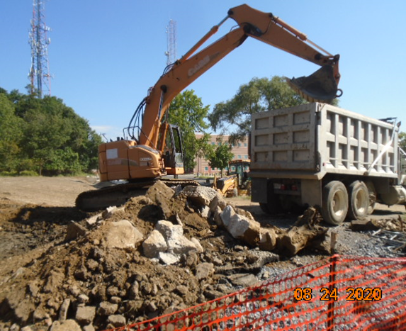

Phase B – Crew hauling excavated materials from site

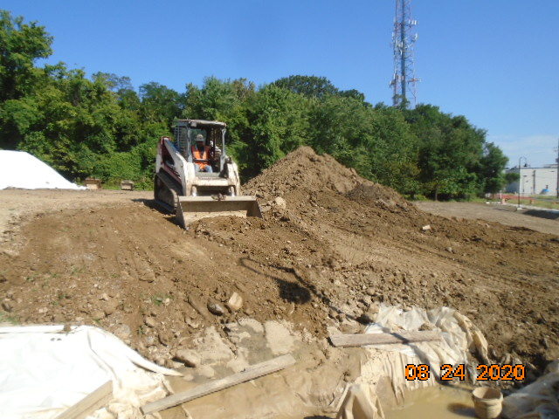

Phase B – Crew grading the slope line along the trail

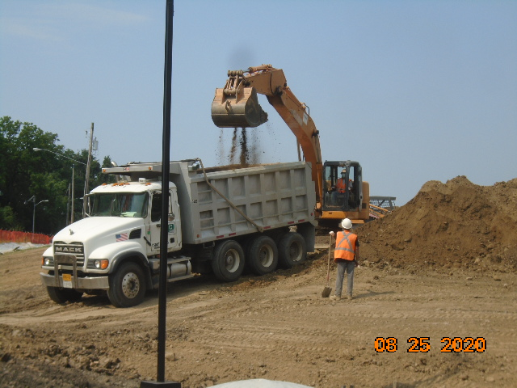

Phase B – Crew removing excavated materials from site

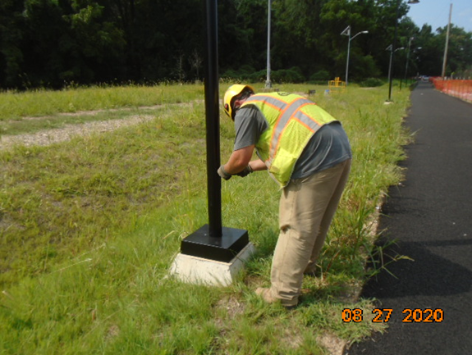

Phase B – Electrician working on light pole wires

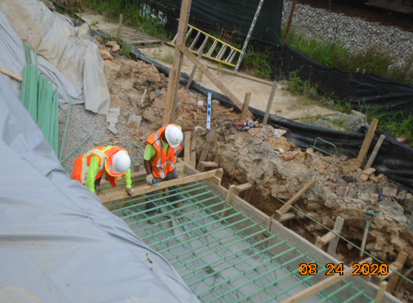

Phase D – Crew tying retaining wall footing rebars

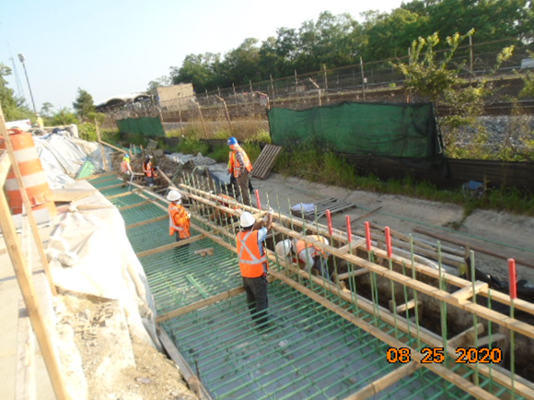

Phase D – Crew installing retaining wall footing rebars

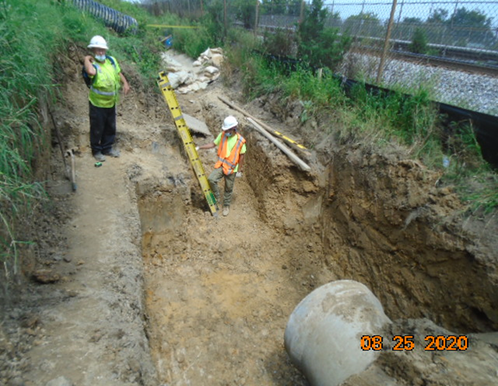

Phase D – Crew excavated manhole base

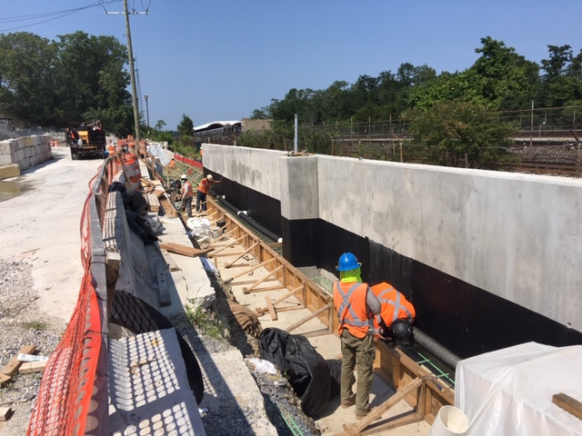

Phase D – Crew construction wedge wall forms

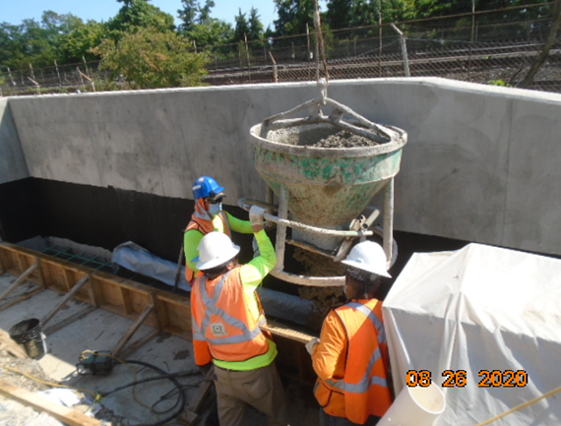

Phase D – Crew placing wedge wall concrete

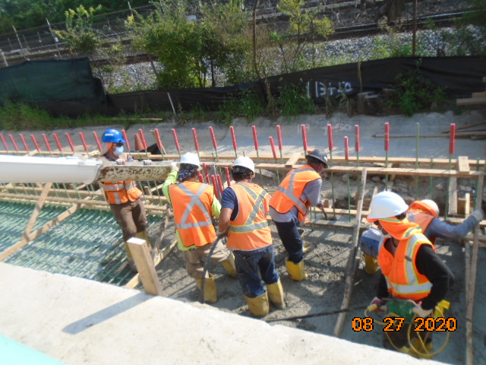

Phase D – Crew placing retaining wall footing concrete