Metropolitan Branch Trail Design Build, South Segment
DC CONTRACT NO. DCKA-2016-C-0044
FAP No.: STP-2016 (060)

CONSTRUCTION MANAGER’S
WEEKLY PROGRESS REPORT

08/16/2020 – 08/22/2020

Project Website: www.metbranchtrail-forttotten.com
For Additional Trail Information Please see www.metbranchtrail.com

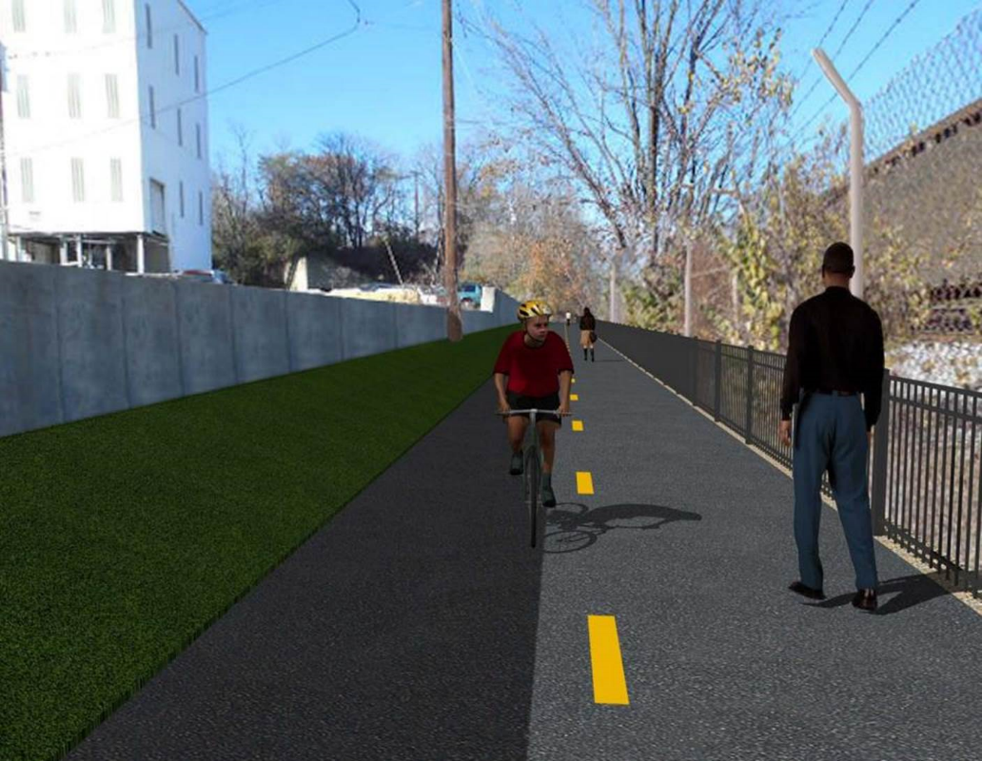

Proposed Metropolitan Branch Trail

1. PROJECT DESCRIPTION

The planned Metropolitan Branch Trail Project (“the Project”) consists of the design and construction of a new trail adjacent to CSX tracks and WMATA Red Line tracks along John McCormack Drive, adjacent to Fort Totten Metro Station, and on NPS property in NE, Washington D.C. The trail begins approximately 1500 feet south of Bates Road NE on the east side of John McCormack Drive NE, extending north along the WMATA and CSX tracks to the Fort Totten Metro Station tie in with First Place NE. An existing trail connection from Gallatin Road NE to the Fort Totten Metro Station will be reconstructed as a part of the Project.

The Project is 83.15% Federally-Funded and 16.85% District-Funded. Potomac Construction is the Design Build contractor.

Delon Hampton and Associates Chartered is providing Construction Management and Inspection services. Specific Construction Scope of Work includes:

- Provide mobilization and demobilization, provision and maintenance of Engineer’s field facilities, field layout, employee training, and other incidental work required for a quality, complete and finished product;
- Establishment and maintenance of vehicular and pedestrian traffic including signs, barricades and other transition devices; reconfiguring the devices in conjunction with changes in work areas; and their removal and disposal upon project completion, including restoration of disturbed areas;
- Clearing and grubbing, as required within the LOD;
- Removal of unsuitable material, excavation, and backfilling and pervious paving to construct a new trail;
- Protection of trees during construction;
- Provide ADA compliant trail connections and pedestrian ramps;
- Provide retaining walls as necessary to stay within the LOD and minimize property impacts following visual requirements specified for retaining walls on NPS property;
- Provide new permanent regulatory and wayfinding signs for the trail and all trail connection intersections;
- Provide road and trail pavement markings;
- Provide landscaping within the LOD for the Project including special requirements for landscaping on NPS property;
- Provide erosion and sediment control measures, storm water management facilities, including pervious asphalt pavement and bioretention facilities;
- Provide utility coordination, identification, locating, and protection of all utilities encountered during design and construction including relocation of Pepco poles along Aggregate Industries property; and
- Provide new WMATA security fencing between the trail and CSXT tracks.
- Remove existing sidewalk and widen sidewalk to 10’ along the west side of 1st place NE from Metropolitan Branch Trail to entrance to WMATA bus loop, on the west side.

2. STATUS OF CONSTRUCTION / PROGRESS SUMMARY

Work performed this week:

Design

- Phase D 3-ring binder for 100% Plans
- Stakeholders acceptance for Phase D Final Design Plans
- Railing Design Submittal to WMATA and DDOT
- CSX Approval of Phase D Means and Methods

Construction:

Phase B

- Demobilized staging area
- Demolished and removed temporary asphalt at Gallatin Street, N.E. connection area.
- Excavated and graded ditch along the North side of the trail
- Place topsoil and seeded ditch line along the North side of the trail
- Excavated and graded ditch along the West side of the trail
- Place topsoil and seeded ditch line along the West side of the trail

- Hauled away excavated materials from site

Phase D

- Demolished and removed existing concrete slab
- Excavated retaining wall footings
- Constructed retaining wall footings forms
- Placed retaining wall bedding stone
- Installed retaining wall footings rebars
- Purged retaining wall outer face
- Excavated drainage pipes trench
- Placed drainage pipes bedding stone
- Installed and backfilled drainage pipes
- Constructed drainage manhole
- Demolished existing concrete ditch
- CSX flagger’s operation and safety tool box talk

CM Consultant:

- Monitored construction progress, make sure all applicable inspections and testing were
performed
- Reviewed Inspection Daily Reports
- Updated Project Files
- Update Project Webpage
- Updated documents in SharePoint
- Communication with the stakeholder in terms of submittals

3. MEETINGS / PROJECT COORDINATION

Tue 08/18/20 DDOT DHA Coordination Meeting conference call was held at 9:00 A.M.

4. DAILY WORK PERFORMED

Sun 08/16/20 No work performed.
Mon 08/17/20 Phase B – Performed landscaping along the north side of the trial
near at Gallatin St N.E. The crew cleaned up the site, re-graded the ditch line, placed topsoil, seeded and mulched. Potomac driver hauled away the excavated soil.
Phase B – Electrical work – No work scheduled.
Phase D – Demolished and removed existing concrete slab. Constructed wedge wall forms. Excavated retaining wall footings. Placed retaining wall footings bedding stone. Excavated drainage pipes trench. Placed drainage pipes bedding stone. Constructed brick manhole.
Tue 08/18/20 Phase B – Excavated and graded the swale and two feet shoulder on
the West side of the trail.
Electrical Work – Electrical work – No work scheduled.
Phase D – Constructed retaining wall footings forms. Excavated drainage pipes trench. Placed drainage pipes bedding stone. Installed and backfilled drainage pipes. Purged outer face of retaining wall.
Wed 08/19/20 Phase B – No work performed due to rain.
Phase B - Electrical Work – No work scheduled.
Phase D – No work performed due to rain.
Thurs 08/20/20 Phase B – Excavated and graded the swale and two feet shoulder on
the West side of the trail.
Phase B – Electrical – No work scheduled.
Phase D – Placed plastic over retaining wall footing pad. Installed footings rebars. Placed drainage pipes bedding stone. Installed and backfilled drainage pipes.
Fri 08/21/20 Phase B – Excavated and graded the swale and two feet shoulder on
the West side of the trail.
Phase B – Electrical – No work scheduled.
Phase D – Place plastic over retaining wall footing pad. Installed footings rebars. Placed drainage pipes bedding stone. Installed and backfilled drainage pipes.
Sat 08/22/20 No work scheduled

5. INSPECTION & MATERIAL TESTS PERFORMED

Jobsite Safety Inspection  Erosion and Sediment Control inspection  MOT Inspection  Compaction Test - Passed  Asphalt Material Testing  Concrete Material Testing  ** Note - Additional Material Test Results can be found on DDOT QA QC Material Division Tracking SharePoint website. | Infiltration Tests  Dynamic Cone Penetration (DCP) Tests  Rebars Inspection - Ongoing
6. DBE PARTICIPATION SUMMARIES

Potomac Construction (Contractor)
- DBE Goal for Contractor is 15%. To-date the Contractor has achieved 40% of their goal.

Delon Hampton & Associates (CM)
- DBE Goal for the CM is 10%. To-date the CM has achieved 18% of their Goal.

7. ACCIDENTS / INCIDENTS

None occurred on-site during this week.

8. PHOTOS OF THE WORK PERFORMED

12. PHOTOS OF WORK PERFORMED THIS PERIOD

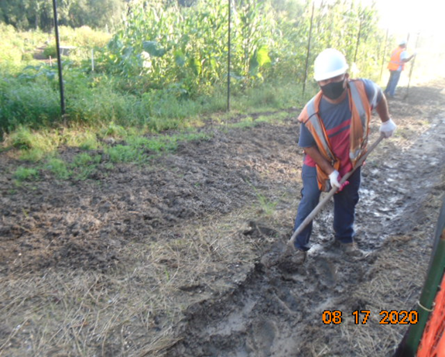
Phase B - Crew cleaning the ditch along the North side of the trail

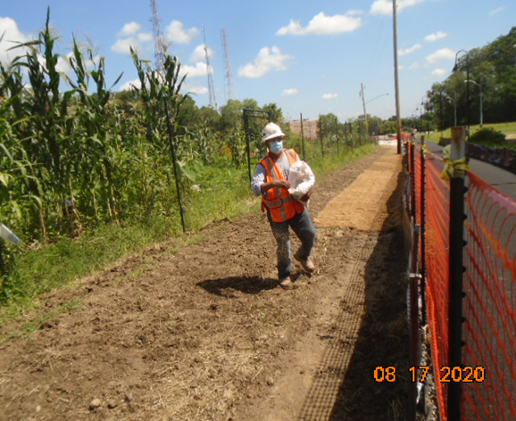
Phase B – Crew seeding the ditch line
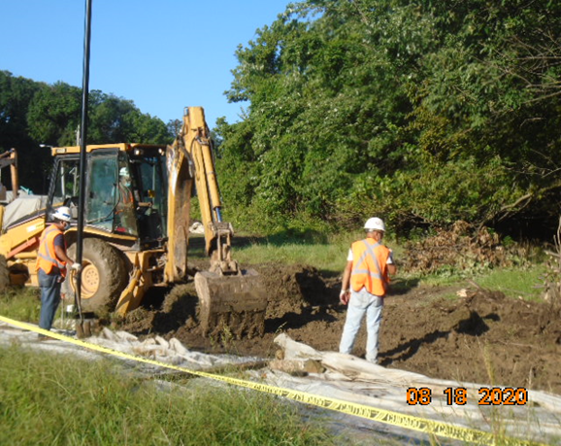
Phase B – Crew excavating ditch line along the trail

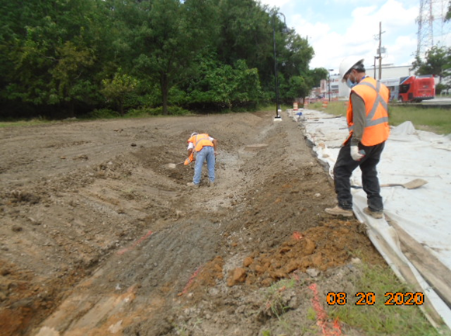
Phase B – Crew grading ditch along the West side of the trail

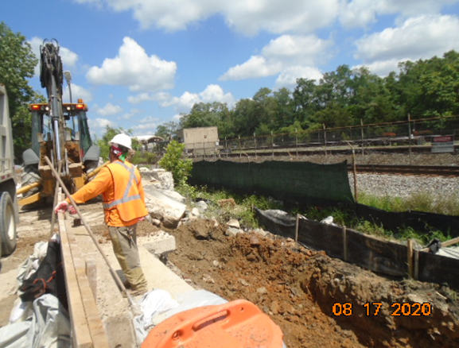
Phase D – Crew excavating retaining wall footing

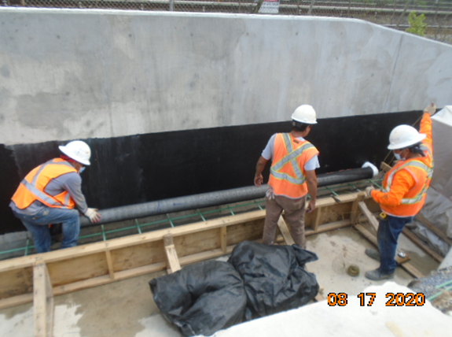
Phase D – Crew installing underdrain pipe at retaining wall

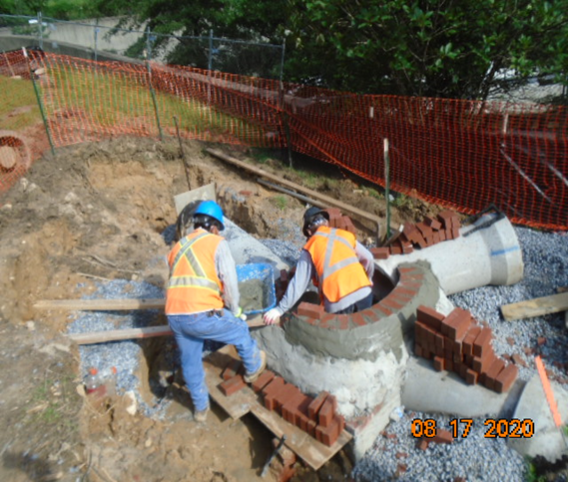
Phase D – Crew constructing brick manhole

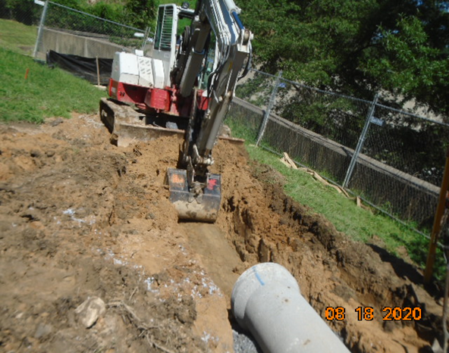
Phase D – Crew excavating drainage pipe trench

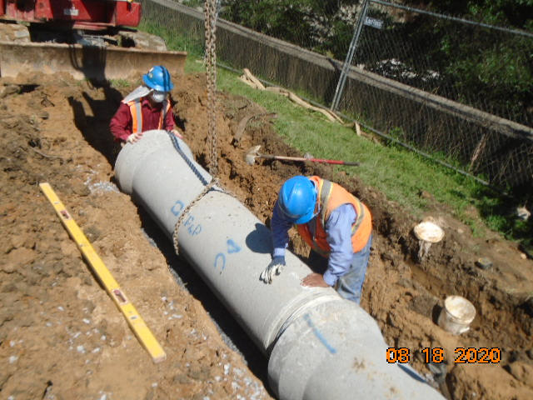
Phase D – Crew installing drainage pipes

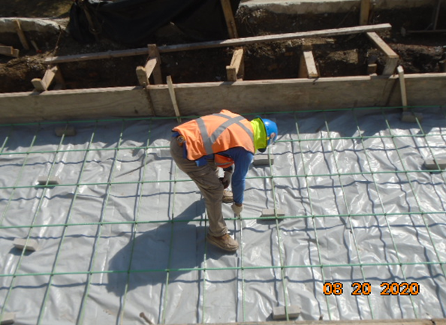
Phase D – Crew tying retaining wall footings rebars

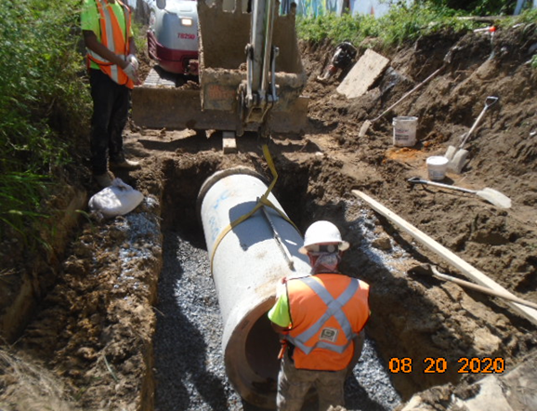
Phase D – Crew installing drainage pipes

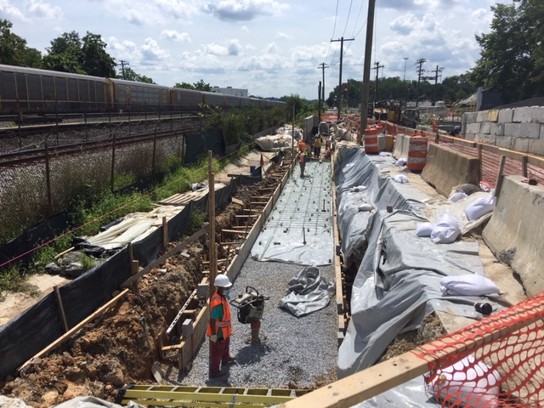
Phase D – Crew constructing retaining wall footing forms

