Metropolitan Branch Trail Design Build, South Segment
DC CONTRACT NO. DCKA-2016-C-0044
FAP No.: STP-2016 (060)

CONSTRUCTION MANAGER’S
WEEKLY PROGRESS REPORT

08/09/2020 – 08/15/2020

Project Website: www.metbranchtrail-forttotten.com
For Additional Trail Information Please see www.metbranchtrail.com

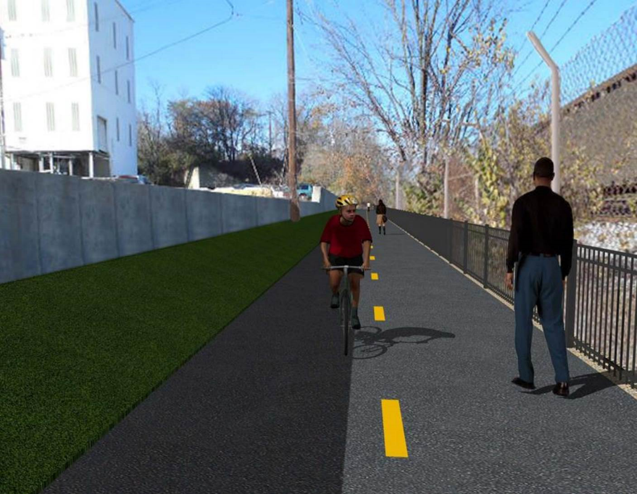

Proposed Metropolitan Branch Trail

1. PROJECT DESCRIPTION

The planned Metropolitan Branch Trail Project (“the Project”) consists of the design and construction of a new trail adjacent to CSX tracks and WMATA Red Line tracks along John McCormack Drive, adjacent to Fort Totten Metro Station, and on NPS property in NE, Washington D.C. The trail begins approximately 1500 feet south of Bates Road NE on the east side of John McCormack Drive NE, extending north along the WMATA and CSX tracks to the Fort Totten Metro Station tie in with First Place NE. An existing trail connection from Gallatin Road NE to the Fort Totten Metro Station will be reconstructed as a part of the Project.

The Project is 83.15% Federally-Funded and 16.85% District-Funded. Potomac Construction is the Design Build contractor.

Delon Hampton and Associates Chartered is providing Construction Management and Inspection services. Specific Construction Scope of Work includes:

- Provide mobilization and demobilization, provision and maintenance of Engineer’s field facilities, field layout, employee training, and other incidental work required for a quality, complete and finished product;
- Establishment and maintenance of vehicular and pedestrian traffic including signs, barricades and other transition devices; reconfiguring the devices in conjunction with changes in work areas; and their removal and disposal upon project completion, including restoration of disturbed areas;
- Clearing and grubbing, as required within the LOD;
- Removal of unsuitable material, excavation, and backfilling and pervious paving to construct a new trail;
- Protection of trees during construction;
- Provide ADA compliant trail connections and pedestrian ramps;
- Provide retaining walls as necessary to stay within the LOD and minimize property impacts following visual requirements specified for retaining walls on NPS property;
- Provide new permanent regulatory and wayfinding signs for the trail and all trail connection intersections;
- Provide road and trail pavement markings;
- Provide landscaping within the LOD for the Project including special requirements for landscaping on NPS property;
- Provide erosion and sediment control measures, storm water management facilities, including pervious asphalt pavement and bioretention facilities;
- Provide utility coordination, identification, locating, and protection of all utilities encountered during design and construction including relocation of Pepco poles along Aggregate Industries property; and
- Provide new WMATA security fencing between the trail and CSXT tracks.
- Remove existing sidewalk and widen sidewalk to 10’ along the west side of 1st place NE from Metropolitan Branch Trail to entrance to WMATA bus loop, on the west side.

2. STATUS OF CONSTRUCTION / PROGRESS SUMMARY

Work performed this week:

Design

- Phase D 3-ring binder for 100% Plans
- Stakeholders acceptance for Phase D Final Design Plans
- Railing Design Submittal to WMATA and DDOT
- CSX Approval of Phase D Means and Methods

Construction:

Phase B

- Demobilized staging area
- Demolished and removed temporary asphalt at Gallatin Street, N.E. connection area.
- Graded ditch and placed topsoil along the North side of the trail
- Hauled away excavated materials from site

Phase D

- Demolished and removed existing concrete slab
- Excavated retaining wall footings
- Constructed retaining wall footings forms
- Excavated drainage pipes trench
- Placed drainage pipes bedding stone
- Installed and backfilled drainage pipes
- Constructed drainage manhole
- Demolished existing concrete ditch
- Delivered perforated drainage pipes
- CSX flagger’s operation and safety tool box talk

CM Consultant:

- Monitored construction progress, make sure all applicable inspections and testing were
performed
- Reviewed Inspection Daily Reports
- Reviewed Change Order Package
- Attended DDOT CM Project Coordination Meeting
- Attended QAQC Meeting
- Updated Project Files
- Update Project Webpage
- Updated documents in SharePoint
- Communication with the stakeholder in terms of submittals

3. MEETINGS / PROJECT COORDINATION

Wed 08/12/20 DHA DDOT Coordination Meeting conference call was held at 1:00 P.M.
Fri 08/14/20 QAQC Meeting conference call was held at 10:00 A.M.

4. DAILY WORK PERFORMED

Sun 08/09/20 No work performed.
Mon 08/10/20 Phase B – Demobilized staging area. Hauled away excavated material
from site.
Phase B – Electrical work – No work scheduled.
Phase D – Demolished and removed existing concrete slab. Tied wedge wall rebars. Constructed wedge wall forms. Installed underdrain pipes. Demolished and removed existing concrete ditch. Excavated drainage pipes trench. Placed drainage pipes bedding stone. Installed and backfilled drainage pipes. Placed concrete at drainage manhole base. Demolished concrete ditch. Installed temporary drainage pipes. Hauled away excavated materials from the site.
Tue 08/11/20 Phase B – Demolished and removed temporary asphalt placed along the
North Side of the trail connection area at Gallatin Street N.E. Graded ditch and placed topsoil along the North side of the trail. Hauled away excavated materials from the site.
Electrical Work – Electrical work – No work scheduled.
Phase D – Demolished and removed existing concrete slab. Tied wedge wall rebars. Constructed wedge wall forms. Installed underdrain pipes. Demolished and removed existing concrete ditch. Excavated drainage pipes trench. Placed drainage pipes bedding stone. Installed and backfilled drainage pipes. Tied rebars and place concrete for manhole base. Demolished concrete ditch. Installed temporary drainage pipes. Hauled away excavated materials from site.
Wed 08/12/20 Phase B – No work performed due to rain.
Phase B - Electrical Work – No work scheduled.
Phase D –Demolished and removed existing concrete slab. Excavated retaining wall footings. Hauled away excavated materials from the site.
Thurs 08/13/20 Phase B – No work performed due to rain.
Phase B – Electrical – No work scheduled.
Phase D – No work performed due to rain.
Fri 08/14/20 Phase B – No work performed due to wet site condition
Phase B – Electrical – No work scheduled.
Phase D – Installed retaining wall rebars. Constructed retaining wall forms. Excavated drainage pipes trench. Placed drainage pipes bedding stone. Installed and backfilled drainage pipes. Constructed drainage manhole.
Sat 08/15/20 No work scheduled

5. INSPECTION & MATERIAL TESTS PERFORMED

Jobsite Safety Inspection  Erosion and Sediment Control inspection  MOT Inspection  Compaction Test - Passed  Asphalt Material Testing  Concrete Material Testing – Results Pending  ** Note - Additional Material Test Results can be found on DDOT QA QC Material Division Tracking SharePoint website. | Infiltration Tests  Dynamic Cone Penetration (DCP) Tests  Rebars Inspection - Passed
6. DBE PARTICIPATION SUMMARIES

Potomac Construction (Contractor)
- DBE Goal for Contractor is 15%. To-date the Contractor has achieved 40% of their goal.

Delon Hampton & Associates (CM)
- DBE Goal for the CM is 10%. To-date the CM has achieved 18% of their Goal.

7. ACCIDENTS / INCIDENTS

None occurred on-site during this week.

8. PHOTOS OF THE WORK PERFORMED

12. PHOTOS OF WORK PERFORMED THIS PERIOD

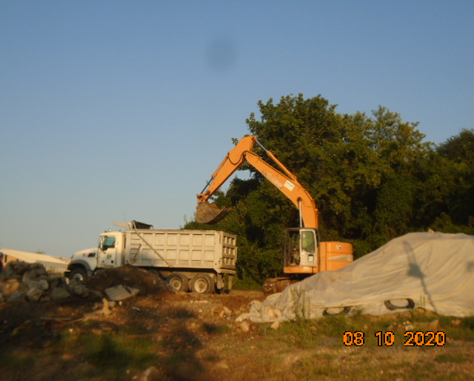
Phase B – Crew hauling away excavated material from the site

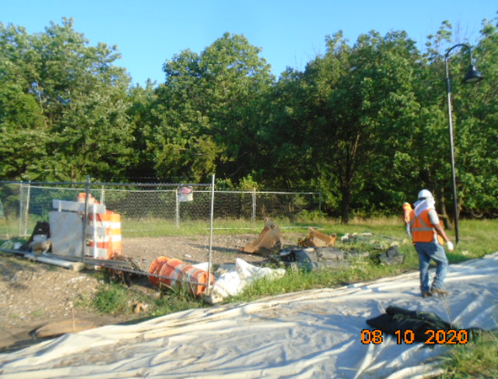
Phase B – Crew demobilizing staging area
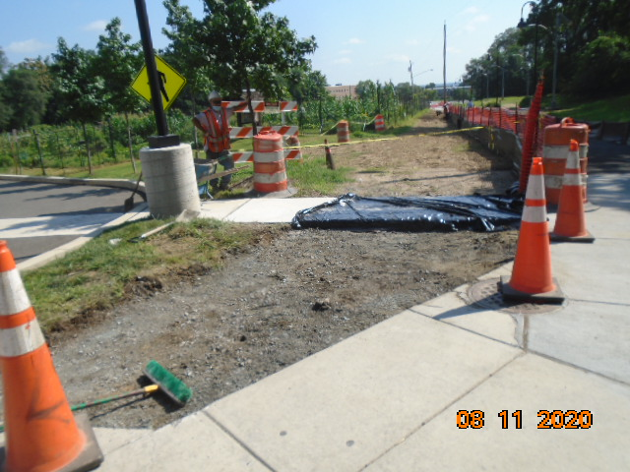
Phase B – Crew regraded area along the North side of the trail

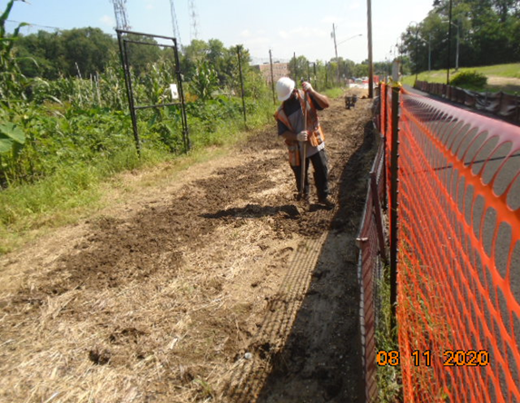
Phase B – Crew applying topsoil along the North side of the trail

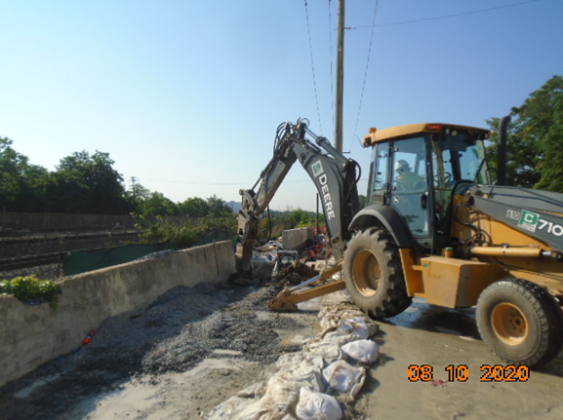
Phase D – Crew demolishing existing concrete slab

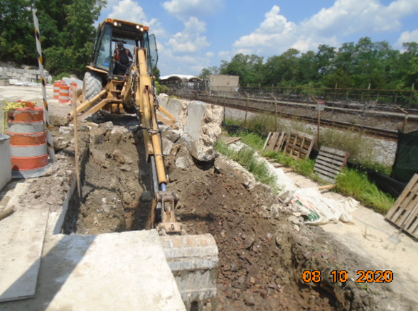
Phase D – Crew excavating retaining wall footing
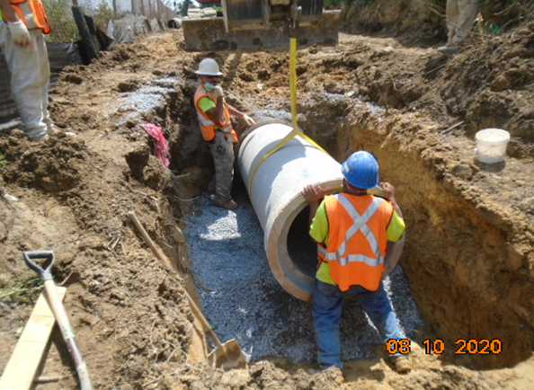
Phase D – Crew installing drainage pipes

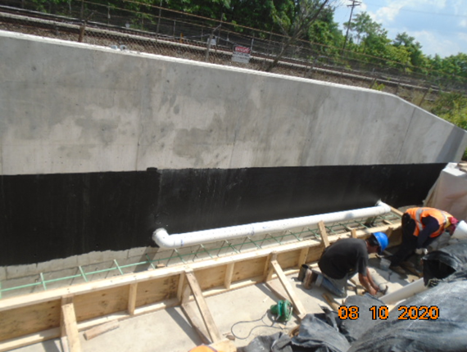
Phase D – Crew constructing wedge wall forms and installing underdrain
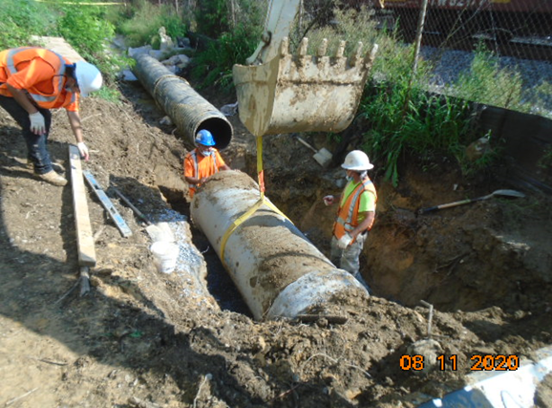
Phase D – Crew installing drainage pipes

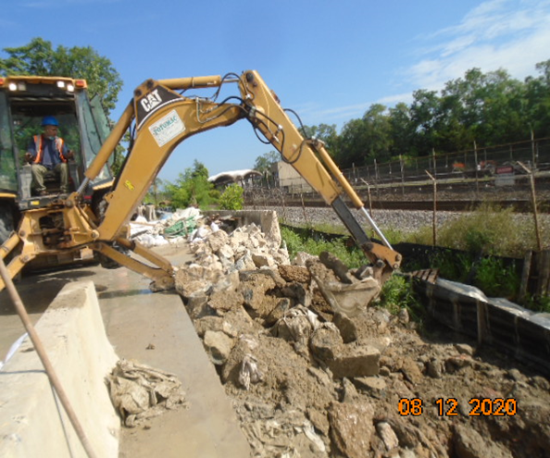
Phase D – Crew demolishing existing concrete slab

