Metropolitan Branch Trail Design Build, South Segment
DC CONTRACT NO. DCKA-2016-C-0044
FAP No.: STP-2016 (060)

CONSTRUCTION MANAGER’S
WEEKLY PROGRESS REPORT

08/02/2020 – 08/08/2020

Project Website: www.metbranchtrail-forttotten.com
For Additional Trail Information Please see www.metbranchtrail.com

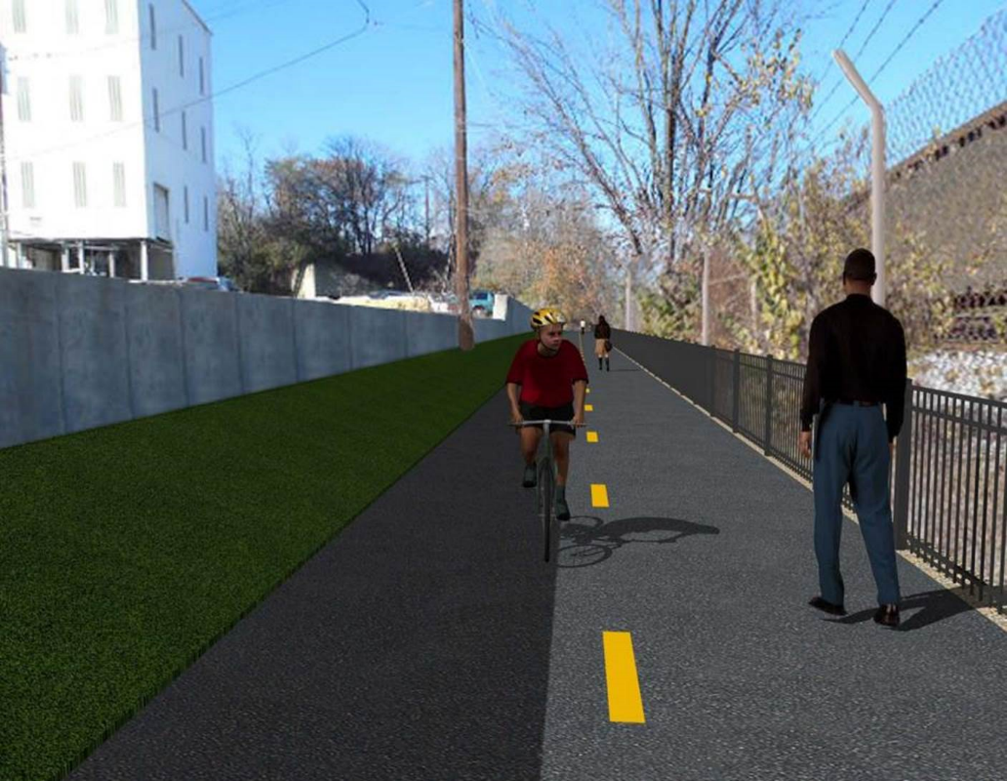

Proposed Metropolitan Branch Trail

1. PROJECT DESCRIPTION

The planned Metropolitan Branch Trail Project (“the Project”) consists of the design and construction of a new trail adjacent to CSX tracks and WMATA Red Line tracks along John McCormack Drive, adjacent to Fort Totten Metro Station, and on NPS property in NE, Washington D.C. The trail begins approximately 1500 feet south of Bates Road NE on the east side of John McCormack Drive NE, extending north along the WMATA and CSX tracks to the Fort Totten Metro Station tie in with First Place NE. An existing trail connection from Gallatin Road NE to the Fort Totten Metro Station will be reconstructed as a part of the Project.

The Project is 83.15% Federally-Funded and 16.85% District-Funded. Potomac Construction is the Design Build contractor.

Delon Hampton and Associates Chartered is providing Construction Management and Inspection services. Specific Construction Scope of Work includes:

- Provide mobilization and demobilization, provision and maintenance of Engineer’s field facilities, field layout, employee training, and other incidental work required for a quality, complete and finished product;
- Establishment and maintenance of vehicular and pedestrian traffic including signs, barricades and other transition devices; reconfiguring the devices in conjunction with changes in work areas; and their removal and disposal upon project completion, including restoration of disturbed areas;
- Clearing and grubbing, as required within the LOD;
- Removal of unsuitable material, excavation, and backfilling and pervious paving to construct a new trail;
- Protection of trees during construction;
- Provide ADA compliant trail connections and pedestrian ramps;
- Provide retaining walls as necessary to stay within the LOD and minimize property impacts following visual requirements specified for retaining walls on NPS property;
- Provide new permanent regulatory and wayfinding signs for the trail and all trail connection intersections;
- Provide road and trail pavement markings;
- Provide landscaping within the LOD for the Project including special requirements for landscaping on NPS property;
- Provide erosion and sediment control measures, storm water management facilities, including pervious asphalt pavement and bioretention facilities;
- Provide utility coordination, identification, locating, and protection of all utilities encountered during design and construction including relocation of Pepco poles along Aggregate Industries property; and
- Provide new WMATA security fencing between the trail and CSXT tracks.
- Remove existing sidewalk and widen sidewalk to 10’ along the west side of 1st place NE from Metropolitan Branch Trail to entrance to WMATA bus loop, on the west side.

2. STATUS OF CONSTRUCTION / PROGRESS SUMMARY

Work performed this week:

Design

- Phase D 3-ring binder for 100% Plans
- Stakeholders acceptance for Phase D Final Design Plans
- Railing Design Submittal to WMATA and DDOT
- CSX Approval of Phase D Means and Methods

Construction:

Phase B

- Constructed Bioswale check dams along the north side of the trail
- Fabricated gabion baskets
- Installed gabion baskets in the Bioswale
- Demolished existing sidewalk concrete at Gallatin Street
- Constructed sidewalk, curb and gutter and ADA ramp forms
- Poured sidewalk, curb and gutter and ADA ramp concrete
- Hauled away excavated materials from the site

Phase D

- Stripped retaining wall concrete
- Demolished and removed existing concrete slab
- Excavated retaining wall footings
- Applied water proofing at retaining wall
- Excavated drainage pipes trench
- Placed drainage pipes bedding stone
- Installed and backfilled drainage pipes
- Constructed brick manhole
- Removed existing WMATA fence
- Installed temporary fence
- Installed super silt fence
- Delivered perforated drainage pipes
- CSX flagger’s operation and safety tool box talk

CM Consultant:

- Monitored construction progress, make sure all applicable inspections and testing were
performed
- Reviewed Inspection Daily Reports
- Reviewing Change Order Package
- Attended Change Order Negotiation Meeting
- Attended QAQC Meeting
- Updated Project Files
- Update Project Webpage
- Updating documents in SharePoint
- Communication with the stakeholder in terms of submittals

3. MEETINGS / PROJECT COORDINATION

Tue 08/04/20 MBT Progress Meeting conference call was held at 10:00A.M.
Thurs 08/06/20 DDOT DHA and PCCI Change Order Negotiation Meeting conference
call was held at 10:00 A.M.
Fri 08/07/20 QAQC Meeting conference call was held at 10:00 A.M.

4. DAILY WORK PERFORMED

Sun 08/02/20 No work performed.
Mon 08/03/20 Phase B – Constructed Bioswale check dam along the North side of the
trail. Installed prefabricated gabion baskets and riprap in the Bioswale. Hauled away excavated material from the site.
Phase B – Electrical work – No work scheduled.
Phase D – Stripped retaining wall forms. Demolished and removed existing concrete slab. Excavated drainage pipes trench. Placed drainage pipes bedding stone. Installed and backfilled drainage pipes. Constructed brick manhole. Hauled away excavated materials from the site.
Tue 08/04/20 Phase B – Work cancelled due to rain.
Electrical Work – Electrical work – No work scheduled.
Phase D – Work cancelled due to rain.
Wed 08/05/20 Phase B – Constructed Bioswale check dams. Installed prefabricated
gabion baskets in the Bioswale. Demolished existing sidewalk and removed demolished concrete from job site. Performed formwork for side walk concrete. Hauled away excavated material from the
site.
Phase B - Electrical Work – No work scheduled.
Phase D – Stripped retaining wall forms. Demolished and removed existing concrete slab. Excavated retaining wall footings. Applied waterproofing membrane along the retaining wall inner face. Excavated drainage pipes trench. Constructed brick manhole. Removed existing WMATA fence and installed temporary fence. Installed super silt fence. Delivered perforated drainage pipe. Hauled away excavated materials from the site.
Thurs 08/06/20 Phase B – Work cancelled due to wet site conditions from overnight
rain.
Phase B – Electrical – No work scheduled.
Phase D – Work cancelled due to wet site conditions from overnight
rain.
Fri 08/07/20 Phase B – Placed sidewalk, curb and gutter and ramp concrete.
Installed gabion baskets in the Bioswale.
Phase B – Electrical – No work scheduled.
Phase D –Excavated and backfilled drainage manholes. Excavated retaining wall footings.
Sat 08/08/20 No work scheduled

5. INSPECTION & MATERIAL TESTS PERFORMED

Jobsite Safety Inspection  Erosion and Sediment Control inspection  MOT Inspection  Compaction Test - Passed  Asphalt Material Testing  Concrete Material Testing – Results Pending  ** Note - Additional Material Test Results can be found on DDOT QA QC Material Division Tracking SharePoint website. | Infiltration Tests  Dynamic Cone Penetration (DCP) Tests  Rebars Inspection - Passed
6. DBE PARTICIPATION SUMMARIES

Potomac Construction (Contractor)
- DBE Goal for Contractor is 15%. To-date the Contractor has achieved 40% of their goal.

Delon Hampton & Associates (CM)
- DBE Goal for the CM is 10%. To-date the CM has achieved 18% of their Goal.

7. ACCIDENTS / INCIDENTS

None occurred on-site during this week.

8. PHOTOS OF THE WORK PERFORMED

12. PHOTOS OF WORK PERFORMED THIS PERIOD

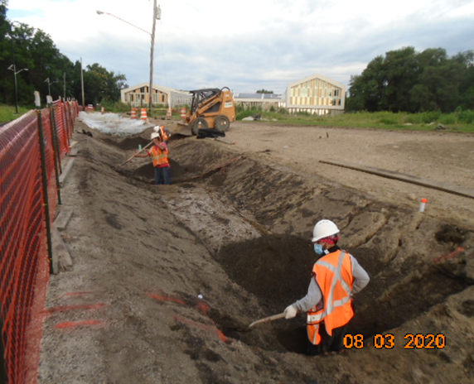
Phase B – Crew excavating check dams in the Bioswale

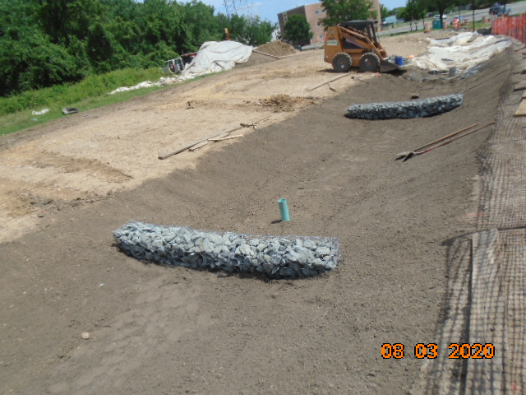
Phase B – Crew installing gabion baskets in the Bioswale.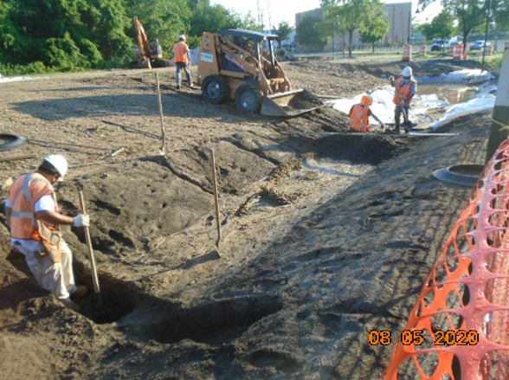
Phase B – Crew constructing Bioswale check dams

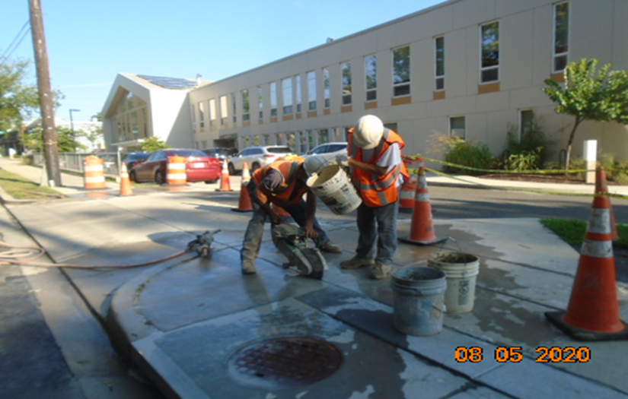
Phase B – Crew saw-cutting existing sidewalk concrete

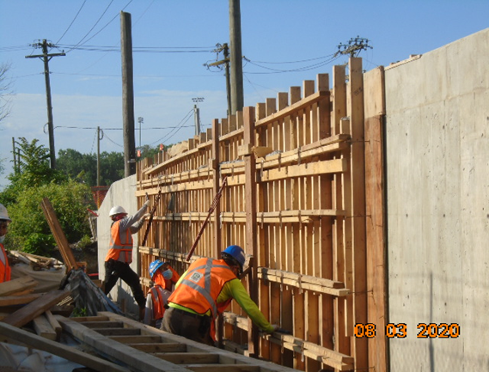
Phase D – Crew stripping retaining wall forms

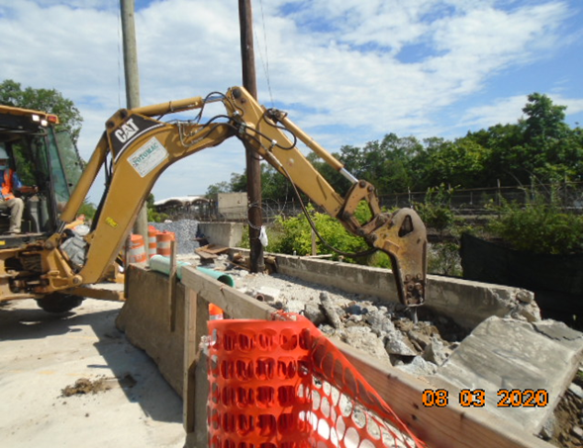
Phase D – Crew demolishing existing concrete slab

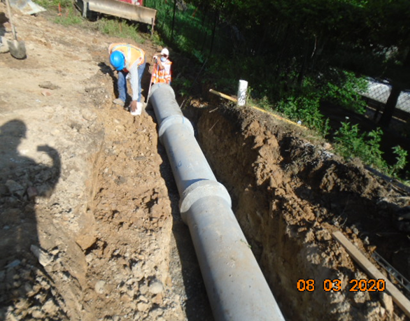
Phase D – Crew installing drainage pipes

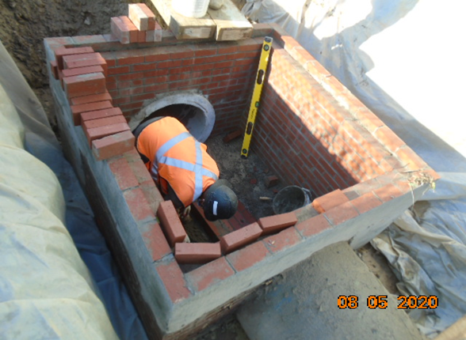
Phase D – Crew constructing brick manhole

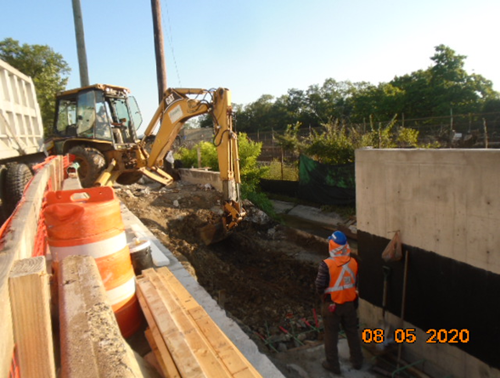
Phase D – Crew excavating retaining wall footing

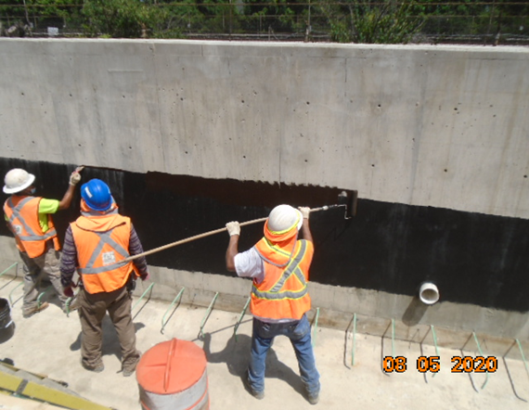
Phase D – Crew applying water proofing at retaining wall

