Metropolitan Branch Trail Design Build, South Segment
DC CONTRACT NO. DCKA-2016-C-0044
FAP No.: STP-2016 (060)

CONSTRUCTION MANAGER’S
WEEKLY PROGRESS REPORT

07/26/2020 – 08/01/2020

Project Website: www.metbranchtrail-forttotten.com
For Additional Trail Information Please see www.metbranchtrail.com

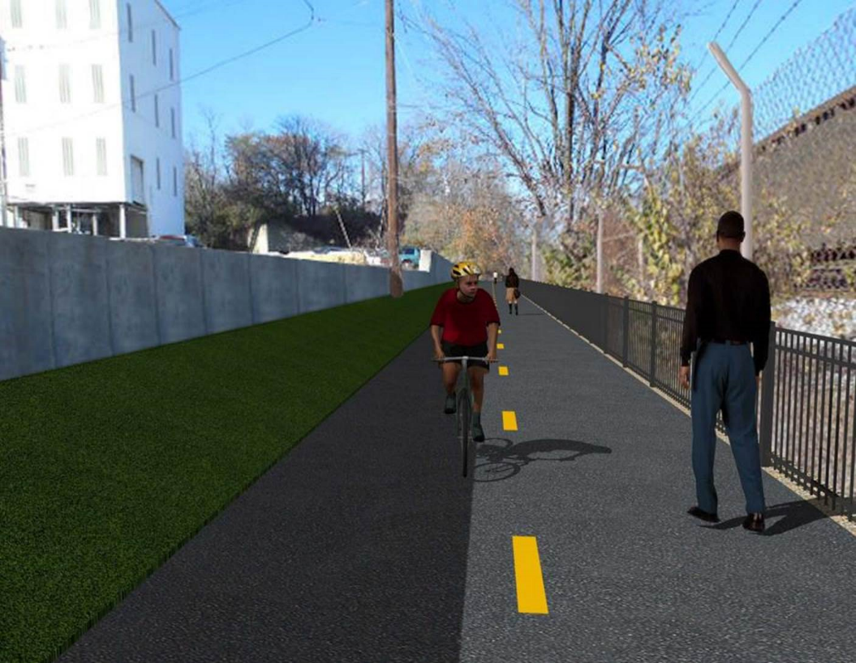

Proposed Metropolitan Branch Trail

1. PROJECT DESCRIPTION

The planned Metropolitan Branch Trail Project (“the Project”) consists of the design and construction of a new trail adjacent to CSX tracks and WMATA Red Line tracks along John McCormack Drive, adjacent to Fort Totten Metro Station, and on NPS property in NE, Washington D.C. The trail begins approximately 1500 feet south of Bates Road NE on the east side of John McCormack Drive NE, extending north along the WMATA and CSX tracks to the Fort Totten Metro Station tie in with First Place NE. An existing trail connection from Gallatin Road NE to the Fort Totten Metro Station will be reconstructed as a part of the Project.

The Project is 83.15% Federally-Funded and 16.85% District-Funded. Potomac Construction is the Design Build contractor.

Delon Hampton and Associates Chartered is providing Construction Management and Inspection services. Specific Construction Scope of Work includes:

- Provide mobilization and demobilization, provision and maintenance of Engineer’s field facilities, field layout, employee training, and other incidental work required for a quality, complete and finished product;
- Establishment and maintenance of vehicular and pedestrian traffic including signs, barricades and other transition devices; reconfiguring the devices in conjunction with changes in work areas; and their removal and disposal upon project completion, including restoration of disturbed areas;
- Clearing and grubbing, as required within the LOD;
- Removal of unsuitable material, excavation, and backfilling and pervious paving to construct a new trail;
- Protection of trees during construction;
- Provide ADA compliant trail connections and pedestrian ramps;
- Provide retaining walls as necessary to stay within the LOD and minimize property impacts following visual requirements specified for retaining walls on NPS property;
- Provide new permanent regulatory and wayfinding signs for the trail and all trail connection intersections;
- Provide road and trail pavement markings;
- Provide landscaping within the LOD for the Project including special requirements for landscaping on NPS property;
- Provide erosion and sediment control measures, storm water management facilities, including pervious asphalt pavement and bioretention facilities;
- Provide utility coordination, identification, locating, and protection of all utilities encountered during design and construction including relocation of Pepco poles along Aggregate Industries property; and
- Provide new WMATA security fencing between the trail and CSXT tracks.
- Remove existing sidewalk and widen sidewalk to 10’ along the west side of 1st place NE from Metropolitan Branch Trail to entrance to WMATA bus loop, on the west side.

2. STATUS OF CONSTRUCTION / PROGRESS SUMMARY

Work performed this week:

Design

- Phase D 3-ring binder for 100% Plans
- Stakeholders acceptance for Phase D Final Design Plans
- Railing Design Submittal to WMATA and DDOT
- WMATA Approval of Full Construction Permit
- CSX Approval of Phase D Means and Methods

Construction:

Phase B

- Constructed Bioswale check dams along the north side of the trail
- Fabricated gabion baskets
- Installed gabion baskets at the Bioswale
- Hauled away excavated materials from the site

Phase D

- Placed retaining wall concrete
- Wet cured retaining wall concrete
- Constructed retaining wall forms
- Tied retaining wall rebars
- Applied waterproofing at retaining wall inner face
- Excavated drainage pipes trench
- Placed drainage pipes bedding stone
- Installed and backfilled drainage pipes
- Installed and backfilled drainage manholes
- CSX flagger’s operation and safety tool box talk

CM Consultant:

- Monitored construction progress, make sure all applicable inspections and testing were
performed
- Reviewed Inspection Daily Reports
- Reviewing Change Order Package
- Attended QAQC Meeting
- Updated Project Files
- Update Project Webpage
- Updating documents in SharePoint
- Communication with the stakeholder in terms of submittals

3. MEETINGS / PROJECT COORDINATION

Wed 07/29/20 DDOT DHA Meeting conference call was held at 10:00A.M.
Fri 07/31/20 QAQC Meeting conference call was held at 10:00 A.M.

4. DAILY WORK PERFORMED

Sun 07/26/20 No work performed.
Mon 07/27/20 Phase B – Constructed Bioswale check dam along the North side of the
trail. Installed prefabricated gabion basket and riprap in the bioretention filter media. Hauled away excavated material from the site.
Phase B – Electrical work – No work performed.
Phase D – Constructed retaining wall inner face forms. Excavated drainage pipes trench. Placed drainage manhole base concrete. Placed bedding stone for drainage pipes. Installed and backfilled drainage pipes. Installed drainage inlet.
Tue 07/28/20 Phase B – Constructed Bioswale check dam along the North side of the
trail. Installed prefabricated gabion basket and riprap in the bioretention filter media. Hauled away excavated material from the site.
Electrical Work – Electrical work – No work performed
Phase D – Placed retaining wall concrete. Installed temporary drainage pipes. Excavated drainage pipes trench. Placed bedding stone for drainage pipes. Installed and backfilled drainage pipes. Constructed brick manhole.
Wed 07/29/20 Phase B – Constructed Bioswale check dams. Installed prefabricated
gabion baskets in the Bioswale. Hauled away excavated material from the
site.
Phase B - Electrical Work – No work performed
Phase D – Wet cured retaining wall concrete. Stripped retaining wall forms. Excavated drainage pipes trench. Placed bedding stone for drainage pipes. Installed and backfilled drainage pipes. Constructed brick manhole.
Thurs 07/30/20 Phase B – Constructed Bioswale check dams. Installed prefabricated
gabion baskets in the Bioswale. Hauled away excavated material from the
site.
Phase B – Electrical – No work performed
Phase D – Wet cured retaining wall concrete. Stripped retaining wall forms. Applied waterproofing membrane at the inner face of retaining wall. Placed bedding stone for drainage pipes. Installed and backfilled drainage pipes. Constructed brick manhole.
Fri 07/31/20 Phase B – Work cancelled due to wet site condition
Phase B – Electrical – No work performed.
Phase D – Work cancelled due to wet site condition.
Sat 08/01/20 No work scheduled

5. INSPECTION & MATERIAL TESTS PERFORMED

Jobsite Safety Inspection  Erosion and Sediment Control inspection  MOT Inspection  Compaction Test - Passed  Asphalt Material Testing  Concrete Material Testing – Results Pending  ** Note - Additional Material Test Results can be found on DDOT QA QC Material Division Tracking SharePoint website. | Infiltration Tests  Dynamic Cone Penetration (DCP) Tests  Rebars Inspection – Passed
6. DBE PARTICIPATION SUMMARIES

Potomac Construction (Contractor)
- DBE Goal for Contractor is 15%. To-date the Contractor has achieved 40% of their goal.

Delon Hampton & Associates (CM)
- DBE Goal for the CM is 10%. To-date the CM has achieved 18% of their Goal.

7. ACCIDENTS / INCIDENTS
None occurred on-site during this week.

8. PHOTOS OF THE WORK PERFORMED

12. PHOTOS OF WORK PERFORMED THIS PERIOD

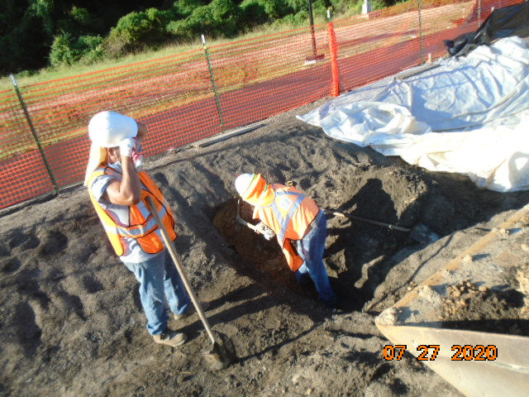
Phase B – Crew excavating Bioswale check dam

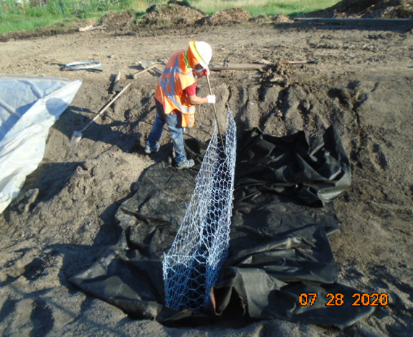
Phase B – Crew constructing Bioswale check dam

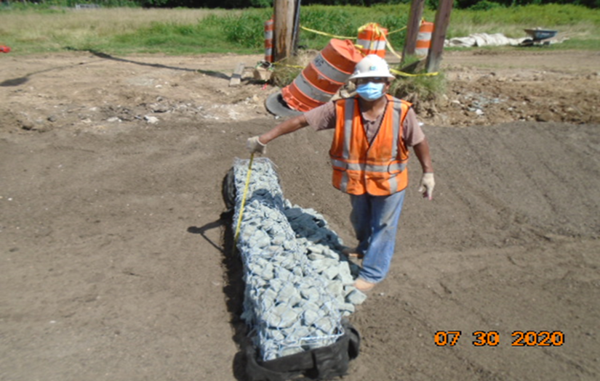
Phase B – Crew installing gabion basket at the Bioswale

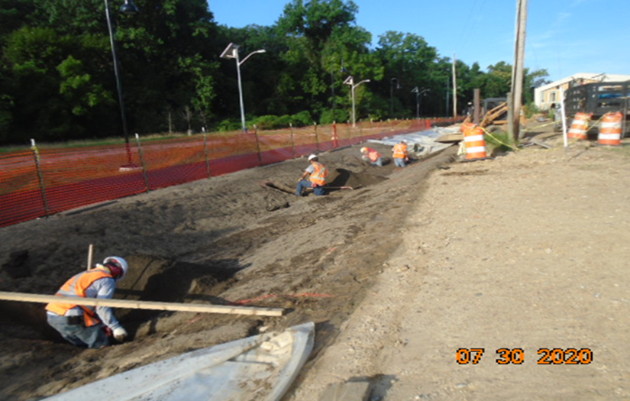
Phase B – Crew constructing check dam at the Bioswale

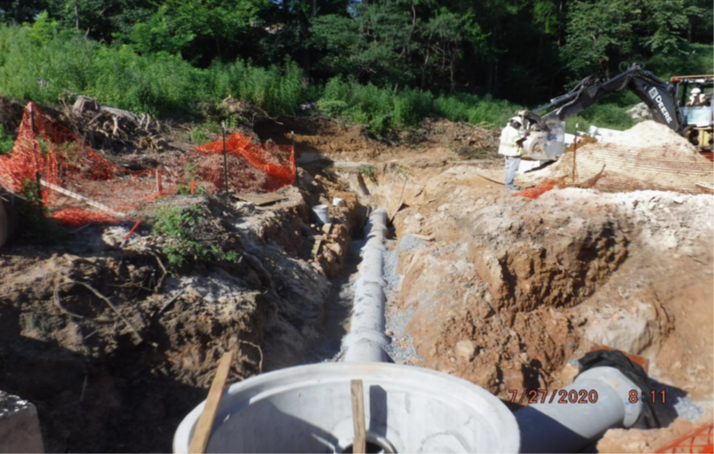
Phase D – Crew installing drainage pipes

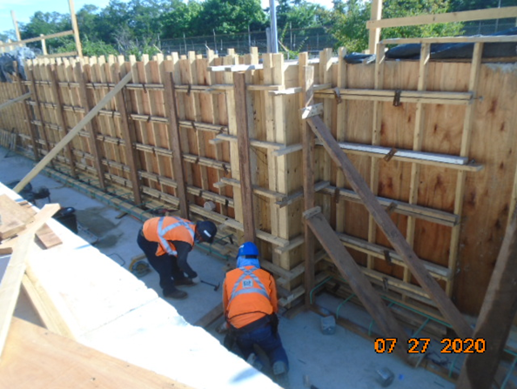
Phase D – Crew constructing retaining wall forms

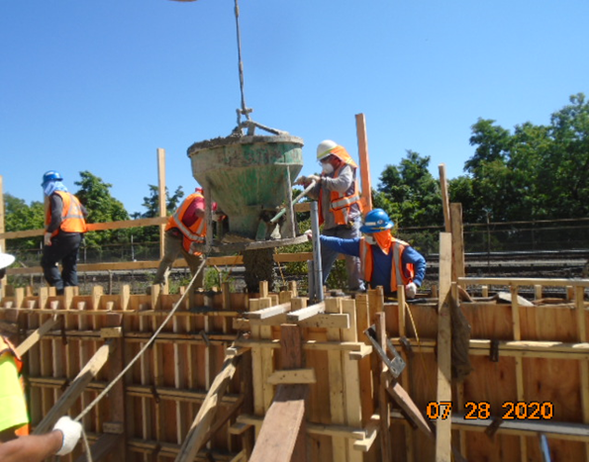
Phase D – Crew placing retaining wall concrete

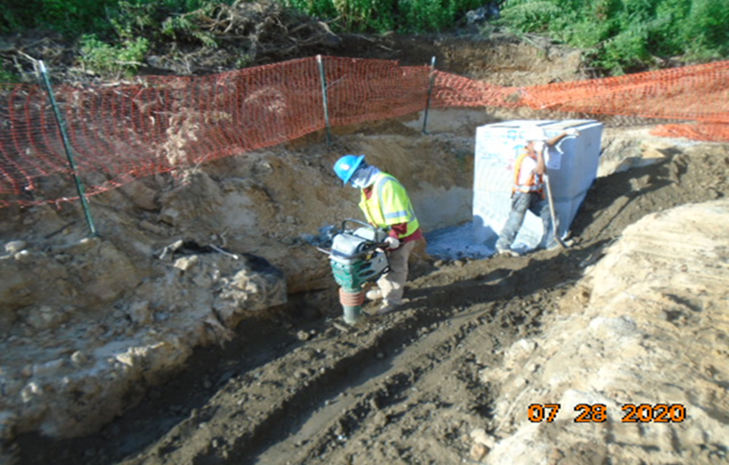
Phase D – Crew compacting trench backfill

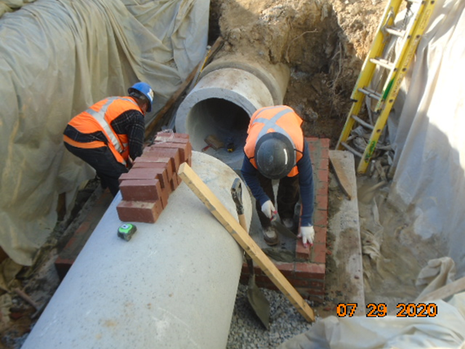
Phase D – Crew constructing brick manhole

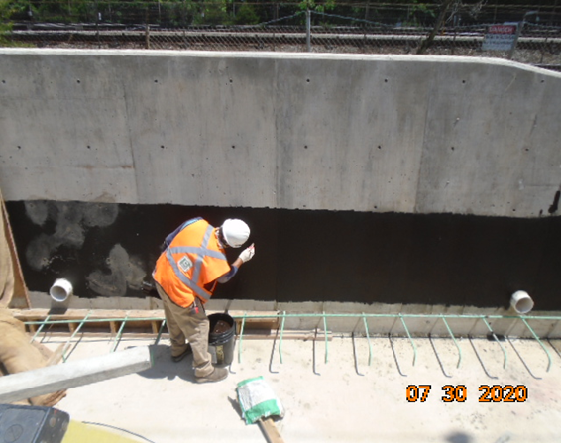
Phase D – Crew applying water proofing on retaining wall

