Metropolitan Branch Trail Design Build, South Segment
DC CONTRACT NO. DCKA-2016-C-0044
FAP No.: STP-2016 (060)

CONSTRUCTION MANAGER’S
WEEKLY PROGRESS REPORT

07/19/2020 – 07/25/2020

Project Website: www.metbranchtrail-forttotten.com
For Additional Trail Information Please see www.metbranchtrail.com

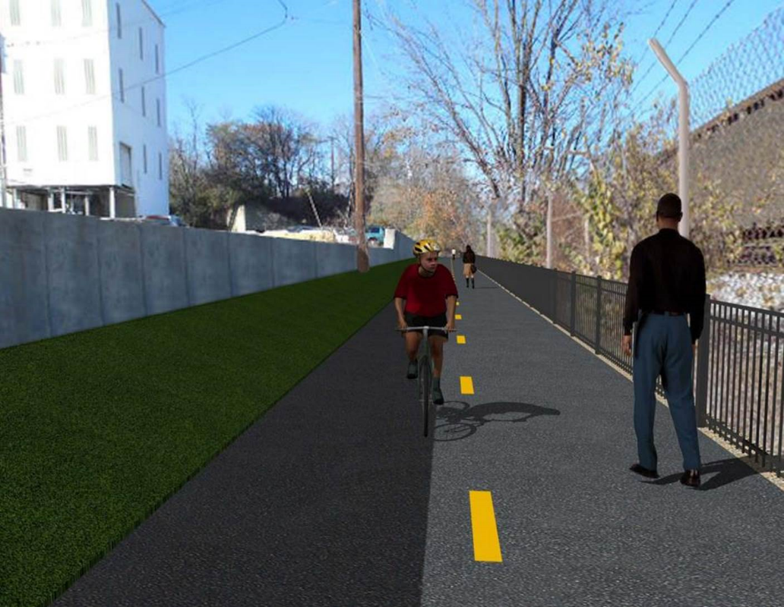

Proposed Metropolitan Branch Trail

1. PROJECT DESCRIPTION

The planned Metropolitan Branch Trail Project (“the Project”) consists of the design and construction of a new trail adjacent to CSX tracks and WMATA Red Line tracks along John McCormack Drive, adjacent to Fort Totten Metro Station, and on NPS property in NE, Washington D.C. The trail begins approximately 1500 feet south of Bates Road NE on the east side of John McCormack Drive NE, extending north along the WMATA and CSX tracks to the Fort Totten Metro Station tie in with First Place NE. An existing trail connection from Gallatin Road NE to the Fort Totten Metro Station will be reconstructed as a part of the Project.

The Project is 83.15% Federally-Funded and 16.85% District-Funded. Potomac Construction is the Design Build contractor.

Delon Hampton and Associates Chartered is providing Construction Management and Inspection services. Specific Construction Scope of Work includes:

- Provide mobilization and demobilization, provision and maintenance of Engineer’s field facilities, field layout, employee training, and other incidental work required for a quality, complete and finished product;
- Establishment and maintenance of vehicular and pedestrian traffic including signs, barricades and other transition devices; reconfiguring the devices in conjunction with changes in work areas; and their removal and disposal upon project completion, including restoration of disturbed areas;
- Clearing and grubbing, as required within the LOD;
- Removal of unsuitable material, excavation, and backfilling and pervious paving to construct a new trail;
- Protection of trees during construction;
- Provide ADA compliant trail connections and pedestrian ramps;
- Provide retaining walls as necessary to stay within the LOD and minimize property impacts following visual requirements specified for retaining walls on NPS property;
- Provide new permanent regulatory and wayfinding signs for the trail and all trail connection intersections;
- Provide road and trail pavement markings;
- Provide landscaping within the LOD for the Project including special requirements for landscaping on NPS property;
- Provide erosion and sediment control measures, storm water management facilities, including pervious asphalt pavement and bioretention facilities;
- Provide utility coordination, identification, locating, and protection of all utilities encountered during design and construction including relocation of Pepco poles along Aggregate Industries property; and
- Provide new WMATA security fencing between the trail and CSXT tracks.
- Remove existing sidewalk and widen sidewalk to 10’ along the west side of 1st place NE from Metropolitan Branch Trail to entrance to WMATA bus loop, on the west side.

2. STATUS OF CONSTRUCTION / PROGRESS SUMMARY

Work performed this week:

Design

- Phase D 3-ring binder for 100% Plans
- Stakeholders acceptance for Phase D Final Design Plans
- Railing Design Submittal to WMATA and DDOT
- WMATA Approval of Full Construction Permit
- CSX Approval of Phase D Means and Methods

Construction:

Phase B

- Performed Bioswale construction along the North side of the trail
- Excavated and graded ditch along the North side of the trail
- Placed and graded plant bed soil at the Bioswale
- Placed bioretention soil at the Bioswale
- Repaired silt fence
- Delivered plant bed soil
- Hauled away excavated materials from the site

Phase D

- Placed retaining wall concrete
- Wet cured retaining wall concrete
- Constructed retaining wall forms
- Tied retaining wall rebars
- Demolished existing concrete ditch
- Excavated drainage pipes trench
- Placed drainage pipes bedding stone
- Installed and backfilled drainage pipes
- Installed and backfilled drainage manhole
- Delivered drainage pipes and manhole
- CSX flagger’s operation and safety tool box talk

CM Consultant:

- Monitored construction progress, make sure all applicable inspections and testing were
performed
- Reviewed Inspection Daily Reports
- Reviewing Change Order Package
- Reviewed Monthly Payment Invoice
- Attended DDOT CSX PCCI and Designer Coordination Meeting conference call
- Attended Project Progress Meeting conference call
- Attended QAQC Meeting
- Updated Project Files
- Update Project Webpage
- Updating documents in SharePoint
- Communication with the stakeholder in terms of submittals

3. MEETINGS / PROJECT COORDINATION

Mon 07/20/20 DDOT CSX PCCI and Designer Coordination Meeting conference call
was held at 11:00 A.M.
Fri 07/17/20 QAQC Meeting conference call was held at 10:00 A.M.

4. DAILY WORK PERFORMED

Sun 07/19/20 No work performed.
Mon 07/20/20 Phase B – Constructed Bioswale. Excavated and graded slope line along
the North side of the trail. Hauled away excavated material from the site.
Phase B – Electrical work – No work performed.
Phase D – Placed retaining wall concrete. Excavated drainage pipes trench. Placed bedding stone for drainage pipes. Installed and backfilled drainage pipes.
Tue 07/21/20 Phase B – Constructed Bioswale. Excavated and graded slope line along
the North side of the trail. Hauled away excavated material from the site. Repaired silt fence.
Electrical Work – Electrical work – No work performed
Phase D – Wet cured retaining wall concrete. Tied retaining wall rebars. Constructed retaining wall inner face forms. Demolished and removed existing concrete ditch. Installed temporary drainage pipes. Excavated drainage pipes trench. Placed bedding stone for drainage pipes. Installed and backfilled drainage pipes. Installed drainage manhole. Delivered drainage pipes.
Wed 07/22/20 Phase B – Constructed Bioswale check dams. Fabricated gabion baskets.
Excavated bioretention filter media.
Phase B - Electrical Work – No work performed
Phase D – Wet cured retaining wall concrete. Tied retaining wall rebars. Constructed retaining wall inner face forms. Demolished and removed existing concrete ditch. Excavated drainage pipes trench. Placed bedding stone for drainage pipes. Installed and backfilled drainage pipes. Installed drainage manhole.
Thurs 07/23/20 Phase B – Cleaned site and repaired silt fence. Delivered rip rap.
Phase B – Electrical – No work performed
Phase D – Wet cured retaining wall concrete. Strip retaining wall forms. Tied drainage manhole base rebars. Excavated drainage pipes trench. Installed pipes and backfilled trench. Constructed retaining wall inner face forms.
Fri 07/24/20 Phase B – Cleaned site. No work performed due to wet site condition.
Phase B – Electrical – No work performed.
Phase D – Constructed retaining wall inner face forms. Drainage pipes and manhole installation work cancelled due to wet site condition.

Sat 07/25/20 No work scheduled

5. INSPECTION & MATERIAL TESTS PERFORMED

Jobsite Safety Inspection  Erosion and Sediment Control inspection  MOT Inspection  Compaction Test - Passed  Asphalt Material Testing  Concrete Material Testing – Results Pending  ** Note - Additional Material Test Results can be found on DDOT QA QC Material Division Tracking SharePoint website. | Infiltration Tests  Dynamic Cone Penetration (DCP) Tests  Rebars Inspection – Ongoing
6. DBE PARTICIPATION SUMMARIES

Potomac Construction (Contractor)
- DBE Goal for Contractor is 15%. To-date the Contractor has achieved 40% of their goal.

Delon Hampton & Associates (CM)
- DBE Goal for the CM is 10%. To-date the CM has achieved 18% of their Goal.

7. ACCIDENTS / INCIDENTS
None occurred on-site during this week.

8. PHOTOS OF THE WORK PERFORMED

12. PHOTOS OF WORK PERFORMED THIS PERIOD

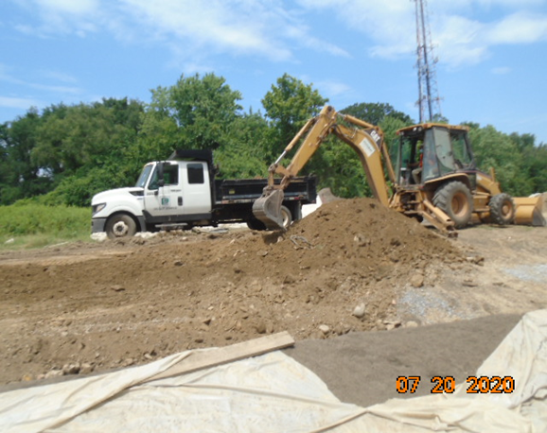
Phase B – Crew excavating slope line along the North side of the trail

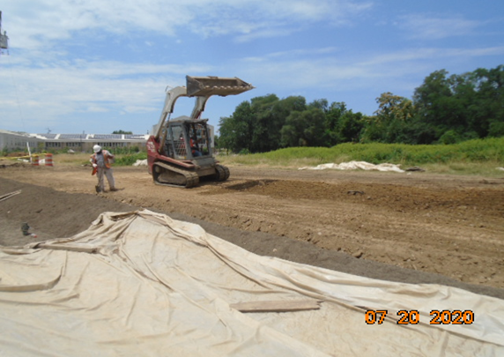
Phase B – Crew grading slope line along the North side of the trail

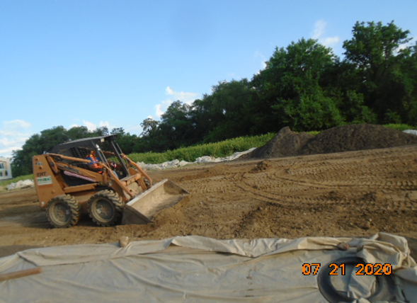
Phase B – Crew grading slope along the North side of trail.

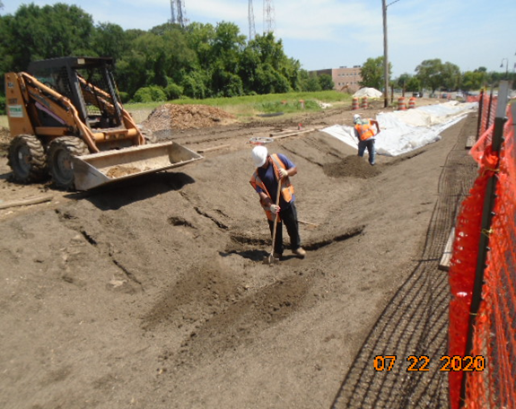
Phase B – Crew constructing check dams at Bioswale

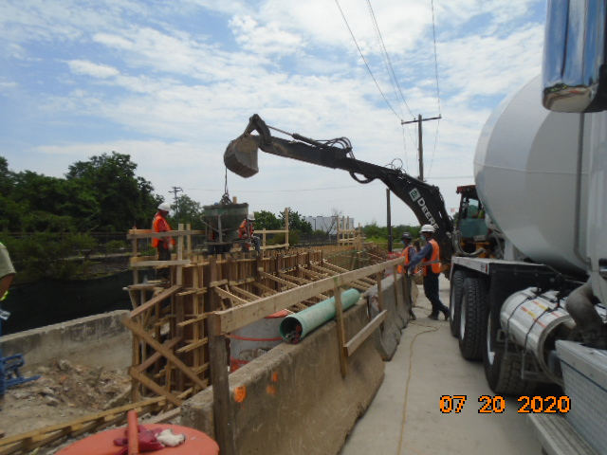
Phase D – Crew placing retaining wall concrete

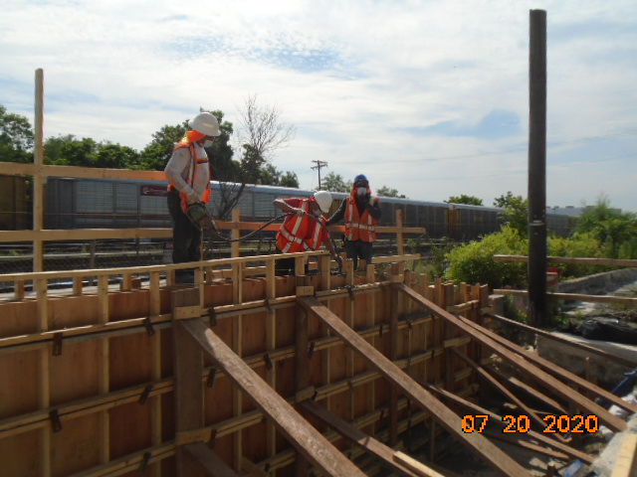
Phase D – Crew placing retaining wall concrete

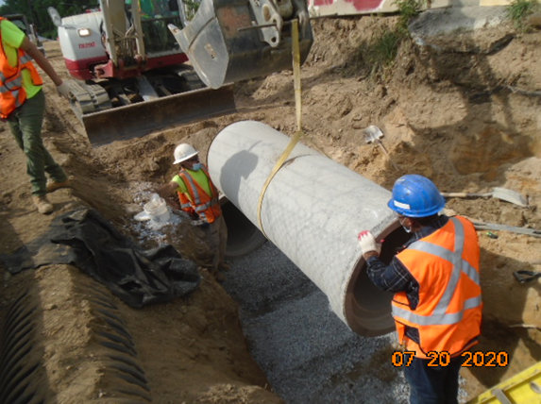
Phase D – Crew installing drainage pipes

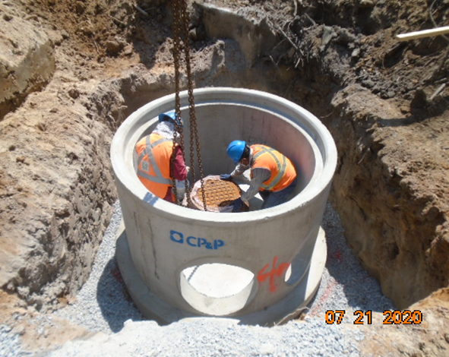
Phase D – Crew installing drainage manhole

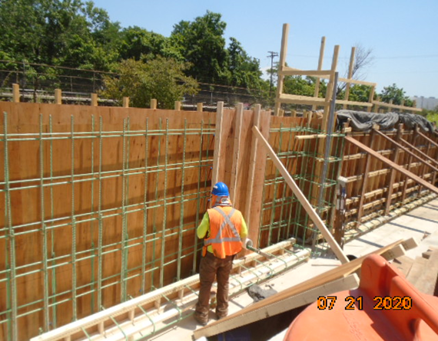
Phase D – Crew constructing retaining wall forms

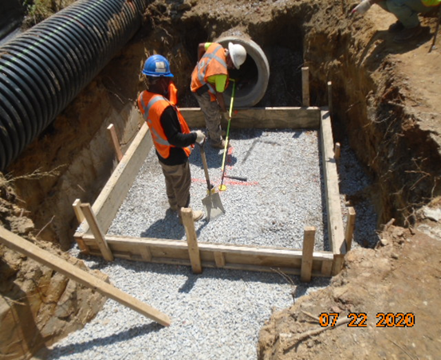
Phase D – Crew placing stone at manhole base

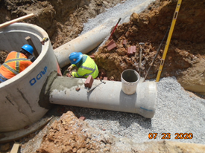
Phase D – Crew installing drainage pipes

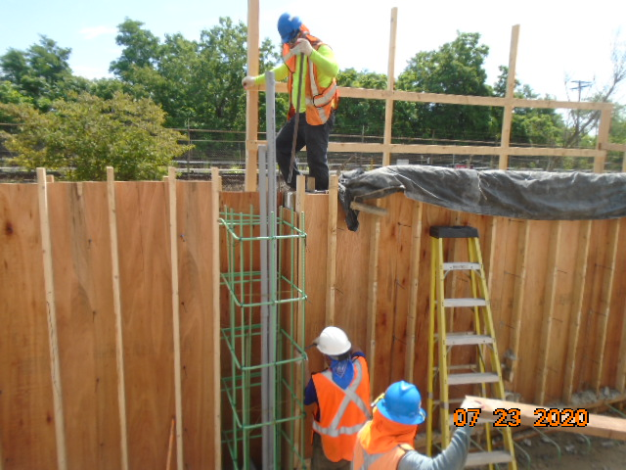
Phase D – Crew constructing retaining wall forms

