**Metropolitan Branch Trail Design Build, South Segment**

**DC CONTRACT NO. DCKA-2016-C-0044**

**FAP No.: STP-2016 (060)**

CONSTRUCTION MANAGER’S

WEEKLY PROGRESS REPORT

07/18/2021 – 07/24/2021

Project Website: [www.metbranchtrail-forttotten.com](http://www.metbranchtrail-forttotten.com)

For Additional Trail Information Please see [www.metbranchtrail.com](http://www.metbranchtrail.com)

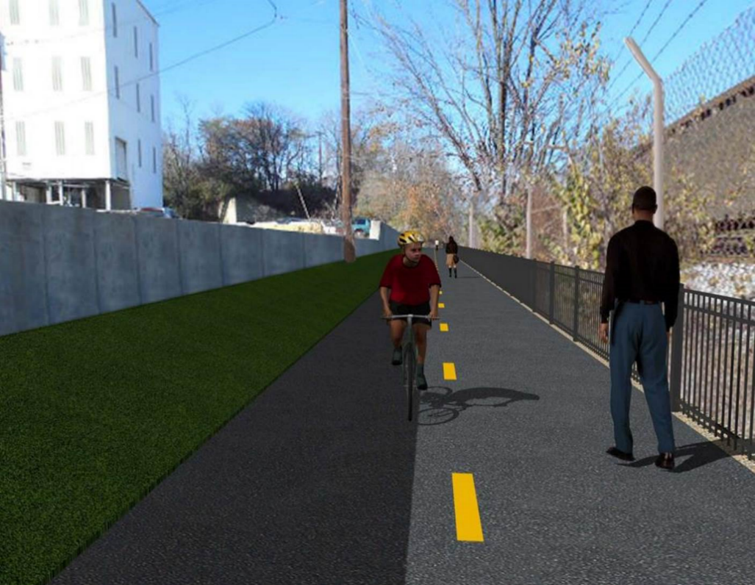

**Proposed Metropolitan Branch Trail**

**1. PROJECT DESCRIPTION**

The planned Metropolitan Branch Trail Project (“the Project”) consists of the design and construction of a new trail adjacent to CSX tracks and WMATA Red Line tracks along John McCormack Drive, adjacent to Fort Totten Metro Station, and on NPS property in NE, Washington D.C. The trail begins approximately 1500 feet south of Bates Road NE on the east side of John McCormack Drive NE, extending north along the WMATA and CSX tracks to the Fort Totten Metro Station tie in with First Place NE. An existing trail connection from Gallatin Road NE to the Fort Totten Metro Station will be reconstructed as a part of the Project.

The Project is 83.15% Federally-Funded and 16.85% District-Funded. Potomac Construction is the Design Build contractor.

Delon Hampton and Associates Chartered is providing Construction Management and Inspection services. Specific Construction Scope of Work includes:

* Provide mobilization and demobilization, provision and maintenance of Engineer’s field facilities, field layout, employee training, and other incidental work required for a quality, complete and finished product;
* Establishment and maintenance of vehicular and pedestrian traffic including signs, barricades and other transition devices; reconfiguring the devices in conjunction with changes in work areas; and their removal and disposal upon project completion, including restoration of disturbed areas;
* Clearing and grubbing, as required within the LOD;
* Removal of unsuitable material, excavation, and backfilling and pervious paving to construct a new trail;
* Protection of trees during construction;
* Provide ADA compliant trail connections and pedestrian ramps;
* Provide retaining walls as necessary to stay within the LOD and minimize property impacts following visual requirements specified for retaining walls on NPS property;
* Provide new permanent regulatory and wayfinding signs for the trail and all trail connection intersections;
* Provide road and trail pavement markings;
* Provide landscaping within the LOD for the Project including special requirements for landscaping on NPS property;
* Provide erosion and sediment control measures, storm water management facilities, including pervious asphalt pavement and bioretention facilities;
* Provide utility coordination, identification, locating, and protection of all utilities encountered during design and construction including relocation of Pepco poles along Aggregate Industries property; and
* Provide new WMATA security fencing between the trail and CSXT tracks.
* Remove existing sidewalk and widen sidewalk to 10’ along the west side of 1st place NE from Metropolitan Branch Trail to entrance to WMATA bus loop, on the west side.

**2. STATUS OF CONSTRUCTION / PROGRESS SUMMARY**

**Work performed this week:**

**Design**

* 100 % Complete

**Construction:**

**Phase D**

* Excavated and graded trail path
* Installed geotextile fabric at the trail
* Installed 4” perforated underdrain pipe
* Placed and graded trail bedding stone
* Installed retaining wall S0 rebar
* Installed rebar cage and H pile for RW S3 foundation
* Placed concrete for retaining wall S3 foundation
* Cad weld RW S3 H piles shear studs
* Graded slope behind south side curb
* Seeded slope area behind south side curb
* Installed erosion straw matt behind south side curb
* Grounded chain link fence
* Removed orange safety fence
* CSX flagger’s operation and safety tool box talk

**CM Consultant:**

* Monitored construction progress, make sure all applicable inspections and testing were performed
* Attended MBT Project Progress Meeting
* Prepared CM Weekly Report to post
* Prepared CM weekly report to DDOT
* Monitored QC field testing
* Updated Project Files
* Updated Project Logs
* Updated Project Webpage
* Updated documents in DHA SharePoint site
* Updated DDOT Sharepoint site
* Communication with PCCI and stakeholders in terms of submittals

**3. MEETINGS / PROJECT COORDINATION**

Tue 07/20/21 MBT Project Progress Meeting was held at 10:00 A.M.

**4. DAILY WORK PERFORMED**

Sun 07/18/21 No work performed.

Mon 07/19/21 Phase D – Installed retaining wall S0 rebar. Cad weld shear

studs to H piles flange. Excavated and graded trail path. Installed

geo-textile fabric. Installed 4” perforated underdrain. Placed and graded

bedding stone. Grounded chain link fence.

Phase D – Electrical Work – No work performed.

Tue 07/20/21 Phase D – Installed retaining wall S0 wall section rebar. Shaft-drilled retaining wall S3 foundation. Installed rebar cage and H piles for S3 wall foundation. Placed concrete for S3 foundations. Excavated slope behind RW S3 H piles for lagging installation. Graded slope behind north side curb. Installed straw matt at the area behind south side curb. Grounded chain link fence.

Phase D – Electrical Work – No work performed.

Wed 07/21/21 Phase D – Installed retaining wall S3 wall section rebar. Excavated slope behind RW S3 H piles for lagging installation. Installed RW S3 lagging boards. Installed geo-textile fabric at slope behind RW S3 piles. Backfilled trench behind RW S3 piles with No. 57 stone.

Phase D – Electrical Work – No work performed.

Thurs 07/22/21 Phase D – Install retaining wall S0 rebar. Excavated slope behind RW S3 H piles for lagging installation. Installed RW S3 lagging boards. Installed geo-textile fabric at slope behind RW S3 piles. Backfilled trench behind RW S3 piles with No. 57 stone.

Phase D – Electrical Work – No work performed.

Fri 07/23/21 Phase D – Install retaining wall S0 rebar. Excavated slope behind RW S3

H piles for lagging installation. Hauled off excavated materials to stock pile area. Graded embankment along the trail. Removed orange safety fence

Phase D – Electrical Work – No work performed.

Sat 07/24/21 Phase D – No work scheduled

**5. INSPECTION & MATERIAL TESTS PERFORMED**

|  |  |
| --- | --- |
| Jobsite Safety Inspection  Erosion and Sediment Control inspection  MOT Inspection  Compaction Test  Asphalt Material Testing  Concrete Material Testing – Pending results  **\*\* Note - Additional Material Test Results can be found on DDOT QA QC Material Division Tracking SharePoint website**. | Infiltration Tests  Dynamic Cone Penetration (DCP) Tests  Rebars Inspection – Ongoing |

**6. DBE PARTICIPATION SUMMARIES**

Potomac Construction (Contractor)

* DBE Goal for Contractor is 15%. To-date the Contractor has achieved 49.4% of their goal.

Delon Hampton & Associates (CM)

* DBE Goal for the CM is 10%. To-date the CM has achieved 96.6% of their Goal.

**7. ACCIDENTS / INCIDENTS**

None occurred on-site during this week.

**8. PHOTOS OF THE WORK PERFORMED**

**12. PHOTOS OF WORK PERFORMED THIS PERIOD**

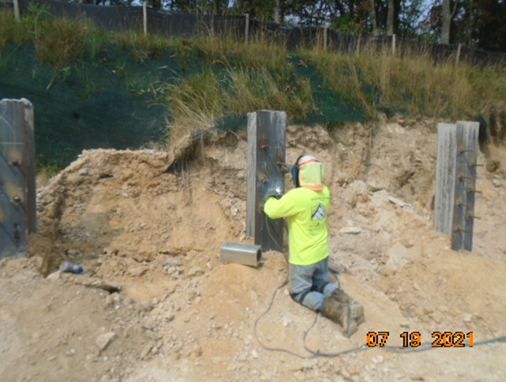

Phase D – Crew welding shear studs

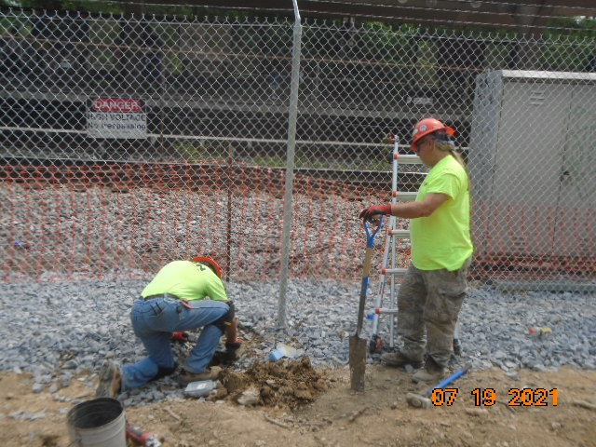

Phase D – Crew grounding the chain link fence post

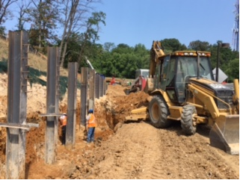

Phase D – Crew excavating to install lagging

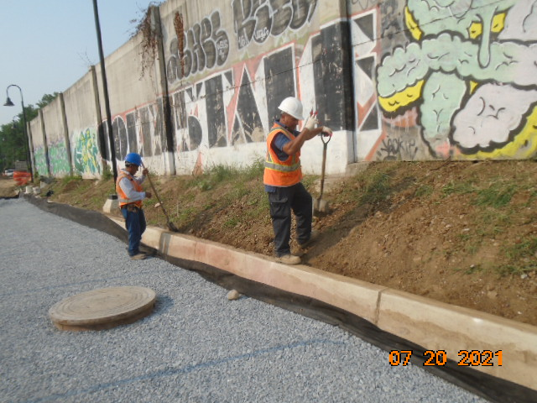

Phase D – Crew grading slope area behind curb

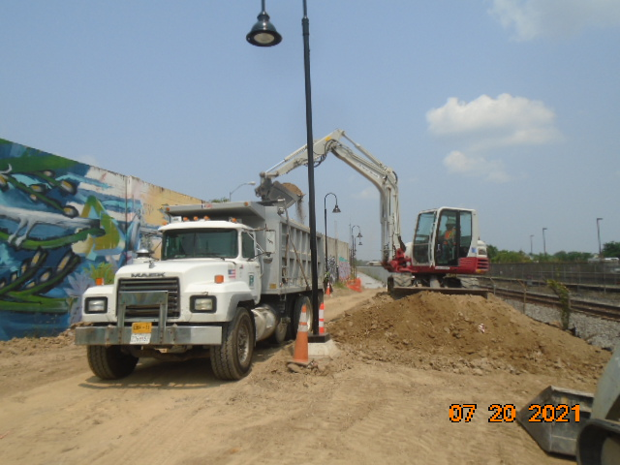

Phase D – Crew hauling off excavated materials

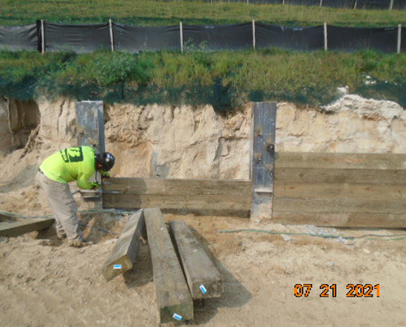

Phase D – Crew installing RW S3 lagging board

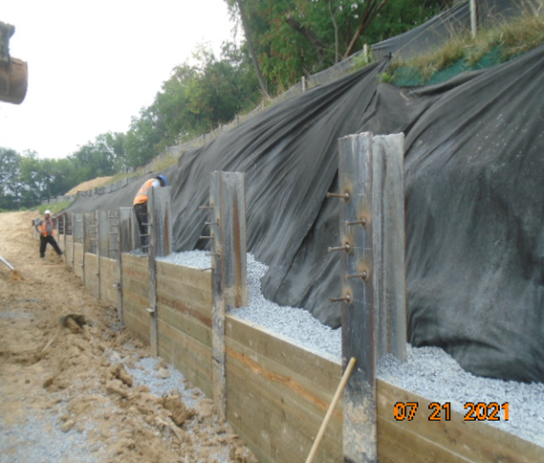

Phase D – Crew backfilling behind RW S3 H piles

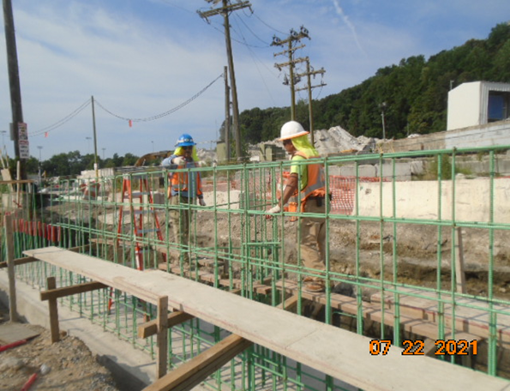

Phase D – Crew installing RW S0 rebar

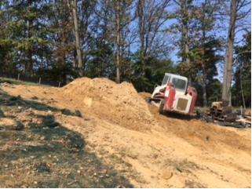

Phase D – Crew grading embankment slope

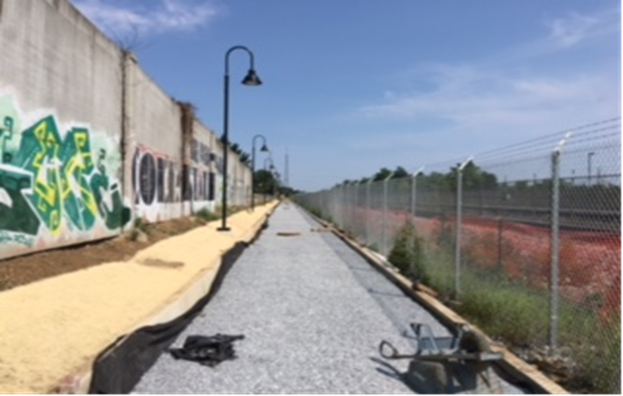

Phase D – Bedding stone and straw matt installed at the trail