Metropolitan Branch Trail Design Build, South Segment
DC CONTRACT NO. DCKA-2016-C-0044
FAP No.: STP-2016 (060)

CONSTRUCTION MANAGER’S
WEEKLY PROGRESS REPORT

07/11/2021 – 07/17/2021

Project Website: www.metbranchtrail-forttotten.com
For Additional Trail Information Please see www.metbranchtrail.com
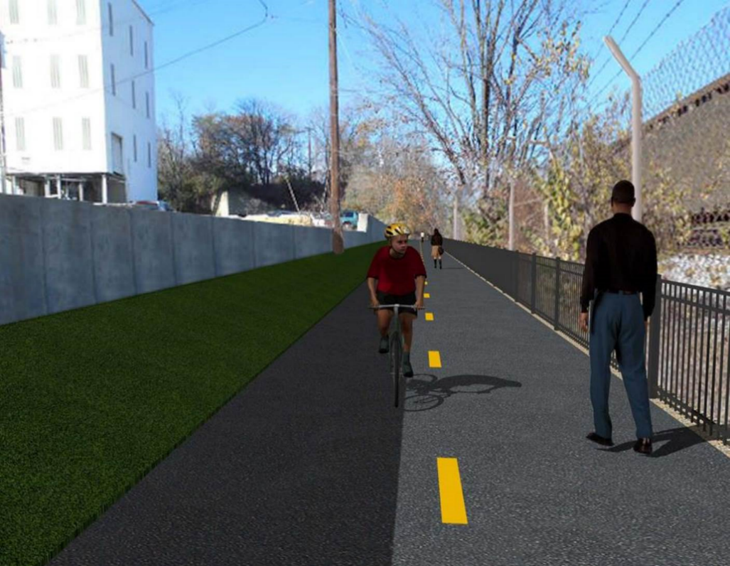

Proposed Metropolitan Branch Trail

1. PROJECT DESCRIPTION

The planned Metropolitan Branch Trail Project (“the Project”) consists of the design and construction of a new trail adjacent to CSX tracks and WMATA Red Line tracks along John McCormack Drive, adjacent to Fort Totten Metro Station, and on NPS property in NE, Washington D.C. The trail begins approximately 1500 feet south of Bates Road NE on the east side of John McCormack Drive NE, extending north along the WMATA and CSX tracks to the Fort Totten Metro Station tie in with First Place NE. An existing trail connection from Gallatin Road NE to the Fort Totten Metro Station will be reconstructed as a part of the Project.

The Project is 83.15% Federally-Funded and 16.85% District-Funded. Potomac Construction is the Design Build contractor.

Delon Hampton and Associates Chartered is providing Construction Management and Inspection services. Specific Construction Scope of Work includes:

- Provide mobilization and demobilization, provision and maintenance of Engineer’s field facilities, field layout, employee training, and other incidental work required for a quality, complete and finished product;
- Establishment and maintenance of vehicular and pedestrian traffic including signs, barricades and other transition devices; reconfiguring the devices in conjunction with changes in work areas; and their removal and disposal upon project completion, including restoration of disturbed areas;
- Clearing and grubbing, as required within the LOD;
- Removal of unsuitable material, excavation, and backfilling and pervious paving to construct a new trail;
- Protection of trees during construction;
- Provide ADA compliant trail connections and pedestrian ramps;
- Provide retaining walls as necessary to stay within the LOD and minimize property impacts following visual requirements specified for retaining walls on NPS property;
- Provide new permanent regulatory and wayfinding signs for the trail and all trail connection intersections;
- Provide road and trail pavement markings;
- Provide landscaping within the LOD for the Project including special requirements for landscaping on NPS property;
- Provide erosion and sediment control measures, storm water management facilities, including pervious asphalt pavement and bioretention facilities;
- Provide utility coordination, identification, locating, and protection of all utilities encountered during design and construction including relocation of Pepco poles along Aggregate Industries property; and
- Provide new WMATA security fencing between the trail and CSXT tracks.
- Remove existing sidewalk and widen sidewalk to 10’ along the west side of 1st place NE from Metropolitan Branch Trail to entrance to WMATA bus loop, on the west side.

2. STATUS OF CONSTRUCTION / PROGRESS SUMMARY

Work performed this week:

Design

- 100 % Complete

Construction:

Phase D

- Performed excavation and fine grading of trail path
- Installed geotextile fabric at trail subgrade
- Installed 4” perforated underdrain pipe
- Placed and graded trail bedding stone
- Constructed retaining wall S0 wall section formwork
- Constructed retaining wall S0 wall section formwork
- Installed retaining wall S0 wall section rebar
- Shaft-drilled retaining wall S3 foundation
- Assembled retaining wall S3 rebar cage
- Installed retaining wall S3 H piles
- Placed concrete for retaining wall S3 foundation
- Cad welded RW S3 H piles shear studs
- Installed chain link fence
- Grounded chain link fence
- CSX flagger’s operation and safety tool box talk

CM Consultant:

- Monitored construction progress, make sure all applicable inspections and testing were performed
- Reviewed PCCI monthly invoice
- Reviewed CSX Invoice
- Prepared CM Weekly Report to post
- Prepared CM weekly report to DDOT
- Monitored QC field testing
- Updated Project Files
- Updated Project Logs
- Updated Project Webpage
- Updated documents in DHA SharePoint site
- Updated DDOT Sharepoint site
- Communication with PCCI and stakeholders in terms of submittals

3. MEETINGS / PROJECT COORDINATION

None during this week.

4. DAILY WORK PERFORMED

Sun 07/11/21 No work performed.
Mon 07/12/21 Phase D – Constructed retaining wall S0 wall section formwork. Shaft-drilled
retaining wall S3 foundation. Installed rebar cage and H piles for S3 wall
foundation. Placed concrete for S3 foundations. Excavated and fine
graded trail path. Installed chain link fence post footing. Placed and graded stone behind chain link fence.
Phase D – Electrical Work – No work performed.
Tue 07/13/21 Phase D – Constructed retaining wall S0 wall section formwork. Shaft-drilled retaining wall S3 foundation. Installed rebar cage and H piles for S3 wall foundation. Placed concrete for S3 foundations. Excavated and fine graded trail path. Installed geotextile fabric and perforated underdrain drain. Placed and graded bedding stone. Grounded chain link fence.
Phase D – Electrical Work – No work performed.
Wed 07/14/21 Phase D – Constructed retaining wall S0 wall section formwork. Stripped retaining wall S0 footing formwork. Installed S0 wall section rebar. Shaft-drilled retaining wall S3 foundation. Installed rebar cage and H piles for S3 wall foundation. Placed concrete for S3 foundations. Placed and fine graded stone trail bedding stone. Installed chain link. Grounded chain link fence.
Phase D – Electrical Work – No work performed.
Thurs 07/15/21 Phase D – Wet cured retaining wall S0 footing concrete. Constructed
retaining wall S0 wall section formwork. Installed retaining wall S0 wall section rebar. Assembled and installed H piles cage. Cad welded RW S3 H piles shear studs. Installed geotextile fabric. Installed 4” perforated trail underdrain. Placed and graded bedding stone at the trail. Installed geotextile fabric. Installed 4” perforated underdrain. Placed and graded bedding stone at the trail.
Phase D – Electrical Work – No work performed.
Fri 07/16/21 Phase D – Constructed retaining wall S0 wall section formwork. Cad
Welded RW S3 H piles shear studs. Installed geotextile fabric. Installed 4” perforated underdrain. Placed and graded bedding stone at the trail. Reset drainage manhole.
Phase D – Electrical Work – No work performed.
Sat 07/17/21 Phase D – No work scheduled

5. INSPECTION & MATERIAL TESTS PERFORMED

Jobsite Safety Inspection  Erosion and Sediment Control inspection  MOT Inspection  Compaction Test  Asphalt Material Testing  Concrete Material Testing – Pending results  ** Note - Additional Material Test Results can be found on DDOT QA QC Material Division Tracking SharePoint website. | Infiltration Tests  Dynamic Cone Penetration (DCP) Tests  Rebars Inspection - Ongoing
6. DBE PARTICIPATION SUMMARIES

Potomac Construction (Contractor)

- DBE Goal for Contractor is 15%. To-date the Contractor has achieved 49.4% of their goal.

Delon Hampton & Associates (CM)

- DBE Goal for the CM is 10%. To-date the CM has achieved 82.7% of their Goal.

7. ACCIDENTS / INCIDENTS

None occurred on-site during this week.

8. PHOTOS OF THE WORK PERFORMED

12. PHOTOS OF WORK PERFORMED THIS PERIOD

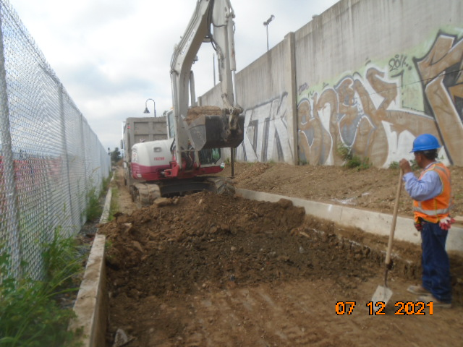
Phase D – Crew excavting the trail path

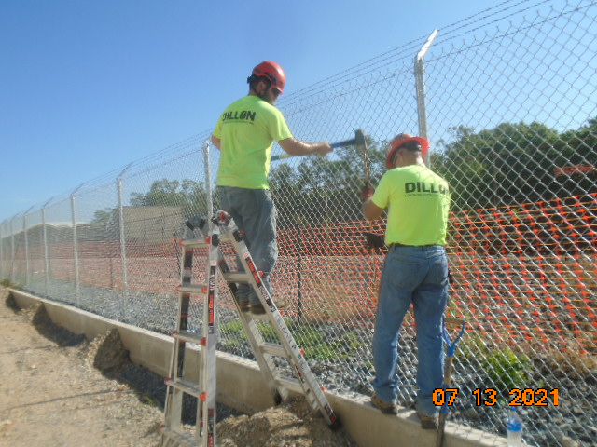
Phase D – Crew grounding chain link fence

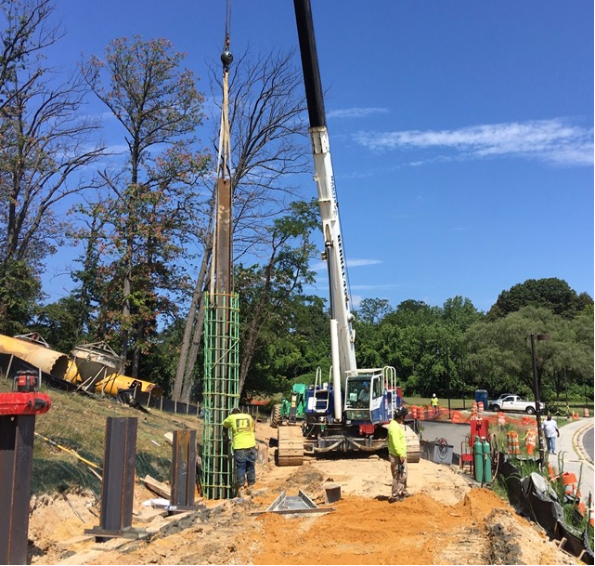
Phase D – Crew insatlling H pile rebar cage for S3 foundation

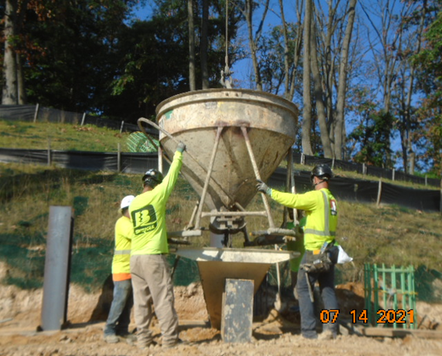
Phase D – Crew placing concrete for retaining wall S3 foundation

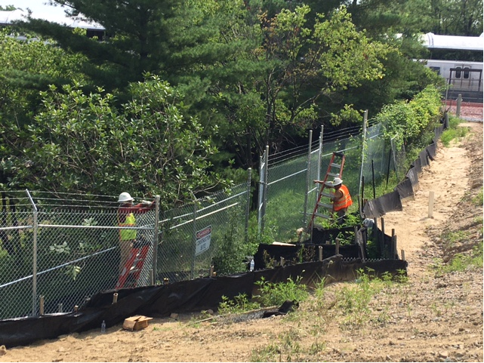
Phase D – Crew insatlling WMATA chain link fence

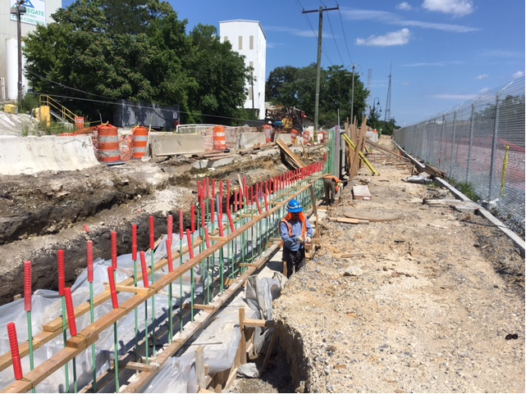
Phase D – Crew stripping retaining wall footin fromwork

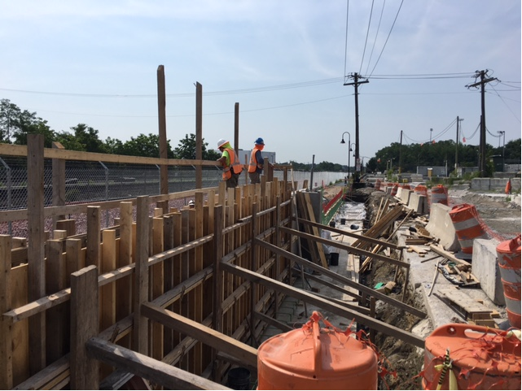Phase D – Crew constructing retaining wall S0 formwork

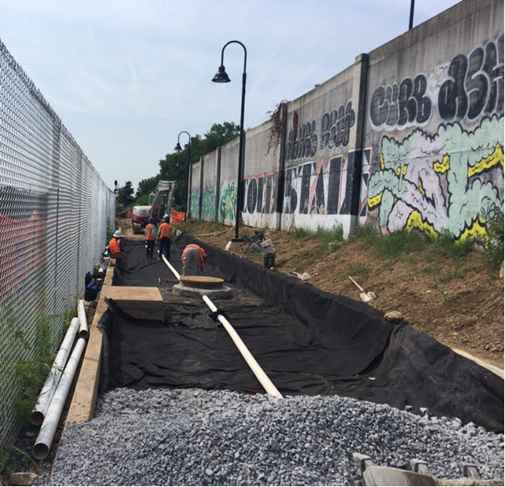
Phase D – Crew installing perforated underdrain at the trail

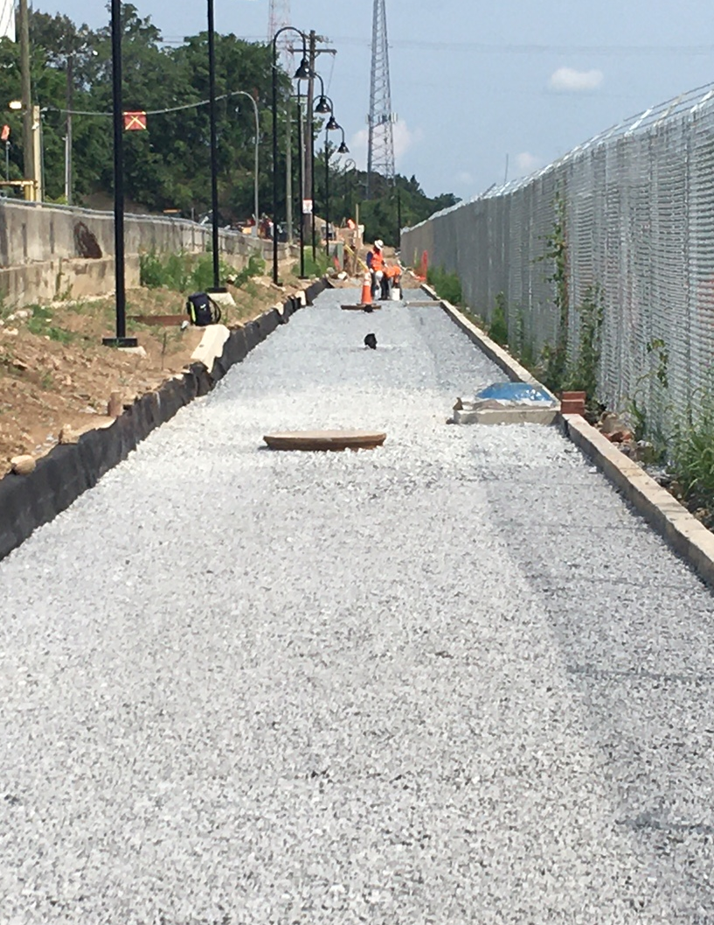
Phase D – Crew fine grading trail bedding stone

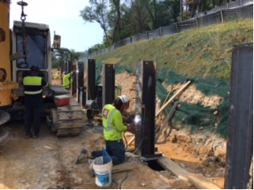
Phase D – Crew welding H piles studs reatinging wall S3

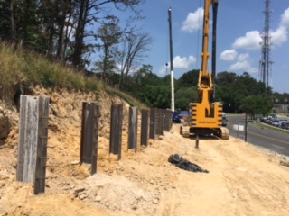
Phase D – RW S3 H piles insatlled

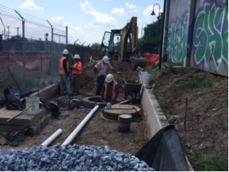
Phase D – Crew resetting drainage manhole

