**Metropolitan Branch Trail Design Build, South Segment**

**DC CONTRACT NO. DCKA-2016-C-0044**

**FAP No.: STP-2016 (060)**

CONSTRUCTION MANAGER’S

WEEKLY PROGRESS REPORT

07/05/2020 – 07/11/2020

Project Website: [www.metbranchtrail-forttotten.com](http://www.metbranchtrail-forttotten.com)

For Additional Trail Information Please see [www.metbranchtrail.com](http://www.metbranchtrail.com)

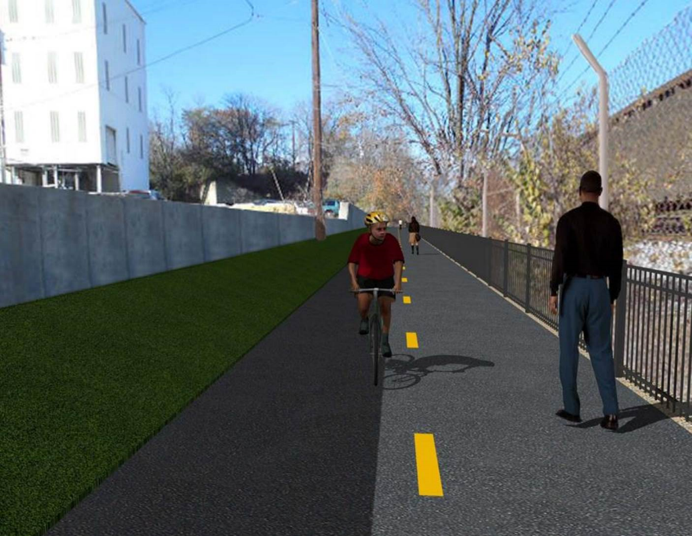

**Proposed Metropolitan Branch Trail**

**1. PROJECT DESCRIPTION**

The planned Metropolitan Branch Trail Project (“the Project”) consists of the design and construction of a new trail adjacent to CSX tracks and WMATA Red Line tracks along John McCormack Drive, adjacent to Fort Totten Metro Station, and on NPS property in NE, Washington D.C. The trail begins approximately 1500 feet south of Bates Road NE on the east side of John McCormack Drive NE, extending north along the WMATA and CSX tracks to the Fort Totten Metro Station tie in with First Place NE. An existing trail connection from Gallatin Road NE to the Fort Totten Metro Station will be reconstructed as a part of the Project.

The Project is 83.15% Federally-Funded and 16.85% District-Funded. Potomac Construction is the Design Build contractor.

Delon Hampton and Associates Chartered is providing Construction Management and Inspection services. Specific Construction Scope of Work includes:

* Provide mobilization and demobilization, provision and maintenance of Engineer’s field facilities, field layout, employee training, and other incidental work required for a quality, complete and finished product;
* Establishment and maintenance of vehicular and pedestrian traffic including signs, barricades and other transition devices; reconfiguring the devices in conjunction with changes in work areas; and their removal and disposal upon project completion, including restoration of disturbed areas;
* Clearing and grubbing, as required within the LOD;
* Removal of unsuitable material, excavation, and backfilling and pervious paving to construct a new trail;
* Protection of trees during construction;
* Provide ADA compliant trail connections and pedestrian ramps;
* Provide retaining walls as necessary to stay within the LOD and minimize property impacts following visual requirements specified for retaining walls on NPS property;
* Provide new permanent regulatory and wayfinding signs for the trail and all trail connection intersections;
* Provide road and trail pavement markings;
* Provide landscaping within the LOD for the Project including special requirements for landscaping on NPS property;
* Provide erosion and sediment control measures, storm water management facilities, including pervious asphalt pavement and bioretention facilities;
* Provide utility coordination, identification, locating, and protection of all utilities encountered during design and construction including relocation of Pepco poles along Aggregate Industries property; and
* Provide new WMATA security fencing between the trail and CSXT tracks.
* Remove existing sidewalk and widen sidewalk to 10’ along the west side of 1st place NE from Metropolitan Branch Trail to entrance to WMATA bus loop, on the west side.

**2. STATUS OF CONSTRUCTION / PROGRESS SUMMARY**

**Work performed this week:**

**Design**

* Phase D 3-ring binder for 100% Plans
* Stakeholders acceptance for Phase D Final Design Plans
* Railing Design Submittal to WMATA and DDOT
* Coordinated with WMATA to obtain full Construction Permit
* Coordinate with CSX Approval of Phase D Means and Methods

**Construction:**

**Phase B**

* Performed Bioswale construction along the North side of the trail
* Installed perforated pipes and placed stone at the Bioswale
* Excavated and graded ditch along the North side of the trail
* Hauled away excavated materials from the site

**Phase D**

* Performed formwork for retaining wall
* Installed rebars at retaining wall
* Installed light pole conduits
* Constructed drainage manhole
* CSX flagger’s operation and safety tool box talk

**CM Consultant:**

* Monitored construction progress, make sure all applicable inspection and testing were

performed

* Reviewed Inspection Daily Reports
* Reviewing Change order package
* Reviewed Project Schedule
* Updated Project Files
* Attended Project Progress Meeting
* Attended QAQC Meeting
* Attended Field Meeting with PCCI and WMATA
* Updating documents in SharePoint
* Communication with the stakeholder in terms of submittals

**3. MEETINGS / PROJECT COORDINATION**

Tue. 07/07/20 MBT Progress Meeting conference call was held at 10:00 A.M.

Wed. 07/09/20 DHA WMATA PCCI Field Meeting was held at 1:00 P.M

Fri. 07/10/20 QAQC Meeting was held at 10:00 A.M.

**4. DAILY WORK PERFORMED**

Sun 07/05/20 No work performed

Mon 07/06/20 Phase B – Performed Bioswale construction along the North side of the

trail. Installed geotextile fabric, placed stone and installed perforated

drainage pipes in the Bioswale. Hauled away unsuitable material for site.

Phase B – Electrical work – No work performed.

Phase D – Installed rebars for manhole base. Poured concrete at manhole base. Stripped retaining wall footing formwork.

Tue 07/07/20 Phase B – Performed Bioswale construction along the North side of the trail. Installed geotextile fabric, placed stone and installed perforated

drainage pipes in the Bioswale. Hauled away unsuitable material for site.

Electrical Work – Electrical work – No work performed.

Phase D – Stripped manhole base formwork. Excavated pipe trench, placed bedding material and installed drainage pipes. Constructed drainage manhole. Installed retaining wall rebars.

Wed 07/08/20 Phase B - Performed Bioswale construction along the North side of the trail. Installed geotextile fabric, placed stone and installed perforated

drainage pipes in the Bioswale. Hauled away unsuitable material for site.

Phase B - Electrical Work – No work performed.

Phase D – Installed wall rebars. Constructed retaining wall forms.

Thurs 07/09/20 Phase B – Excavated Bioswale and excavated and graded ditch along

the North side of the trail.

Phase B – Electrical – No work performed.

Phase D – Electrical Work – Installed light pole conduit.

Phase D – Installed retaining wall rebars. Constructed brick manhole.

Fri 07/10/20 Phase B – Performed Bioswale construction along the North side of the trail. Installed geotextile fabric, placed stone and installed perforated

drainage pipes in the Bioswale.

Phase B – Electrical – No work performed

Phase D – Constructed retaining wall forms. Constructed drainage manhole.

Sat 07/11/20 No work scheduled

**5. INSPECTION & MATERIAL TESTS PERFORMED**

|  |  |
| --- | --- |
| Jobsite Safety Inspection  Erosion and Sediment Control inspection  MOT Inspection  Compaction Test  Asphalt Material Testing  Concrete Material Testing – Results Pending  **\*\* Note - Additional Material Test Results can be found on DDOT QA QC Material Division Tracking SharePoint website**. | Infiltration Tests  Dynamic Cone Penetration (DCP) Tests  Rebars Inspection - Ongoing |

**6. DBE PARTICIPATION SUMMARIES**

Potomac Construction (Contractor)

* DBE Goal for Contractor is 15%. To-date the Contractor has achieved 38% of their goal.

Delon Hampton & Associates (CM)

* DBE Goal for the CM is 10%. To-date the CM has achieved 17% of their Goal.

**7. ACCIDENTS / INCIDENTS**

None occurred on-site during this week.

**8. PHOTOS OF THE WORK PERFORMED**

**12. PHOTOS OF WORK PERFORMED THIS PERIOD**

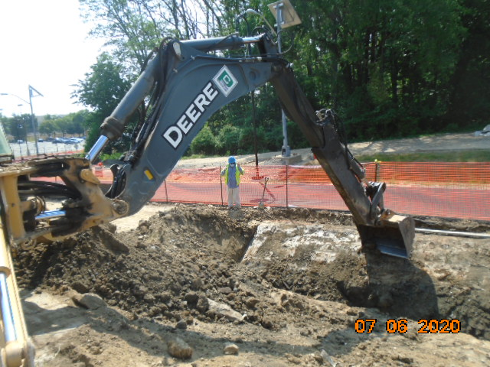

**Phase B – Crew excavating Bioswale along the North side of the trail**

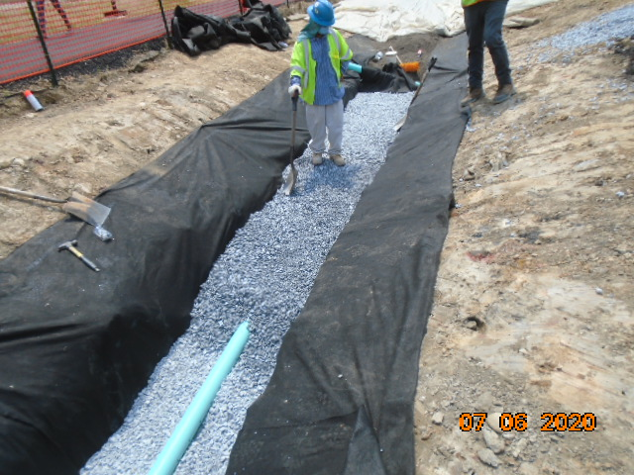

**Phase B – Crew insatlling perforated drainage pipe at the Bioswale**

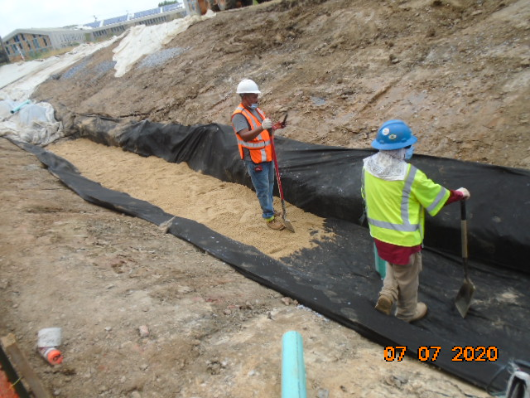

**Phase B – Crew placing pea gravel at Bioswale**

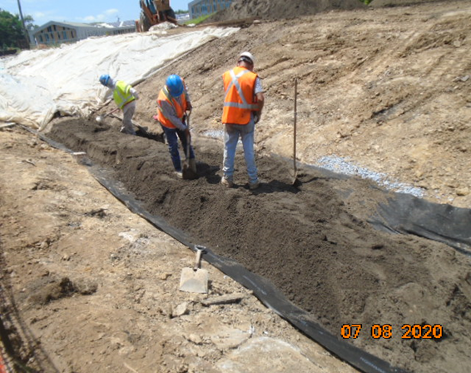

**Phase B – Crew placing Bio-retention soil**

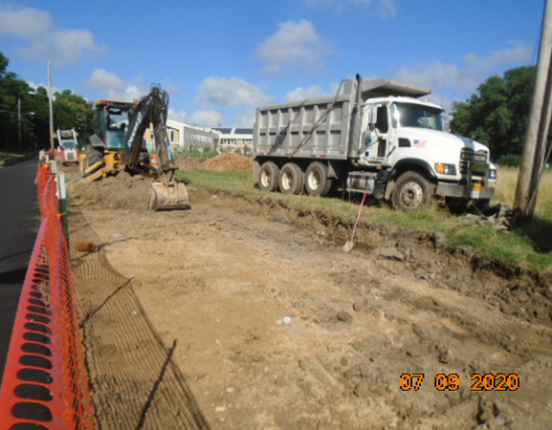

**Phase B – Crew grading North side of trail shoulder**

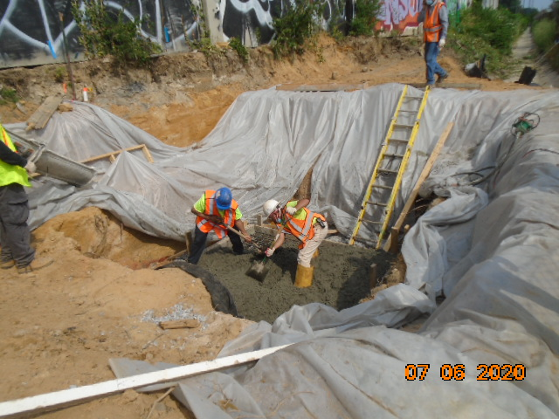

**Phase B – Crew placing concrete at manhole base**

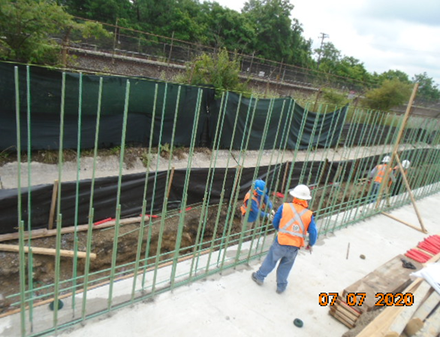

**Phase D – Crew installing rebars at retaining wall**

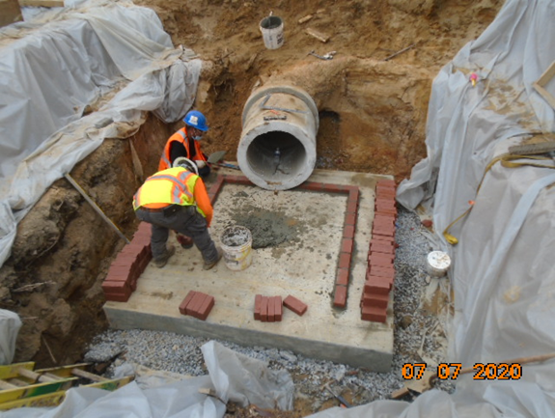

**Phase D – Crew constructing brick manhole**

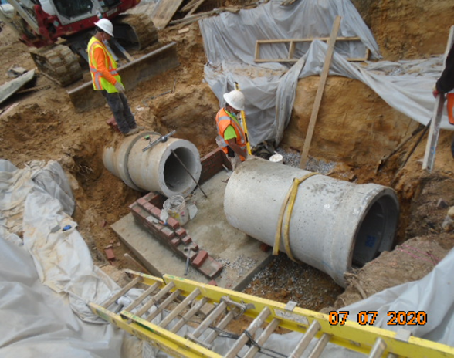

**Phase D – Crew installing drainage pipes**

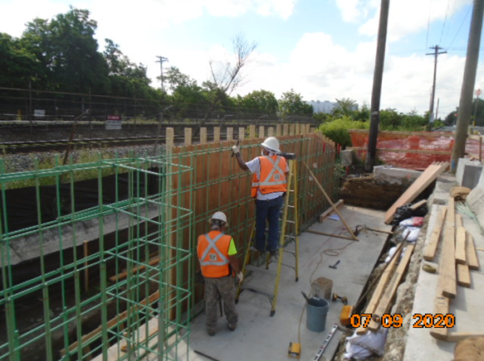

**Phase D – Crew installing constructing retaining wall forms**