Metropolitan Branch Trail Design Build, South Segment
DC CONTRACT NO. DCKA-2016-C-0044
FAP No.: STP-2016 (060)

CONSTRUCTION MANAGER’S
WEEKLY PROGRESS REPORT

06/28/2020 – 07/04/2020

Project Website: www.metbranchtrail-forttotten.com
For Additional Trail Information Please see www.metbranchtrail.com

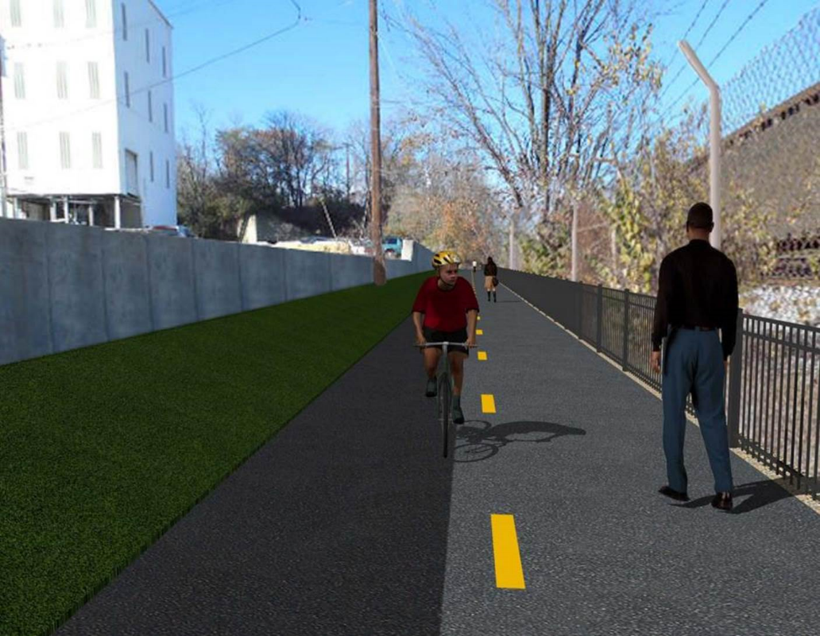

Proposed Metropolitan Branch Trail

1. PROJECT DESCRIPTION

The planned Metropolitan Branch Trail Project (“the Project”) consists of the design and construction of a new trail adjacent to CSX tracks and WMATA Red Line tracks along John McCormack Drive, adjacent to Fort Totten Metro Station, and on NPS property in NE, Washington D.C. The trail begins approximately 1500 feet south of Bates Road NE on the east side of John McCormack Drive NE, extending north along the WMATA and CSX tracks to the Fort Totten Metro Station tie in with First Place NE. An existing trail connection from Gallatin Road NE to the Fort Totten Metro Station will be reconstructed as a part of the Project.

The Project is 83.15% Federally-Funded and 16.85% District-Funded. Potomac Construction is the Design Build contractor.

Delon Hampton and Associates Chartered is providing Construction Management and Inspection services. Specific Construction Scope of Work includes:

- Provide mobilization and demobilization, provision and maintenance of Engineer’s field facilities, field layout, employee training, and other incidental work required for a quality, complete and finished product;
- Establishment and maintenance of vehicular and pedestrian traffic including signs, barricades and other transition devices; reconfiguring the devices in conjunction with changes in work areas; and their removal and disposal upon project completion, including restoration of disturbed areas;
- Clearing and grubbing, as required within the LOD;
- Removal of unsuitable material, excavation, and backfilling and pervious paving to construct a new trail;
- Protection of trees during construction;
- Provide ADA compliant trail connections and pedestrian ramps;
- Provide retaining walls as necessary to stay within the LOD and minimize property impacts following visual requirements specified for retaining walls on NPS property;
- Provide new permanent regulatory and wayfinding signs for the trail and all trail connection intersections;
- Provide road and trail pavement markings;
- Provide landscaping within the LOD for the Project including special requirements for landscaping on NPS property;
- Provide erosion and sediment control measures, storm water management facilities, including pervious asphalt pavement and bioretention facilities;
- Provide utility coordination, identification, locating, and protection of all utilities encountered during design and construction including relocation of Pepco poles along Aggregate Industries property; and
- Provide new WMATA security fencing between the trail and CSXT tracks.
- Remove existing sidewalk and widen sidewalk to 10’ along the west side of 1st place NE from Metropolitan Branch Trail to entrance to WMATA bus loop, on the west side.

2. STATUS OF CONSTRUCTION / PROGRESS SUMMARY

Work performed this week:

Design
- Phase D 3-ring binder for 100% Plans
- Stakeholders acceptance for Phase D Final Design Plans
- Railing Design Submittal to WMATA and DDOT
- WMATA / DDOT Notification Plan for Phase D Construction Activities
- Coordinate with CSX Approval of Phase D Means and Methods
- Coordinate with NPS to evaluate Phase B topsoil

Construction:

Phase B

- Performed Bioswale construction along the North side of the trail
- Installed perforated pipes at the Bioswale
- Backfilled and compacted electrical trench from manhole to manhole
- Installed light pole
- Spliced cables inside electrical manhole
- Installed ground rod at electrical manhole
- NPS visited site to evaluate topsoil
- Hauled away excavated materials from the site

Phase D

- Installed formwork for retaining wall footing
- Installed rebars at retaining wall footings
- Placed concrete at retaining wall footing
- Installed and backfilled drainage pipes
- Excavated manhole trench
- Installed rebars for manhole base
- Repaired silt fence
- CSX flagger’s operation and safety tool box talk

CM Consultant:

- Monitored construction progress, make sure all applicable inspection and testing were
performed
- Reviewed Inspection Daily Reports
- Reviewing Change order package
- Reviewing Project Schedule
- Updated Project Files
- Updating documents in SharePoint
- Communication with the stakeholder in terms of submittals

3. MEETINGS / PROJECT COORDINATION

Mon 06/29/20 DDOT NPS onsite coordination meeting was held at 12:30 P.M.

4. DAILY WORK PERFORMED

Sun 06/28/20 No work performed
Mon 06/29/20 Phase B – Excavated Bioswale along the North side of the trail. Hauled
away unsuitable materials from the site.
Phase B – Electrical work – Backfilled and compacted electrical trench from manhole to manhole. Installed light pole.
Phase D – Installed retaining wall footing rebars. Installed and backfilled drainage pipes. Repaired silt fence.
Tue 06/30/20 Phase B – Excavated Bioswale along the North side of the trail. Hauled
away unsuitable materials form the site.
Electrical Work – Stripped the light pole foundation formwork. Drove ground rod for manholes. Cad-welded the ground rod inside the manholes. Spliced light pole conductors.
Phase D – Installed epoxy rebars at retaining wall footings. Placed bedding material for drainage pipes. Installed drainage pipes.
Wed 07/01/20 Phase B – Performed construction of Bioswale along the North side of the
trail. Installed geotextile fabric, placed stone and installed perforated
drainage pipes in the Bioswale
Phase B - Electrical Work – Drove ground rod at electrical manholes. Spliced cables inside manhole
Phase D – Installed epoxy rebars at retaining wall footings. Excavated trench for drainage manhole. Placed stone at manhole base.
Thurs 07/02/20 Phase B – Performed construction of Bioswale along the North side of the
trail. Installed geotextile fabric, placed stone and installed perforated
drainage pipes in the Bioswale.
Phase B – Electrical – No work performed.
Phase D – Placed concrete at retaining wall footing. Installed formwork for manhole base.
Fri 07/03/20 No work performed - Holiday
Sat 07/04/20 No work scheduled

5. INSPECTION & MATERIAL TESTS PERFORMED

Jobsite Safety Inspection  Erosion and Sediment Control inspection  MOT Inspection  Compaction Test - Passed  Asphalt Material Testing  Concrete Material Testing – Results Pending  ** Note - Additional Material Test Results can be found on DDOT QA QC Material Division Tracking SharePoint website. | Infiltration Tests  Dynamic Cone Penetration (DCP) Tests  Rebars Inspection - Passed
6. DBE PARTICIPATION SUMMARIES

Potomac Construction (Contractor)
- DBE Goal for Contractor is 15%. To-date the Contractor has achieved 38% of their goal.

Delon Hampton & Associates (CM)
- DBE Goal for the CM is 10%. To-date the CM has achieved 17% of their Goal.

7. ACCIDENTS / INCIDENTS
None occurred on-site during this week.

8. PHOTOS OF THE WORK PERFORMED

12. PHOTOS OF WORK PERFORMED THIS PERIOD

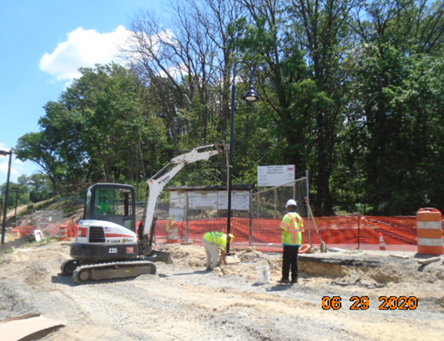
Phase B – Crew installing light pole

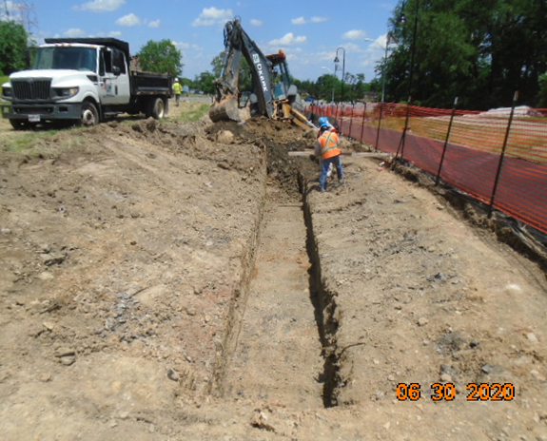
Phase B – Crew excavting Bioswale along the North side of the trail
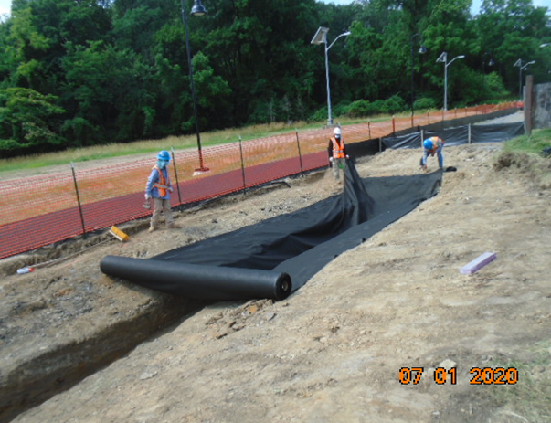
Phase B – Crew insatlling geo-textile fabric at the bioswale

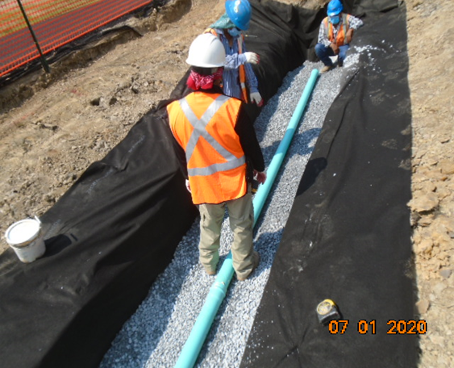
Phase B – Crew installing pipes at the bioswale

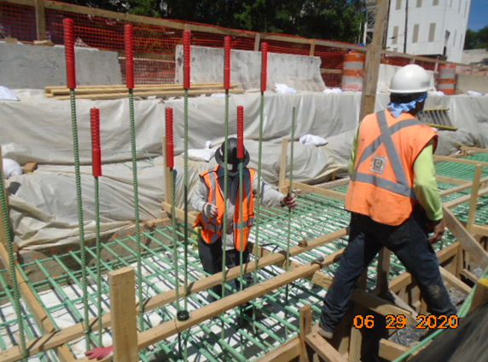
Phase D – Crew installing retaining wall footing rebars

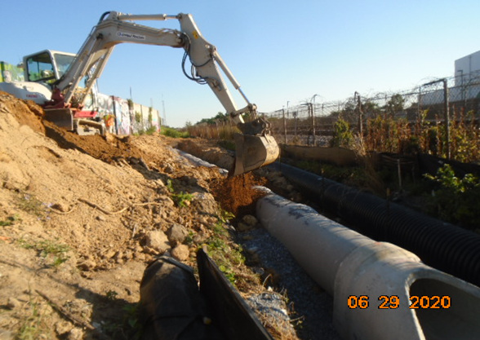
Phase D - Crew backfilling drainage pipes

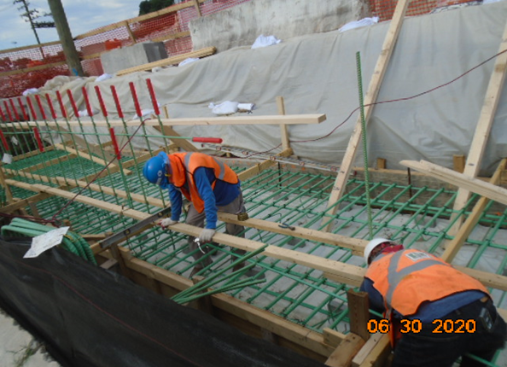
Phase D – Crew insatlling rebars at retaining wall footings

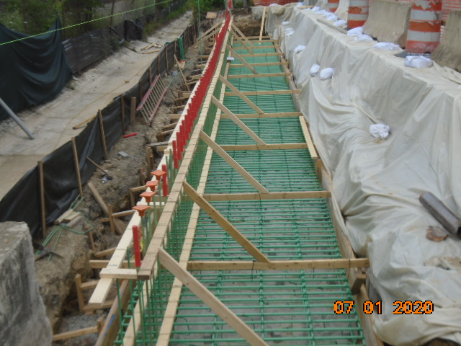
Phase D – Insatlled rebars at retaing wall footing

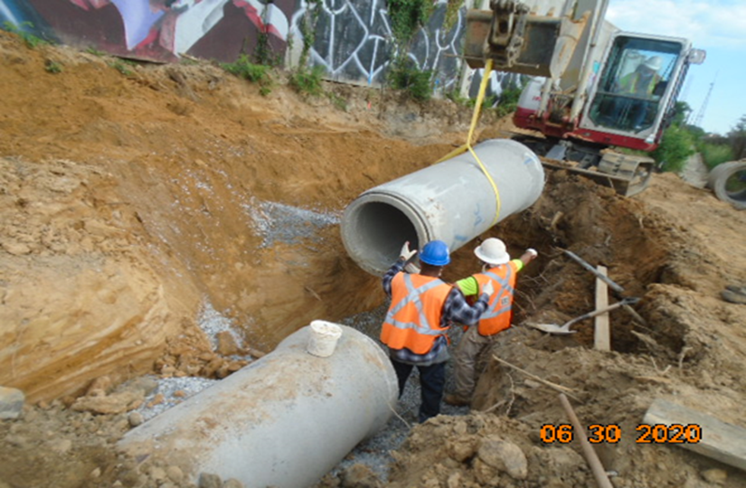
Phase D – Crew insatlling drainage pipes

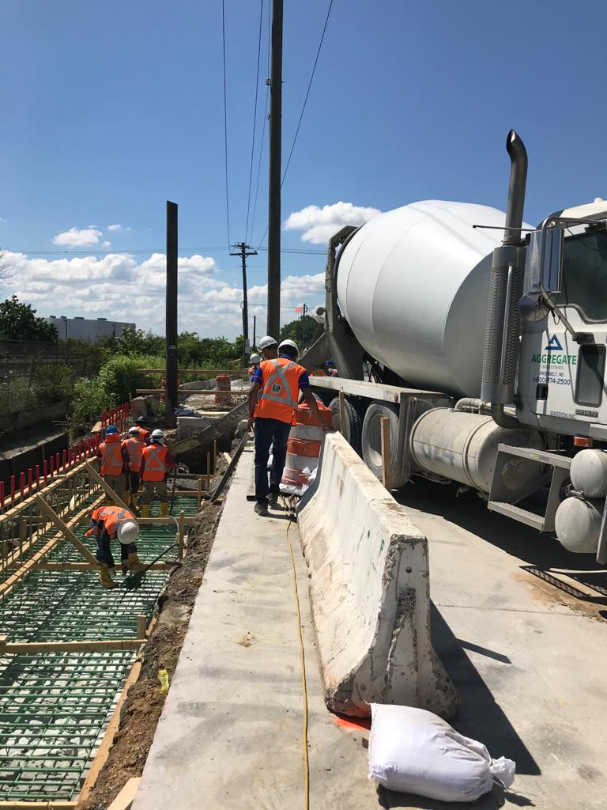
Phase D – Crew placing concrete at retaining wall footing

