Metropolitan Branch Trail Design Build, South Segment
DC CONTRACT NO. DCKA-2016-C-0044
FAP No.: STP-2016 (060)

CONSTRUCTION MANAGER’S
WEEKLY PROGRESS REPORT

06/21/2020 – 06/27/2020

Project Website: www.metbranchtrail-forttotten.com
For Additional Trail Information Please see www.metbranchtrail.com

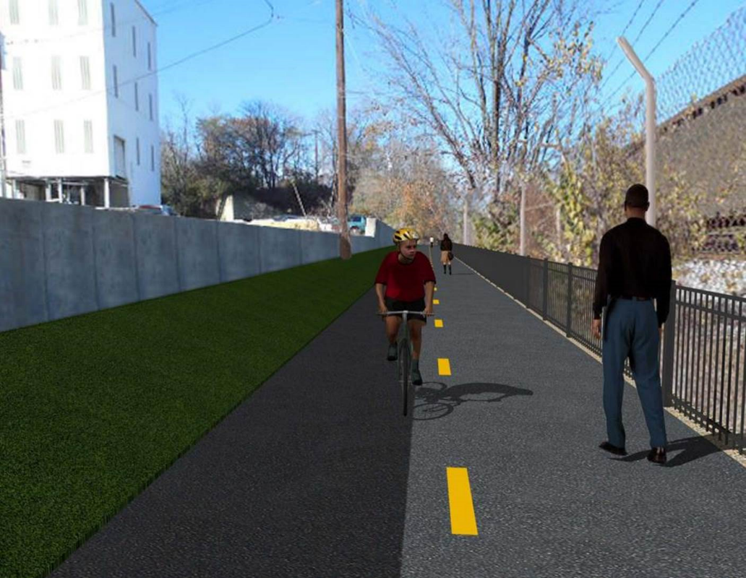

Proposed Metropolitan Branch Trail

1. PROJECT DESCRIPTION

The planned Metropolitan Branch Trail Project (“the Project”) consists of the design and construction of a new trail adjacent to CSX tracks and WMATA Red Line tracks along John McCormack Drive, adjacent to Fort Totten Metro Station, and on NPS property in NE, Washington D.C. The trail begins approximately 1500 feet south of Bates Road NE on the east side of John McCormack Drive NE, extending north along the WMATA and CSX tracks to the Fort Totten Metro Station tie in with First Place NE. An existing trail connection from Gallatin Road NE to the Fort Totten Metro Station will be reconstructed as a part of the Project.

The Project is 83.15% Federally-Funded and 16.85% District-Funded. Potomac Construction is the Design Build contractor.

Delon Hampton and Associates Chartered is providing Construction Management and Inspection services. Specific Construction Scope of Work includes:

- Provide mobilization and demobilization, provision and maintenance of Engineer’s field facilities, field layout, employee training, and other incidental work required for a quality, complete and finished product;
- Establishment and maintenance of vehicular and pedestrian traffic including signs, barricades and other transition devices; reconfiguring the devices in conjunction with changes in work areas; and their removal and disposal upon project completion, including restoration of disturbed areas;
- Clearing and grubbing, as required within the LOD;
- Removal of unsuitable material, excavation, and backfilling and pervious paving to construct a new trail;
- Protection of trees during construction;
- Provide ADA compliant trail connections and pedestrian ramps;
- Provide retaining walls as necessary to stay within the LOD and minimize property impacts following visual requirements specified for retaining walls on NPS property;
- Provide new permanent regulatory and wayfinding signs for the trail and all trail connection intersections;
- Provide road and trail pavement markings;
- Provide landscaping within the LOD for the Project including special requirements for landscaping on NPS property;
- Provide erosion and sediment control measures, storm water management facilities, including pervious asphalt pavement and bioretention facilities;
- Provide utility coordination, identification, locating, and protection of all utilities encountered during design and construction including relocation of Pepco poles along Aggregate Industries property; and
- Provide new WMATA security fencing between the trail and CSXT tracks.
- Remove existing sidewalk and widen sidewalk to 10’ along the west side of 1st place NE from Metropolitan Branch Trail to entrance to WMATA bus loop, on the west side.

2. STATUS OF CONSTRUCTION / PROGRESS SUMMARY

Work performed this week:

Design

- Phase D 3-ring binder for 100% Plans
- Stakeholders acceptance for Phase D Final Design Plans
- Railing Design Submittal to WMATA and DDOT
- Coordinate with WMATA Construction Permit Final Approval
- Coordinate with CSX Approval of Phase D Means and Methods

Construction:

Phase B

- Installed electrical pole foundation
- Pulled cables from manhole to manhole
- Placed concrete at electrical trench
- Backfilled and compacted electrical trench
- PEPCO crew performed transformer connection work from Fort Totten Drive, N.E. to Gallatin Street, N.E.
- Excavated ditch along the North side of the trail
- Excavated Bio Swale along the North Side of the trail
- Performed rough grading along the North side of the trail
- Hauled away stockpiled materials from the site

Phase D

- Cleared the cut trees from the site
- Installed rebars at retaining wall footings
- Excavated drainage pipe trench
- Installed drainage pipes
- Placed stone bedding under drainage pipes
- Hauled away stockpiled material from the site.
- CSX flagger’s operation and safety tool box talk

CM Consultant:

- Monitored construction progress, make sure all applicable inspection and testing were performed
- Reviewed Inspection Daily Reports
- Reviewing Change order package
- Attended MBT Project Progress Meeting
- Attended DDOT DHA coordination conference call meeting
- Attended QA QC Meeting
- Updated Project Files
- Updating documents in SharePoint
- Communication with the stakeholder in terms of submittals

3. MEETINGS / PROJECT COORDINATION

Tue. 06/23/20 MBT Project Progress Meeting conference call was held at 10:00 A.M.
Wed. 06/25/20 DDOT DHA Coordination Meeting conference call was held at 9:00 A.M
Fri. 06/26/20 QAQC Meeting conference call was held at 10:00A.M.

4. DAILY WORK PERFORMED

Sun 06/21/20 No work performed
Mon 06/22/20 Phase B – Excavated and performed rough grading along the North side
of the trail.
Phase B – Electrical work – Installed electrical light pole foundation.
Placed concrete in electrical trench.
Phase D - Cleared the cut trees from the site. Installed rebars for retaining wall footings.
Tue 06/23/20 Phase B – Graded shoulder and slope area along the North side of the
trail. Hauled away the unsuitable materials from the site.
Phase B - Electrical Work – Excavated electrical trench from manhole to manhole. Installed conduits.
Phase D – Cut and cleared the cut trees from the site. Excavated drainage pipe trench. Installed drainage pipe.
Wed 06/24/20 Phase B – Constructed ditch along the North side of the trail. Placed
topsoil on the 2 feet shoulder along the North side of the trail.
Phase B - Electrical Work – Backfilled and compacted electrical trench. PEPCO crew performed transformer connection work from Fort Totten Drive, N.E. to Gallatin Street, N.E.
Phase D – Installed rebars at the retaining wall footing. Installed drainage pipes, placed stone bedding under drainage pipes. Demolished and removed the existing concrete ditch. Installed temporary drainage pipes in the ditch.
Thurs 06/25/20 Phase B – Excavated Bioswale along the North side of the trail.
Phase B - Electrical Work – Backfilled and compacted electrical trench. PEPCO crew performed transformer connection work from Fort Totten Drive, N.E. to Gallatin Street, N.E.
Phase D – Installed rebars at the retaining wall footing. Installed drainage pipes, placed stone bedding under drainage pipes.
Fri 06/26/20 Phase B – Excavated Bioswale along the North side of the trail.
Phase B – Electrical Work – Pulled cables from manhole to manhole. PEPCO crew performed transformer connection work from Fort Totten Drive, N.E. to Gallatin Street, N.E.
Phase D – Installed retaining wall footing rebars. Installed temporary
drainage pipes in the ditch.
Sat 06/27/20 No work scheduled

5. INSPECTION & MATERIAL TESTS PERFORMED

Jobsite Safety Inspection  Erosion and Sediment Control inspection  MOT Inspection  Compaction Test - Passed  Asphalt Material Testing  Concrete Material Testing - Results Pending  ** Note - Additional Material Test Results can be found on DDOT QA QC Material Division Tracking SharePoint website. | Infiltration Tests  Dynamic Cone Penetration (DCP) Tests  Rebars Inspections - Ongoing
6. DBE PARTICIPATION SUMMARIES

Potomac Construction (Contractor)
- DBE Goal for Contractor is 15%. To-date the Contractor has achieved 38% of their goal.

Delon Hampton & Associates (CM)
- DBE Goal for the CM is 10%. To-date the CM has achieved 17% of their Goal.

7. ACCIDENTS / INCIDENTS

None occurred on-site during this week.

8. PHOTOS OF THE WORK PERFORMED

12. PHOTOS OF WORK PERFORMED THIS PERIOD

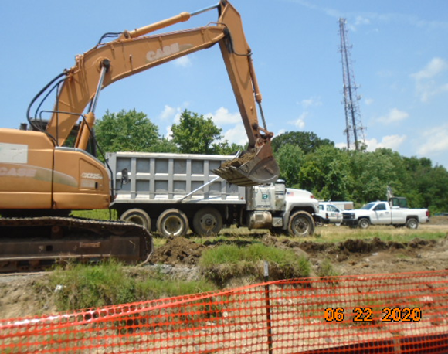
Phase B – Crew excavating ditch along the North side of the trail

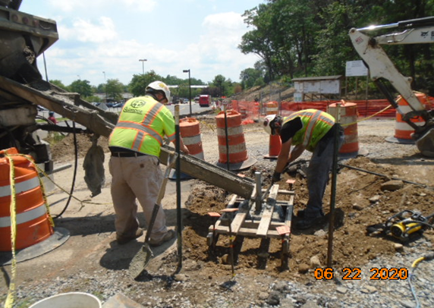
Phase B – Crew placing concrete at the light pole foundation

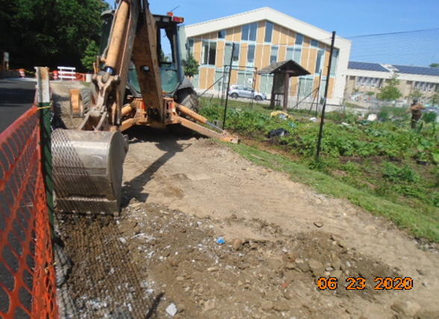
Phase B – Crew performing rough grading along the North side of the trail

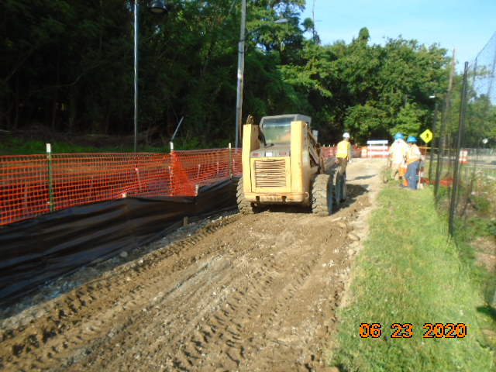
Phase B – Crew rough grading along the North side of the trail

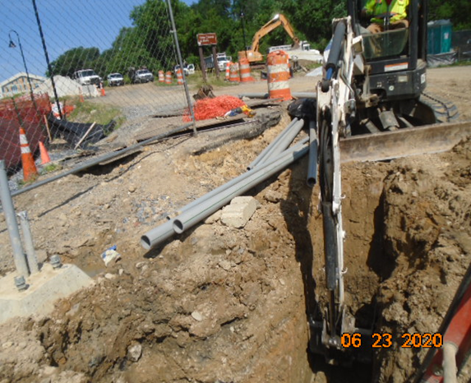
Phase B – Crew exvating electrical trench

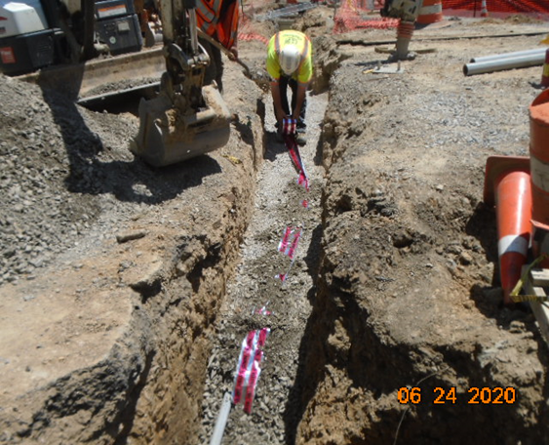
Phase B – Crew backfillin electrical trench and placing caution tape

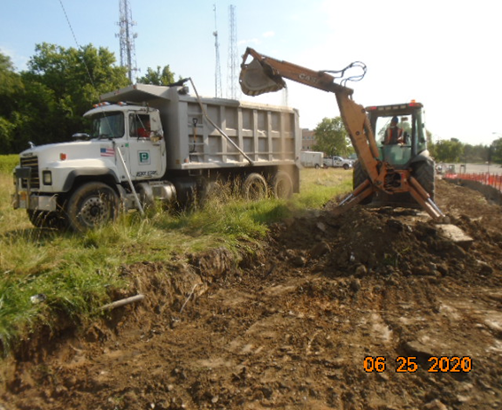
Phase B – Crew excavating Bioswale along the North side of the trail

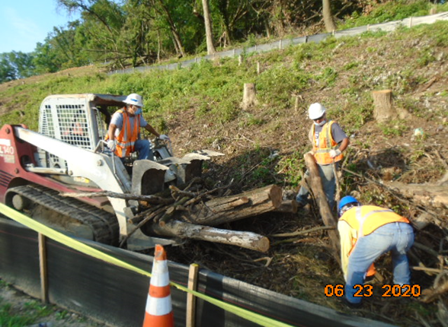
Phase D – Crew clearing the cut trees

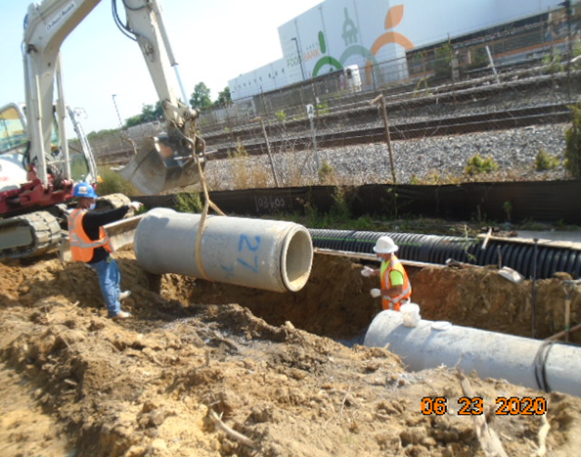
Phase D – Crew installing drainage pipes

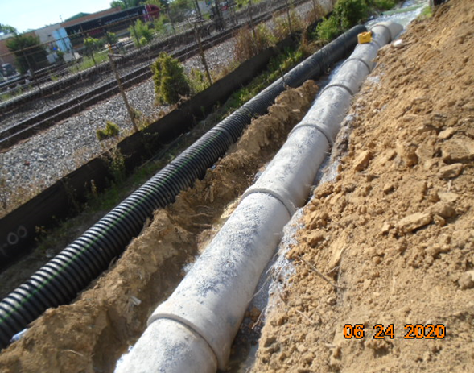
Phase D – Installed drainage pipes

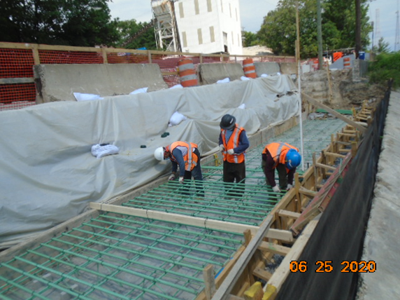
Phase D – Crew installing rebars at the retaining wall footing

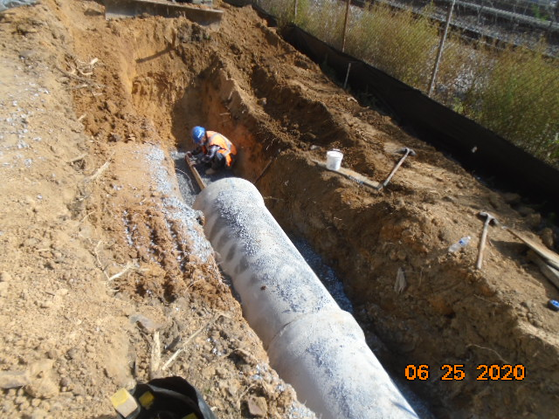
Phase D – Crew insatlling drainage pipes

