Metropolitan Branch Trail Design Build, South Segment
DC CONTRACT NO. DCKA-2016-C-0044
FAP No.: STP-2016 (060)

CONSTRUCTION MANAGER’S
WEEKLY PROGRESS REPORT

06/20/2021 – 06/26/2021

Project Website: www.metbranchtrail-forttotten.com
For Additional Trail Information Please see www.metbranchtrail.com
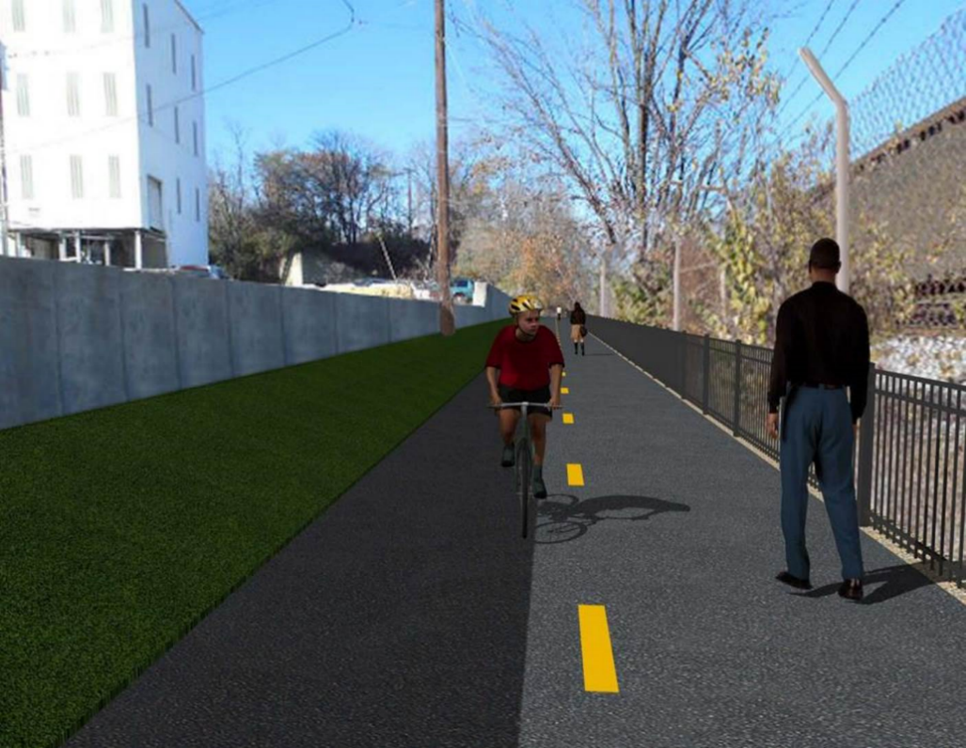

Proposed Metropolitan Branch Trail

1. PROJECT DESCRIPTION

The planned Metropolitan Branch Trail Project (“the Project”) consists of the design and construction of a new trail adjacent to CSX tracks and WMATA Red Line tracks along John McCormack Drive, adjacent to Fort Totten Metro Station, and on NPS property in NE, Washington D.C. The trail begins approximately 1500 feet south of Bates Road NE on the east side of John McCormack Drive NE, extending north along the WMATA and CSX tracks to the Fort Totten Metro Station tie in with First Place NE. An existing trail connection from Gallatin Road NE to the Fort Totten Metro Station will be reconstructed as a part of the Project.

The Project is 83.15% Federally-Funded and 16.85% District-Funded. Potomac Construction is the Design Build contractor.

Delon Hampton and Associates Chartered is providing Construction Management and Inspection services. Specific Construction Scope of Work includes:

- Provide mobilization and demobilization, provision and maintenance of Engineer’s field facilities, field layout, employee training, and other incidental work required for a quality, complete and finished product;
- Establishment and maintenance of vehicular and pedestrian traffic including signs, barricades and other transition devices; reconfiguring the devices in conjunction with changes in work areas; and their removal and disposal upon project completion, including restoration of disturbed areas;
- Clearing and grubbing, as required within the LOD;
- Removal of unsuitable material, excavation, and backfilling and pervious paving to construct a new trail;
- Protection of trees during construction;
- Provide ADA compliant trail connections and pedestrian ramps;
- Provide retaining walls as necessary to stay within the LOD and minimize property impacts following visual requirements specified for retaining walls on NPS property;
- Provide new permanent regulatory and wayfinding signs for the trail and all trail connection intersections;
- Provide road and trail pavement markings;
- Provide landscaping within the LOD for the Project including special requirements for landscaping on NPS property;
- Provide erosion and sediment control measures, storm water management facilities, including pervious asphalt pavement and bioretention facilities;
- Provide utility coordination, identification, locating, and protection of all utilities encountered during design and construction including relocation of Pepco poles along Aggregate Industries property; and
- Provide new WMATA security fencing between the trail and CSXT tracks.
- Remove existing sidewalk and widen sidewalk to 10’ along the west side of 1st place NE from Metropolitan Branch Trail to entrance to WMATA bus loop, on the west side.

2. STATUS OF CONSTRUCTION / PROGRESS SUMMARY

Work performed this week:

Design

- 100 % Complete

Construction:

Phase D

- Constructed retaining wall S0 wall section formwork
- Placed retaining wall S0 concrete
- Constructed drainage manhole
- Performed grading behind retaining wall
- Placed and graded planting soil behind north side curb
- Mobilized shaft drilling equipment
- Shaft drilled light pole foundation
- Constructed light pole foundation formwork
- Installed light pole foundation anchor bolts and rebar
- Placed light pole foundation concrete
- Installed street light poles
- CSX flagger’s operation and safety tool box talk

CM Consultant:

- Monitored construction progress, make sure all applicable inspections and testing were performed
- Reviewed PCCI Monthly Payment Invoice
- Reviewed CSX Monthly Invoice
- Prepared CM Weekly Report to post
- Prepared CM weekly report to DDOT
- Attended Project Progress Meeting
- Monitored QC field testing
- Updated Project Files
- Updated Project Logs
- Updated Project Webpage
- Updated documents in DHA SharePoint site
- Updated DDOT Sharepoint site
- Communication with PCCI and stakeholders in terms of submittals

3. MEETINGS / PROJECT COORDINATION

Tue 06/22/21 MBT Progress Meeting conference call meeting was held at 10:00 A.M.

4. DAILY WORK PERFORMED

Sun 06/20/21 No work performed.
Mon 06/21/21 Phase D – Constructed inner and outer faces of retaining wall formwork.
Demolished retaining wall S1 wing wall. Set up pile driving equipment for retaining wall S3 shaft drilling. Installed collar rebars between manhole 6A and 18” RCP connection pipes. Placed and graded planting soil behind curb.
Phase D – Electrical Work – Shaft drilled street light pole foundations. Set light pole foundations formwork and rebars.
Tue 06/22/21 Phase D – Work cancelled due to rain.
Phase D – Electrical Work – Work cancelled due to rain.
Wed 06/23/21 Phase D – Placed retaining wall S0 concrete. Mobilized equipment and delivered materials for retaining wall S3 construction. Assembled foundation shaft rebars.
Phase D – Electrical Work – Shaft drilled light pole foundation. Installed formwork and rebars at light foundations. Placed concrete at light pole foundations.
Thurs 06/24/21 Phase D – Excavated retaining wall S0 footing. Wet cured retaining wall S0 wall section concrete. Mobilized equipment and delivered materials for retaining wall S3 construction. Assembled foundation shaft rebars. Performed grading behind retaining wall S2.
Phase D – Electrical Work – Pulled dragline in installed conduits.
Fri 06/25/21 Phase D – Excavated retaining wall S0 footing. Set up shaft drilling
equipment. Shaft drilling crew performed test pit drilling. Phase D – Electrical Work – Installed light poles
Sat 06/26/21 Phase D – No work scheduled

5. INSPECTION & MATERIAL TESTS PERFORMED

Jobsite Safety Inspection  Erosion and Sediment Control inspection  MOT Inspection  Compaction Test - Passed  Asphalt Material Testing  Concrete Material Testing – Pending results  ** Note - Additional Material Test Results can be found on DDOT QA QC Material Division Tracking SharePoint website. | Infiltration Tests  Dynamic Cone Penetration (DCP) Tests  Rebars Inspection - Passed
6. DBE PARTICIPATION SUMMARIES

Potomac Construction (Contractor)

- DBE Goal for Contractor is 15%. To-date the Contractor has achieved 49.4% of their goal.

Delon Hampton & Associates (CM)

- DBE Goal for the CM is 10%. To-date the CM has achieved 82.7% of their Goal.

7. ACCIDENTS / INCIDENTS

None occurred on-site during this week.

8. PHOTOS OF THE WORK PERFORMED

12. PHOTOS OF WORK PERFORMED THIS PERIOD

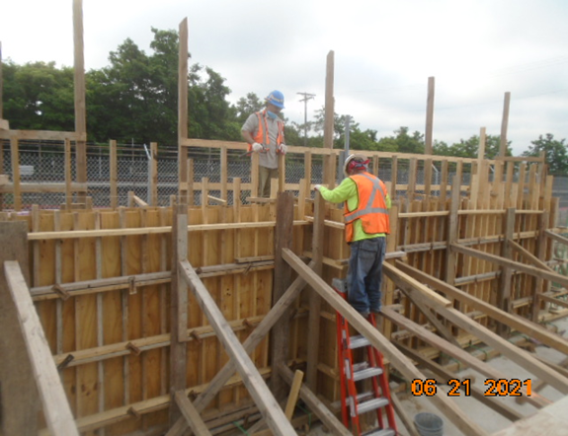
Phase D – Crew constructing retaining wall S0 formwork

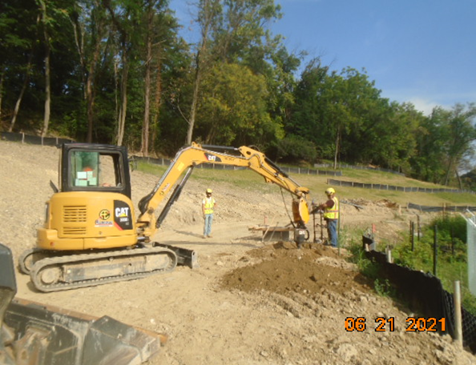
Phase D – Crew shaft drilling light pole foundation
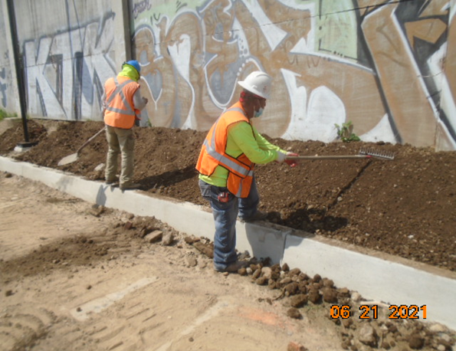
Phase D – Crew placing and grading soil along the curb

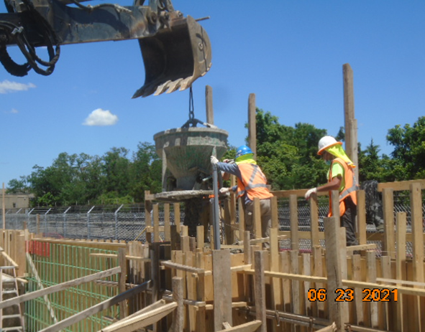
Phase D – Crew placing retaining wall concrete

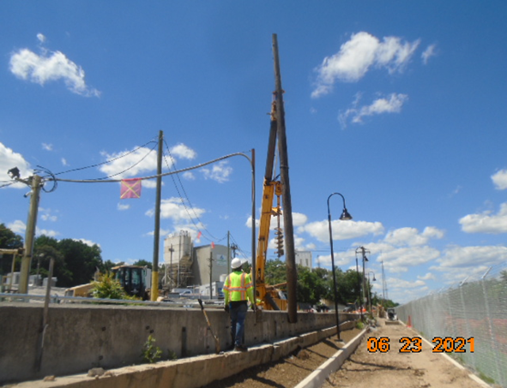
Phase D – Crew removing abandoned utility pole

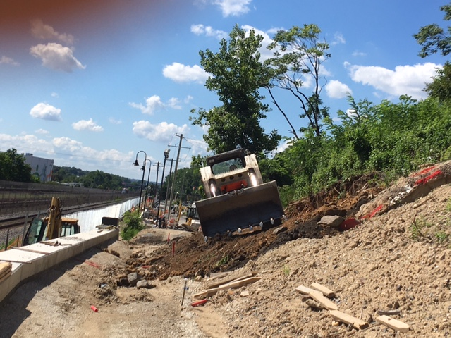
Phase D – Crew grading sloped area behind retaining area S2

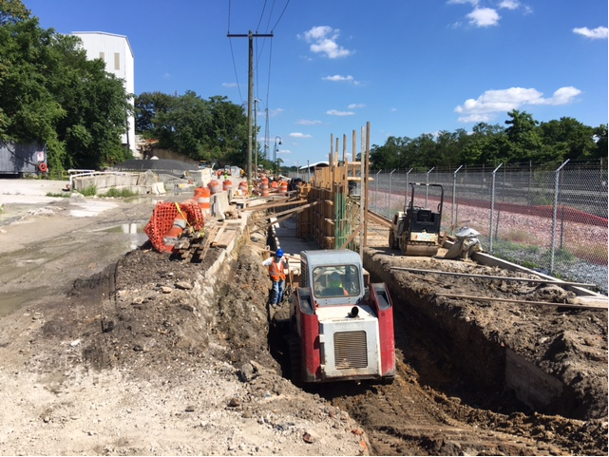
Phase D – Crew excavating retaining wall S0 footing.

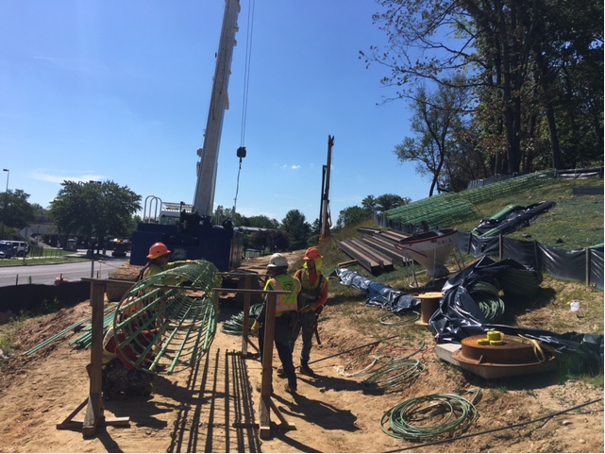
Phase D – Crew assembling shaft rebars

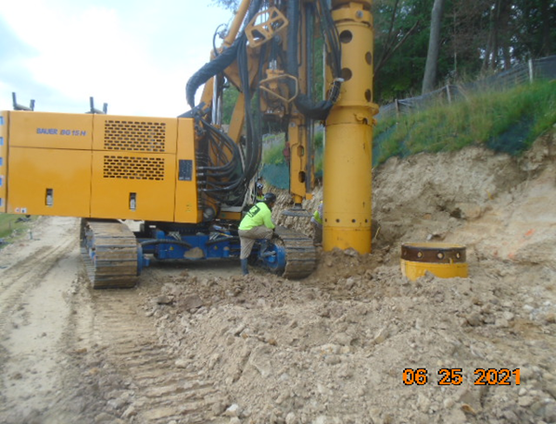
Phase D – Crew drilling test pit

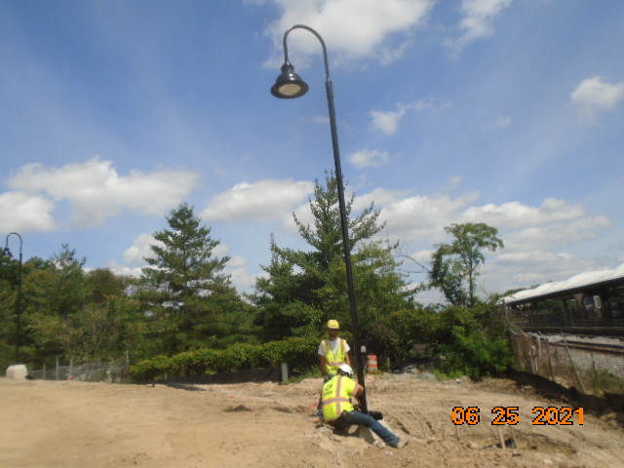
Phase D – Crew installing light pole

