Metropolitan Branch Trail Design Build, South Segment
DC CONTRACT NO. DCKA-2016-C-0044
FAP No.: STP-2016 (060)

CONSTRUCTION MANAGER’S
WEEKLY PROGRESS REPORT

06/14/2020 – 06/20/2020

Project Website: www.metbranchtrail-forttotten.com
For Additional Trail Information Please see www.metbranchtrail.com

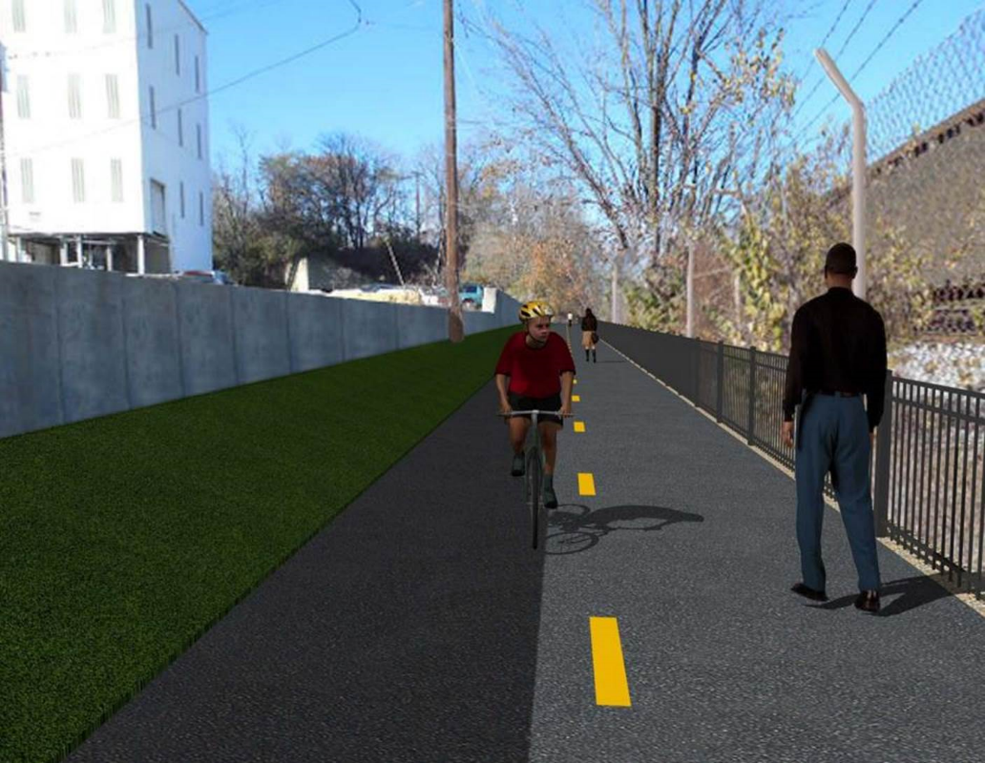

Proposed Metropolitan Branch Trail

1. PROJECT DESCRIPTION

The planned Metropolitan Branch Trail Project (“the Project”) consists of the design and construction of a new trail adjacent to CSX tracks and WMATA Red Line tracks along John McCormack Drive, adjacent to Fort Totten Metro Station, and on NPS property in NE, Washington D.C. The trail begins approximately 1500 feet south of Bates Road NE on the east side of John McCormack Drive NE, extending north along the WMATA and CSX tracks to the Fort Totten Metro Station tie in with First Place NE. An existing trail connection from Gallatin Road NE to the Fort Totten Metro Station will be reconstructed as a part of the Project.

The Project is 83.15% Federally-Funded and 16.85% District-Funded. Potomac Construction is the Design Build contractor.

Delon Hampton and Associates Chartered is providing Construction Management and Inspection services. Specific Construction Scope of Work includes:

- Provide mobilization and demobilization, provision and maintenance of Engineer’s field facilities, field layout, employee training, and other incidental work required for a quality, complete and finished product;
- Establishment and maintenance of vehicular and pedestrian traffic including signs, barricades and other transition devices; reconfiguring the devices in conjunction with changes in work areas; and their removal and disposal upon project completion, including restoration of disturbed areas;
- Clearing and grubbing, as required within the LOD;
- Removal of unsuitable material, excavation, and backfilling and pervious paving to construct a new trail;
- Protection of trees during construction;
- Provide ADA compliant trail connections and pedestrian ramps;
- Provide retaining walls as necessary to stay within the LOD and minimize property impacts following visual requirements specified for retaining walls on NPS property;
- Provide new permanent regulatory and wayfinding signs for the trail and all trail connection intersections;
- Provide road and trail pavement markings;
- Provide landscaping within the LOD for the Project including special requirements for landscaping on NPS property;
- Provide erosion and sediment control measures, storm water management facilities, including pervious asphalt pavement and bioretention facilities;
- Provide utility coordination, identification, locating, and protection of all utilities encountered during design and construction including relocation of Pepco poles along Aggregate Industries property; and
- Provide new WMATA security fencing between the trail and CSXT tracks.
- Remove existing sidewalk and widen sidewalk to 10’ along the west side of 1st place NE from Metropolitan Branch Trail to entrance to WMATA bus loop, on the west side.

2. STATUS OF CONSTRUCTION / PROGRESS SUMMARY

Work performed this week:

Design

- Phase D 3-ring binder for 100% Plans
- Stakeholders acceptance for Phase D Final Design Plans
- Railing Design Submittal to WMATA and DDOT
- WMATA / DDOT Notification Plan for Phase D Construction Activities
- Coordinate with CSX Approval of Phase D Means and Methods
- Submittal D 100% Final Plans were delivered to DDOT field office
- Sent Geotechnical Report to Contractor

Construction:

Phase B

- Relocate pedestrian traffic to the new trail
- Removed and hauled away jersey barriers from the site
- Demolished and removed existing temporary trail asphalt
- Excavated electrical trench from manhole to manhole
- Hauled away excavated materials from the site

Phase D

- Cut trees and cleared the cut trees from the site
- Excavated retaining wall footing
- Placed stone at the retaining wall footing pad
- Constructed trench drain for the end section.
- Hauled away stockpiled material from the site.
- Installed temporary drainage pipe at the existing concrete ditch.
- Performed surveying and marking storm pipe stakeout
- CSX flagger’s operation and safety tool box talk

CM Consultant:

- Monitored construction progress, make sure all applicable inspection and testing were performed
- Reviewed Inspection Daily Reports
- Reviewing Change order package
- Worked on posting WMATA Notification Notices on project website
- Attended DDOT PCCI Retaining Wall unforeseen condition meeting
- Attended DDOT QA Meeting
- Attended QA QC Meeting
- Updated Project Files
- Updating documents in SharePoint
- Communication with the stakeholder in terms of submittals

3. MEETINGS / PROJECT COORDINATION

Wed. 06/17/20 DDOT PCCI Designer Meeting conference call to discuss Retaining
Wall Unforeseen conditions was held at 9:00A.M.
Thurs. 06/18/20 DDOT DHA QA Meeting conference call was held at 10:30 A.M.
Fri. 06/19/20 QAQC Meeting conference call was held at 10:00A.M.

4. DAILY WORK PERFORMED

Sun 06/14/20 No work performed
Mon 06/15/20 Phase B – Relocated pedestrian traffic to the new trail. Removed jersey
barriers from the trail and hauled them off from the trail. DOEE inspector visited site performed DOEE inspection.
Phase B – Electrical work – No work performed.
Phase D - Cut and cleared the cut trees from the site. Excavated retaining wall footing.
Tue 06/16/20 Phase B – Removed and hauled away jersey barriers from the site
Phase B - Electrical Work – Drilled light pole foundation. Installed conduits. Set forms, installed rebars and anchor bolts.
Phase D – Cut and cleared the cut trees from the site. Placed stone at the retaining wall footing pad.
Wed 06/17/20 Phase B – Removed and hauled away jersey barriers from the site.
Demolished and removed temporary trail asphalt. Hauled away stockpiled material from the site.
Phase B - Electrical Work – No work performed.
Phase D - Cleared the cut trees from the site. Installed formwork for retaining wall footing. Demolished existing concrete ditch. Constructed trench drain for the end section.
Thurs 06/18/20 Phase B – Demolished and removed temporary trail asphalt. Hauled
away stockpiled material from the site.
Phase B - Electrical Work – No work performed.
Phase D – Cleared the cut trees from the site. Demolished existing concrete ditch. Installed temporary drainage pipe at the existing concrete ditch.
Fri 06/19/20 Phase B – Demolished and removed temporary trail asphalt. Hauled
away stockpiled material from the site. Excavated electrical trench
Phase B – Electrical Work – Excavated electrical trench.
Phase D – Cut and cleared the cut trees from the site. Installed formwork for retaining wall footing. Installed temporary drainage pipe at the existing concrete ditch.

Sat 06/20/20 No work scheduled

5. INSPECTION & MATERIAL TESTS PERFORMED

Jobsite Safety Inspection  Erosion and Sediment Control inspection  MOT Inspection  Compaction Test  Asphalt Material Testing  Concrete Material Testing  ** Note - Additional Material Test Results can be found on DDOT QA QC Material Division Tracking SharePoint website. | Infiltration Tests  Dynamic Cone Penetration (DCP) Tests – The subgrade has been tested. Awaiting to receive DCP test results for the foundation subgrade.  Rebars Inspections
6. DBE PARTICIPATION SUMMARIES

Potomac Construction (Contractor)
- DBE Goal for Contractor is 15%. To-date the Contractor has achieved 38% of their goal.

Delon Hampton & Associates (CM)
- DBE Goal for the CM is 10%. To-date the CM has achieved 17% of their Goal.

7. ACCIDENTS / INCIDENTS

None occurred on-site during this week.

8. PHOTOS OF THE WORK PERFORMED

12. PHOTOS OF WORK PERFORMED THIS PERIOD

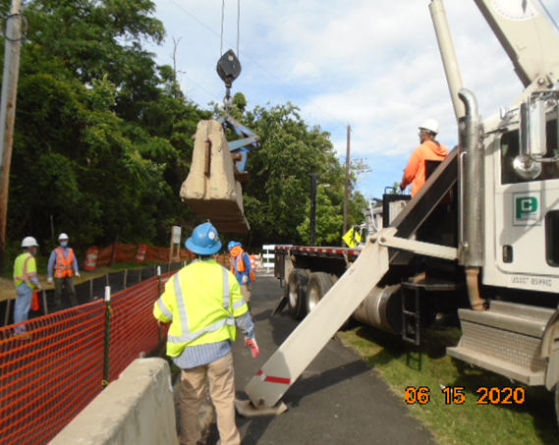
Phase B – Crew removing jersey barriers

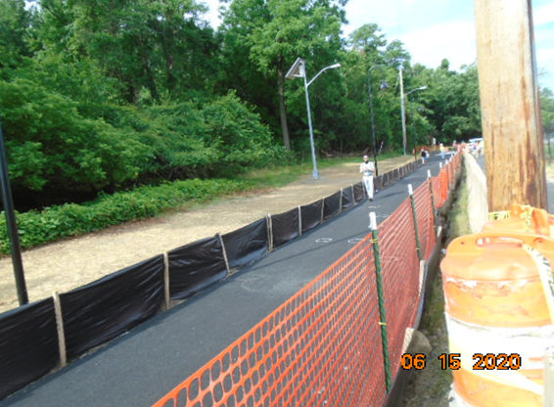
Phase B – Trail opened to pedestrians
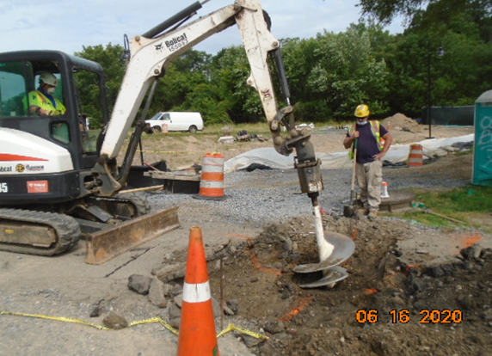
Phase B – Crew shaft drilling electrical pole foundation

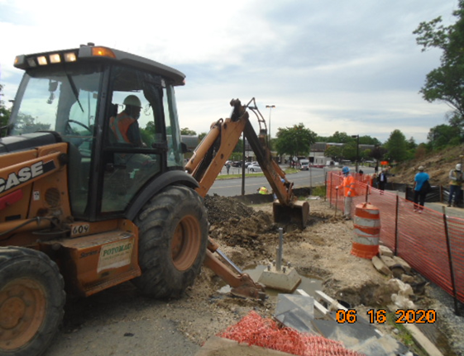
Phase B – Crew excavating electrical trench line

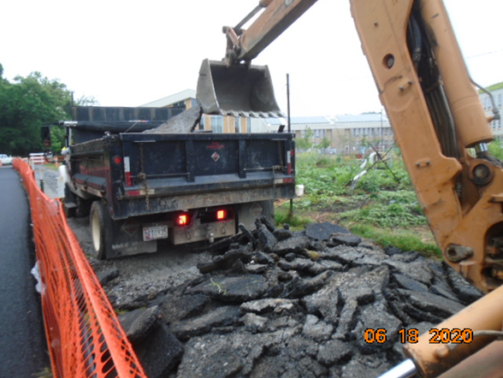
Phase B – Crew hauling away demolished asphalt from the site

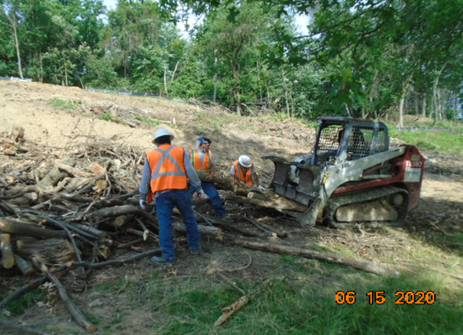
Phase D – Crew clearing the cut trees

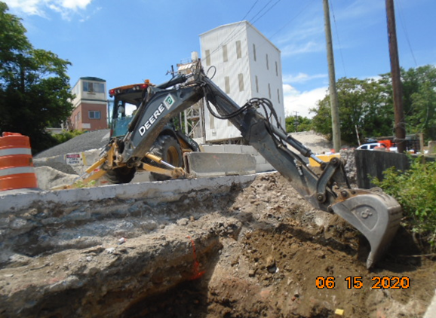
Phase D – Crew excavating retaining wall footing

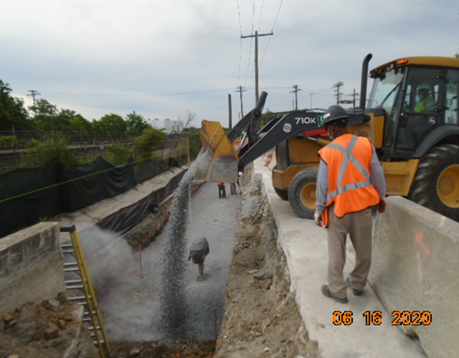
Phase D – Crew placing stone at retaining wall footing pad

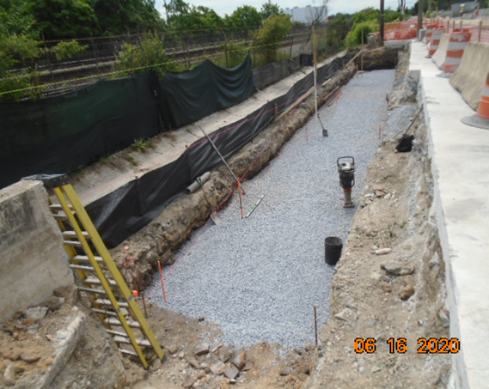
Phase D – Retaining wall footing pad

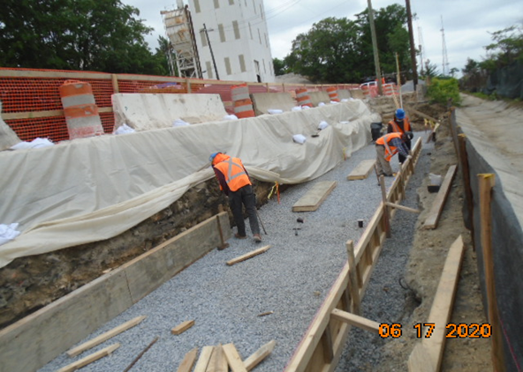
Phase D – Crew installing formwork for retaining wall footing

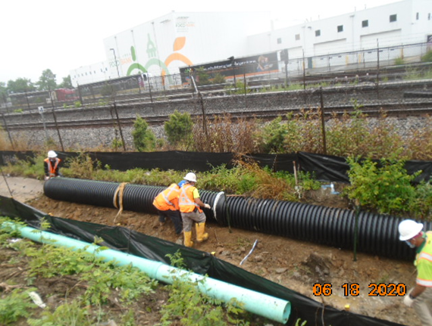
Phase D – Crew installing temporary pipes

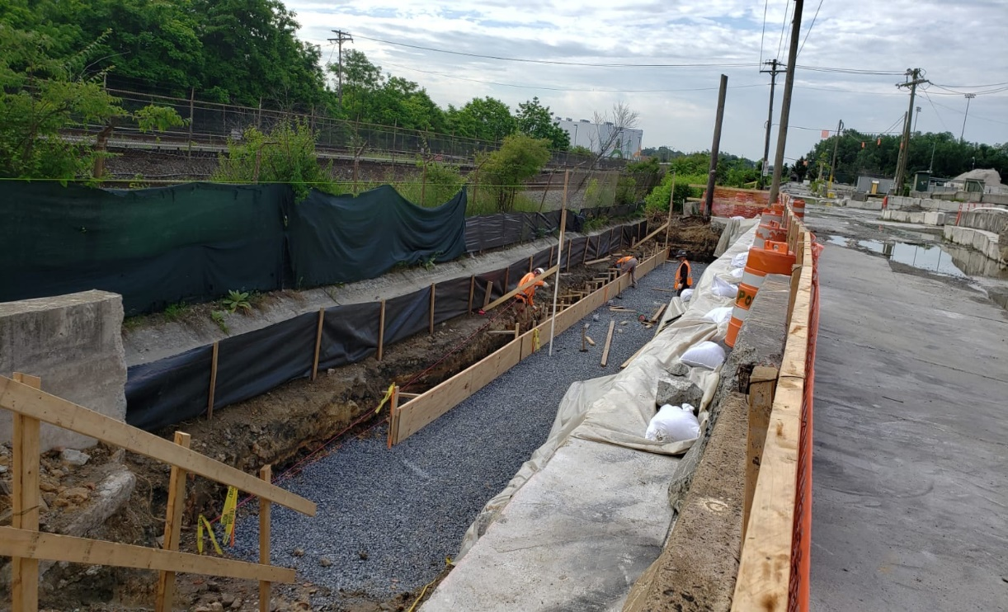
Phase D – Crew insatlling retaining wall footing formwork

