**Metropolitan Branch Trail Design Build, South Segment**

**DC CONTRACT NO. DCKA-2016-C-0044**

**FAP No.: STP-2016 (060)**

CONSTRUCTION MANAGER’S

WEEKLY PROGRESS REPORT

06/07/2020 – 06/13/2020

Project Website: [www.metbranchtrail-forttotten.com](http://www.metbranchtrail-forttotten.com)

For Additional Trail Information Please see [www.metbranchtrail.com](http://www.metbranchtrail.com)

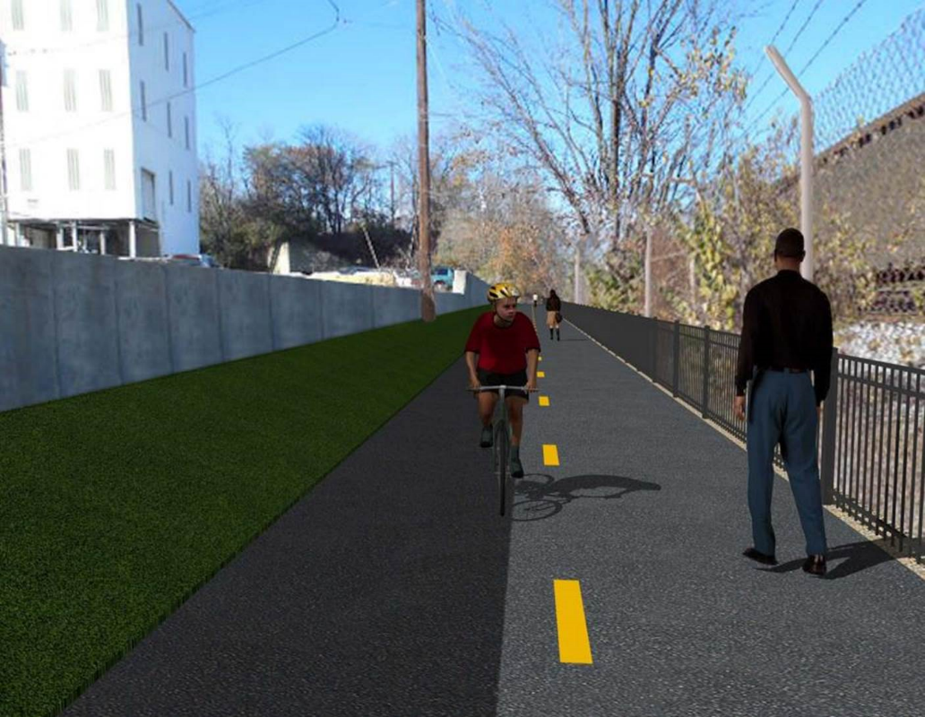

**Proposed Metropolitan Branch Trail**

**1. PROJECT DESCRIPTION**

The planned Metropolitan Branch Trail Project (“the Project”) consists of the design and construction of a new trail adjacent to CSX tracks and WMATA Red Line tracks along John McCormack Drive, adjacent to Fort Totten Metro Station, and on NPS property in NE, Washington D.C. The trail begins approximately 1500 feet south of Bates Road NE on the east side of John McCormack Drive NE, extending north along the WMATA and CSX tracks to the Fort Totten Metro Station tie in with First Place NE. An existing trail connection from Gallatin Road NE to the Fort Totten Metro Station will be reconstructed as a part of the Project.

The Project is 83.15% Federally-Funded and 16.85% District-Funded. Potomac Construction is the Design Build contractor.

Delon Hampton and Associates Chartered is providing Construction Management and Inspection services. Specific Construction Scope of Work includes:

* Provide mobilization and demobilization, provision and maintenance of Engineer’s field facilities, field layout, employee training, and other incidental work required for a quality, complete and finished product;
* Establishment and maintenance of vehicular and pedestrian traffic including signs, barricades and other transition devices; reconfiguring the devices in conjunction with changes in work areas; and their removal and disposal upon project completion, including restoration of disturbed areas;
* Clearing and grubbing, as required within the LOD;
* Removal of unsuitable material, excavation, and backfilling and pervious paving to construct a new trail;
* Protection of trees during construction;
* Provide ADA compliant trail connections and pedestrian ramps;
* Provide retaining walls as necessary to stay within the LOD and minimize property impacts following visual requirements specified for retaining walls on NPS property;
* Provide new permanent regulatory and wayfinding signs for the trail and all trail connection intersections;
* Provide road and trail pavement markings;
* Provide landscaping within the LOD for the Project including special requirements for landscaping on NPS property;
* Provide erosion and sediment control measures, storm water management facilities, including pervious asphalt pavement and bioretention facilities;
* Provide utility coordination, identification, locating, and protection of all utilities encountered during design and construction including relocation of Pepco poles along Aggregate Industries property; and
* Provide new WMATA security fencing between the trail and CSXT tracks.
* Remove existing sidewalk and widen sidewalk to 10’ along the west side of 1st place NE from Metropolitan Branch Trail to entrance to WMATA bus loop, on the west side.

**2. STATUS OF CONSTRUCTION / PROGRESS SUMMARY**

**Work performed this week:**

**Design**

* Phase D 3-ring binder for 100% Plans
* Stakeholders acceptance for Phase D Final Design Plans
* Railing Design Submittal to WMATA and DDOT
* WMATA / DDOT Notification Plan for Phase D Construction Activities

**Construction:**

**Phase B**

* Removed solar light pole foundation and backfilled trench.
* Applied topsoil along the trail
* Installed silt fence along the South side of the trail
* Installed safety fence along the trail
* Pressure washed the temporary trail

**Phase D**

* Cut trees and cleared the cut trees from the site
* Performed rough grading
* Saw cut and demolished existing concrete slab
* Excavated retaining wall footing
* Placed stone at the retaining wall footing pad
* Performed surveying and marking storm pipe stakeout
* Excavated test pits
* Delivered storm pipes to the site.
* Installed WMATA Notification Posters
* DDOT and QA performed inspection of stored electrical items

**CM Consultant:**

* Monitored construction progress, make sure all applicable inspection and testing were performed
* Reviewed Inspection Daily Reports
* Reviewing Invoice for the month of May
* Worked on posting WMATA Notification Notices on project website
* Attended WMATA PCCI site coordination meeting to Post WMATA Notification Posters on the project site
* Attended DDOT PEPCO PCCI Field Meeting to relocate guide wires (Phase D)
* Attended Project Progress Meeting
* Attended QA QC Meeting
* Updated Project Files
* Updating documents in SharePoint
* Communication with the stakeholder in terms of submittals

**3. MEETINGS / PROJECT COORDINATION**

Tue. 06/09/20 Progress Meeting conference call was held at 10:00 A.M.

Wed. 06/09/20 DDOT WMATA and PCCI meeting to discuss electrical items and to coordinate disconnect and reconnect of electrical power was held at 10:00 A.M.

Wed. 06/10/20 CM WMATA and PCCI meeting to post WMATA Notification Posters

was held on site at 10:30 A.M

Fri. 06/13/20 QA/QC Meeting conference call was held at 10:00 A.M.

**4. DAILY WORK PERFORMED**

Sun 06/07/20 No work performed

Mon 06/08/20 Phase B – Removed solar light pole foundation and backfilled trench.

Fine graded and applied top soil on the disturbed areas.

Phase B – Electrical work – No work performed

Phase D - Cut and cleared the cut trees from the site. Demolished and hauled away the existing concrete slab from the site. Excavated the retaining wall footing.

Tue 06/09/20 Phase B – Removed solar light pole foundation and backfilled trench.

Fine graded and applied top soil on the disturbed areas.

Phase B - Electrical Work – No work performed.

Phase D - Cut and cleared the cut trees from the site. Demolished and hauled away the existing concrete slab from the site. Excavated the retaining wall footing.

Wed 06/10/20 Phase B – Removed solar light pole foundation and backfilled trench.

Installed silt fence along the South side of the trail. Hauled off onsite stockpile materials from the site.

Phase B - Electrical Work – Worked on fixing frame of electrical pole.

Phase D - Cut and cleared the cut trees from the site. Demolished and hauled away the existing concrete slab from the site. Excavated the retaining wall footing.

Thurs 06/11/20 Phase B – Install silt fence along the South side of the trail. Install safety

fence along the South side of the trail. Pressure washed temporary trail.

Phase B - Electrical Work – No work performed

Phase D – Cut and cleared the cut trees from the site. Demolished and hauled away the existing concrete slab from the site. Excavated the retaining wall footing. Installed four WMATA Notification Posters on the site.

Fri 06/13/20 Phase B – Install silt fence along the South side of the trail.

Phase B – Electrical Work – No work performed

Phase D – Cut and cleared the cut trees from the site. Demolished and hauled away the existing concrete slab from the site. Excavated the retaining wall footing.

Sat 06/14/20 No work scheduled

**5. INSPECTION & MATERIAL TESTS PERFORMED**

|  |  |
| --- | --- |
| Jobsite Safety Inspection  Erosion and Sediment Control inspection  MOT Inspection  Compaction Test  Asphalt Material Testing  Concrete Material Testing | Infiltration facility Material Testing |

**6. DBE PARTICIPATION SUMMARIES**

Potomac Construction (Contractor)

* DBE Goal for Contractor is 15%. To-date the Contractor has achieved 38% of their goal.

Delon Hampton & Associates (CM)

* DBE Goal for the CM is 10%. To-date the CM has achieved 17% of their Goal.

**7. ACCIDENTS / INCIDENTS**

None occurred on-site during this week.

**8. PHOTOS OF THE WORK PERFORMED**

**12. PHOTOS OF WORK PERFORMED THIS PERIOD**

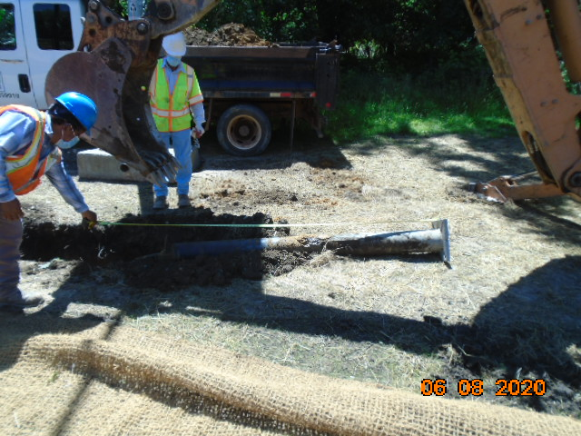

**Phase B – Crew removing light pole foundation**

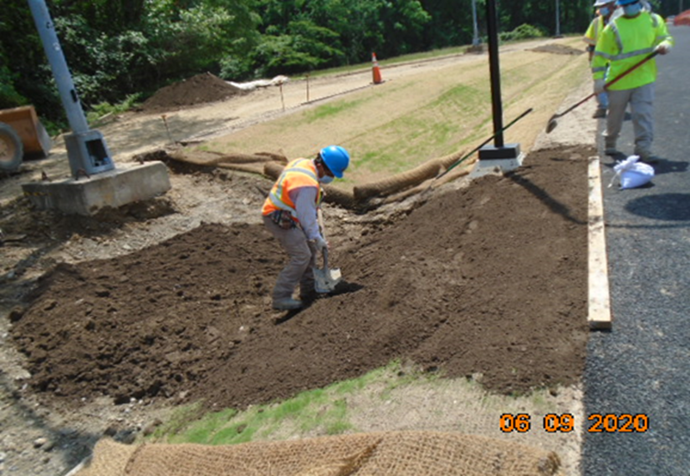

**Phase B – Crew applying topsoil along North side of the trail**

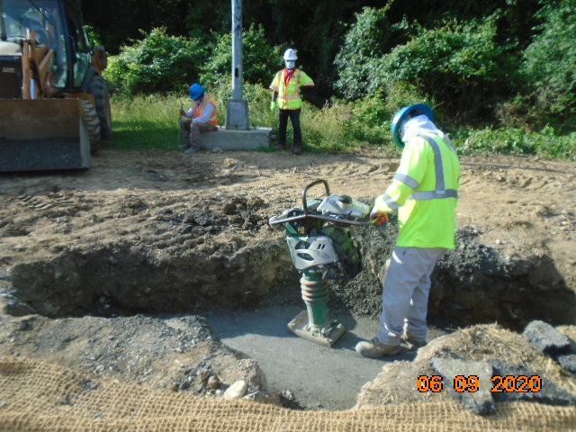

**Phase B – Crew compacting the trench**

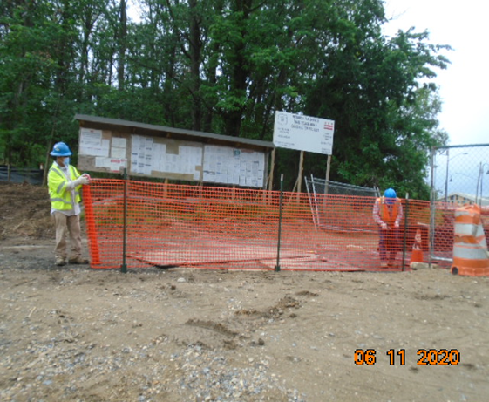

**Phase B – Crew installing safety fence**

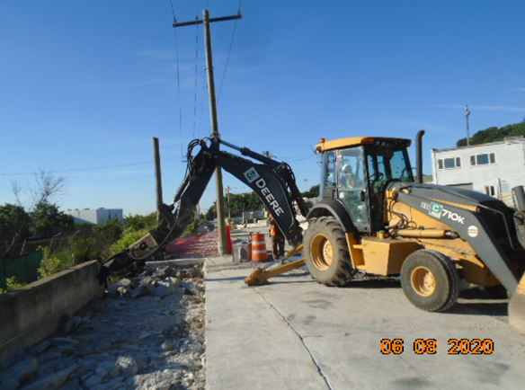

**Phase D – Crew demolishing the existing concrete slab**

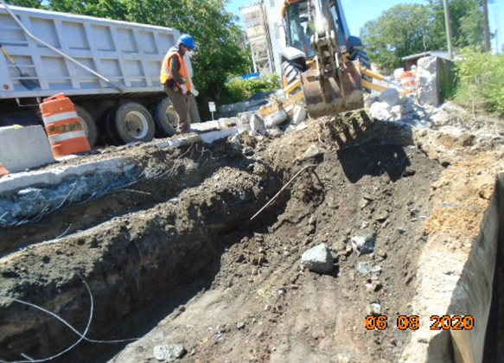

**Phase D – Crew excavating retaining wall footing**

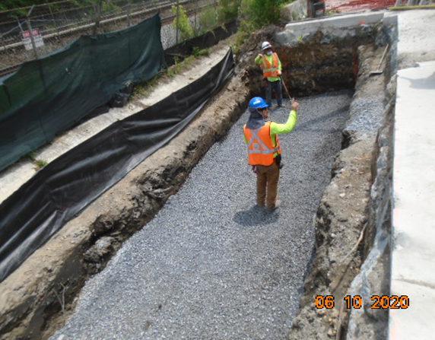

**Phase D – Crew placing stone at retaining wall footing padd**

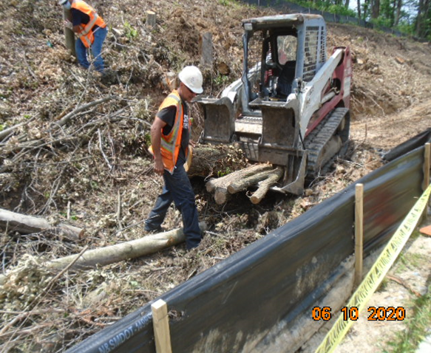

**Phase D – Crew clearing the cut trees**

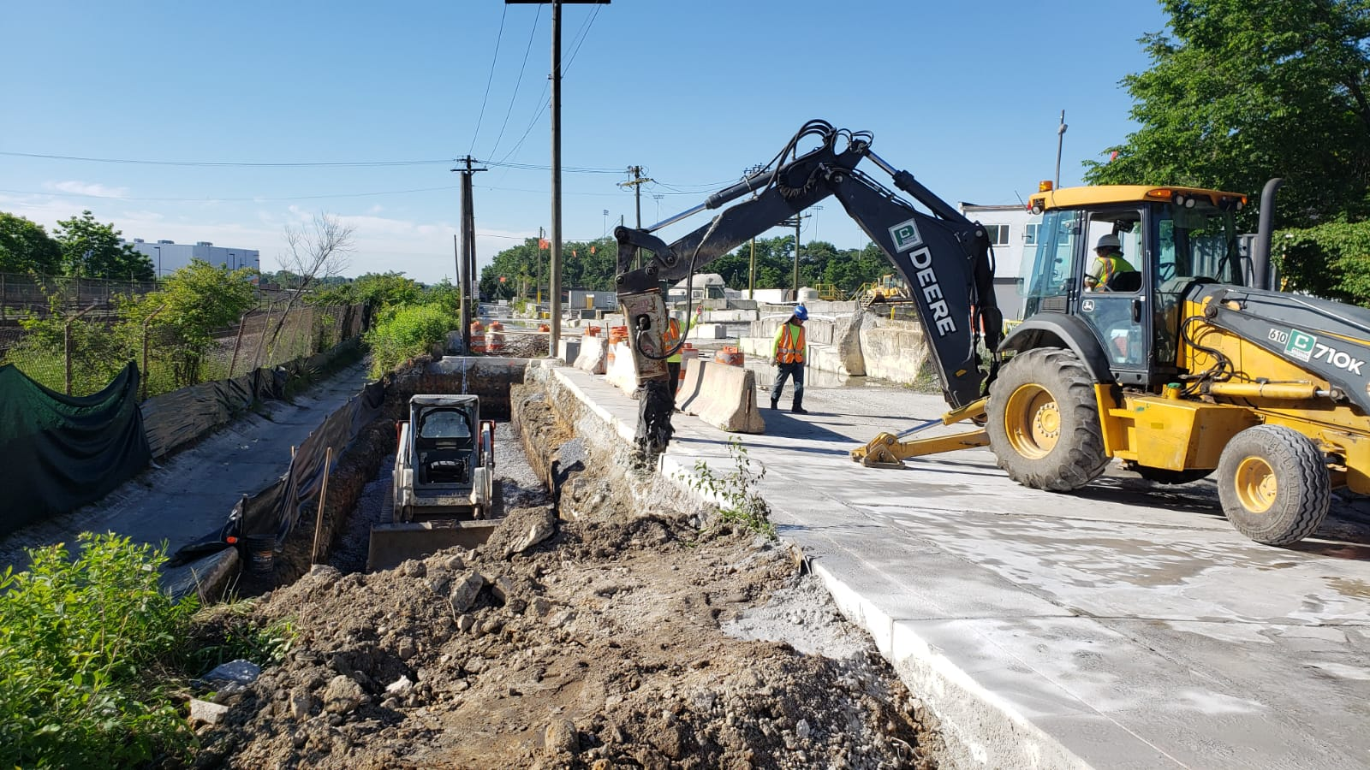

**Phase D – Crew excavating retaining wall footing**