Metropolitan Branch Trail Design Build, South Segment
DC CONTRACT NO. DCKA-2016-C-0044
FAP No.: STP-2016 (060)

CONSTRUCTION MANAGER’S
WEEKLY PROGRESS REPORT

06/06/2021 – 06/12/2021

Project Website: www.metbranchtrail-forttotten.com
For Additional Trail Information Please see www.metbranchtrail.com
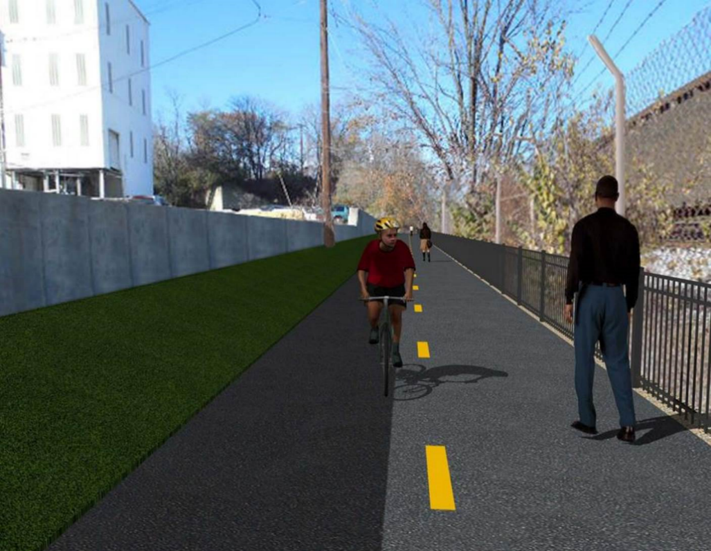

Proposed Metropolitan Branch Trail

1. PROJECT DESCRIPTION

The planned Metropolitan Branch Trail Project (“the Project”) consists of the design and construction of a new trail adjacent to CSX tracks and WMATA Red Line tracks along John McCormack Drive, adjacent to Fort Totten Metro Station, and on NPS property in NE, Washington D.C. The trail begins approximately 1500 feet south of Bates Road NE on the east side of John McCormack Drive NE, extending north along the WMATA and CSX tracks to the Fort Totten Metro Station tie in with First Place NE. An existing trail connection from Gallatin Road NE to the Fort Totten Metro Station will be reconstructed as a part of the Project.

The Project is 83.15% Federally-Funded and 16.85% District-Funded. Potomac Construction is the Design Build contractor.

Delon Hampton and Associates Chartered is providing Construction Management and Inspection services. Specific Construction Scope of Work includes:

- Provide mobilization and demobilization, provision and maintenance of Engineer’s field facilities, field layout, employee training, and other incidental work required for a quality, complete and finished product;
- Establishment and maintenance of vehicular and pedestrian traffic including signs, barricades and other transition devices; reconfiguring the devices in conjunction with changes in work areas; and their removal and disposal upon project completion, including restoration of disturbed areas;
- Clearing and grubbing, as required within the LOD;
- Removal of unsuitable material, excavation, and backfilling and pervious paving to construct a new trail;
- Protection of trees during construction;
- Provide ADA compliant trail connections and pedestrian ramps;
- Provide retaining walls as necessary to stay within the LOD and minimize property impacts following visual requirements specified for retaining walls on NPS property;
- Provide new permanent regulatory and wayfinding signs for the trail and all trail connection intersections;
- Provide road and trail pavement markings;
- Provide landscaping within the LOD for the Project including special requirements for landscaping on NPS property;
- Provide erosion and sediment control measures, storm water management facilities, including pervious asphalt pavement and bioretention facilities;
- Provide utility coordination, identification, locating, and protection of all utilities encountered during design and construction including relocation of Pepco poles along Aggregate Industries property; and
- Provide new WMATA security fencing between the trail and CSXT tracks.
- Remove existing sidewalk and widen sidewalk to 10’ along the west side of 1st place NE from Metropolitan Branch Trail to entrance to WMATA bus loop, on the west side.

2. STATUS OF CONSTRUCTION / PROGRESS SUMMARY

Work performed this week:

Design

- 100 % Complete

Construction:

Phase D

- Placed concrete for retaining wall S0 footing
- Constructed retaining wall S0 wall section formwork
- Installed retaining wall S0 wall section rebars
- Installed north side curb formwork
- Place concrete for north side curb
- Backfilled behind north side curb
- Excavated electrical trench
- Installed electrical conduits
- Installed electrical manhole
- Backfilled and compacted electrical trench
- CSX flagger’s operation and safety tool box talk

CM Consultant:

- Monitored construction progress, make sure all applicable inspections and testing were performed
- Reviewed PCCI Monthly Payment Invoice
- Reviewed CSX Monthly Invoice
- Prepared CM Weekly Report to post
- Prepared CM weekly report to DDOT
- Attended Project Progress Meeting
- Monitored QC field testing
- Updated Project Files
- Updated Project Logs
- Updated Project Webpage
- Updated documents in DHA SharePoint site
- Updated DDOT Sharepoint site
- Communication with PCCI and stakeholders in terms of submittals

3. MEETINGS / PROJECT COORDINATION

Tue 06/08/20 MBT Project Progress meeting was held at 10:00 A.M.

4. DAILY WORK PERFORMED

Sun 06/06/21 No work performed.
Mon 06/07/21 Phase D – Placed concrete for retaining wall S0 footing. Placed concrete for
north side curb. Excavated drainage manhole. Placed bedding stone for
manhole base. Installed rebars for manhole base. Constructed formwork for manhole base.
Phase D – Electrical Work – Excavated manhole trench. Place bedding stone for manhole base. Installed electrical manhole.
Tue 06/08/21 Phase D –Installed retaining wall S0 footing rebars. Placed concrete for drainage manhole base. Cleared cut trees.
Phase D – Electrical Work – Excavated electrical trench. Installed electrical conduits.
Wed 06/09/21 Phase D – Installed retaining wall S0 wall section rebars. Backfilled behind north side curb. Excavated drainage trench for manhole. Installed chain link fence.
Phase D – Electrical Work – Backfilled and compacted electrical trench. Excavated electrical trench for electrical conduits.
Thurs 06/10/21 Phase D – Installed retaining wall S0 wall section rebars. Constructed
retaining wall S0 formwork. Constructed drainage manhole.
Phase D – Electrical Work – Installed electrical conduits. Backfilled and
compacted electrical conduits trench.
Fri 06/11/21 Phase D – Work cancelled due to rain.
Sat 06/12/21 Phase D – No work scheduled

5. INSPECTION & MATERIAL TESTS PERFORMED

Jobsite Safety Inspection  Erosion and Sediment Control inspection  MOT Inspection  Compaction Test - Passed  Asphalt Material Testing  Concrete Material Testing – Pending results  ** Note - Additional Material Test Results can be found on DDOT QA QC Material Division Tracking SharePoint website. | Infiltration Tests  Dynamic Cone Penetration (DCP) Tests  Rebars Inspection - Passed
6. DBE PARTICIPATION SUMMARIES

Potomac Construction (Contractor)

- DBE Goal for Contractor is 15%. To-date the Contractor has achieved 49.4% of their goal.

Delon Hampton & Associates (CM)

- DBE Goal for the CM is 10%. To-date the CM has achieved 82.7% of their Goal.

7. ACCIDENTS / INCIDENTS

None occurred on-site during this week.

8. PHOTOS OF THE WORK PERFORMED

12. PHOTOS OF WORK PERFORMED THIS PERIOD

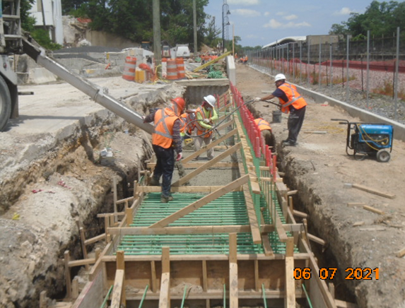
Phase D – Crew placing retaining wall S0 concrete

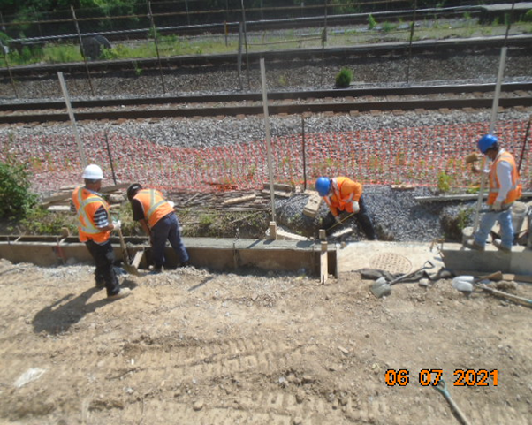
Phase D – Crew finishing concrete for north side curb
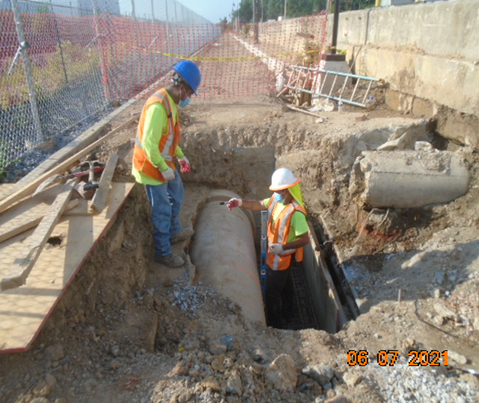
Phase D – Crew forming drainage manhole

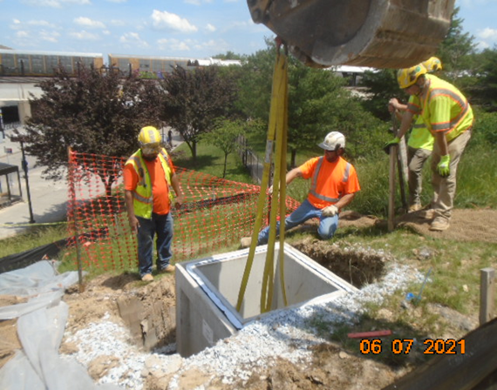
Phase D – Crew installing electrical manhole

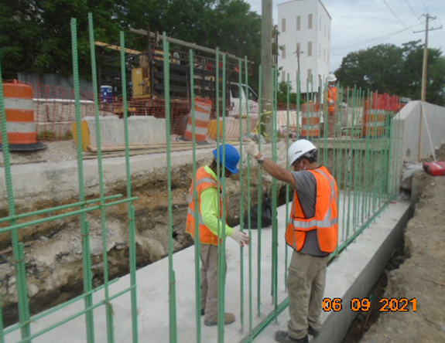
Phase D – Crew tying retaining wall S0 rebars

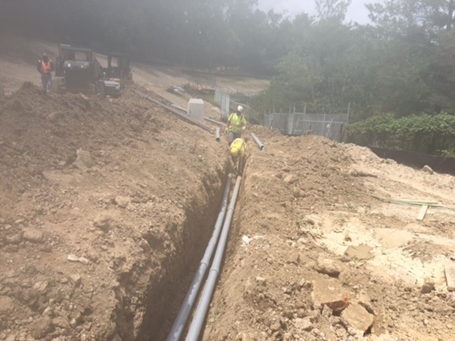
Phase D – Crew installing electrical conduits

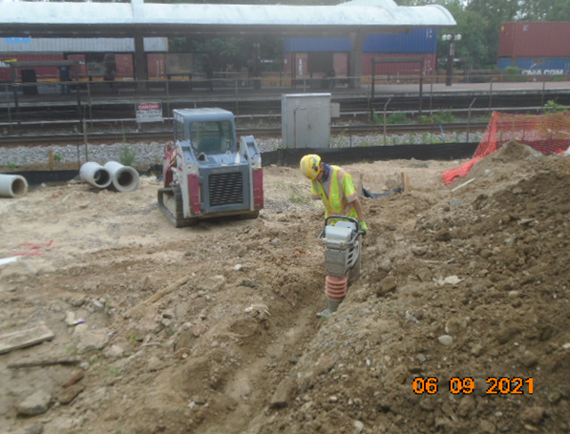
Phase D – Crew compacting electrical trench

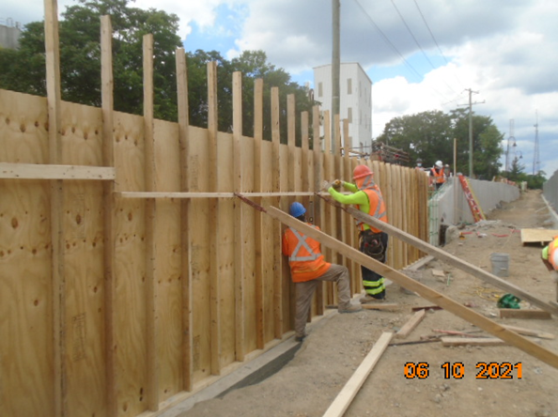
Phase D – Crew constructing retaining wall S0 formwork

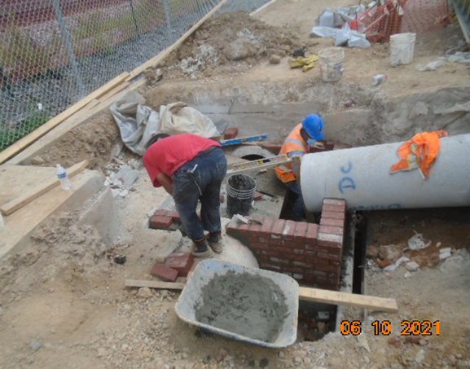
Phase D – Crew constructing drainage manhole

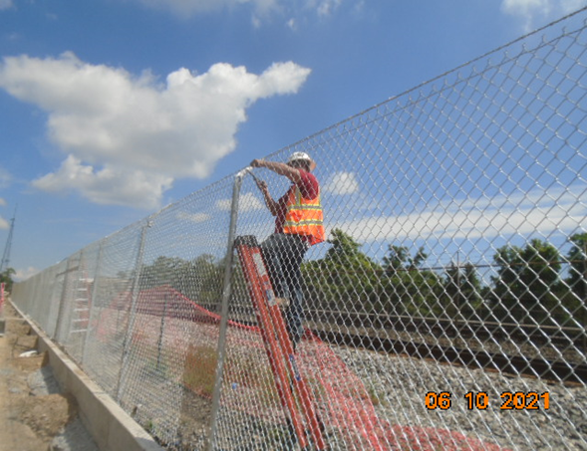
Phase D – Crew installing chain link fence

