Metropolitan Branch Trail Design Build, South Segment
DC CONTRACT NO. DCKA-2016-C-0044
FAP No.: STP-2016 (060)

CONSTRUCTION MANAGER’S
WEEKLY PROGRESS REPORT

05/31/2020 – 06/06/2020

Project Website: www.metbranchtrail-forttotten.com
For Additional Trail Information Please see www.metbranchtrail.com

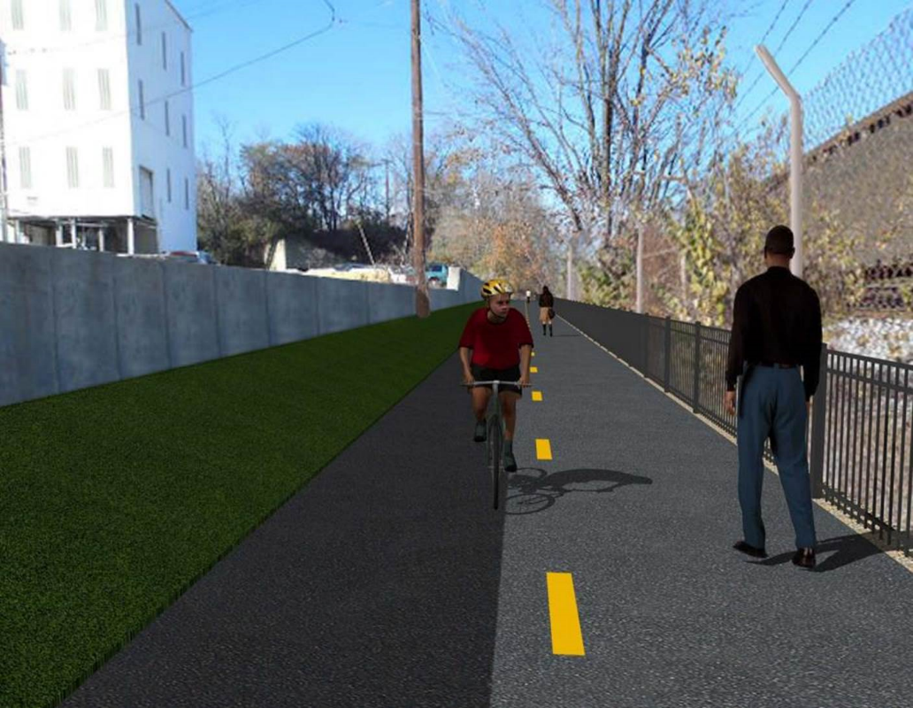

Proposed Metropolitan Branch Trail

1. PROJECT DESCRIPTION

The planned Metropolitan Branch Trail Project (“the Project”) consists of the design and construction of a new trail adjacent to CSX tracks and WMATA Red Line tracks along John McCormack Drive, adjacent to Fort Totten Metro Station, and on NPS property in NE, Washington D.C. The trail begins approximately 1500 feet south of Bates Road NE on the east side of John McCormack Drive NE, extending north along the WMATA and CSX tracks to the Fort Totten Metro Station tie in with First Place NE. An existing trail connection from Gallatin Road NE to the Fort Totten Metro Station will be reconstructed as a part of the Project.

The Project is 83.15% Federally-Funded and 16.85% District-Funded. Potomac Construction is the Design Build contractor.

Delon Hampton and Associates Chartered is providing Construction Management and Inspection services. Specific Construction Scope of Work includes:

- Provide mobilization and demobilization, provision and maintenance of Engineer’s field facilities, field layout, employee training, and other incidental work required for a quality, complete and finished product;
- Establishment and maintenance of vehicular and pedestrian traffic including signs, barricades and other transition devices; reconfiguring the devices in conjunction with changes in work areas; and their removal and disposal upon project completion, including restoration of disturbed areas;
- Clearing and grubbing, as required within the LOD;
- Removal of unsuitable material, excavation, and backfilling and pervious paving to construct a new trail;
- Protection of trees during construction;
- Provide ADA compliant trail connections and pedestrian ramps;
- Provide retaining walls as necessary to stay within the LOD and minimize property impacts following visual requirements specified for retaining walls on NPS property;
- Provide new permanent regulatory and wayfinding signs for the trail and all trail connection intersections;
- Provide road and trail pavement markings;
- Provide landscaping within the LOD for the Project including special requirements for landscaping on NPS property;
- Provide erosion and sediment control measures, storm water management facilities, including pervious asphalt pavement and bioretention facilities;
- Provide utility coordination, identification, locating, and protection of all utilities encountered during design and construction including relocation of Pepco poles along Aggregate Industries property; and
- Provide new WMATA security fencing between the trail and CSXT tracks.
- Remove existing sidewalk and widen sidewalk to 10’ along the west side of 1st place NE from Metropolitan Branch Trail to entrance to WMATA bus loop, on the west side.

2. STATUS OF CONSTRUCTION / PROGRESS SUMMARY

Work performed this week:

Design
- Phase D 3-ring binder for 100% Plans
- Stakeholders Acceptance for Phase D Final Design Plans
- Railing Design Submittal to WMATA and DDOT
- NPS Approval for Phase D Emergency Action Plans
- WMATA / DDOT Notification Plan for Phase D Construction Activities
- DDOT Reviewed Means and Methods for Phase D construction activities
- WMATA Approval for SSWP Monitoring Plan
- CSX reviewing Phase D means and methods for construction activities

Construction:

Phase B
- Watered the seeded area
- Installed silt fence along the North side of the fence
- Install safety fence along the North side of the fence
- Pepco onsite to take measurements for the relocation of Pepco transformer

Phase D

- Cut trees and cleared the cut trees from the job site
- Installed silt fence along the existing sidewalk
- Performed rough grading
- Sawcut and demolished existing concrete slab.
- Performed surveying and marking storm pipe stakeout
- Excavated test pits
- Delivered storm pipes to the site.

CM Consultant:

- Monitored construction progress, make sure all applicable inspection and testing were performed
- Reviewed Inspection Daily Reports
- Reviewing Invoice for May.
- Updated Project Files
- Updating documents in SharePoint
- Communication with the stakeholder in terms of submittals

3. MEETINGS / PROJECT COORDINATION

Tue. 06/03/20 DDOT PEPCO PCCI field meeting was held at 8:30 A.M.
Thur. 06/04/20 DDOT QA Meeting conference call was held at 11:00 A.M.
Fri. 06/05/20 QA/QC Meeting conference call was held at 10:00 A.M.
Fri. 06/05/20 DDOT CSX Coordination Meeting was held at 8:00 A.M.
4. DAILY WORK PERFORMED

Sun 05/31/20 No work performed
Mon 06/01/20 Phase B – installed the silt fence along the north side of the trail.
Installed safety fence along the north side of the trail. Delivered five temporary light poles bases to the site.
Phase D - Cut and cleared the cut trees from the site.
Tue 06/02/20 Phase B – Watered the landscape. Pepco electricians were onsite to
take measurements and to coordinate the upcoming installation of the
secondary transformer.
Phase B - Electrical Work – No work performed.
Phase D - Cleared the cut trees from the site. Performed rough grading. Installed silt fence. Surveyor performed survey and marking stormwater pipes stakeout. Excavated test pits.
Wed 06/03/20 Phase B - No work performed
Phase B - Electrical Work – No work performed
Phase D - Excavated test pits. Sawcut the existing concrete slab. Installed silt fence. Cleared the cut trees from the site.
Thurs 06/04/20 Phase B - No work performed
Phase B - Electrical Work – Removed light pole foundation. Excavated and compacted electrical conduit trench. Relocated six solar light poles on temporary lightpole bases.
Phase D – Installed silt fence. Sawcut the existing concrete slab. Demolished the existing concrete slab.
Fri 06/05/20 Phase B – No work performed.
Phase B - Electrical Work – No work performed.
Phase D – Cleared cut trees from the site. Demolished the existing concrete slab.
Sat 06/06/20 No work scheduled

5. INSPECTION & MATERIAL TESTS PERFORMED

Jobsite Safety Inspection  Erosion and Sediment Control inspection  MOT Inspection  Compaction Test  Asphalt Material Testing  Concrete Material Testing | Infiltration facility Material Testing
6. DBE PARTICIPATION SUMMARIES
Potomac Construction (Contractor)
- DBE Goal for Contractor is 15%. To-date the Contractor has achieved 36% of their goal.

Delon Hampton & Associates (CM)
- DBE Goal for the CM is 10%. To-date the CM has achieved 0% of their Goal.

7. ACCIDENTS / INCIDENTS

None occurred on-site during this week.

8. PHOTOS OF THE WORK PERFORMED

12. PHOTOS OF WORK PERFORMED THIS PERIOD

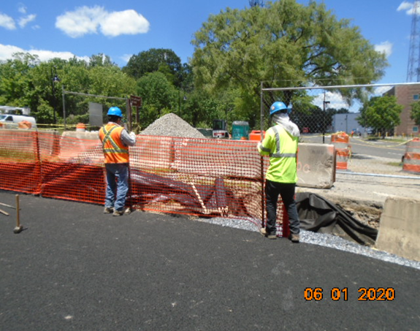
Phase B – Crew installing safety fence along the North side of the trail

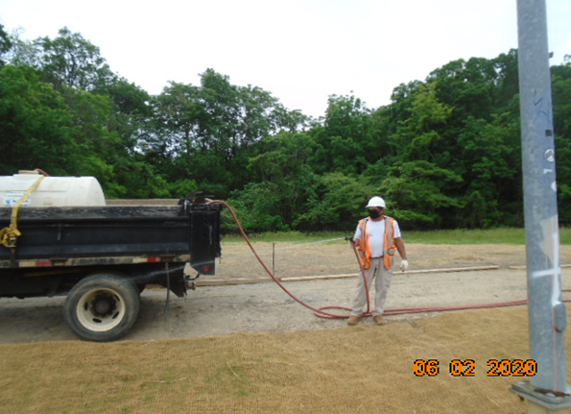
Phase B – Crew watering the landscape
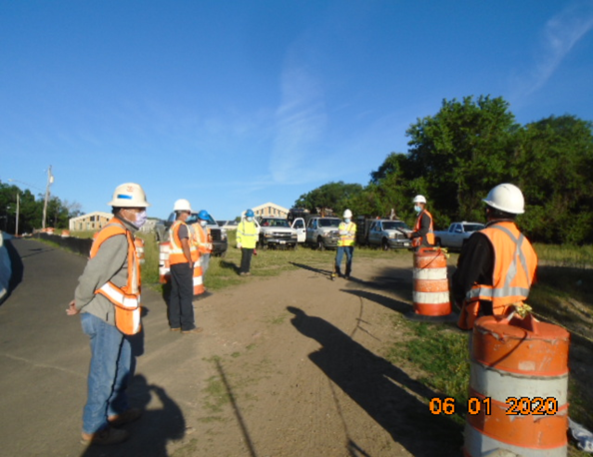
Phase B – Crew attending daily safety briefing

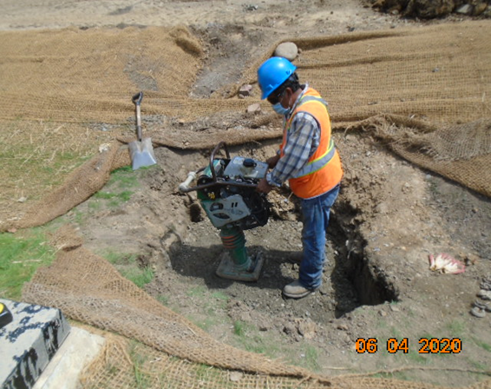
Phase B – Crew compacting trench

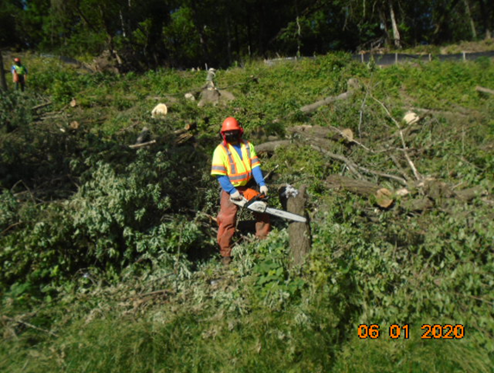
Phase D – Crew cutting the tree

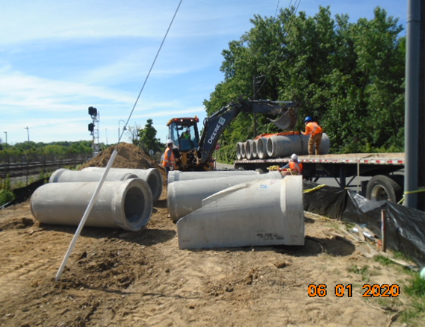
Phase D – Crew unloading drainage pipes

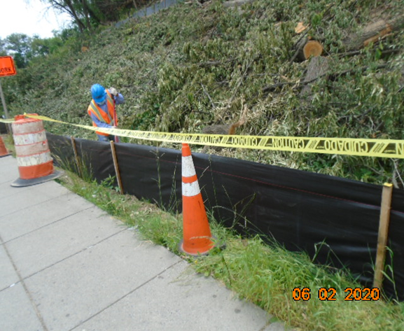
Phase D – Crew installing silt fence

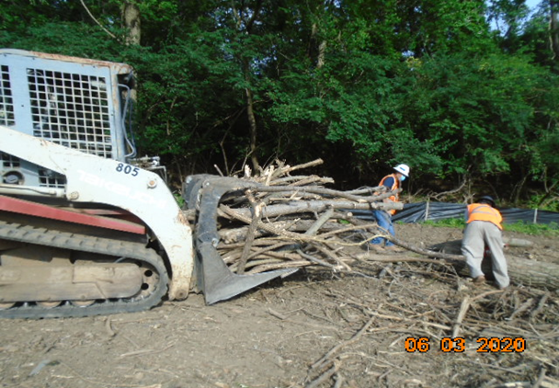
Phase D – Crew clearing cut trees

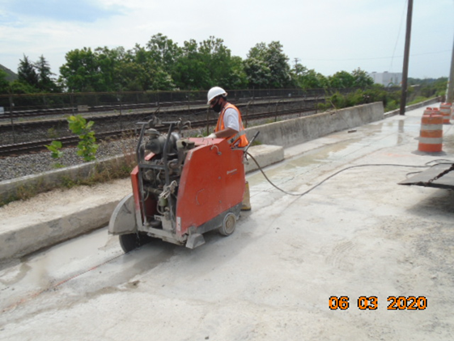
Phase D – Crew saw cutting the existing concrete slab

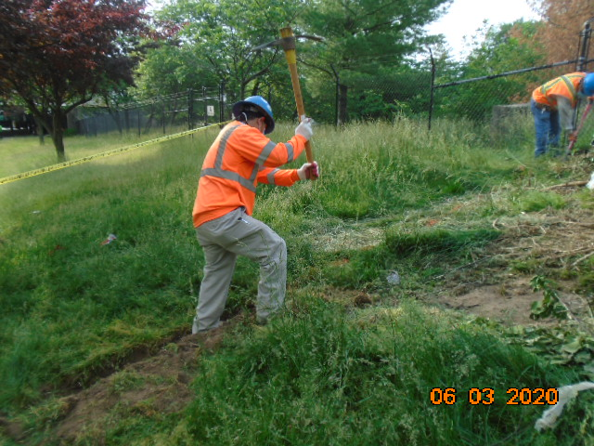
Phase D – Crew excavating to install silt fence

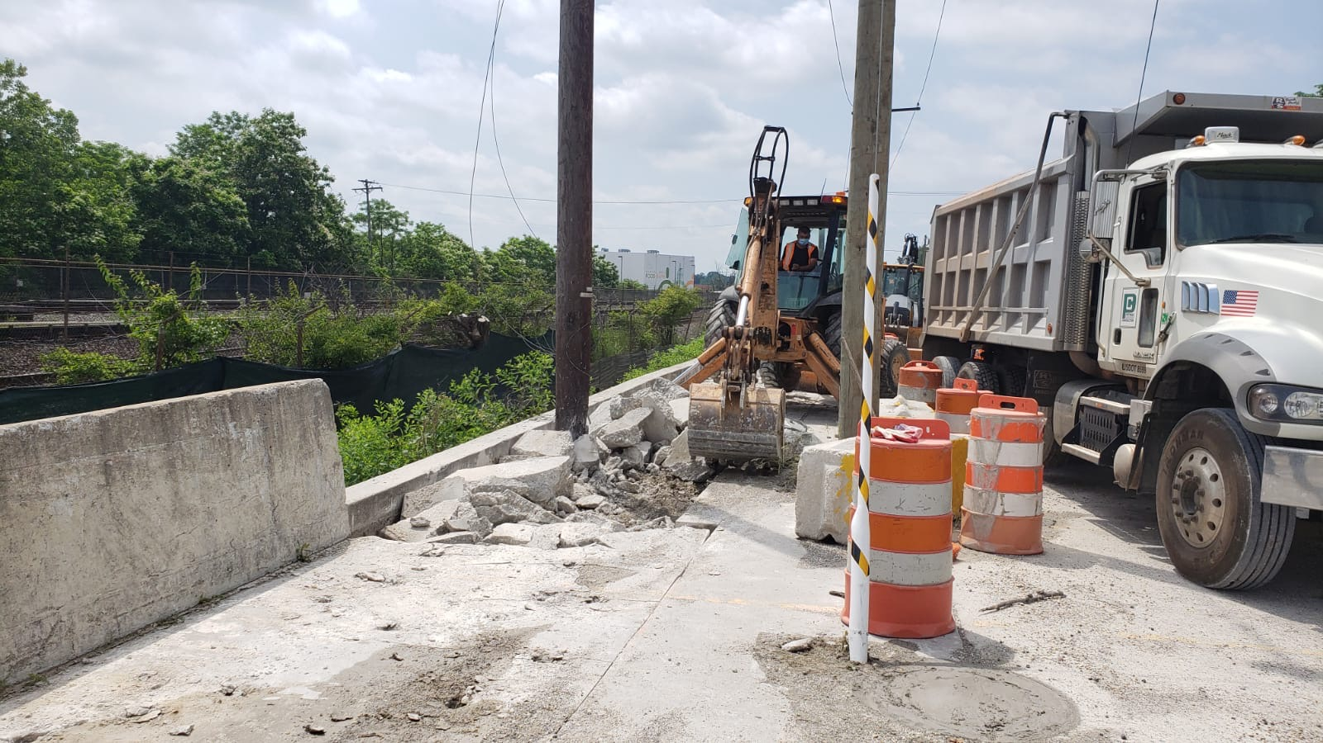
Phase D – Crew demolishing existing concrete

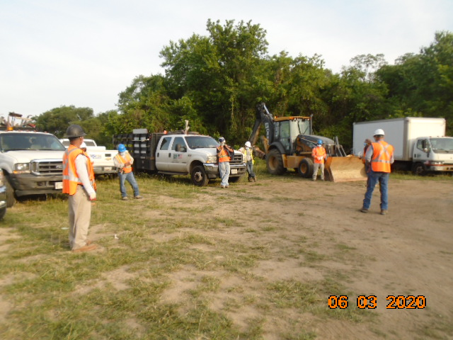
Phase D – Crew attending safety briefing

