**Metropolitan Branch Trail Design Build, South Segment**

**DC CONTRACT NO. DCKA-2016-C-0044**

**FAP No.: STP-2016 (060)**

CONSTRUCTION MANAGER’S

WEEKLY PROGRESS REPORT

05/23/2021 – 05/29/2021

Project Website: [www.metbranchtrail-forttotten.com](http://www.metbranchtrail-forttotten.com)

For Additional Trail Information Please see [www.metbranchtrail.com](http://www.metbranchtrail.com)

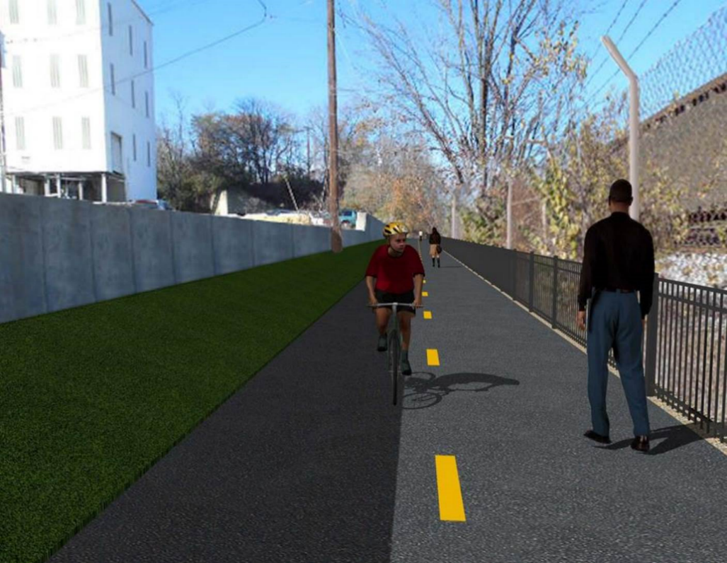

**Proposed Metropolitan Branch Trail**

**1. PROJECT DESCRIPTION**

The planned Metropolitan Branch Trail Project (“the Project”) consists of the design and construction of a new trail adjacent to CSX tracks and WMATA Red Line tracks along John McCormack Drive, adjacent to Fort Totten Metro Station, and on NPS property in NE, Washington D.C. The trail begins approximately 1500 feet south of Bates Road NE on the east side of John McCormack Drive NE, extending north along the WMATA and CSX tracks to the Fort Totten Metro Station tie in with First Place NE. An existing trail connection from Gallatin Road NE to the Fort Totten Metro Station will be reconstructed as a part of the Project.

The Project is 83.15% Federally-Funded and 16.85% District-Funded. Potomac Construction is the Design Build contractor.

Delon Hampton and Associates Chartered is providing Construction Management and Inspection services. Specific Construction Scope of Work includes:

* Provide mobilization and demobilization, provision and maintenance of Engineer’s field facilities, field layout, employee training, and other incidental work required for a quality, complete and finished product;
* Establishment and maintenance of vehicular and pedestrian traffic including signs, barricades and other transition devices; reconfiguring the devices in conjunction with changes in work areas; and their removal and disposal upon project completion, including restoration of disturbed areas;
* Clearing and grubbing, as required within the LOD;
* Removal of unsuitable material, excavation, and backfilling and pervious paving to construct a new trail;
* Protection of trees during construction;
* Provide ADA compliant trail connections and pedestrian ramps;
* Provide retaining walls as necessary to stay within the LOD and minimize property impacts following visual requirements specified for retaining walls on NPS property;
* Provide new permanent regulatory and wayfinding signs for the trail and all trail connection intersections;
* Provide road and trail pavement markings;
* Provide landscaping within the LOD for the Project including special requirements for landscaping on NPS property;
* Provide erosion and sediment control measures, storm water management facilities, including pervious asphalt pavement and bioretention facilities;
* Provide utility coordination, identification, locating, and protection of all utilities encountered during design and construction including relocation of Pepco poles along Aggregate Industries property; and
* Provide new WMATA security fencing between the trail and CSXT tracks.
* Remove existing sidewalk and widen sidewalk to 10’ along the west side of 1st place NE from Metropolitan Branch Trail to entrance to WMATA bus loop, on the west side.

**2. STATUS OF CONSTRUCTION / PROGRESS SUMMARY**

**Work performed this week:**

**Design**

* 100 % Complete

**Construction:**

**Phase D**

* Excavated and compacted retaining wall S0 footing
* Constructed retaining wall S0 footing formwork
* Installed retaining wall S0 footing rebars
* Compacted backfill behind retaining wall
* Excavated south side curb trench
* Installed water proofing membrane along south side curb
* Installed 6 inches perforated underdrain along south side curb
* Installed curb formwork
* Placed concrete for south side curb
* Installed WMATA/CSX chain link fence fabric
* Installed electrical manhole
* Installed light poles
* Backfilled and compacted electrical trench
* CSX flagger’s operation and safety tool box talk

**CM Consultant:**

* Monitored construction progress, make sure all applicable inspections and testing were performed
* Reviewed PCCI Monthly Payment Invoice
* Reviewed CSX Monthly Invoice
* Prepared on Change Order package
* Reviewed Project Schedule
* Prepared CM Weekly Report to post
* Prepared CM weekly report to DDOT
* Attended field meeting with contractor
* Monitored QC field testing
* Updated Project Files
* Updated Project Logs
* Updated Project Webpage
* Updated documents in DHA SharePoint site
* Updated DDOT Sharepoint site
* Communication with PCCI in terms of submittals

**3. MEETINGS / PROJECT COORDINATION**

Thursday 05/27/20 DHA PCCI field meeting was held at 9:30 A.M.

**4. DAILY WORK PERFORMED**

Sun 05/23/21 No work performed.

Mon 05/24/21 Phase D – Applied damp proofing at back side of retaining wall S2. Place

porous backfill behind retaining wall S2. Compacted and backfilled behind retaining wall S2. Installed geotextile fabric around 6” perforated drain at retaining wall S2. Excavated 6” pipe under drain along south side curb. Installed water proof membrane along the north side curb. Grounded chain link fence. Installed chain link fabric.

Phase D – Electrical Work – Excavated manhole trench.

Tue 05/25/21 Phase D – Excavated and graded concrete swale behind retaining wall S2. Installed water proofing membrane along south side curb trench. Installed chain link fence fabric.

Phase D – Electrical Work – Excavated and installed electrical manhole.

Wed 05/26/21 Phase D – Installed retaining wall S0 rebars. Excavated north side curb trench. Installed 6 inches perforated under drain pipe and water proofing membrane along north side curb. Installed curb formwork. Placed concrete for south side curb.

Phase D – Electrical Work – Installed electrical manhole. Backfilled and compacted electrical manhole trench.

Thurs 05/27/21 Phase D – Installed retaining wall S0 formwork. Excavated south side curb

trench. Installed water proofing membrane along south side curb. Backfilled under drain pipe trench.

Phase D – Electrical Work – Installed street light poles

Fri 05/28/21 Phase D – Installed rebars for retaining wall S0 footings. Installed formwork for south side curb. Installed chain link fence fabric.

Phase D – Electrical Work – No work performed.

Sat 05/29/21 Phase D – No work scheduled

**5. INSPECTION & MATERIAL TESTS PERFORMED**

|  |  |
| --- | --- |
| Jobsite Safety Inspection  Erosion and Sediment Control inspection  MOT Inspection  Compaction Test - Passed  Asphalt Material Testing  Concrete Material Testing – Pending results  **\*\* Note - Additional Material Test Results can be found on DDOT QA QC Material Division Tracking SharePoint website**. | Infiltration Tests  Dynamic Cone Penetration (DCP) Tests - Passed  Rebars Inspection - Ongoing |

**6. DBE PARTICIPATION SUMMARIES**

Potomac Construction (Contractor)

* DBE Goal for Contractor is 15%. To-date the Contractor has achieved 49.4% of their goal.

Delon Hampton & Associates (CM)

* DBE Goal for the CM is 10%. To-date the CM has achieved 82.7% of their Goal.

**7. ACCIDENTS / INCIDENTS**

None occurred on-site during this week.

**8. PHOTOS OF THE WORK PERFORMED**

**12. PHOTOS OF WORK PERFORMED THIS PERIOD**

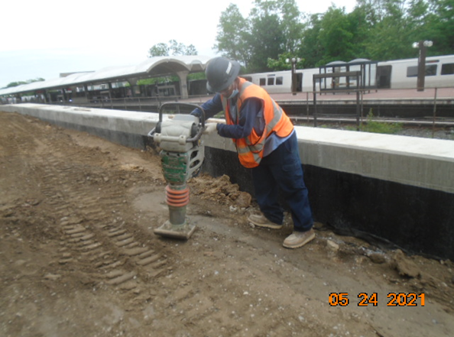

Phase D – Crew compacting backfill behind retaining wall S2

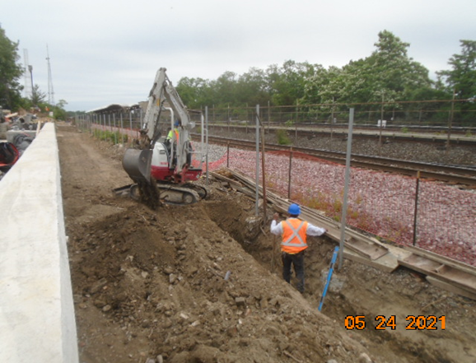

Phase D – Crew excavating south side curb 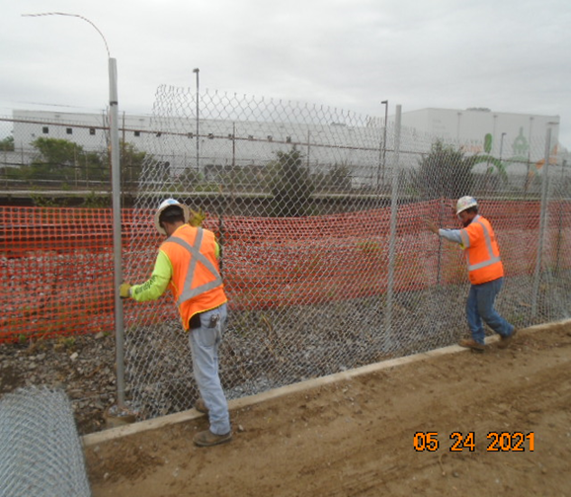

Phase D – Crew installing chain link fence fabric

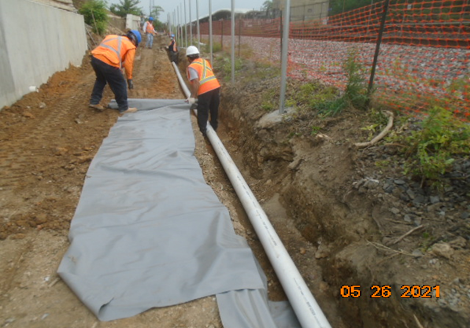

Phase D – Crew installing water proofing membrane along north side curb

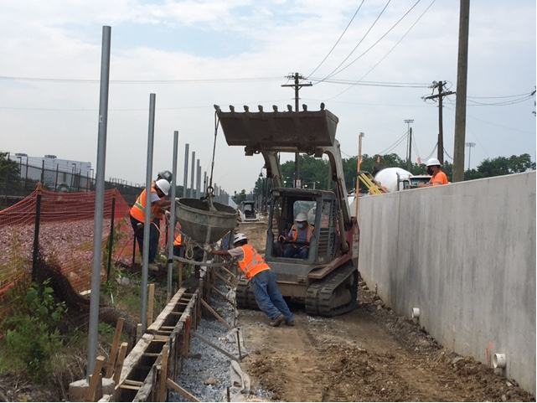

Phase D – Crew placing concrete for north side curb

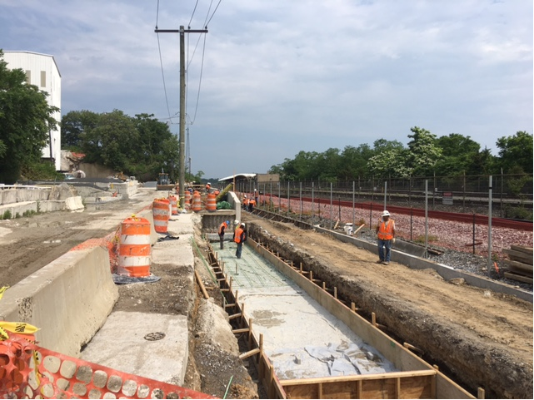

Phase D – Crew installing retaining wall S0 footing rebars

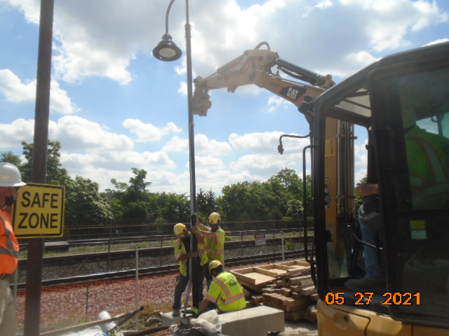

Phase D – Crew installing light pole

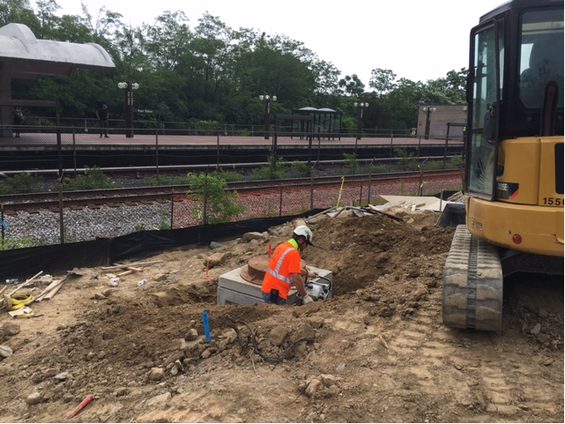

Phase D – Crew compacting electrical manhole

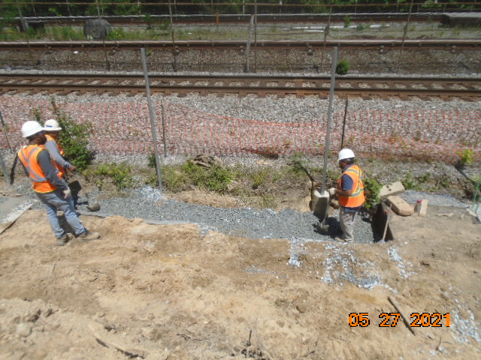

Phase D – Crew backfilling under drain trench

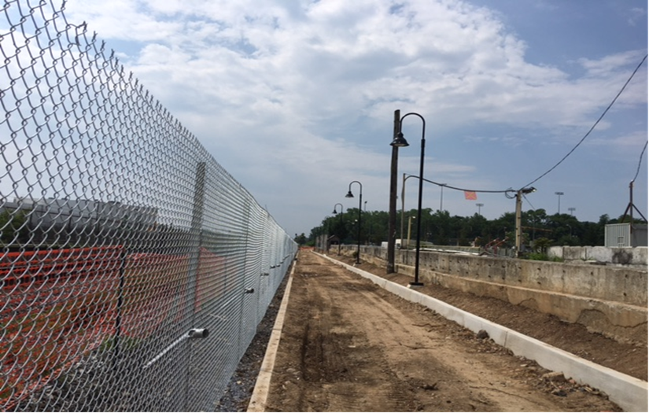

Phase D – Light poles installed