Metropolitan Branch Trail Design Build, South Segment
DC CONTRACT NO. DCKA-2016-C-0044
FAP No.: STP-2016 (060)

CONSTRUCTION MANAGER’S
WEEKLY PROGRESS REPORT

05/16/2021 – 05/22/2021

Project Website: www.metbranchtrail-forttotten.com
For Additional Trail Information Please see www.metbranchtrail.com
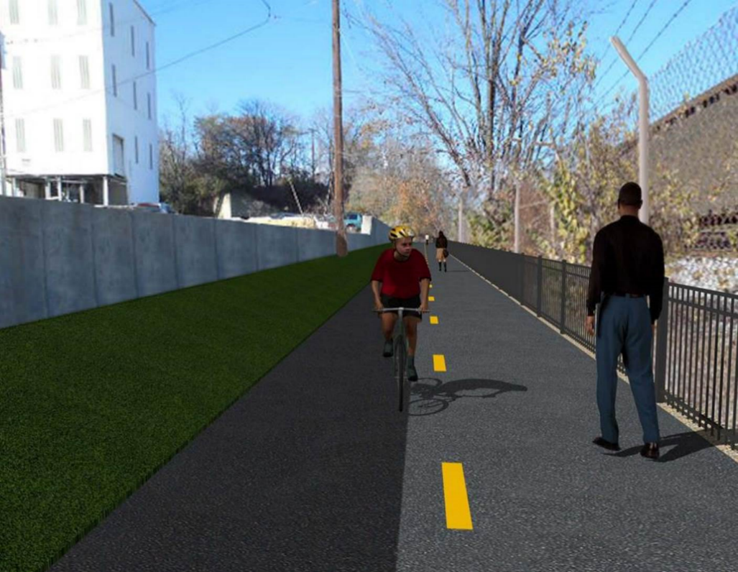

Proposed Metropolitan Branch Trail

1. PROJECT DESCRIPTION

The planned Metropolitan Branch Trail Project (“the Project”) consists of the design and construction of a new trail adjacent to CSX tracks and WMATA Red Line tracks along John McCormack Drive, adjacent to Fort Totten Metro Station, and on NPS property in NE, Washington D.C. The trail begins approximately 1500 feet south of Bates Road NE on the east side of John McCormack Drive NE, extending north along the WMATA and CSX tracks to the Fort Totten Metro Station tie in with First Place NE. An existing trail connection from Gallatin Road NE to the Fort Totten Metro Station will be reconstructed as a part of the Project.

The Project is 83.15% Federally-Funded and 16.85% District-Funded. Potomac Construction is the Design Build contractor.

Delon Hampton and Associates Chartered is providing Construction Management and Inspection services. Specific Construction Scope of Work includes:

- Provide mobilization and demobilization, provision and maintenance of Engineer’s field facilities, field layout, employee training, and other incidental work required for a quality, complete and finished product;
- Establishment and maintenance of vehicular and pedestrian traffic including signs, barricades and other transition devices; reconfiguring the devices in conjunction with changes in work areas; and their removal and disposal upon project completion, including restoration of disturbed areas;
- Clearing and grubbing, as required within the LOD;
- Removal of unsuitable material, excavation, and backfilling and pervious paving to construct a new trail;
- Protection of trees during construction;
- Provide ADA compliant trail connections and pedestrian ramps;
- Provide retaining walls as necessary to stay within the LOD and minimize property impacts following visual requirements specified for retaining walls on NPS property;
- Provide new permanent regulatory and wayfinding signs for the trail and all trail connection intersections;
- Provide road and trail pavement markings;
- Provide landscaping within the LOD for the Project including special requirements for landscaping on NPS property;
- Provide erosion and sediment control measures, storm water management facilities, including pervious asphalt pavement and bioretention facilities;
- Provide utility coordination, identification, locating, and protection of all utilities encountered during design and construction including relocation of Pepco poles along Aggregate Industries property; and
- Provide new WMATA security fencing between the trail and CSXT tracks.
- Remove existing sidewalk and widen sidewalk to 10’ along the west side of 1st place NE from Metropolitan Branch Trail to entrance to WMATA bus loop, on the west side.

2. STATUS OF CONSTRUCTION / PROGRESS SUMMARY

Work performed this week:

Design

- 100 % Complete

Construction:

Phase D

- Constructed wedge wall formwork
- Placed wedge wall concrete
- Striped wedge wall S2 formwork
- Excavated retaining wall S0 footing
- Compacted retaining wall S0 footing
- Constructed retaining wall S0 footing formwork
- Excavated north side curb trench
- Installed curb formwork
- Placed curb concrete
- Excavated south side curb trench
- Installed south side curb formwork
- Installed street light poles
- Backfilled and compacted electrical trench
- CSX flagger’s operation and safety tool box talk

CM Consultant:

- Monitored construction progress, make sure all applicable inspections and testing were performed
- Reviewed PCCI Monthly Payment Invoice
- Reviewed CSX Monthly Invoice
- Worked on Change Order package
- Prepared CM Weekly Report to post
- Prepared CM weekly report to DDOT
- Attended field meeting with contractor
- Monitored QC field testing
- Updated Project Files
- Updated Project Logs
- Updated Project Webpage
- Updated documents in DHA SharePoint site
- Updated DDOT Sharepoint site
- Communication with PCCI in terms of submittals

3. MEETINGS / PROJECT COORDINATION

Fri 05/21/2021 DHA PCCI field meeting was held at 1:30 P.M.

4. DAILY WORK PERFORMED

Sun 05/16/21 No work performed.
Mon 05/17/21 Phase D – Constructed retaining wall S2 wedge wall (RW S2) formwork.
Pre- assembled 6 inches perforated drainage pipe. Excavated north side curb trench. Installed curb formwork.
Phase D – Electrical Work – Pulled dragline through installed conduits.
Tue 05/18/21 Phase D – Constructed retaining wall S2 wedge wall formwork. Installed 6 inches perforated drainage pipe. Place retaining wall S2 wedge wall concrete. Constructed retaining wall S0 footing formwork. Installed WMATA chain link fence. Braced fence top frame and top rail. Grounded CSX chain link fence.
Phase D – Electrical Work – Excavated electrical trench line between electrical manholes M4 and M5. Installed electrical conduits.
Wed 05/19/21 Phase D – Stripped retaining wall S2 wedge wall formwork. Applied damp proofing materials on back side of retaining wall S2. Placed porous backfill behind retaining wall S2. Backfilled and compacted behind retaining wall S2. Placed north side curb concrete. Grounded CSX chain link fence posts.
Phase D – Electrical Work – Excavated electrical trench between manholes
M4 and M5. Installed conduits. Backfilled and compacted electrical trench.
Thurs 05/20/21 Phase D – Backfilled and compacted behind retaining wall S2. Applied
damp proofing on retaining wall S2 backside. Cleared and graded slope
along north side of trail.
Phase D – Electrical Work – Backfilled and compacted electrical trench. Installed street light poles
Fri 05/21/21 Phase D – Compacted and backfilled behind retaining wall S2. Excavated
south side curb trench. Installed curb formwork. Grounded CSX fence.
Phase D – Electrical Work – Installed light poles.
Sat 05/22/21 Phase D – No work scheduled

5. INSPECTION & MATERIAL TESTS PERFORMED

Jobsite Safety Inspection  Erosion and Sediment Control inspection  MOT Inspection  Compaction Test - Passed  Asphalt Material Testing  Concrete Material Testing – Pending results  ** Note - Additional Material Test Results can be found on DDOT QA QC Material Division Tracking SharePoint website. | Infiltration Tests  Dynamic Cone Penetration (DCP) Tests - Passed  Rebars Inspection - Passed
6. DBE PARTICIPATION SUMMARIES

Potomac Construction (Contractor)

- DBE Goal for Contractor is 15%. To-date the Contractor has achieved 49.4% of their goal.

Delon Hampton & Associates (CM)

- DBE Goal for the CM is 10%. To-date the CM has achieved 82.7% of their Goal.

7. ACCIDENTS / INCIDENTS

None occurred on-site during this week.

8. PHOTOS OF THE WORK PERFORMED

12. PHOTOS OF WORK PERFORMED THIS PERIOD

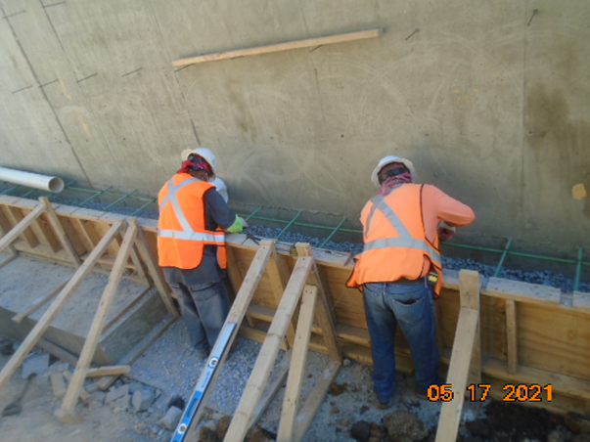
Phase D – Crew constructing wedge wall formwork

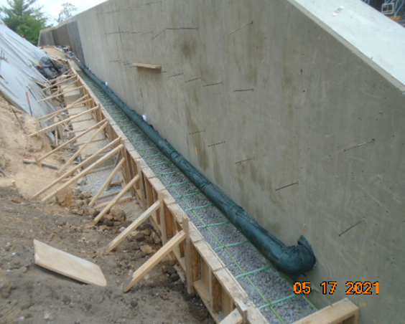
Phase D – Wedge wall formwork and drainage pipe retaining wall S2
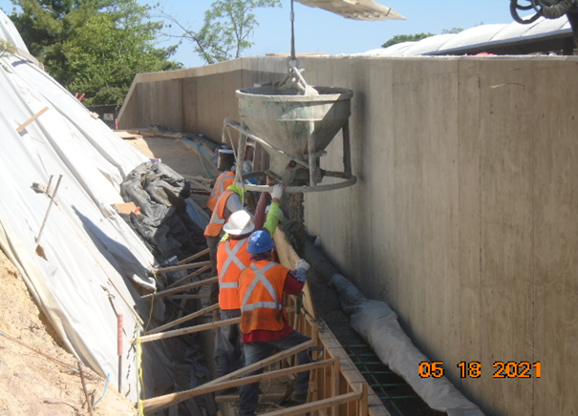
Phase D – Crew placing wedge wall concrete

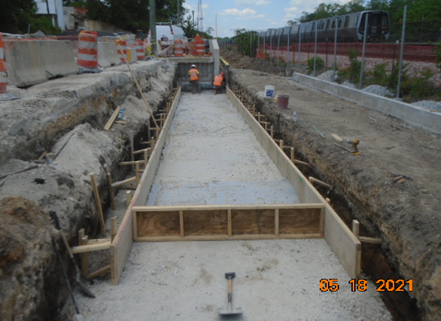
Phase D – Crew constructing retaining wall S0 footing formwork

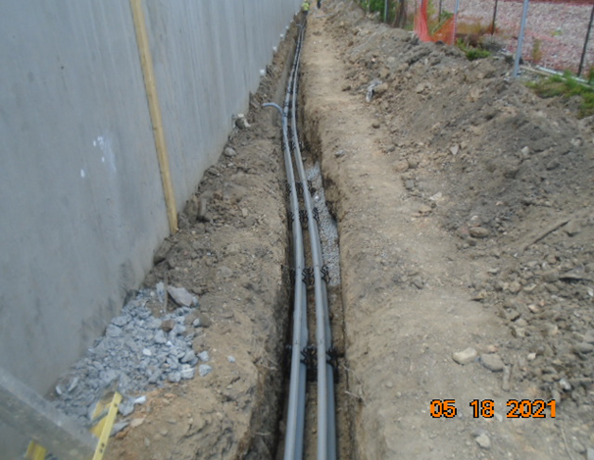
Phase D – Conduits installed in the trench

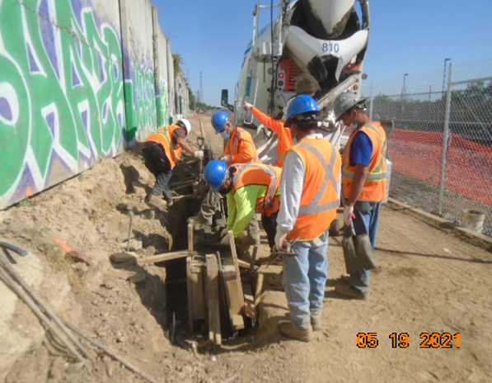
Phase D – Crew placing concrete at north side curb

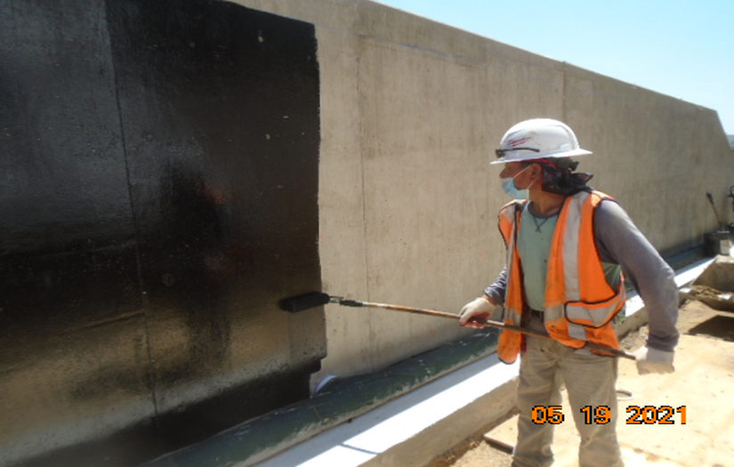
Phase D – Crew applying damp proofing retaining wall S2

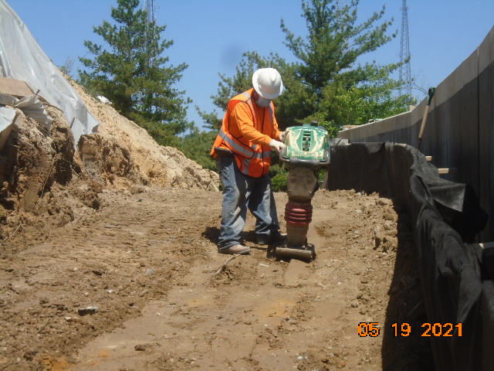
Phase D – Crew compacting backfill behind retaining wall S2

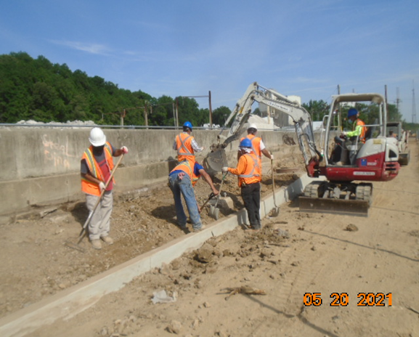
Phase D – Crew grading north side trail slope area

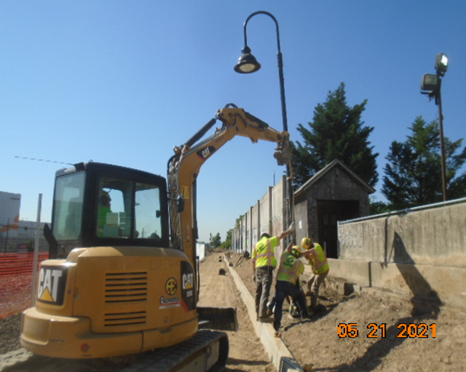
Phase D – Crew installing light pole

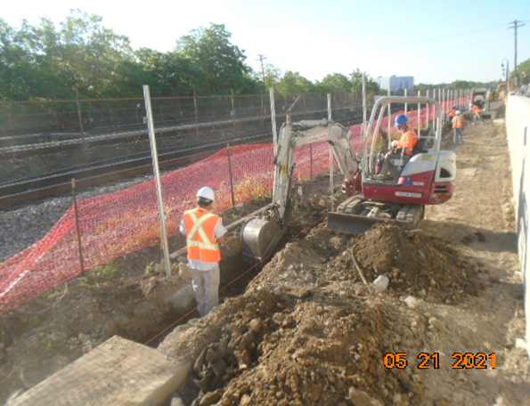
Phase D – Crew excavating south side curb trench

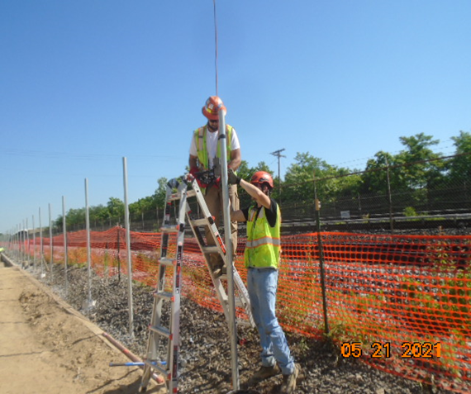
Phase D – Crew installing grounding CSX fence

