**Metropolitan Branch Trail Design Build, South Segment**

**DC CONTRACT NO. DCKA-2016-C-0044**

**FAP No.: STP-2016 (060)**

CONSTRUCTION MANAGER’S

WEEKLY PROGRESS REPORT

05/10/2020 – 05/16/2020

Project Website: [www.metbranchtrail-forttotten.com](http://www.metbranchtrail-forttotten.com)

For Additional Trail Information Please see [www.metbranchtrail.com](http://www.metbranchtrail.com)

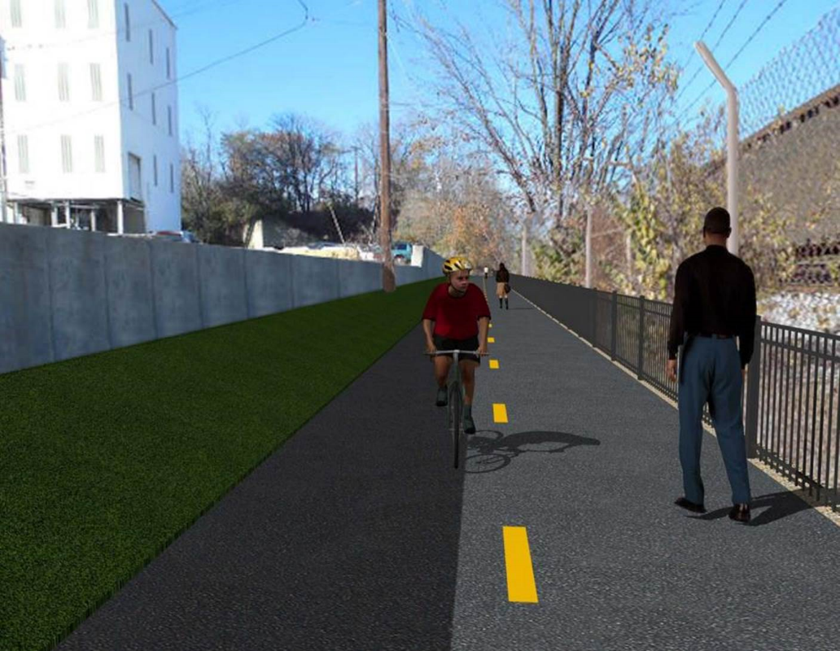

**Proposed Metropolitan Branch Trail**

**1. PROJECT DESCRIPTION**

The planned Metropolitan Branch Trail Project (“the Project”) consists of the design and construction of a new trail adjacent to CSX tracks and WMATA Red Line tracks along John McCormack Drive, adjacent to Fort Totten Metro Station, and on NPS property in NE, Washington D.C. The trail begins approximately 1500 feet south of Bates Road NE on the east side of John McCormack Drive NE, extending north along the WMATA and CSX tracks to the Fort Totten Metro Station tie in with First Place NE. An existing trail connection from Gallatin Road NE to the Fort Totten Metro Station will be reconstructed as a part of the Project.

The Project is 83.15% Federally-Funded and 16.85% District-Funded. Potomac Construction is the Design Build contractor.

Delon Hampton and Associates Chartered is providing Construction Management and Inspection services. Specific Construction Scope of Work includes:

* Provide mobilization and demobilization, provision and maintenance of Engineer’s field facilities, field layout, employee training, and other incidental work required for a quality, complete and finished product;
* Establishment and maintenance of vehicular and pedestrian traffic including signs, barricades and other transition devices; reconfiguring the devices in conjunction with changes in work areas; and their removal and disposal upon project completion, including restoration of disturbed areas;
* Clearing and grubbing, as required within the LOD;
* Removal of unsuitable material, excavation, and backfilling and pervious paving to construct a new trail;
* Protection of trees during construction;
* Provide ADA compliant trail connections and pedestrian ramps;
* Provide retaining walls as necessary to stay within the LOD and minimize property impacts following visual requirements specified for retaining walls on NPS property;
* Provide new permanent regulatory and wayfinding signs for the trail and all trail connection intersections;
* Provide road and trail pavement markings;
* Provide landscaping within the LOD for the Project including special requirements for landscaping on NPS property;
* Provide erosion and sediment control measures, storm water management facilities, including pervious asphalt pavement and bioretention facilities;
* Provide utility coordination, identification, locating, and protection of all utilities encountered during design and construction including relocation of Pepco poles along Aggregate Industries property; and
* Provide new WMATA security fencing between the trail and CSXT tracks.
* Remove existing sidewalk and widen sidewalk to 10’ along the west side of 1st place NE from Metropolitan Branch Trail to entrance to WMATA bus loop, on the west side.

**2. STATUS OF CONSTRUCTION / PROGRESS SUMMARY**

**Work performed this week:**

**Design**

* Address comments on retaining wall railings
* Phase D 3-ring binder for 100% Plans

**Construction:**

**Phase B**

* Placed and graded topsoil along the south side of the trail

**Phase D**

* Performed clearing and grubbing
* Performed rough grading
* Performed tree removal

**CM Consultant:**

* Monitored construction progress, make sure all applicable inspection and testing were performed
* Attended QA/QC Meeting Conference Call
* Attended DDOT MPD Cameras and Cables Installation Meeting
* Reviewed Inspection Daily Reports
* Updated Project Files
* Updating documents in SharePoint
* Reviewed and finalized Pay Estimate No. 16.
* Communication with the stakeholder in terms of submittals

**3. MEETINGS / PROJECT COORDINATION**

Tue. 05/12/20 Progress Meeting conference call was held at 10:00A.M.

Thur. 05/14/20 DDOT, MPD, Potomac Construction and Aldridge Electric conference

call was held at 10:30 A.M.

Fri. 05/15/20 QA/QC Meeting conference call was held at 10:00 A.M.

**4. DAILY WORK PERFORMED**

Sun 05/10/20 No work performed

Mon 05/11/20 Phase B - No work performed.

Phase B - Electrical Phase - No work performed

Phase D - Performed clearing and grubbing, tree removal and rough grading.

Tue 05/12/20 Phase B - No work performed

Phase B - Electrical Work - No work performed

Phase D - Performed clearing and grubbing, tree removal and rough grading.

Wed 05/13/20 Phase B - Placed and graded the topsoil along the South side of the trail

Scarified and applied topsoil at the contaminated area along the South side of the trail.

Phase B - Electrical Work – No work performed

Phase D – Performed tree removal

Thurs 05/14/20 Phase B - Placed topsoil and seeded the topsoil at the ditch along the

South side of the trail.

Phase B - Electrical Work – No work performed

Phase D - Performed clearing and grubbing, tree removal and rough grading

Fri 05/15/20 Phase B - Placed topsoil and applied seed at the ditch along the South

side of the trail

Phase B - Electrical Work – No work performed

Phase D – Performed tree removal, clearing and grubbing. Silt Fence installation.

Sat 05/16/20 No work scheduled

**5. INSPECTION & MATERIAL TESTS PERFORMED**

|  |  |
| --- | --- |
| Jobsite Safety Inspection  Erosion and Sediment Control inspection  MOT Inspection  Compaction Test  Asphalt Material Testing  Concrete Material Testing | Infiltration facility Material Testing |

**6. DBE PARTICIPATION SUMMARIES**

Potomac Construction (Contractor)

* DBE Goal for Contractor is 15%. To-date the Contractor has achieved 36% of their goal.

Delon Hampton & Associates (CM)

* DBE Goal for the CM is 10%. To-date the CM has achieved 0% of their Goal.

**7. ACCIDENTS / INCIDENTS**

None occurred on-site.

**8. PHOTOS OF THE WORK PERFORMED**

**12. PHOTOS OF WORK PERFORMED THIS PERIOD**

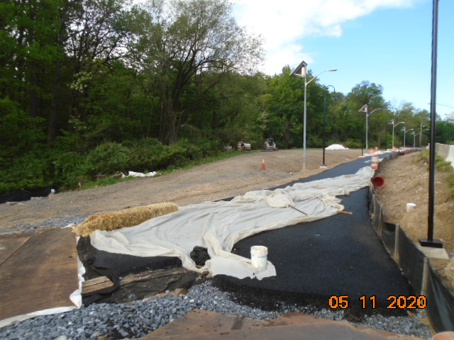

**Phase B – No work performed**

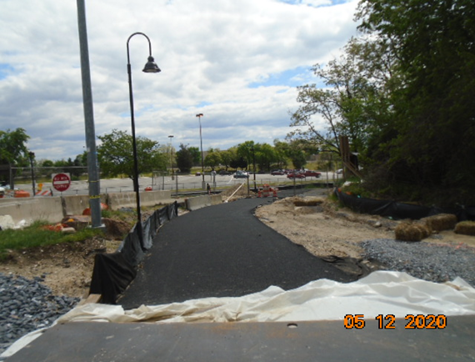

**Phase B – No work performed**

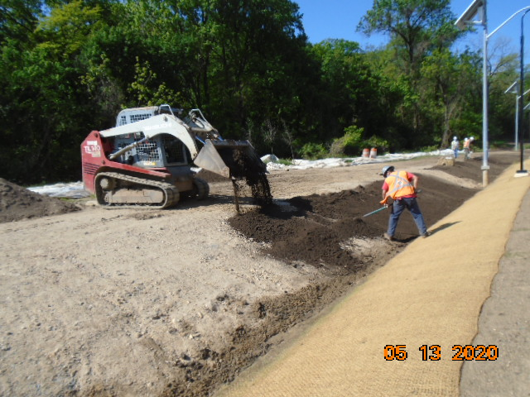

**Phase B – Placing and Grading of Topsoil along the South side of the Trail**

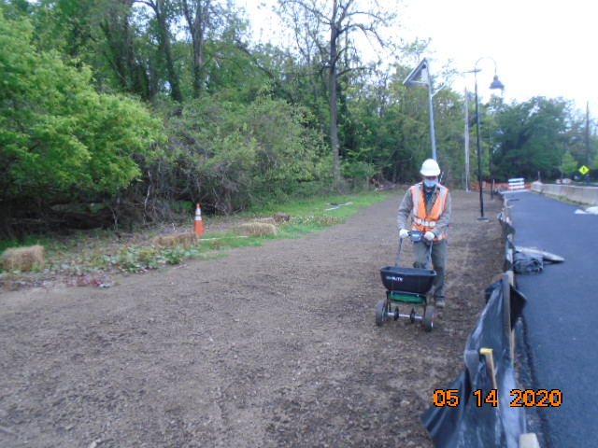

**Phase B – Application of Seeds along the South side of the Trail**

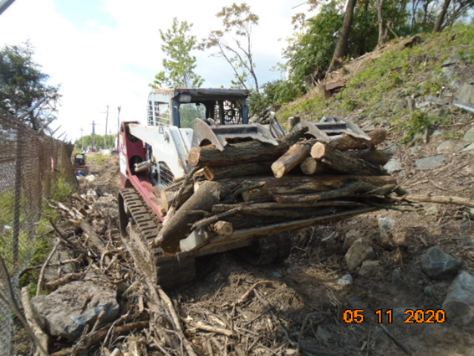

**Phase D – Tree Removal in progress**

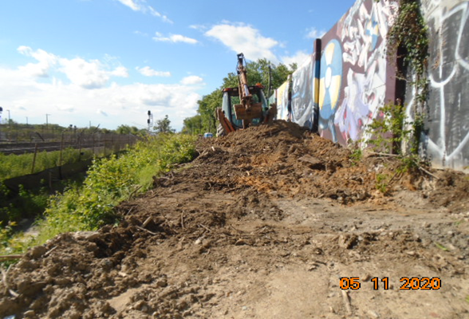

**Phase D – Clearing and Grubbing in progress**

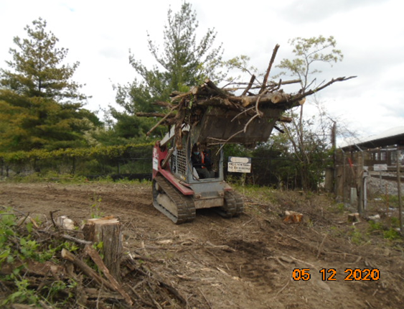

**Phase D – Tree Removal in progress**

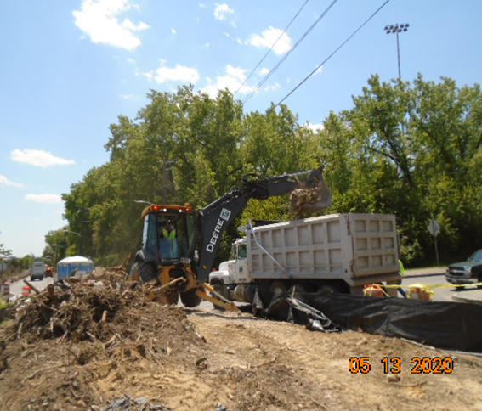

**Phase D – Hauling unsuitable material from the job site**

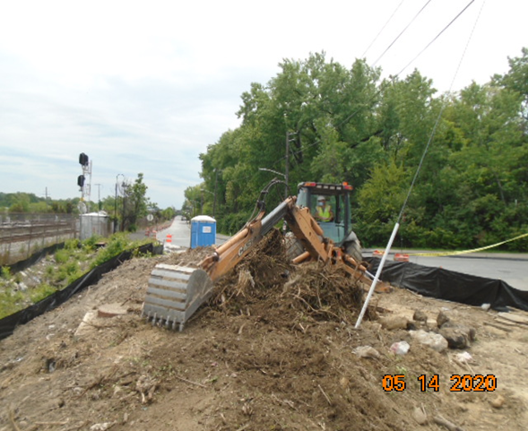

**Phase D – Clearing and Grubbing in progress**

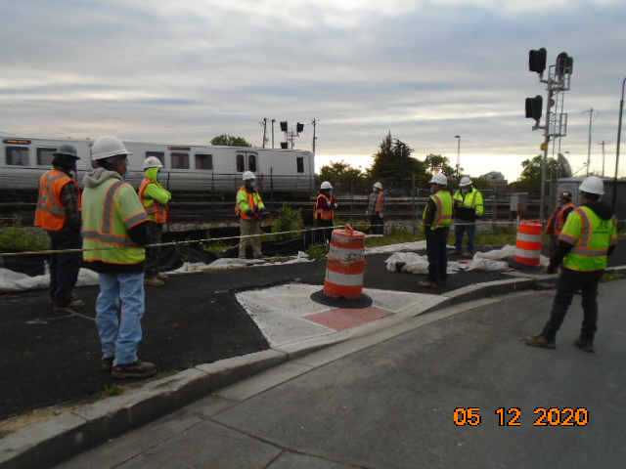

**Phase D – Safety Meeting to emphasize compliance with the CDC COVI-19 Guidelines**