Metropolitan Branch Trail Design Build, South Segment
DC CONTRACT NO. DCKA-2016-C-0044
FAP No.: STP-2016 (060)

CONSTRUCTION MANAGER’S
WEEKLY PROGRESS REPORT

05/09/2021 – 05/15/2021

Project Website: www.metbranchtrail-forttotten.com
For Additional Trail Information Please see www.metbranchtrail.com
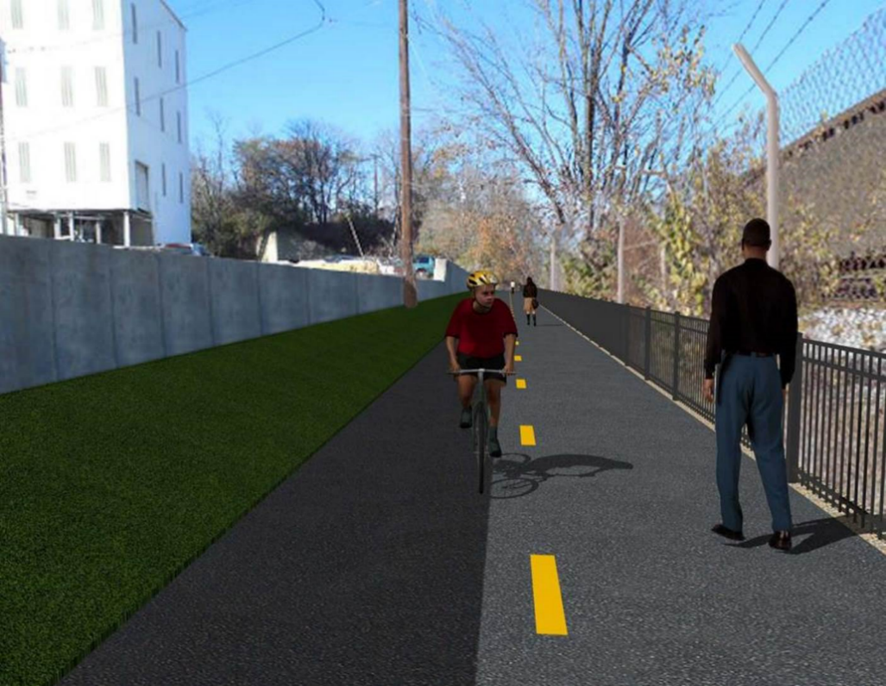

Proposed Metropolitan Branch Trail

1. PROJECT DESCRIPTION

The planned Metropolitan Branch Trail Project (“the Project”) consists of the design and construction of a new trail adjacent to CSX tracks and WMATA Red Line tracks along John McCormack Drive, adjacent to Fort Totten Metro Station, and on NPS property in NE, Washington D.C. The trail begins approximately 1500 feet south of Bates Road NE on the east side of John McCormack Drive NE, extending north along the WMATA and CSX tracks to the Fort Totten Metro Station tie in with First Place NE. An existing trail connection from Gallatin Road NE to the Fort Totten Metro Station will be reconstructed as a part of the Project.

The Project is 83.15% Federally-Funded and 16.85% District-Funded. Potomac Construction is the Design Build contractor.

Delon Hampton and Associates Chartered is providing Construction Management and Inspection services. Specific Construction Scope of Work includes:

- Provide mobilization and demobilization, provision and maintenance of Engineer’s field facilities, field layout, employee training, and other incidental work required for a quality, complete and finished product;
- Establishment and maintenance of vehicular and pedestrian traffic including signs, barricades and other transition devices; reconfiguring the devices in conjunction with changes in work areas; and their removal and disposal upon project completion, including restoration of disturbed areas;
- Clearing and grubbing, as required within the LOD;
- Removal of unsuitable material, excavation, and backfilling and pervious paving to construct a new trail;
- Protection of trees during construction;
- Provide ADA compliant trail connections and pedestrian ramps;
- Provide retaining walls as necessary to stay within the LOD and minimize property impacts following visual requirements specified for retaining walls on NPS property;
- Provide new permanent regulatory and wayfinding signs for the trail and all trail connection intersections;
- Provide road and trail pavement markings;
- Provide landscaping within the LOD for the Project including special requirements for landscaping on NPS property;
- Provide erosion and sediment control measures, storm water management facilities, including pervious asphalt pavement and bioretention facilities;
- Provide utility coordination, identification, locating, and protection of all utilities encountered during design and construction including relocation of Pepco poles along Aggregate Industries property; and
- Provide new WMATA security fencing between the trail and CSXT tracks.
- Remove existing sidewalk and widen sidewalk to 10’ along the west side of 1st place NE from Metropolitan Branch Trail to entrance to WMATA bus loop, on the west side.

2. STATUS OF CONSTRUCTION / PROGRESS SUMMARY

Work performed this week:

Design

- 100 % Complete

Construction:

Phase D

- Constructed retaining wall S2 formwork
- Placed retaining wall S2 wall section concrete
- Striped retaining wall S2 formwork
- Excavated retaining wall S0 footing
- Excavated north curb trench
- Installed curb formwork
- Placed curb concrete
- Excavated electrical trench
- Installed electrical conduits
- Backfilled and compacted electrical trench
- CSX flagger’s operation and safety tool box talk

CM Consultant:

- Monitored construction progress, make sure all applicable inspections and testing were performed
- Reviewed PCCI Monthly Payment Invoice
- Reviewed draft Change Order package
- Attended Bi-weekly Project Progress Meeting
- Attended field meeting with PCCI
- Attended DHA and NPS field meeting at Phase B
- Prepared CM Weekly Report to post
- Prepared CM weekly report to DDOT
- Monitored QC field testing
- Updated Project Files
- Updated Project Logs
- Updated Project Webpage
- Updated documents in DHA SharePoint site
- Updated DDOT Sharepoint site
- Communication with PCCI in terms of submittals

3. MEETINGS / PROJECT COORDINATION

Mon 05/10/2021 DHA PCCI field meeting was held at 10:30 A.M.
Tue 05/11/2021 MBT Progress Meeting conference call was held at 10:30 A.M.
Wed 05/12/2021 DDOT PCCI field meeting for Phase B NPS items was held at 1:30 P.M.
Thurs 05/13/2021 DHA NPS Field Meeting was held at 9:00 A.M

4. DAILY WORK PERFORMED

Sun 05/09/21 No work performed.
Mon 05/10/21 Phase D – Demolished concrete slab and leaning wall. Installed curb
formwork.
Phase D – Electrical Work – Backfilled and compacted electrical trench.
Tue 05/11/21 Phase D – Placed retaining wall S2 wall section concrete. Demolished and
removed concrete slab and AI leaning wall.
Phase D – Electrical Work – Shaft drill street light pole foundation. Installed curb formwork.
Wed 05/12/21 Phase D – Placed curb concrete. Installed curb formwork.
Phase D – Electrical Work – Shaft drill street light pole foundation. Installed
light pole foundation formwork. Placed light pole foundation concrete.
Thurs 05/13/21 Phase D – Excavated retaining wall S0 footing. Excavated the north curb
trench. Installed curb formwork.
Phase D – Electrical Work -
Fri 05/14/21 Phase D – Striped retaining wall S2 formwork. Excavated retaining wall S0
footing. Placed RC-6 and installed geotextile at RW S0 footing. Excavated the north curb trench. Retaining wall S2 wall section formwork. Installed chain link fence.
Phase D – Electrical Work – Excavated electrical trench. Installed electrical conduits.
Sat 05/15/21 Phase D – Striped retaining wall S2 wall section. Constructed wedge wall
formwork. Assembled retaining wall S2 drainage pipe. Placed north
curb concrete.
Phase D – Striped electrical manhole foundation formwork. Encased electrical conduits in concrete.

5. INSPECTION & MATERIAL TESTS PERFORMED

Jobsite Safety Inspection  Erosion and Sediment Control inspection  MOT Inspection  Compaction Test - Passed  Asphalt Material Testing  Concrete Material Testing – Pending results  ** Note - Additional Material Test Results can be found on DDOT QA QC Material Division Tracking SharePoint website. | Infiltration Tests  Dynamic Cone Penetration (DCP) Tests - Passed  Rebars Inspection - Passed
6. DBE PARTICIPATION SUMMARIES

Potomac Construction (Contractor)

- DBE Goal for Contractor is 15%. To-date the Contractor has achieved 49.4% of their goal.

Delon Hampton & Associates (CM)

- DBE Goal for the CM is 10%. To-date the CM has achieved 82.7% of their Goal.

7. ACCIDENTS / INCIDENTS

None occurred on-site during this week.

8. PHOTOS OF THE WORK PERFORMED

12. PHOTOS OF WORK PERFORMED THIS PERIOD

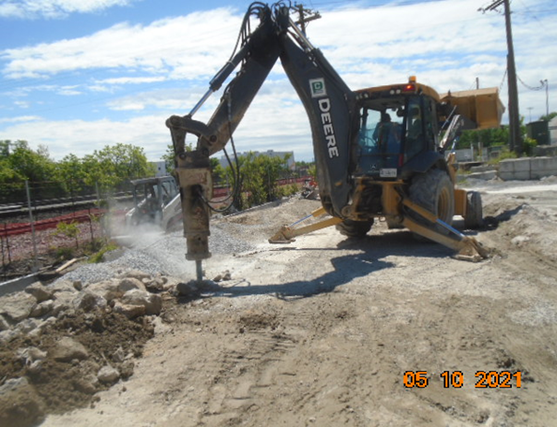
Phase D – Crew demolishing existing concrete

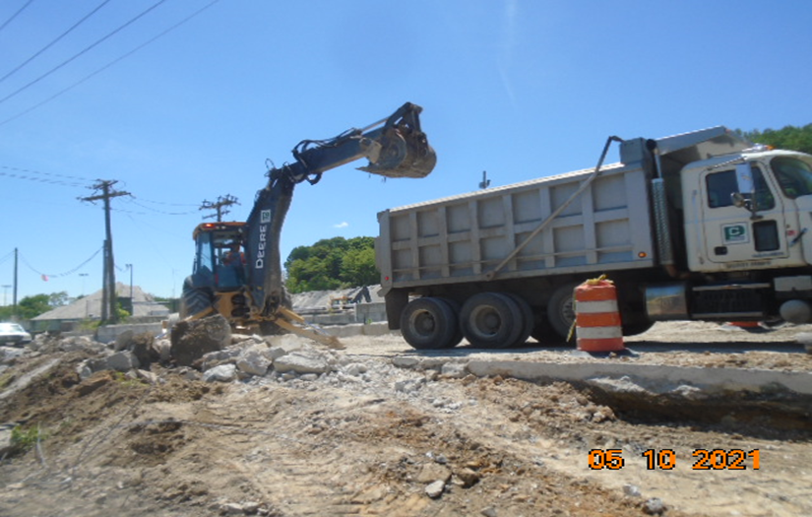
Phase D – Crew hauling away demolished concrete

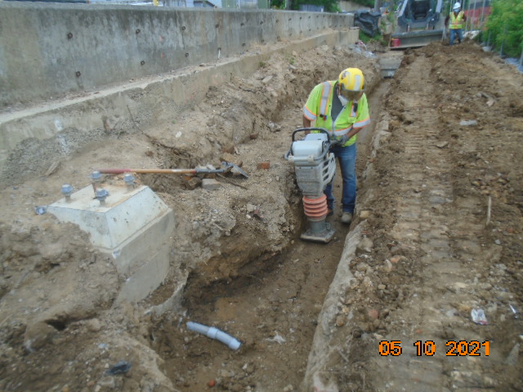
Phase D – Crew compacting electrical trench

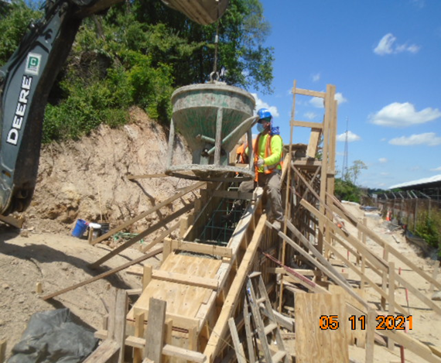
Phase D – Crew placing retaining wall S2 concrete

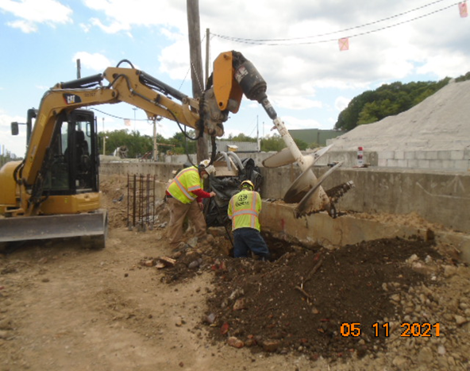
Phase D – Shaft drilling light pole foundation

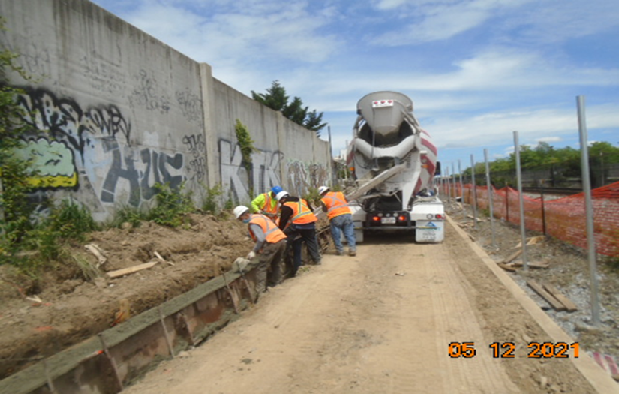
Phase D – Crew placing curb concrete
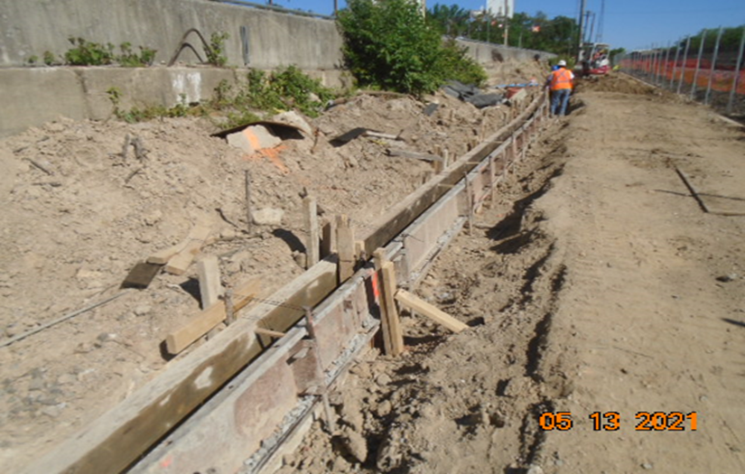
Phase D – Crew installing curb forms

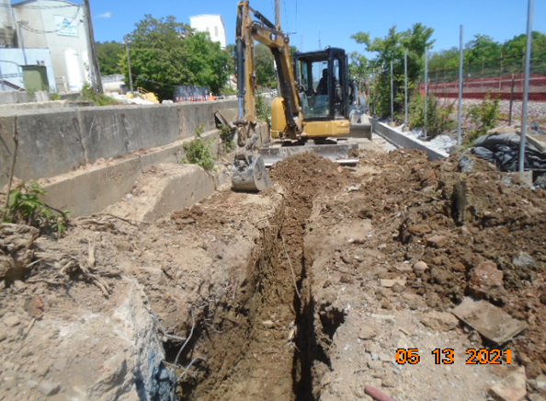
Phase D – Crew excavating electrical trench

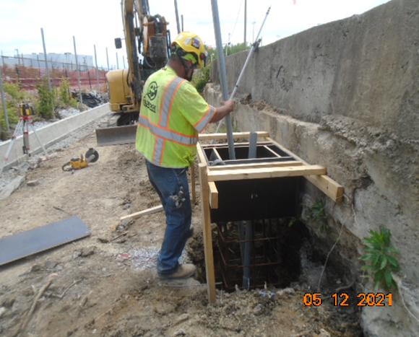
Phase D – Crew installing conduits in light pole foundation

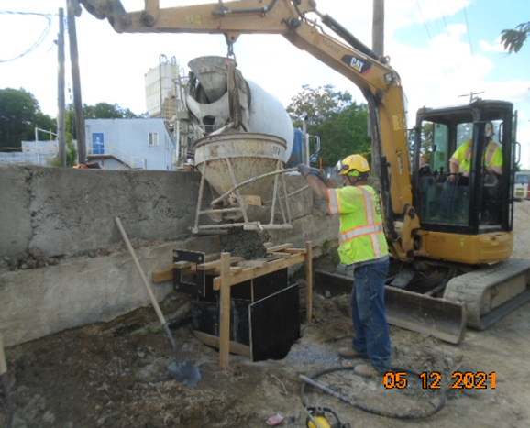
Phase D – Crew placing light pole foundation concrete

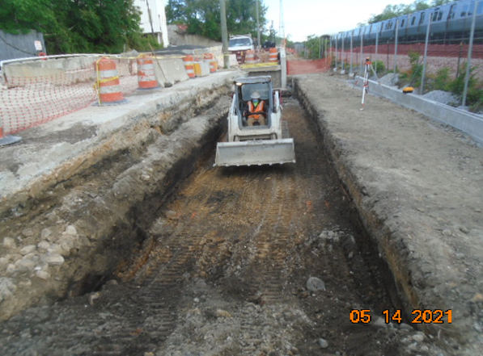
Phase D – Crew excavating retaining wall S0 footing

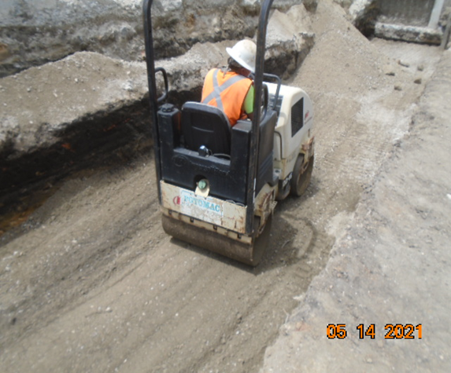
Phase D – Crew compacting retaining wall S0 footing
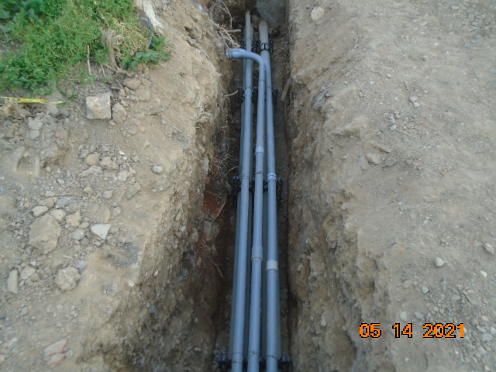
Phase D – Installed electrical conduits

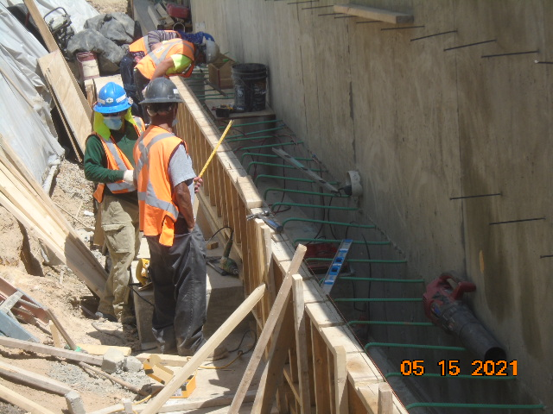
Phase D – Crew constructing wedge wall formwork

