**Metropolitan Branch Trail Design Build, South Segment**

**DC CONTRACT NO. DCKA-2016-C-0044**

**FAP No.: STP-2016 (060)**

CONSTRUCTION MANAGER’S

WEEKLY PROGRESS REPORT

05/02/2021 – 05/08/2021

Project Website: [www.metbranchtrail-forttotten.com](http://www.metbranchtrail-forttotten.com)

For Additional Trail Information Please see [www.metbranchtrail.com](http://www.metbranchtrail.com)

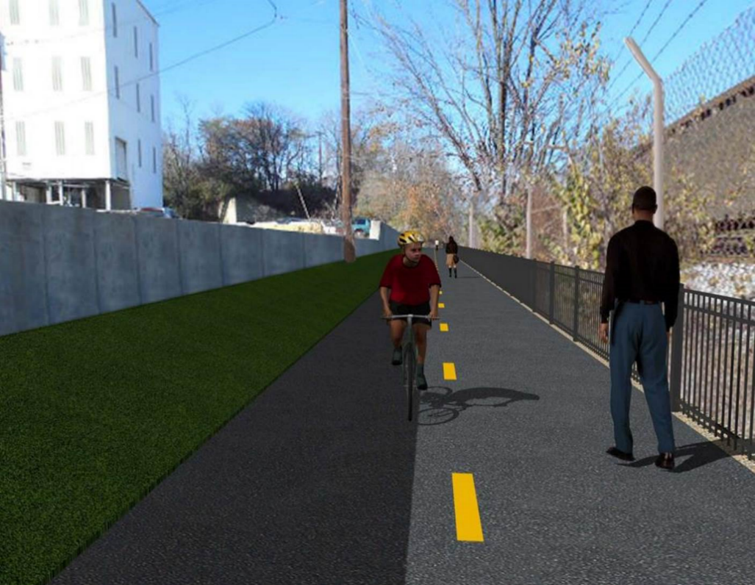

**Proposed Metropolitan Branch Trail**

**1. PROJECT DESCRIPTION**

The planned Metropolitan Branch Trail Project (“the Project”) consists of the design and construction of a new trail adjacent to CSX tracks and WMATA Red Line tracks along John McCormack Drive, adjacent to Fort Totten Metro Station, and on NPS property in NE, Washington D.C. The trail begins approximately 1500 feet south of Bates Road NE on the east side of John McCormack Drive NE, extending north along the WMATA and CSX tracks to the Fort Totten Metro Station tie in with First Place NE. An existing trail connection from Gallatin Road NE to the Fort Totten Metro Station will be reconstructed as a part of the Project.

The Project is 83.15% Federally-Funded and 16.85% District-Funded. Potomac Construction is the Design Build contractor.

Delon Hampton and Associates Chartered is providing Construction Management and Inspection services. Specific Construction Scope of Work includes:

* Provide mobilization and demobilization, provision and maintenance of Engineer’s field facilities, field layout, employee training, and other incidental work required for a quality, complete and finished product;
* Establishment and maintenance of vehicular and pedestrian traffic including signs, barricades and other transition devices; reconfiguring the devices in conjunction with changes in work areas; and their removal and disposal upon project completion, including restoration of disturbed areas;
* Clearing and grubbing, as required within the LOD;
* Removal of unsuitable material, excavation, and backfilling and pervious paving to construct a new trail;
* Protection of trees during construction;
* Provide ADA compliant trail connections and pedestrian ramps;
* Provide retaining walls as necessary to stay within the LOD and minimize property impacts following visual requirements specified for retaining walls on NPS property;
* Provide new permanent regulatory and wayfinding signs for the trail and all trail connection intersections;
* Provide road and trail pavement markings;
* Provide landscaping within the LOD for the Project including special requirements for landscaping on NPS property;
* Provide erosion and sediment control measures, storm water management facilities, including pervious asphalt pavement and bioretention facilities;
* Provide utility coordination, identification, locating, and protection of all utilities encountered during design and construction including relocation of Pepco poles along Aggregate Industries property; and
* Provide new WMATA security fencing between the trail and CSXT tracks.
* Remove existing sidewalk and widen sidewalk to 10’ along the west side of 1st place NE from Metropolitan Branch Trail to entrance to WMATA bus loop, on the west side.

**2. STATUS OF CONSTRUCTION / PROGRESS SUMMARY**

**Work performed this week:**

**Design**

* 100 % Complete

**Construction:**

**Phase D**

* Constructed retaining wall S2 formwork
* Installed retaining wall S2 rebars
* Placed and graded curb bedding stone
* Installed curb formwork
* Placed curb concrete
* Installed chain link fence
* Excavated electrical trench
* Installed electrical conduits
* Backfilled and compacted electrical trench
* CSX flagger’s operation and safety tool box talk

**CM Consultant:**

* Monitored construction progress, make sure all applicable inspections and testing were performed
* Reviewed PCCI Monthly Payment Invoice
* Attend field meeting with PCCI
* Prepared CM Weekly Report to post
* Prepared CM weekly report to DDOT
* Monitored QC field testing
* Updated Project Files
* Updated Project Logs
* Updated Project Webpage
* Updated documents in DHA SharePoint site
* Updated DDOT Sharepoint site
* Communication with PCCI in terms of submittals

**3. MEETINGS / PROJECT COORDINATION**

Tue 05/04/2021 DHA PCCI field meeting was held at 10:00 A.M.

**4. DAILY WORK PERFORMED**

Sun 05/02/21 No work performed.

Mon 05/03/21 Phase D – Constructed retaining wall S2 outer face formwork including 15”

Ashlar pattern and greenscreen panel. Placed and graded # 57 curb bedding stone. Braced fence post, top rail and tension wire.

Phase D – Electrical Work – Backfilled and compacted electrical trench.

Tue 05/04 /21 Phase D – Constructed retaining wall S2 outer face formwork including 15”

Ashlar pattern and greenscreen panel. Installed retaining wall rebars.

Placed curb concrete. Installed fence and braced fence post. Braced fence tension wire and top rail.

Phase D – Electrical Work – Backfilled and compacted electrical trench.

Wed 05/05/21 Phase D – No work performed due to rain.

Phase D – Electrical Work – No work performed due to rain.

Thurs 05/06/21 Phase D – Constructed retaining wall S2 outer face formwork including 15”

Ashlar pattern and greenscreen panel. Installed retaining wall rebars. Installed chain link fence. Placed and graded stone behind curb. Framed brace rail, top rail and tension wire. Excavated chain link fence post footing.

Phase D – Electrical Work – Excavated electrical trench. Installed electrical conduits.

Fri 05/07/21 Phase D – Installed retaining wall S2 wall section rebars. Constructed

retaining wall S2 wall section formwork. Installed chain link fence.

Phase D – Electrical Work – Excavated electrical trench. Installed electrical conduits.

Sat 05/08/21 No work scheduled

**5. INSPECTION & MATERIAL TESTS PERFORMED**

|  |  |
| --- | --- |
| Jobsite Safety Inspection  Erosion and Sediment Control inspection  MOT Inspection  Compaction Test - Passed  Asphalt Material Testing  Concrete Material Testing – Pending results  **\*\* Note - Additional Material Test Results can be found on DDOT QA QC Material Division Tracking SharePoint website**. | Infiltration Tests  Dynamic Cone Penetration (DCP) Tests - Passed  Rebars Inspection - Ongoing |

**6. DBE PARTICIPATION SUMMARIES**

Potomac Construction (Contractor)

* DBE Goal for Contractor is 15%. To-date the Contractor has achieved 49.4% of their goal.

Delon Hampton & Associates (CM)

* DBE Goal for the CM is 10%. To-date the CM has achieved 82.7% of their Goal.

**7. ACCIDENTS / INCIDENTS**

None occurred on-site during this week.

**8. PHOTOS OF THE WORK PERFORMED**

**12. PHOTOS OF WORK PERFORMED THIS PERIOD**

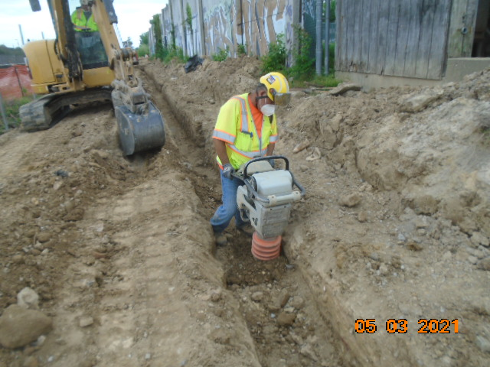

Phase D – Crew compacting electrical trench

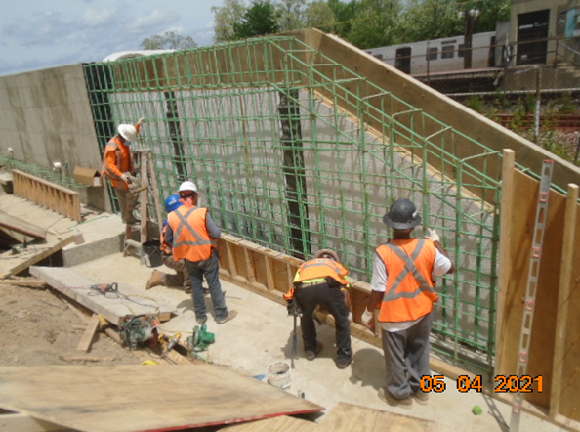

Phase D – Crew constructing retaining wall S2 formwork

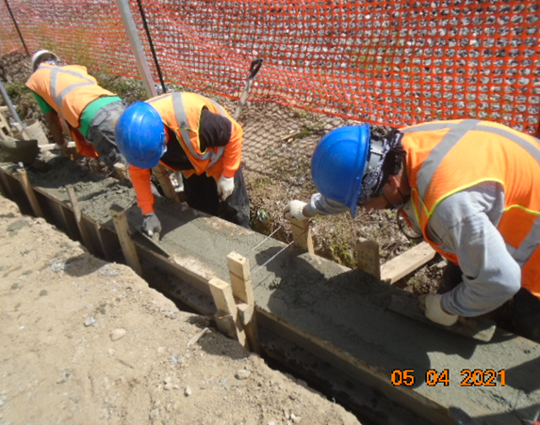

Phase D – Crew finishing curb concrete

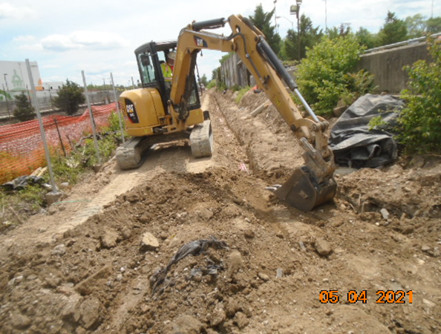

Phase D – Crew backfilling electrical trench

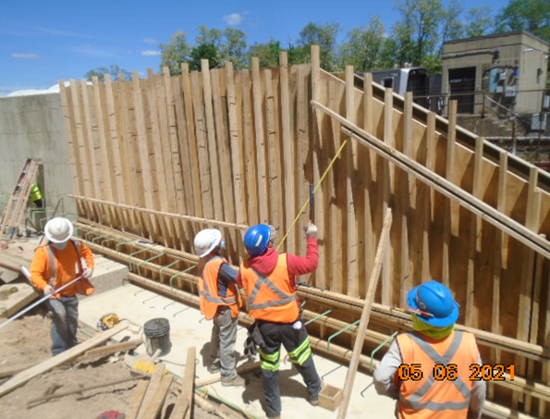

Phase D – Crew constructing retaining wall formwork

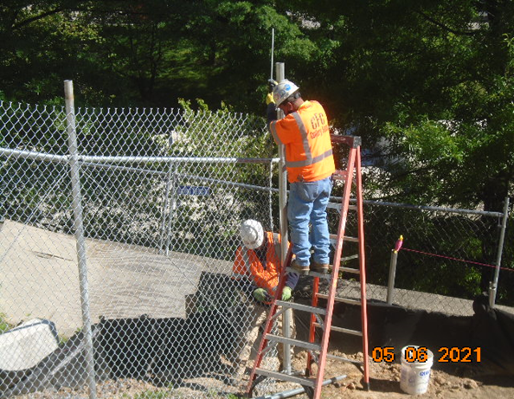

Phase D – Crew installing chain link fence

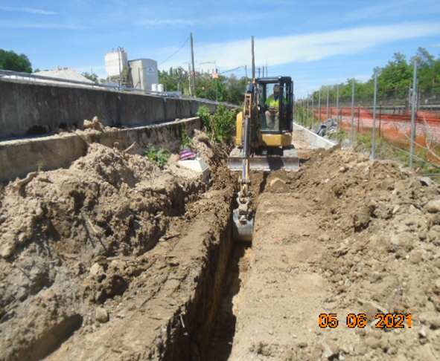

Phase D – Crew excavating electrical trench

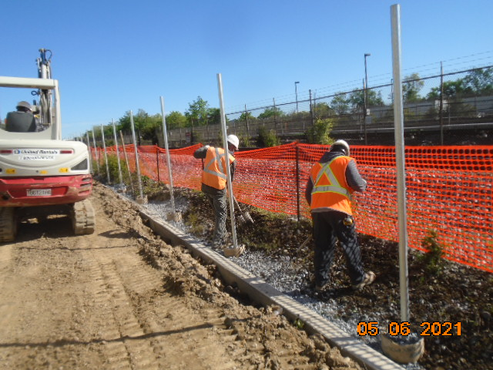

Phase D – Crew grading stone behind curb