**Metropolitan Branch Trail Design Build, South Segment**

**DC CONTRACT NO. DCKA-2016-C-0044**

**FAP No.: STP-2016 (060)**

CONSTRUCTION MANAGER’S

WEEKLY PROGRESS REPORT

04/25/2021 – 05/01/2021

Project Website: [www.metbranchtrail-forttotten.com](http://www.metbranchtrail-forttotten.com)

For Additional Trail Information Please see [www.metbranchtrail.com](http://www.metbranchtrail.com)

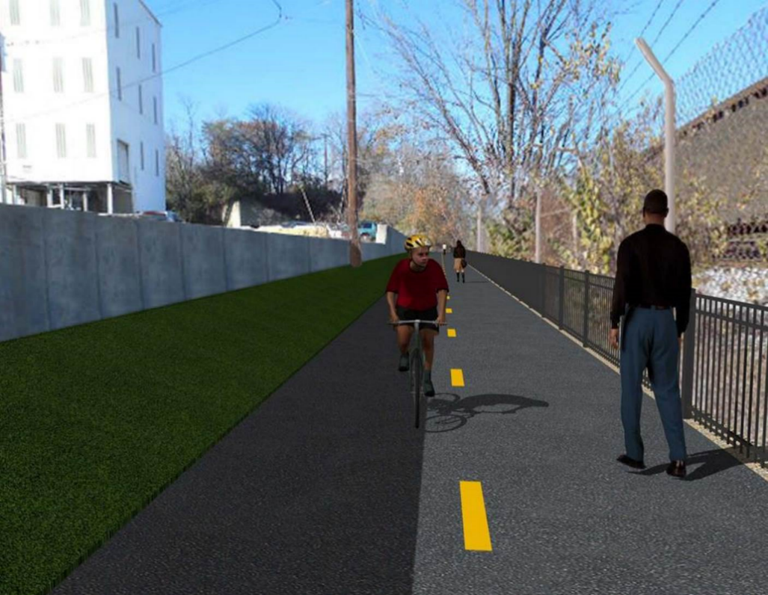

**Proposed Metropolitan Branch Trail**

**1. PROJECT DESCRIPTION**

The planned Metropolitan Branch Trail Project (“the Project”) consists of the design and construction of a new trail adjacent to CSX tracks and WMATA Red Line tracks along John McCormack Drive, adjacent to Fort Totten Metro Station, and on NPS property in NE, Washington D.C. The trail begins approximately 1500 feet south of Bates Road NE on the east side of John McCormack Drive NE, extending north along the WMATA and CSX tracks to the Fort Totten Metro Station tie in with First Place NE. An existing trail connection from Gallatin Road NE to the Fort Totten Metro Station will be reconstructed as a part of the Project.

The Project is 83.15% Federally-Funded and 16.85% District-Funded. Potomac Construction is the Design Build contractor.

Delon Hampton and Associates Chartered is providing Construction Management and Inspection services. Specific Construction Scope of Work includes:

* Provide mobilization and demobilization, provision and maintenance of Engineer’s field facilities, field layout, employee training, and other incidental work required for a quality, complete and finished product;
* Establishment and maintenance of vehicular and pedestrian traffic including signs, barricades and other transition devices; reconfiguring the devices in conjunction with changes in work areas; and their removal and disposal upon project completion, including restoration of disturbed areas;
* Clearing and grubbing, as required within the LOD;
* Removal of unsuitable material, excavation, and backfilling and pervious paving to construct a new trail;
* Protection of trees during construction;
* Provide ADA compliant trail connections and pedestrian ramps;
* Provide retaining walls as necessary to stay within the LOD and minimize property impacts following visual requirements specified for retaining walls on NPS property;
* Provide new permanent regulatory and wayfinding signs for the trail and all trail connection intersections;
* Provide road and trail pavement markings;
* Provide landscaping within the LOD for the Project including special requirements for landscaping on NPS property;
* Provide erosion and sediment control measures, storm water management facilities, including pervious asphalt pavement and bioretention facilities;
* Provide utility coordination, identification, locating, and protection of all utilities encountered during design and construction including relocation of Pepco poles along Aggregate Industries property; and
* Provide new WMATA security fencing between the trail and CSXT tracks.
* Remove existing sidewalk and widen sidewalk to 10’ along the west side of 1st place NE from Metropolitan Branch Trail to entrance to WMATA bus loop, on the west side.

**2. STATUS OF CONSTRUCTION / PROGRESS SUMMARY**

**Work performed this week:**

**Design**

* 100 % Complete

**Construction:**

**Phase A**

* Applied thermoplastic pavement markings

**Phase B**

* Applied thermoplastic pavement marking for pedestrian crosswalk at 1st Place N.E.
* Applied yellow dash lines at trail

**Phase D**

* Constructed retaining wall S2 formwork
* Installed retaining wall S2 rebars
* Striped retaining wall S2 wall section formwork
* Constructed retaining wall S2 footing formwork
* Installed retaining wall S2 footing rebars
* Installed water proofing along the curb side of the trail
* Placed curb and gutter bedding stone
* Constructed curb and gutter formwork
* Placed curb and gutter concrete
* Excavated chain link fence post footing
* Installed sonotube in fence post footing
* Placed concrete for chain link fence post footing
* Excavated electrical conduits trench line
* Installed electrical conduits
* Backfilled and compacted electrical trench
* Applied thermoplastic pavement markings Phase B and Phase A
* CSX flagger’s operation and safety tool box talk

**CM Consultant:**

* Monitored construction progress, make sure all applicable inspections and testing were performed
* Reviewed CSX invoice
* Attended DHA and NPS field meeting walk through meeting
* Attended MBT Progress Meeting
* Prepared CM Weekly Report to post
* Prepared CM weekly report to DDOT
* Prepared progress meeting minutes
* Monitored QC field testing
* Updated Project Files
* Updated Project Logs
* Updated Project Webpage
* Updated documents in DHA SharePoint site
* Updated DDOT Sharepoint site
* Communication with the stakeholder in terms of submittals

**3. MEETINGS / PROJECT COORDINATION**

Tue 04/27/2021 MBT Progress Meeting Microsoft Teams Meeting was held at 10:00 A.M.

Wed 04/29/2021 DDOT DHA and NPS field meeting was held at 12:00 A.M.

**4. DAILY WORK PERFORMED**

Sun 04/25/21 No work performed.

Mon 04/26/21 Phase B – Applied thermoplastic pavement marking.

Phase D – Constructed retaining wall S2 formwork. Installed retaining wall S2 rebars. Striped retaining wall S2 wall section formwork.

Placed concrete for curb and gutter. Excavated fence post footing. Installed sonotube in fence post footing.

Phase D – Electrical Work – Excavated electrical trench. Installed electrical conduits. Backfilled and compacted electrical trench.

Tue 04/27/21 Phase D – Installed rebars for retaining wall S2 footing. Placed concrete

for retaining wall S2 footing. Placed and fine graded #57 stone for curb.

Set forms for curb concrete.

Phase D – Electrical Work – Excavated electrical trench line.

Wed 04/28/21 Phase A – Applied thermoplastic pavement marking.

Phase D – Placed curb and gutter concrete. Excavated fence post footing. Installed sonotube in fence post footing.

Phase D – Electrical Work – Backfilled and compacted electrical trench.

Thurs 04/29/21 Phase D – Excavated chain link fence post footing. Excavated trench for electrical conduits. Installed conduits. Backfilled and compacted electrical trench.

Phase D – Electrical Work – Excavated electrical conduits trench. Installed conduits.

Fri 04/30/21 Phase D – Installed retaining wall S2 wall section rebars. Constructed

retaining wall S2 wall section formwork. Placed fence post footing

concrete.

Phase D – Electrical Work – Backfilled and compacted electrical trench.

Sat 05/01/21 No work scheduled

**5. INSPECTION & MATERIAL TESTS PERFORMED**

|  |  |
| --- | --- |
| Jobsite Safety Inspection  Erosion and Sediment Control inspection  MOT Inspection  Compaction Test - Passed  Asphalt Material Testing  Concrete Material Testing – Pending results  **\*\* Note - Additional Material Test Results can be found on DDOT QA QC Material Division Tracking SharePoint website**. | Infiltration Tests  Dynamic Cone Penetration (DCP) Tests - Passed  Rebars Inspection - Passed |

**6. DBE PARTICIPATION SUMMARIES**

Potomac Construction (Contractor)

* DBE Goal for Contractor is 15%. To-date the Contractor has achieved 49.4% of their goal.

Delon Hampton & Associates (CM)

* DBE Goal for the CM is 10%. To-date the CM has achieved 82.7% of their Goal.

**7. ACCIDENTS / INCIDENTS**

None occurred on-site during this week.

**8. PHOTOS OF THE WORK PERFORMED**

**12. PHOTOS OF WORK PERFORMED THIS PERIOD**

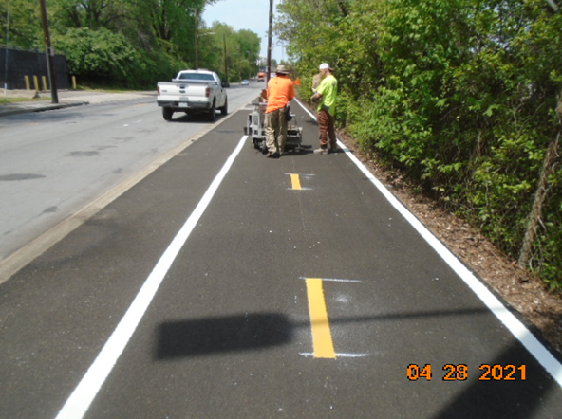

Phase A – Crew applying thermoplastic pavement markings at the trail

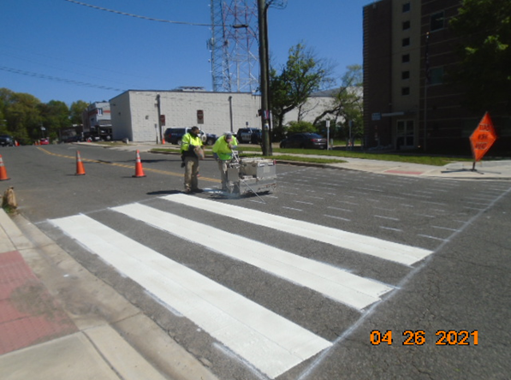

Phase D – Crew applying pavement markings at pedestrian crosswalk

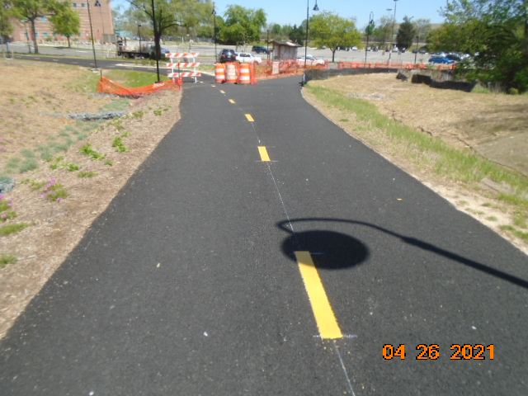

Phase B Pavement markings

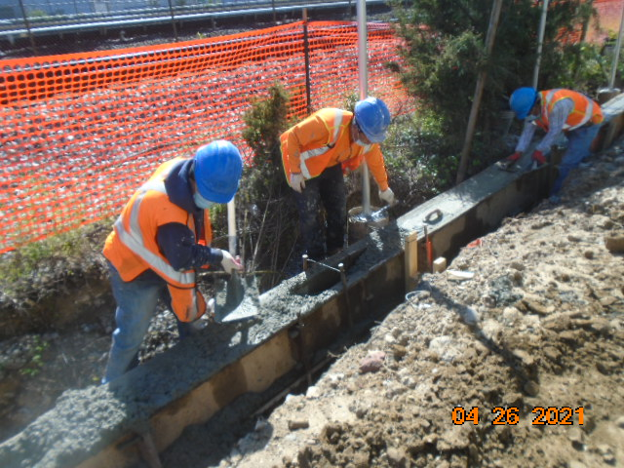

Phase D – Crew finishing concrete curb

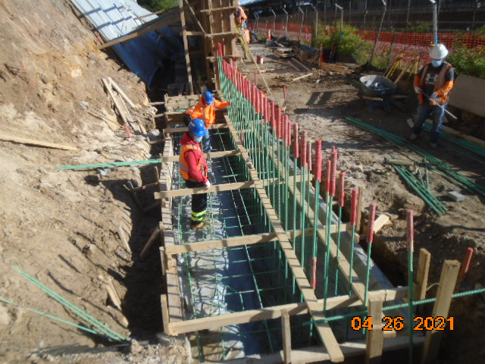

Phase D – Crew installing retaining wall footing rebars

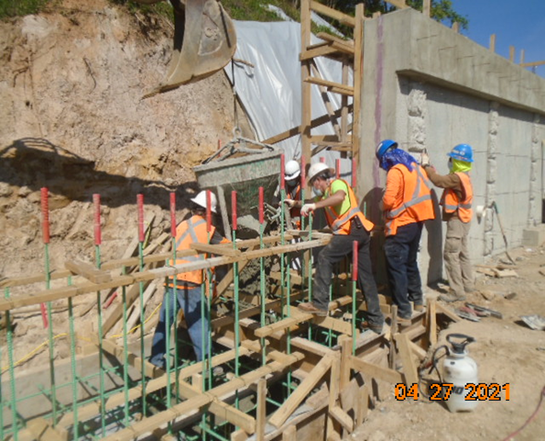

Phase D – Crew placing concrete for retaining wall S2 footing

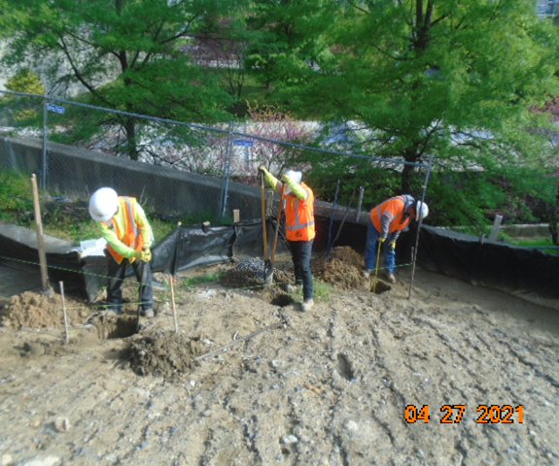

Phase D – Crew excavating chain link fence footing

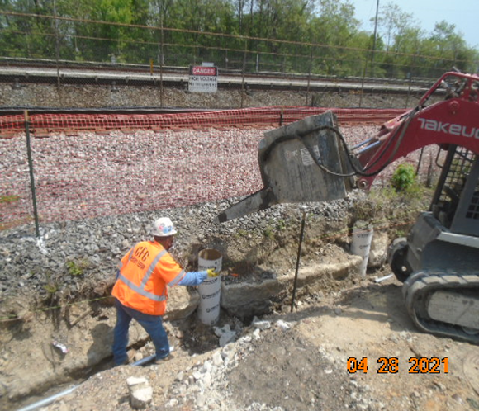

Phase D – Crew placing fence post footing concrete

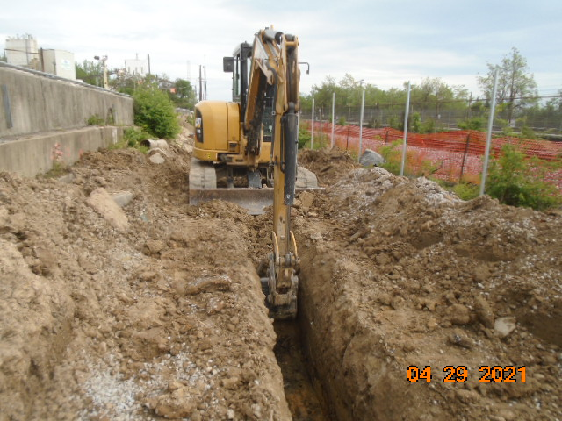

Phase D – Crew excavating electrical trench

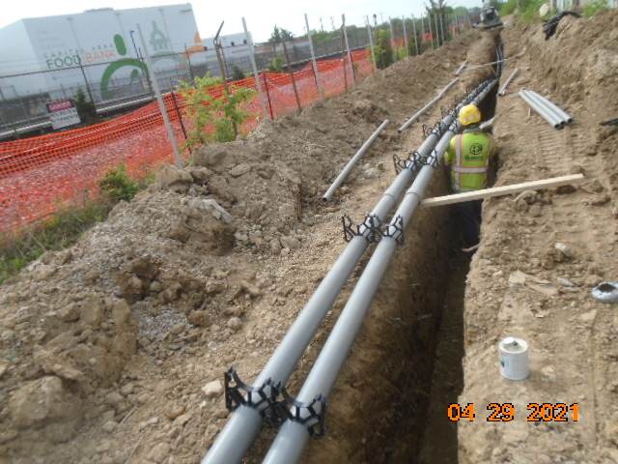

Phase D – Crew installing electrical conduits

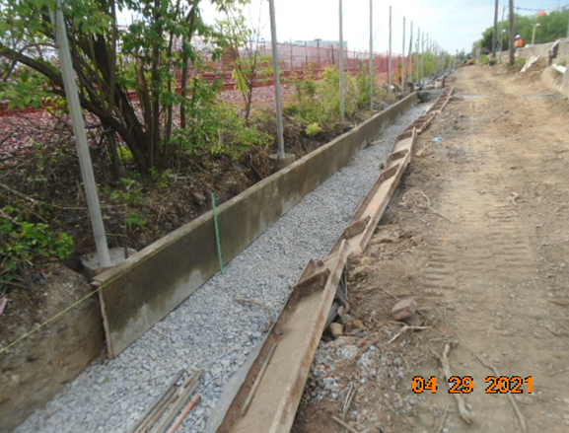

Phase D – Curb and gutter formwork

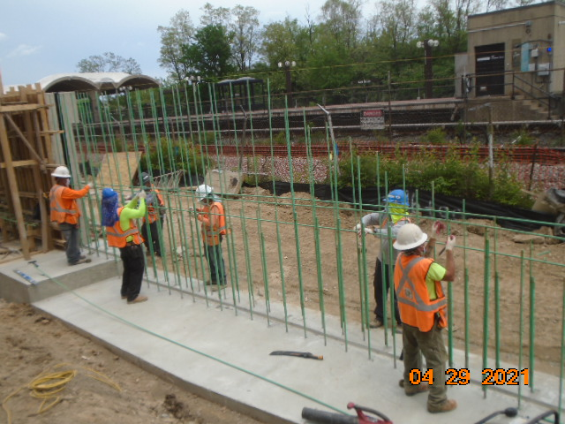

Phase D – Crew tying retaining wall S2 rebars