Metropolitan Branch Trail Design Build, South Segment
DC CONTRACT NO. DCKA-2016-C-0044
FAP No.: STP-2016 (060)

CONSTRUCTION MANAGER’S
WEEKLY PROGRESS REPORT

04/19/2020 – 04/25/2020

Project Website: www.metbranchtrail-forttotten.com
For Additional Trail Information Please see www.metbranchtrail.com

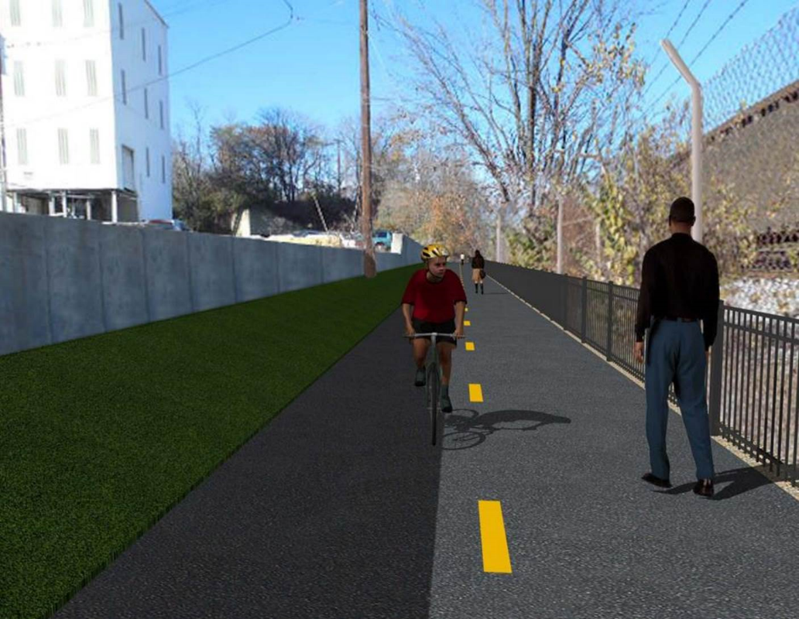

Proposed Metropolitan Branch Trail

1. PROJECT DESCRIPTION

The planned Metropolitan Branch Trail Project (“the Project”) consists of the design and construction of a new trail adjacent to CSX tracks and WMATA Red Line tracks along John McCormack Drive, adjacent to Fort Totten Metro Station, and on NPS property in NE, Washington D.C. The trail begins approximately 1500 feet south of Bates Road NE on the east side of John McCormack Drive NE, extending north along the WMATA and CSX tracks to the Fort Totten Metro Station tie in with First Place NE. An existing trail connection from Gallatin Road NE to the Fort Totten Metro Station will be reconstructed as a part of the Project.

The Project is 83.15% Federally-Funded and 16.85% District-Funded. Potomac Construction is the Design Build contractor.

Delon Hampton and Associates Chartered is providing Construction Management and Inspection services. Specific Construction Scope of Work includes:

Existing street light poles from the beginning point of the project south to Michigan Avenue shall have the existing luminaires replaced with new LED cobra head luminaires, see Section 16 of the Project Technical Provisions for details;

- Provide mobilization and demobilization, provision and maintenance of Engineer’s field facilities, field layout, employee training, and other incidental work required for a quality, complete and finished product;
- Establishment and maintenance of vehicular and pedestrian traffic including signs, barricades and other transition devices; reconfiguring the devices in conjunction with changes in work areas; and their removal and disposal upon project completion, including restoration of disturbed areas;
- Clearing and grubbing, as required within the LOD;
- Removal of unsuitable material, excavation, and backfilling and pervious paving to construct a new trail;
- Protection of trees during construction;
- Provide ADA compliant trail connections and pedestrian ramps;
- Provide retaining walls as necessary to stay within the LOD and minimize property impacts following visual requirements specified for retaining walls on NPS property;
- Provide new permanent regulatory and wayfinding signs for the trail and all trail connection intersections;
- Provide road and trail pavement markings;
- Provide landscaping within the LOD for the Project including special requirements for landscaping on NPS property;
- Provide erosion and sediment control measures, storm water management facilities, including pervious asphalt pavement and bioretention facilities;
- Provide utility coordination, identification, locating, and protection of all utilities encountered during design and construction including relocation of Pepco poles along Aggregate Industries property; and
- Provide new WMATA security fencing between the trail and CSXT tracks.
- Remove existing sidewalk and widen sidewalk to 10’ along the west side of 1st place NE from Metropolitan Branch Trail to entrance to WMATA bus loop, on the west side.

2. STATUS OF CONSTRUCTION / PROGRESS SUMMARY

Work performed this week:

Design

- Comment reposes to DCRA comments submitted to DDOT and it is under review
- Final comment resolution matrix for Submittal D submitted to DDOT and it is under review
- DC Water utility release letter is in process and will be sent to DDOT

Construction:

Phase B
- Constructing diches along the south side of the trail
- Compacting electrical trench line
- Installing silt fence along the trail
- Installing erosion control matting along the ditches
- Installing ground rods and saddle racks in manholes
- Splicing cables inside electrical manholes
- Pulling cables from manhole to light poles

Phase D

- No work performed

CM Consultant:

- Monitored construction progress, make sure all applicable inspection and testing were performed
- Attended Design Coordination Meeting conference call
- Attended DDOT DHA schedule update conference call
- Attended QA/QC meeting conference call
- Reviewed Inspection Daily Reports
- Updated project files
- Communication with the stakeholder in terms of submittals

3. MEETINGS / PROJECT COORDINATION

Tues. 04/21/20 Design Coordination Meeting conference call was held at 10:00
A.M.
Wed. 04/22/20 DDOT DHA schedule update conference call was held at 2:00 P.M.
Fri. 04/24/20 QA/QC Meeting conference call was held at 10:00 A.M.

4. DAILY WORK PERFORMED

Sun 04/19/20 No work performed
Mon 04/20/20 Phase B - Excavated and graded ditches along the south side of the trail.
Applied topsoil on the 2 ft. shoulder along the south side trail. Installed silt fence on the south side of the trail.
Phase B - Electrical Phase - Installed saddle racks inside the manholes. Pulled cable from manhole to manhole.
Phase D - No work performed
Tue 04/21/20 Phase B - Excavated and graded the ditch along the south side of the
trail. Removed unsuitable material from the site.
Phase B - Electrical Work - Installed ground rod and saddle racks in electrical manhole. Spliced cables inside the manhole. Cleaned and re-compacted the contaminated trench area.
Phase D - No work performed.
Wed 04/22/20 Phase B - Placed and graded topsoil, applied seeding
and installed erosion control matting on the south side along the trail
Phase B - Electrical Work - Installed ground rod in manholes. Pulled cables from manhole to Pepco light pole. Performed cable splicing in manhole. Installed light pole.
Phase D - No work performed
Thurs 04/23/20 Phase B - Excavated and graded ditches along the south side of the
trail. Placed and seeded top soil, and installed erosion control matting
along the south side of the trail.
Phase B - Electrical Work - Installed ground rod at light pole foundations. grounded and installed saddle racks in manhole. Pulled camera to light pole. Installed light poles.
Phase D - No work performed.
Fri 04/24/20 Phase B – Work is canceled due to rain
Phase D - No work performed.
Sat 04/25/20 No work scheduled

5. INSPECTION & MATERIAL TESTS PERFORMED

Jobsite Safety Inspection  Erosion and Sediment Control inspection  MOT Inspection  Compaction Test  Asphalt Material Testing  Concrete Material Testing | Infiltration facility Material Testing
6. DBE PARTICIPATION SUMMARIES

Potomac Construction (Contractor)
- DBE Goal for Contractor is 15%. To-date the Contractor has achieved 36% of their goal.

Delon Hampton & Associates (CM)
- DBE Goal for the CM is 10%. To-date the CM has achieved 0% of their Goal.

7. ACCIDENTS / INCIDENTS
None occurred on-site.

8. PHOTOS OF THE WORK PERFORMED

12. PHOTOS OF WORK PERFORMED THIS PERIOD

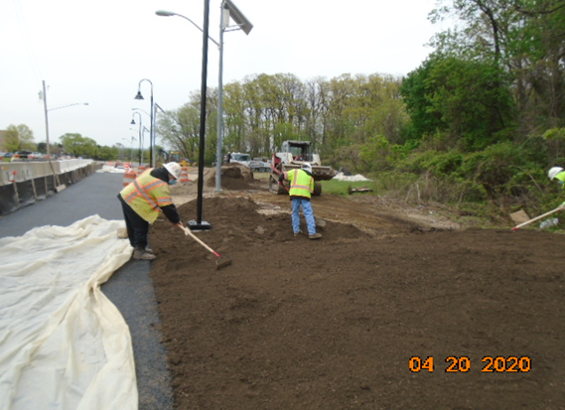
Phase B – Grading topsoil along the trail

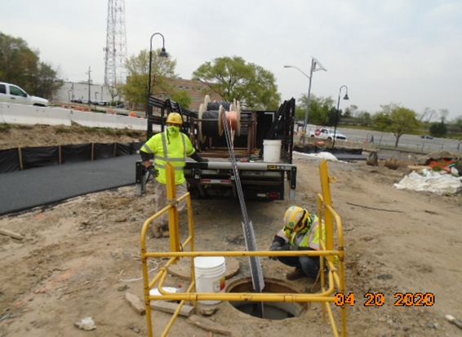
Phase B – Crew pulling cables

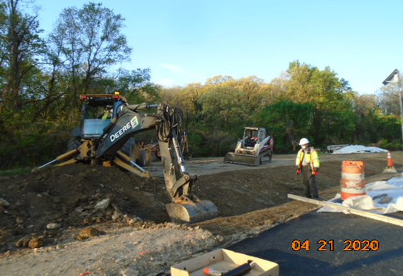
Phase B – Crew excavating ditches along the trail

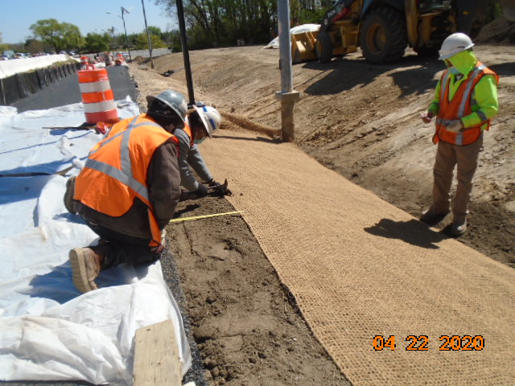
Phase B – Crew installing erosion control matting along the south side of the trail

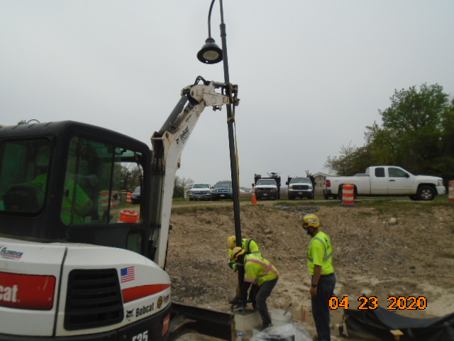
Phase B – Crew installing light pole

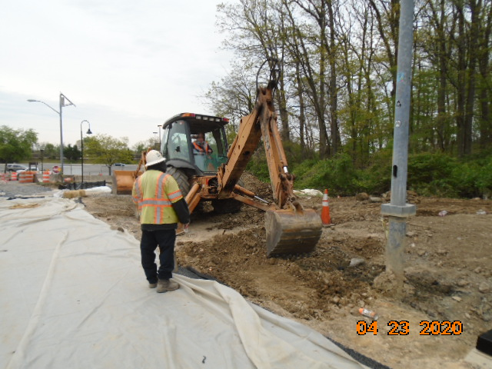
Phase B – Crew excavating ditches along the south side of the trail

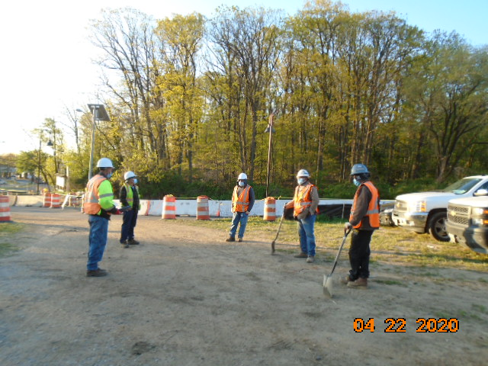
Phase B – Crew practicing social distancing and wearing face masks

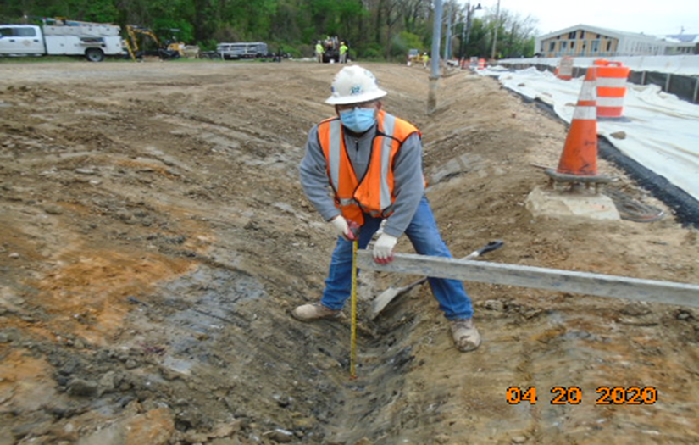
Phase B – Crew wearing PPE and face mask

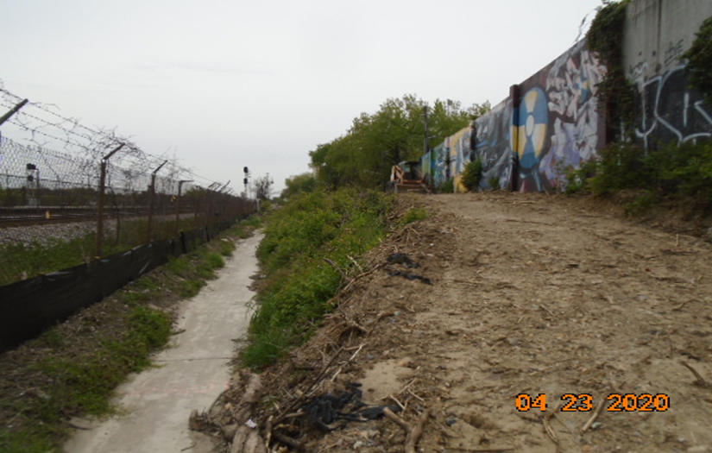
Phase D – No work performed

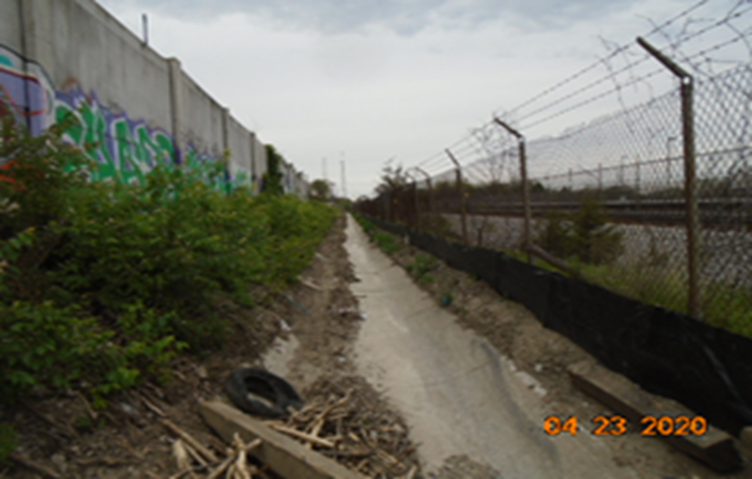
Phase D – No work Performed

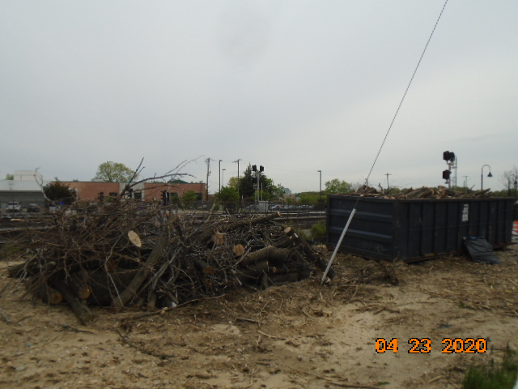
Phase D – No work performed

