Metropolitan Branch Trail Design Build, South Segment
DC CONTRACT NO. DCKA-2016-C-0044
FAP No.: STP-2016 (060)

CONSTRUCTION MANAGER’S
WEEKLY PROGRESS REPORT

04/18/2021 – 04/24/2021

Project Website: www.metbranchtrail-forttotten.com
For Additional Trail Information Please see www.metbranchtrail.com
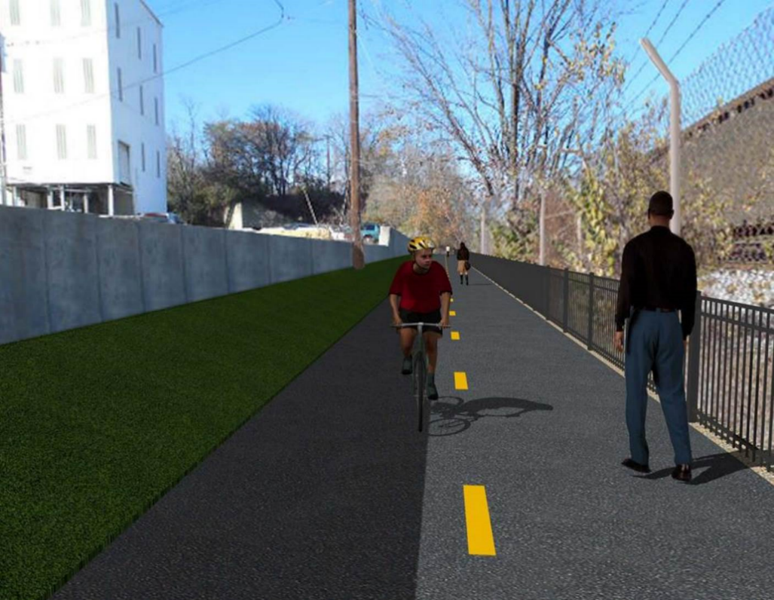

Proposed Metropolitan Branch Trail

1. PROJECT DESCRIPTION

The planned Metropolitan Branch Trail Project (“the Project”) consists of the design and construction of a new trail adjacent to CSX tracks and WMATA Red Line tracks along John McCormack Drive, adjacent to Fort Totten Metro Station, and on NPS property in NE, Washington D.C. The trail begins approximately 1500 feet south of Bates Road NE on the east side of John McCormack Drive NE, extending north along the WMATA and CSX tracks to the Fort Totten Metro Station tie in with First Place NE. An existing trail connection from Gallatin Road NE to the Fort Totten Metro Station will be reconstructed as a part of the Project.

The Project is 83.15% Federally-Funded and 16.85% District-Funded. Potomac Construction is the Design Build contractor.

Delon Hampton and Associates Chartered is providing Construction Management and Inspection services. Specific Construction Scope of Work includes:

- Provide mobilization and demobilization, provision and maintenance of Engineer’s field facilities, field layout, employee training, and other incidental work required for a quality, complete and finished product;
- Establishment and maintenance of vehicular and pedestrian traffic including signs, barricades and other transition devices; reconfiguring the devices in conjunction with changes in work areas; and their removal and disposal upon project completion, including restoration of disturbed areas;
- Clearing and grubbing, as required within the LOD;
- Removal of unsuitable material, excavation, and backfilling and pervious paving to construct a new trail;
- Protection of trees during construction;
- Provide ADA compliant trail connections and pedestrian ramps;
- Provide retaining walls as necessary to stay within the LOD and minimize property impacts following visual requirements specified for retaining walls on NPS property;
- Provide new permanent regulatory and wayfinding signs for the trail and all trail connection intersections;
- Provide road and trail pavement markings;
- Provide landscaping within the LOD for the Project including special requirements for landscaping on NPS property;
- Provide erosion and sediment control measures, storm water management facilities, including pervious asphalt pavement and bioretention facilities;
- Provide utility coordination, identification, locating, and protection of all utilities encountered during design and construction including relocation of Pepco poles along Aggregate Industries property; and
- Provide new WMATA security fencing between the trail and CSXT tracks.
- Remove existing sidewalk and widen sidewalk to 10’ along the west side of 1st place NE from Metropolitan Branch Trail to entrance to WMATA bus loop, on the west side.

2. STATUS OF CONSTRUCTION / PROGRESS SUMMARY

Work performed this week:

Design

- 100 % Complete

Construction:

Phase B

- Scarified and regraded the north side of the trail. Spread additional topsoil at various locations.

Phase D

- Constructed retaining wall S2 formwork
- Installed retaining wall S2 rebars
- Placed concrete for retaining wall S2
- Excavated retaining wall S2 footing
- Constructed retaining wall S2 footing formwork
- Installed water proofing along the curb side of the trail
- Placed curb and gutter bedding stone
- Constructed curb and gutter formwork
- Placed concrete for curb and gutter
- Excavated chain link fence post footing
- Installed sonotubes in fence post footing
- Placed concrete for chain link fence post footing
- Excavated trench for electrical conduits
- Installed electrical conduits
- Backfilled and compacted electrical trench
- CSX flagger’s operation and safety tool box talk

CM Consultant:

- Monitored construction progress, make sure all applicable inspections and testing were performed
- Prepared scope of work for Aggregate Industries property fence
- Reviewed CSX invoice
- Attended DHA and AI field meeting
- Prepared CM Weekly Report to post
- Prepared CM weekly report to DDOT
- Monitored QC field testing
- Updated Project Files
- Updated project logs
- Updated Project Webpage
- Updated documents in DHA SharePoint sites
- Updated DDOT Sharepoint site
- Communication with the stakeholder in terms of submittals

3. MEETINGS / PROJECT COORDINATION

Wed 04/21/2021 DDOT DHA and AI field meeting was held at 10:00 A.M.

4. DAILY WORK PERFORMED

Sun 04/18/21 No work performed.
Mon 04/19/21 Phase B – Scarified and regraded the north side of the trail. Placed
additional topsoil at various locations.
Phase D – Constructed retaining wall S2 formwork. Performed
backfilling and compaction behind retaining wall S2. Excavated drainage trench for 6” under drain. Installed underdrain pipes. Backfilled underdrain pipe trench. Installed waterproofing membrane along the curb side of the trail. Excavate fence post footing.
Phase D – Electrical Work – Crew onsite dropped equipment.
Tue 04/20/21 Phase B – Hydro seeded various areas.
Phase D – Placed concrete for retaining wall S2 wall section. Excavated
trench for 6” underdrain pipe. Installed 6” perforated underdrain pipe. Installed waterproofing membrane along the curb side of the trail. Placed and fine graded #57 stone for curb. Set forms for curb concrete.
Phase D – Electrical Work – Excavated electrical trench. Installed electrical conduits.
Wed 04/21/21 Phase D – Excavated retaining wall S2 footing. Applied damp proofing
material on the backside of retaining wall 2. Backfilled and compacted drainage inlet.
Phase D – Electrical Work – Backfilled and compacted electrical trench.
Thurs 04/22/21 Phase D – Excavated retaining wall S2 footing. Hauled off excavated
materials. Placed curb and gutter concrete. Excavated chain link
fence post footing. Excavated trench for electrical conduits. Installed
conduits. Backfilled and compacted electrical trench.
Phase D – Electrical Work – Excavated electrical conduits trench. Installed conduits. Backfilled and compacted electrical trench.
Fri 04/23/21 Phase D – Constructed retaining wall S2 footing formwork. Installed
retaining wall S2 rebars. Place concrete for curb and gutter. Excavated
fence post footing.
Phase D – Electrical Work – Excavated electrical conduits trench. Installed conduits. Backfilled and compacted electrical trench.
Sat 04/24/21 No work scheduled

5. INSPECTION & MATERIAL TESTS PERFORMED

Jobsite Safety Inspection  Erosion and Sediment Control inspection  MOT Inspection  Compaction Test - Passed  Asphalt Material Testing  Concrete Material Testing – Pending results  ** Note - Additional Material Test Results can be found on DDOT QA QC Material Division Tracking SharePoint website. | Infiltration Tests  Dynamic Cone Penetration (DCP) Tests - Passed  Rebars Inspection - Passed
6. DBE PARTICIPATION SUMMARIES

Potomac Construction (Contractor)

- DBE Goal for Contractor is 15%. To-date the Contractor has achieved 49.4% of their goal.

Delon Hampton & Associates (CM)

- DBE Goal for the CM is 10%. To-date the CM has achieved 82.7% of their Goal.

7. ACCIDENTS / INCIDENTS

None occurred on-site during this week.

8. PHOTOS OF THE WORK PERFORMED

12. PHOTOS OF WORK PERFORMED THIS PERIOD

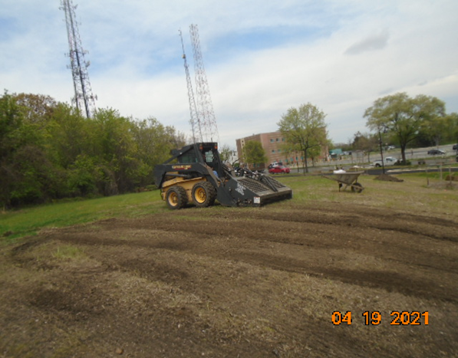
Phase B – Crew regrading topsoil on the north side of the trail

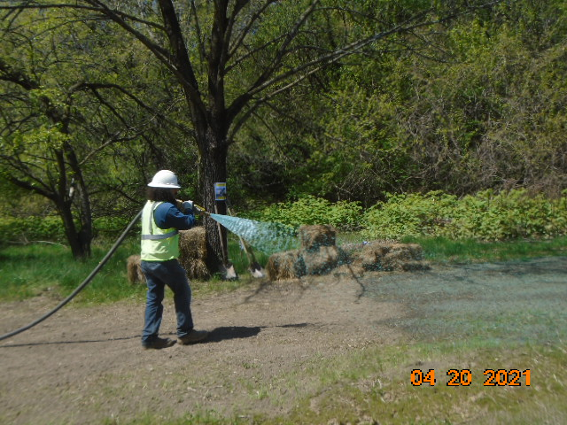
Phase B – Crew hydro seeding north side of the trail
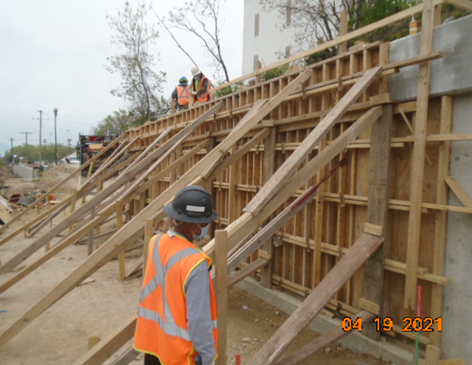
Phase D – Crew constructing retaining wall S2 formwork

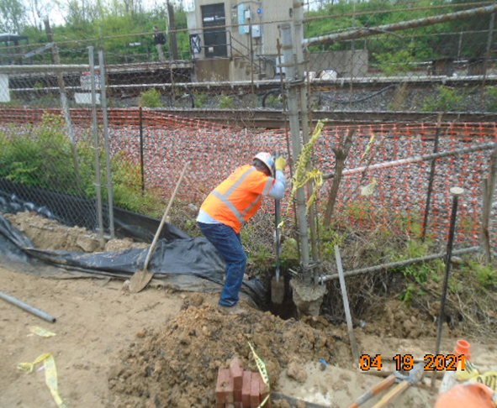
Phase D – Crew excavating fence footing

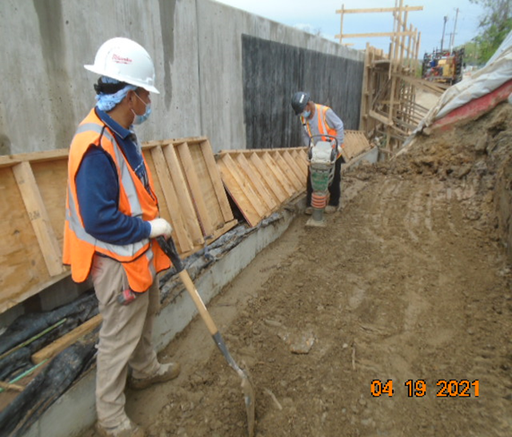
Phase D – Crew compacting behind S2 wall

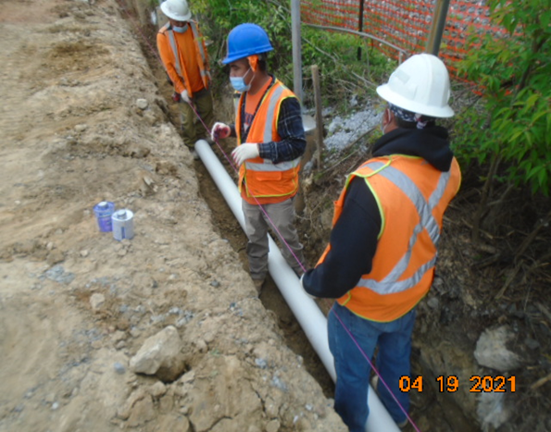
Phase D – Crew installing underdrain pipe

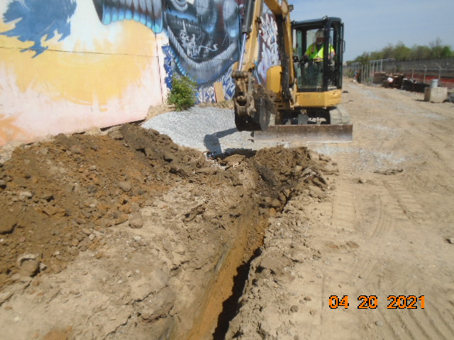
Phase D – Crew excavating electrical conduit trench

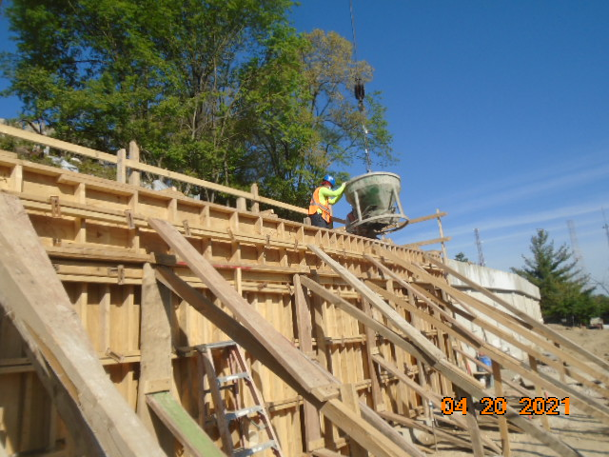
Phase D – Crew placing concrete at retaining wall S2

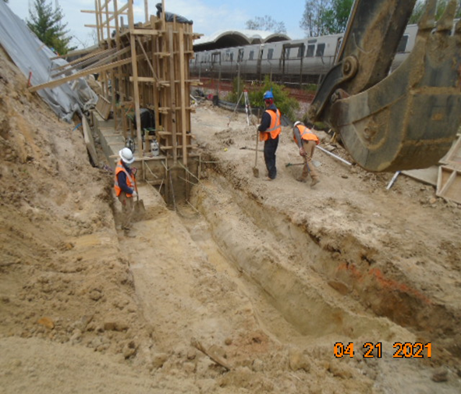
Phase D – Crew excavating retaining wall S2 footing

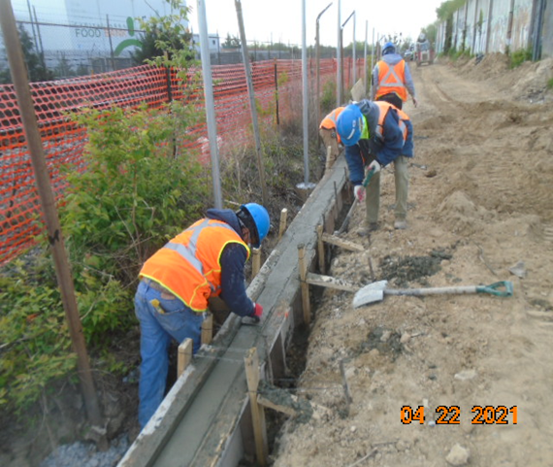
Phase D – Crew finishing curb and gutter concrete

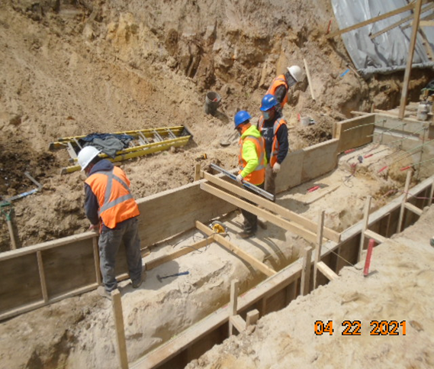
Phase D – Crew constructing retaining wall S2 footing formwork

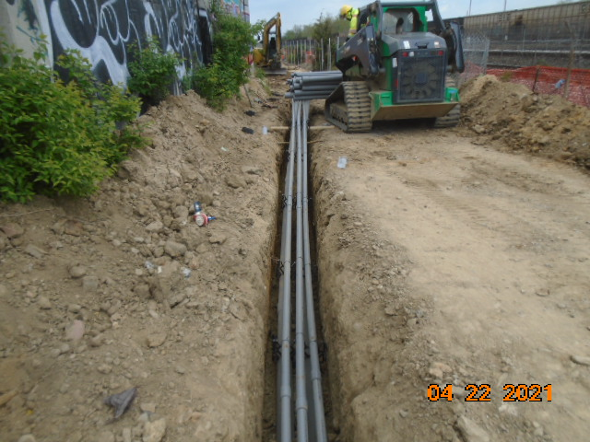
Phase D – Installed electrical conduits

