**Metropolitan Branch Trail Design Build, South Segment**

**DC CONTRACT NO. DCKA-2016-C-0044**

**FAP No.: STP-2016 (060)**

CONSTRUCTION MANAGER’S

WEEKLY PROGRESS REPORT

04/11/2021 – 04/17/2021

Project Website: [www.metbranchtrail-forttotten.com](http://www.metbranchtrail-forttotten.com)

For Additional Trail Information Please see [www.metbranchtrail.com](http://www.metbranchtrail.com)

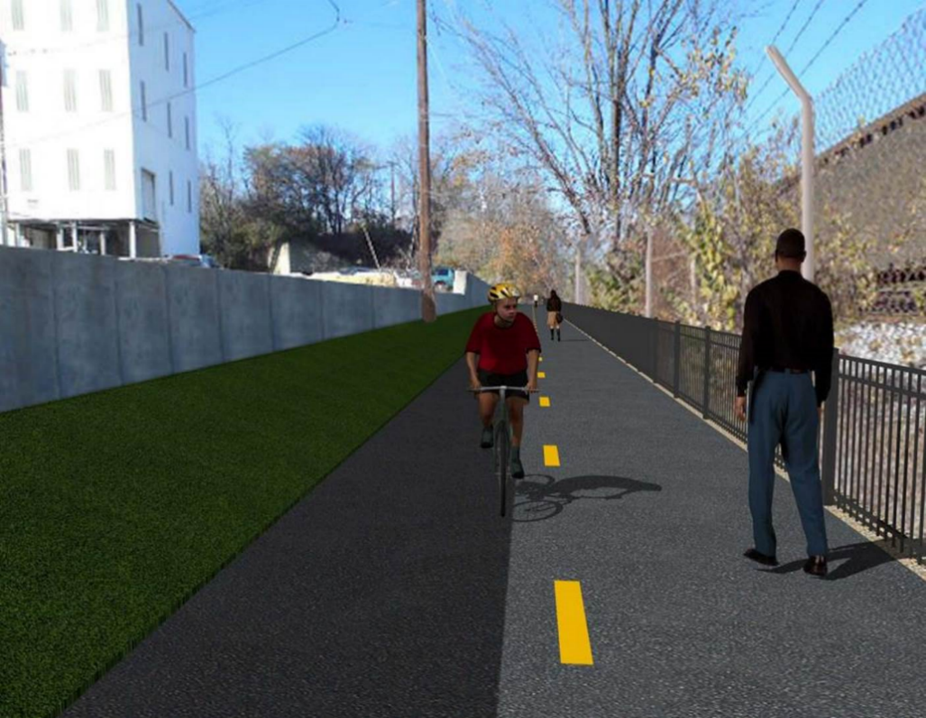

**Proposed Metropolitan Branch Trail**

**1. PROJECT DESCRIPTION**

The planned Metropolitan Branch Trail Project (“the Project”) consists of the design and construction of a new trail adjacent to CSX tracks and WMATA Red Line tracks along John McCormack Drive, adjacent to Fort Totten Metro Station, and on NPS property in NE, Washington D.C. The trail begins approximately 1500 feet south of Bates Road NE on the east side of John McCormack Drive NE, extending north along the WMATA and CSX tracks to the Fort Totten Metro Station tie in with First Place NE. An existing trail connection from Gallatin Road NE to the Fort Totten Metro Station will be reconstructed as a part of the Project.

The Project is 83.15% Federally-Funded and 16.85% District-Funded. Potomac Construction is the Design Build contractor.

Delon Hampton and Associates Chartered is providing Construction Management and Inspection services. Specific Construction Scope of Work includes:

* Provide mobilization and demobilization, provision and maintenance of Engineer’s field facilities, field layout, employee training, and other incidental work required for a quality, complete and finished product;
* Establishment and maintenance of vehicular and pedestrian traffic including signs, barricades and other transition devices; reconfiguring the devices in conjunction with changes in work areas; and their removal and disposal upon project completion, including restoration of disturbed areas;
* Clearing and grubbing, as required within the LOD;
* Removal of unsuitable material, excavation, and backfilling and pervious paving to construct a new trail;
* Protection of trees during construction;
* Provide ADA compliant trail connections and pedestrian ramps;
* Provide retaining walls as necessary to stay within the LOD and minimize property impacts following visual requirements specified for retaining walls on NPS property;
* Provide new permanent regulatory and wayfinding signs for the trail and all trail connection intersections;
* Provide road and trail pavement markings;
* Provide landscaping within the LOD for the Project including special requirements for landscaping on NPS property;
* Provide erosion and sediment control measures, storm water management facilities, including pervious asphalt pavement and bioretention facilities;
* Provide utility coordination, identification, locating, and protection of all utilities encountered during design and construction including relocation of Pepco poles along Aggregate Industries property; and
* Provide new WMATA security fencing between the trail and CSXT tracks.
* Remove existing sidewalk and widen sidewalk to 10’ along the west side of 1st place NE from Metropolitan Branch Trail to entrance to WMATA bus loop, on the west side.

**2. STATUS OF CONSTRUCTION / PROGRESS SUMMARY**

**Work performed this week:**

**Design**

* 100 % Complete

**Construction:**

**Phase B**

* Address Punch List items

**Phase D**

* Constructed retaining wall S2 formwork
* Installed retaining wall S2 rebars
* Excavated chain link fence posts footing
* Installed sonotubes in fence post footing
* Placed concrete for chain link fence post footing
* Excavated drainage trench for 6” underdrain pipe
* Placed bedding stone and installed drainage pipe
* Excavated drainage trench for 6” perforated underdrain pipe
* Assembled rebars for light pole base
* CSX flagger’s operation and safety tool box talk

**CM Consultant:**

* Monitored construction progress, make sure all applicable inspections and testing were

performed

* Developed scope of work for change order
* Work on Change Order draft package
* Reviewed CSX monthly payment estimate
* Prepared CM Weekly Report to post
* Prepared CM weekly report to DDOT
* Attended DHA and AI field meeting
* Prepared and distributed DDOT DHA and AI meeting minutes
* Updated Project Files
* Updated project logs
* Updated Project Webpage
* Updated documents in DHA SharePoint sites
* Updated DDOT Sharepoint site
* Communication with the stakeholder in terms of submittals

**3. MEETINGS / PROJECT COORDINATION**

Wed 04/14/2021 DDOT DHA and AI Microsoft Teams Meeting was held at 2:00 P.M.

Thur 04/15/21 DHA and Aggregate Industries field meeting was held at 2:00 P.M.

**4. DAILY WORK PERFORMED**

Sun 04/11/21 No work performed.

Mon 04/12/21 Phase D – Constructed retaining wall S2 formwork. Placed concrete for

chain link fence posts footing.

Phase D – Electrical Work – Assembled rebars for light pole base

Tue 04/13/21 Phase D – Constructed retaining wall S2 footing outer face formwork.

Installed retaining wall S2 footing rebars. Excavated chain link fence

post footing. Installed Sonotube in fence footing.

Phase D – Electrical Work – Made preparation for excavation of light pole foundation. Preassembled light pole base rebars.

Wed 04/14/21 Phase D – Constructed retaining wall inner face formwork. Set precast

Inlet. Placed concrete for chain link fence post footing.

Phase D – Electrical Work – Pre-assembled light pole rebars for light

pole base.

Thurs 04/15/21 Phase D – Constructed retaining wall S2 formwork. Installed rebars to

raise precast inlet I-9. Constructed forms for inlet I-9.

Excavated chain link fence post footing. Installed Sonotube at chain link fence posts footing.

Phase D – Electrical Work – Made preparation for excavation of light pole foundation. Preassembled light pole base rebars.

Fri 04/16/21 Phase D – Constructed retaining wall formwork. Excavated chain link

fence post footing. Excavated trench for underdrain pipe. Placed bedding stone and installed 6” perforated underdrain pipe. Backfilled underdrain trench. Excavated chain link fence post footing. Installed Sonotube at chain link fence post footing.

Phase D – Electrical Work – Made preparation for excavation of light pole foundation. Preassembled light pole base rebars.

Sat 04/17/21 No work scheduled

**5. INSPECTION & MATERIAL TESTS PERFORMED**

|  |  |
| --- | --- |
| Jobsite Safety Inspection  Erosion and Sediment Control inspection  MOT Inspection  Compaction Test - Passed  Asphalt Material Testing  Concrete Material Testing – Pending results  **\*\* Note - Additional Material Test Results can be found on DDOT QA QC Material Division Tracking SharePoint website**. | Infiltration Tests  Dynamic Cone Penetration (DCP) Tests - Passed  Rebars Inspection - Ongoing |

**6. DBE PARTICIPATION SUMMARIES**

Potomac Construction (Contractor)

* DBE Goal for Contractor is 15%. To-date the Contractor has achieved 49.4% of their goal.

Delon Hampton & Associates (CM)

* DBE Goal for the CM is 10%. To-date the CM has achieved 82.7% of their Goal.

**7. ACCIDENTS / INCIDENTS**

None occurred on-site during this week.

**8. PHOTOS OF THE WORK PERFORMED**

**12. PHOTOS OF WORK PERFORMED THIS PERIOD**

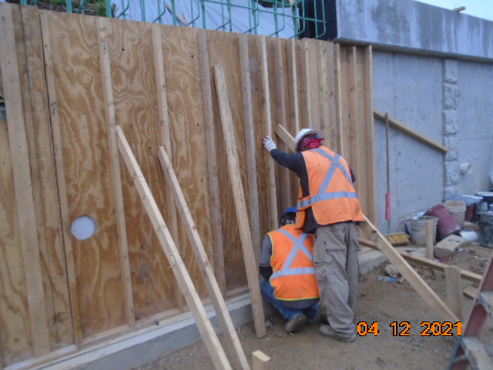

Phase D – Crew setting retaining wall S2 forms

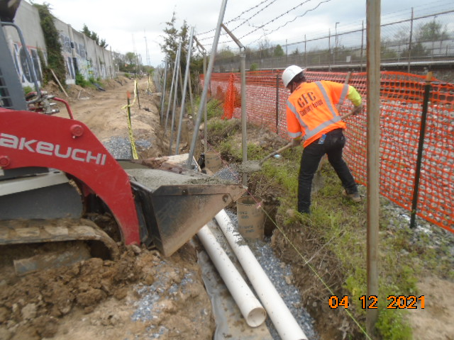

Phase D – Crew placing concrete for retaining wall S2 fence post footing

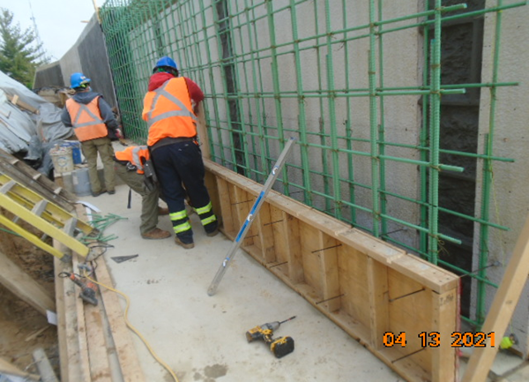

Phase D – Crew tying retaining wall S2 rebars

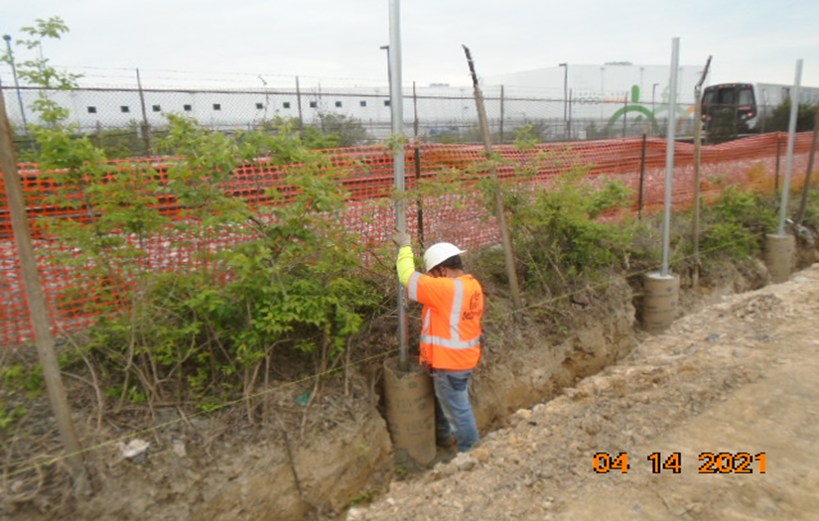

Phase D – Crew setting fence post

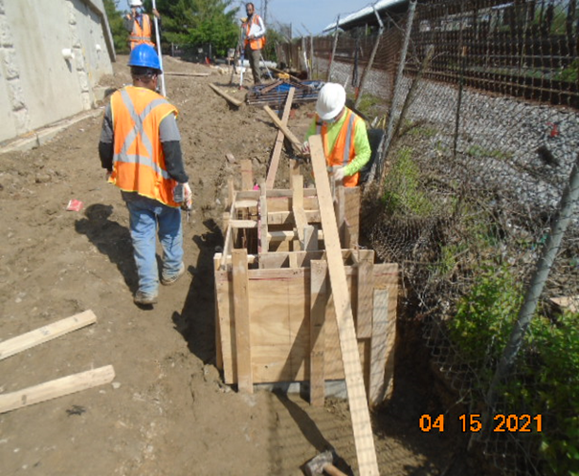

Phase D – Crew constructing inlet formwork

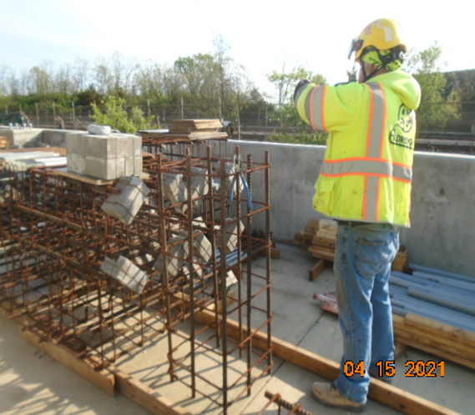

Phase D – Crew assembling streetlight pole rebars

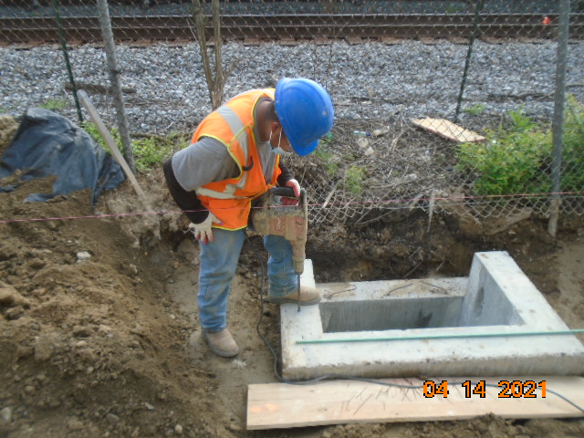

Phase D – Crew drilling inlet for rebar installation

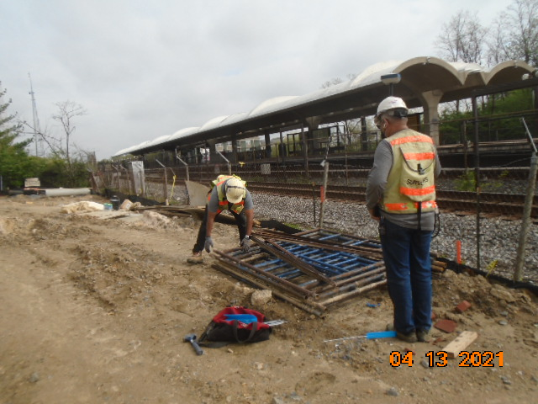

Phase D – Crew staking out streetlight pole foundation