Metropolitan Branch Trail Design Build, South Segment
DC CONTRACT NO. DCKA-2016-C-0044
FAP No.: STP-2016 (060)

CONSTRUCTION MANAGER’S
WEEKLY PROGRESS REPORT

04/04/2021 – 04/10/2021

Project Website: www.metbranchtrail-forttotten.com
For Additional Trail Information Please see www.metbranchtrail.com
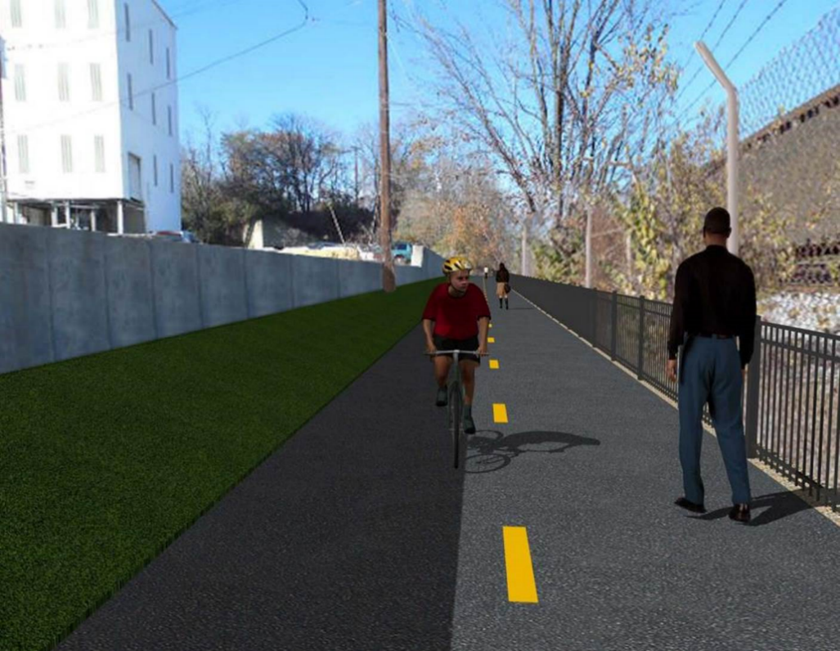

Proposed Metropolitan Branch Trail

1. PROJECT DESCRIPTION

The planned Metropolitan Branch Trail Project (“the Project”) consists of the design and construction of a new trail adjacent to CSX tracks and WMATA Red Line tracks along John McCormack Drive, adjacent to Fort Totten Metro Station, and on NPS property in NE, Washington D.C. The trail begins approximately 1500 feet south of Bates Road NE on the east side of John McCormack Drive NE, extending north along the WMATA and CSX tracks to the Fort Totten Metro Station tie in with First Place NE. An existing trail connection from Gallatin Road NE to the Fort Totten Metro Station will be reconstructed as a part of the Project.

The Project is 83.15% Federally-Funded and 16.85% District-Funded. Potomac Construction is the Design Build contractor.

Delon Hampton and Associates Chartered is providing Construction Management and Inspection services. Specific Construction Scope of Work includes:

- Provide mobilization and demobilization, provision and maintenance of Engineer’s field facilities, field layout, employee training, and other incidental work required for a quality, complete and finished product;
- Establishment and maintenance of vehicular and pedestrian traffic including signs, barricades and other transition devices; reconfiguring the devices in conjunction with changes in work areas; and their removal and disposal upon project completion, including restoration of disturbed areas;
- Clearing and grubbing, as required within the LOD;
- Removal of unsuitable material, excavation, and backfilling and pervious paving to construct a new trail;
- Protection of trees during construction;
- Provide ADA compliant trail connections and pedestrian ramps;
- Provide retaining walls as necessary to stay within the LOD and minimize property impacts following visual requirements specified for retaining walls on NPS property;
- Provide new permanent regulatory and wayfinding signs for the trail and all trail connection intersections;
- Provide road and trail pavement markings;
- Provide landscaping within the LOD for the Project including special requirements for landscaping on NPS property;
- Provide erosion and sediment control measures, storm water management facilities, including pervious asphalt pavement and bioretention facilities;
- Provide utility coordination, identification, locating, and protection of all utilities encountered during design and construction including relocation of Pepco poles along Aggregate Industries property; and
- Provide new WMATA security fencing between the trail and CSXT tracks.
- Remove existing sidewalk and widen sidewalk to 10’ along the west side of 1st place NE from Metropolitan Branch Trail to entrance to WMATA bus loop, on the west side.

2. STATUS OF CONSTRUCTION / PROGRESS SUMMARY

Work performed this week:

Design

- 100 % Complete

Construction:

Phase B

- Glare Shields for Phase B at streetlight poles to be installed
- Security Cameras to be installed
- Punch List items to be addressed

Phase D

- Installed retaining wall rebars
- Constructed retaining wall formwork
- Excavated drainage trench.
- Placed bedding stone and installed drainage pipe
- Excavated drainage trench for 6” perforated underdrain pipe
- Installed ground rods at electrical streetlight poles foundation
- Excavated trench for electrical manhole
- Installed, backfilled and compacted electrical manhole
- CSX flagger’s operation and safety tool box talk

CM Consultant:

- Monitored construction progress, make sure all applicable inspections and testing were
performed
- Reviewed change order
- Reviewed contractor monthly payment estimate
- Prepared CM Weekly Report to post
- Prepared CM weekly report to DDOT
- Attended DDOT DHA PCCI and AI field meeting
- Updated Project Files
- Updated project logs
- Updated Project Webpage
- Updated documents in DHA SharePoint sites
- Updated DDOT Sharepoint site
- Communication with the stakeholder in terms of submittals

3. MEETINGS / PROJECT COORDINATION

Thur 04/08/21 DDOT DHA PCCI and Aggregate Industries Field Meeting was held at 1:00 P.M.

4. DAILY WORK PERFORMED

Sun 04/04/21 No work performed.
Mon 04/05/21 Phase B – Removed silt fence and orange safety fence along the trail.
Phase D – Excavated drainage trench, placed bedding stone and installed
drainage pipe. Excavated chain link fence post footing.
Phase D – Electrical Work – Drove ground rod at the streetlight poles foundation. Megger tested ground rod.
Tue 04/06/21 Phase D – Stripped retaining wall S2 footing formwork. Installed retaining wall
S2 footing rebars. Excavated drainage trench for 6” underdrain pipe. Installed 6” perforated underdrain pipe. Excavated chain link fence post footings.
Phase D – Electrical Work – Excavated manhole trench. Installed electrical manhole. Drove ground rod at the streetlight poles foundation.
Wed 04/07/21 Phase D – Installed retaining wall S2 rebars. Placed concrete cradle for
drainage pipe. Excavated trench for 6” underdrain pipe. Installed Sonotube at chain link footings.
Phase D – Electrical Work – Backfilled and compacted electrical manhole
Thurs 04/08/21 Phase B – Removed silt fence. Installed safety fence.
Phase D – Installed retaining wall rebars. Constructed retaining wall formwork. Excavated drainage trench for 6” underdrain pipe. Excavated chain link fence post footing. Installed Sonotube at chain link fence post footings.
Phase D – Electrical Work – Excavated electrical manhole trench. Installed electrical manhole. Backfilled and compacted electrical manhole.
Fri 04/09/21 Phase D – Constructed retaining wall formwork. Removed tree stumps.
Excavated chain link fence post footings.
Phase D – Electrical Work – Work canceled due to rain
Sat 04/10/21 No work scheduled

5. INSPECTION & MATERIAL TESTS PERFORMED

Jobsite Safety Inspection  Erosion and Sediment Control inspection  MOT Inspection  Compaction Test - Passed  Asphalt Material Testing  Concrete Material Testing – Pending results  ** Note - Additional Material Test Results can be found on DDOT QA QC Material Division Tracking SharePoint website. | Infiltration Tests  Dynamic Cone Penetration (DCP) Tests - Passed  Rebars Inspection - Ongoing
6. DBE PARTICIPATION SUMMARIES

Potomac Construction (Contractor)
- DBE Goal for Contractor is 15%. To-date the Contractor has achieved 49.4% of their goal.

Delon Hampton & Associates (CM)
- DBE Goal for the CM is 10%. To-date the CM has achieved 82.7% of their Goal.

7. ACCIDENTS / INCIDENTS

None occurred on-site during this week.

8. PHOTOS OF THE WORK PERFORMED

12. PHOTOS OF WORK PERFORMED THIS PERIOD

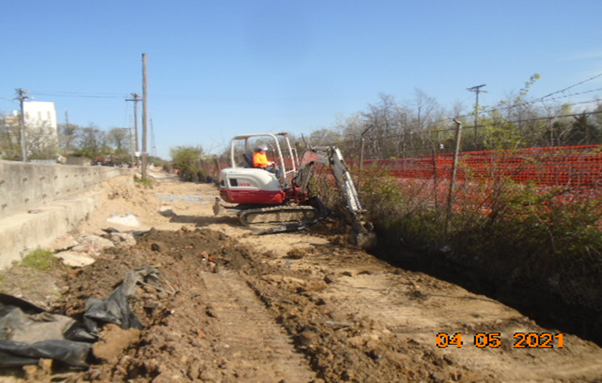
Phase D – Crew excavating trench for 6” underdrain pipe

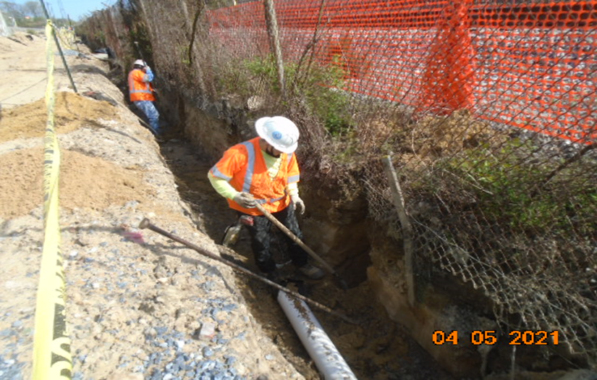
Phase D – Crew excavating chain link fence post footing

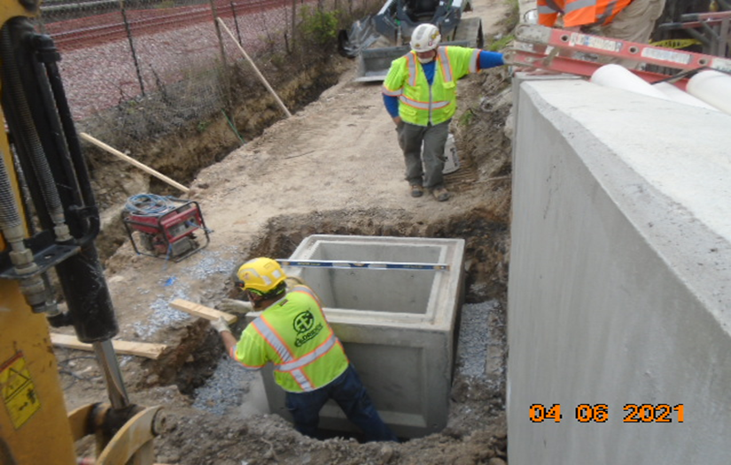
Phase D – Crew installing electrical manhole

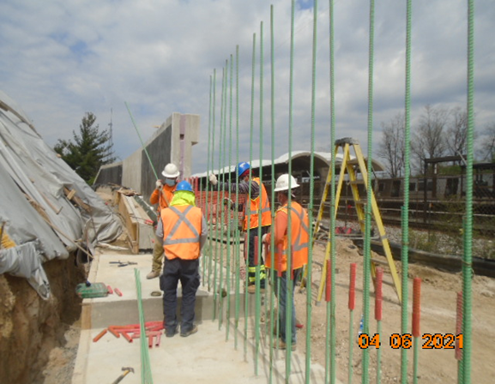
Phase D – Crew installing retaining wall rebars

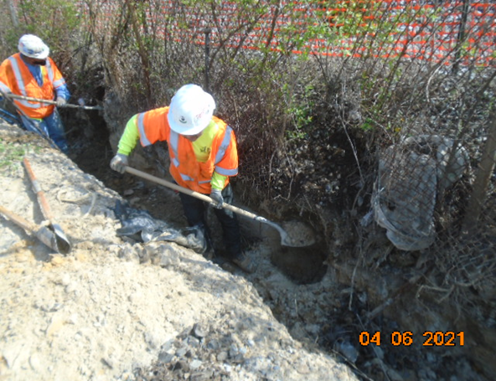
Phase D – Crew excavating chain link fence footing

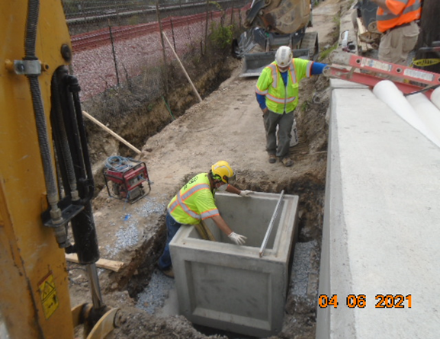
Phase D – Crew installing electrical manhole

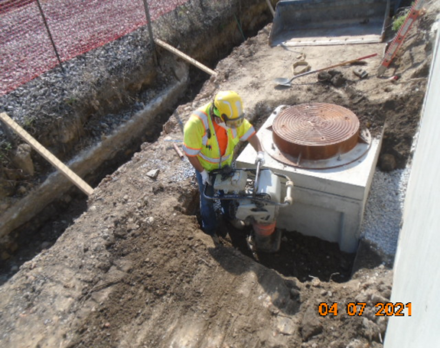
Phase D – Crew compacting electrical manhole

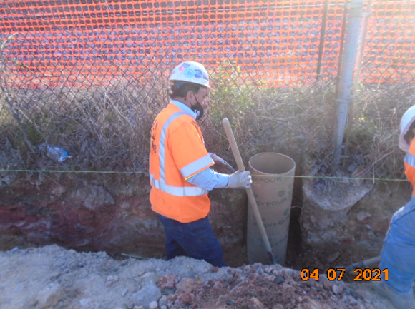
Phase D – Crew installing sonotube at chain link fence footing

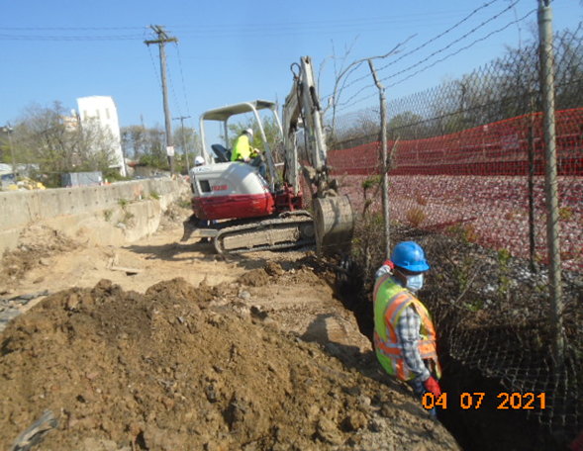
Phase D – Crew excavating 6” underdrain trench

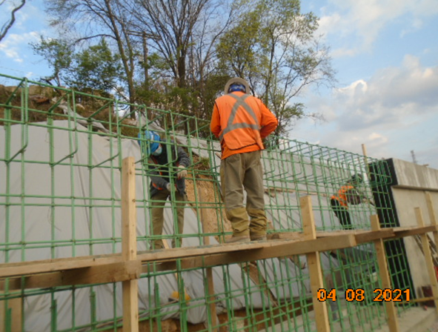
Phase D – Crew installing retaining wall S2 rebars

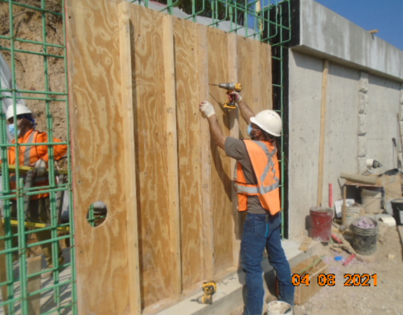
Phase D – Crew constructing retaining wall formwork

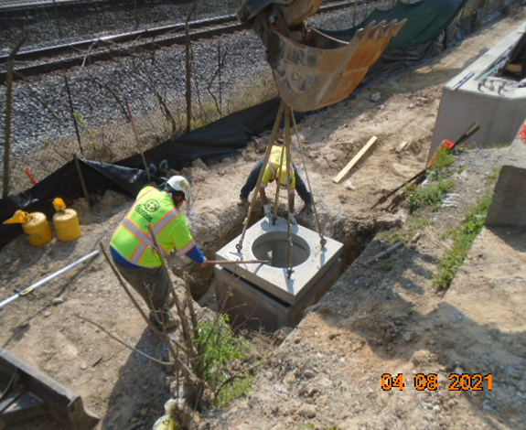
Phase D – Crew installing electrical manhole

