**Metropolitan Branch Trail Design Build, South Segment**

**DC CONTRACT NO. DCKA-2016-C-0044**

**FAP No.: STP-2016 (060)**

CONSTRUCTION MANAGER’S

WEEKLY PROGRESS REPORT

03/29/2020 – 04/04/2020

Project Website: [www.metbranchtrail-forttotten.com](http://www.metbranchtrail-forttotten.com)

For Additional Trail Information Please see [www.metbranchtrail.com](http://www.metbranchtrail.com)

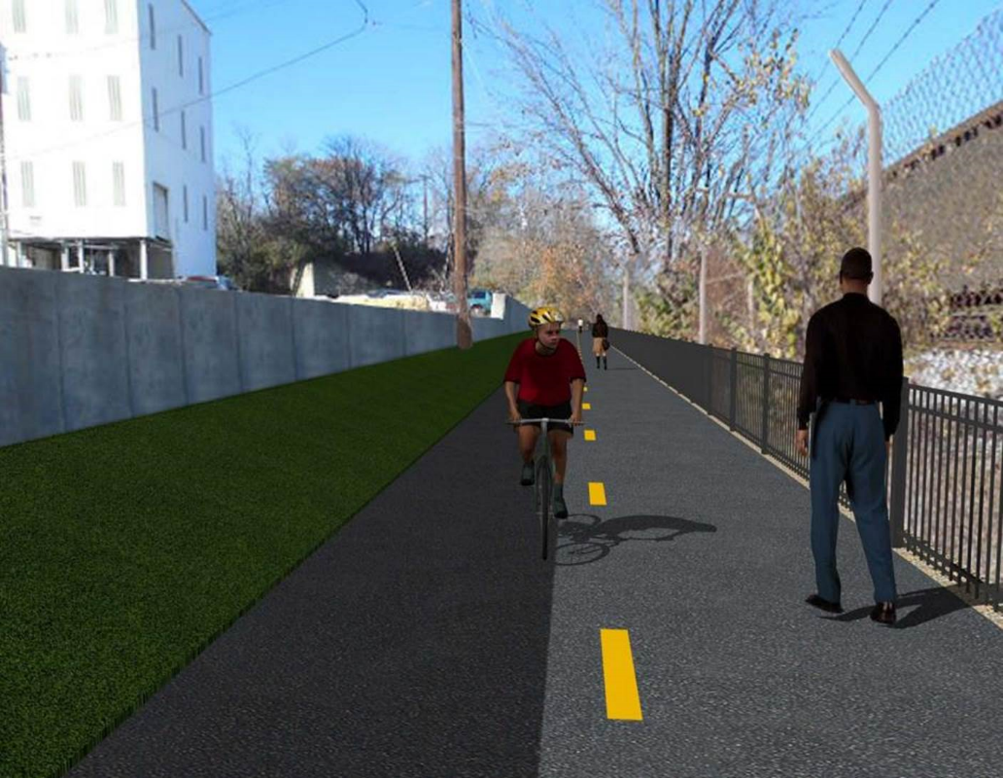

**Proposed Metropolitan Branch Trail**

**1. PROJECT DESCRIPTION**

The planned Metropolitan Branch Trail Project (“the Project”) consists of the design and construction of a new trail adjacent to CSX tracks and WMATA Red Line tracks along John McCormack Drive, adjacent to Fort Totten Metro Station, and on NPS property in NE, Washington D.C. The trail begins approximately 1500 feet south of Bates Road NE on the east side of John McCormack Drive NE, extending north along the WMATA and CSX tracks to the Fort Totten Metro Station tie in with First Place NE. An existing trail connection from Gallatin Road NE to the Fort Totten Metro Station will be reconstructed as a part of the Project.

The Project is 83.15% Federally-Funded and 16.85% District-Funded. Potomac Construction is the Design Build contractor.

Delon Hampton and Associates Chartered is providing Construction Management and Inspection services. Specific Construction Scope of Work includes:

Existing street light poles from the beginning point of the project south to Michigan Avenue shall have the existing luminaires replaced with new LED cobra head luminaires, see Section 16 of the Project Technical Provisions for details;

* Provide mobilization and demobilization, provision and maintenance of Engineer’s field facilities, field layout, employee training, and other incidental work required for a quality, complete and finished product;
* Establishment and maintenance of vehicular and pedestrian traffic including signs, barricades and other transition devices; reconfiguring the devices in conjunction with changes in work areas; and their removal and disposal upon project completion, including restoration of disturbed areas;
* Clearing and grubbing, as required within the LOD;
* Removal of unsuitable material, excavation, and backfilling and pervious paving to construct a new trail;
* Protection of trees during construction;
* Provide ADA compliant trail connections and pedestrian ramps;
* Provide retaining walls as necessary to stay within the LOD and minimize property impacts following visual requirements specified for retaining walls on NPS property;
* Provide new permanent regulatory and wayfinding signs for the trail and all trail connection intersections;
* Provide road and trail pavement markings;
* Provide landscaping within the LOD for the Project including special requirements for landscaping on NPS property;
* Provide erosion and sediment control measures, storm water management facilities, including pervious asphalt pavement and bioretention facilities;
* Provide utility coordination, identification, locating, and protection of all utilities encountered during design and construction including relocation of Pepco poles along Aggregate Industries property; and
* Provide new WMATA security fencing between the trail and CSXT tracks. Remove existing sidewalk and widen sidewalk to 10’ along the west side of 1st place NE from Metropolitan Branch Trail to entrance to WMATA bus loop on the west side.

**2. STATUS OF CONSTRUCTION / PROGRESS SUMMARY**

**Work performed this week:**

**Design**

* Address comments on permit application from DCRA
* Resubmittal of Comment Matrix for Submittal D
* Resubmittal of Plans for Submittal D to DDOT and DC Water
* Obtain DC Water utility release letter
* Work on Permit applications for WMATA for Phase D

**Construction:**

Phase B

* Excavated, graded and placed stone at the proposed trail
* Constructed temporary access ramp to the existing trail
* Excavated and backfilled electrical trench
* Installed light poles

Phase D

* Cut and removed trees within the limit of disturbance. Performed clearing and grubbing
* Installed silt fence
* CSX construction field inspector performed safety briefings
* Monitoring of Aggregate Industries water discharge

**CM Consultant:**

* Monitored construction progress, make sure all applicable inspection and testing were performed.
* Attended Progress Meeting conference call.
* Attended DDOT and QA coordination conference call.
* Attended QA/QC meeting conference call.
* Reviewed Inspection Daily Reports.
* Reviewing pencil copy of Invoice No. 15

**3. MEETINGS / PROJECT COORDINATION**

Tues. 03/31/20 Progress Meeting conference call was held at 10:00 A.M.

Wed 04/01/20 DDOT, DHA QA conference call was held at 1:00 P.M.

Fri. 04/03/20 QA/QC Meeting conference call was held at 10:00 A.M.

**4. DAILY WORK PERFORMED**

Sun 03/29/20 No work performed

Mon 03/30/20 Phase B - Placed and graded stone at the proposed trail. Repaired silt

fence.

Phase B – Electrical Work - Demolished light pole foundation.

Compacted backfill around electrical manhole MH1.

Phase D - Installed silt fence.

Tue 03/31/20 Phase B - Constructed temporary access ramp to the proposed trail.

Phase B - Electrical Work – Backfilled electrical trench.

Phase D - Removed cut trees from the site.

Wed 04/01/20 Phase B - Excavation, stone placing and grading for the proposed trail.

Phase B - Electrical Work – Installed light pole.

Thurs 04/02/20 Phase B - Excavated and removed unsuitable materials from the site.

Phase B - Electrical Work – Backfilled and compacted electrical trench.

Phase D - Removed cut trees from the site.

Fri 04/03/20 Phase B - Excavate, place stone, and tie-in the temporary trail to the

existing trail. Removed unsuitable material from the site.

Phase B - Electrical Work – Backfilled and compacted electrical trench.

04/03/20 Phase D - Removed cut trees from the site.

Sat 04/04/20 No work scheduled

**7. INSPECTION & MATERIAL TESTS PERFORMED**

|  |  |
| --- | --- |
| Jobsite Safety Inspection  Erosion and Sediment Control inspection  MOT Inspection  Compaction Test  Asphalt Material Testing  Concrete Material Testing | Infiltration facility Material Testing |

**10. DBE PARTICIPATION SUMMARIES**

Potomac Construction (Contractor)

* DBE Goal for Contractor is 15%. To-date the Contractor has achieved 36% of their goal.

Delon Hampton & Associates (CM)

* DBE Goal for the CM is 10%. To-date the CM has achieved 0% of their Goal.

**11. ACCIDENTS / INCIDENTS**

None occurred on-site.

**12. PHOTOS OF THE WORK PERFORMED**

**12. PHOTOS OF WORK PERFORMED THIS PERIOD**

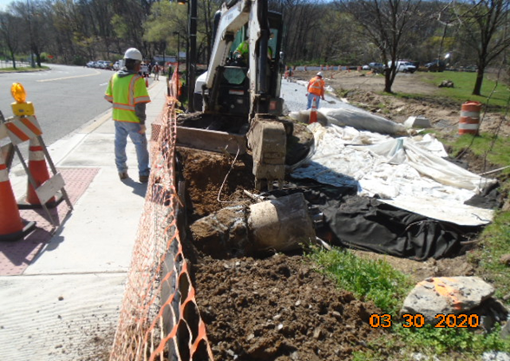

**Phase B – Crew removing existing light pole foundation**

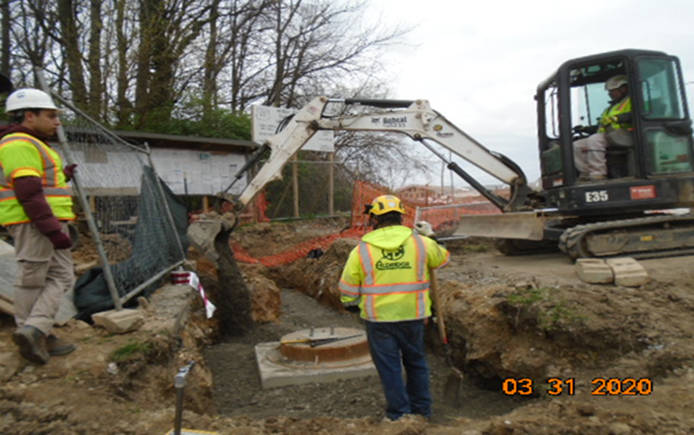

**Phase B – Crew backfilling around Manhole 1**

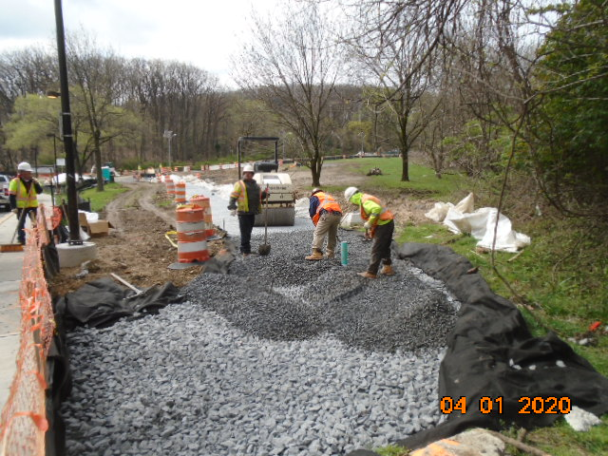

**Phase B – Crew placing stone at the proposed trail**

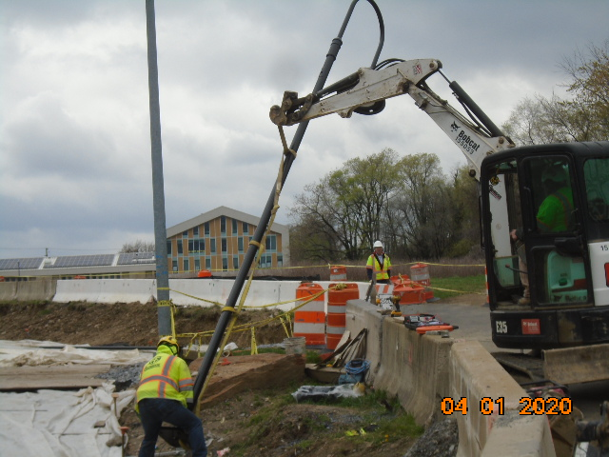

**Phase B – Crew installing light pole**

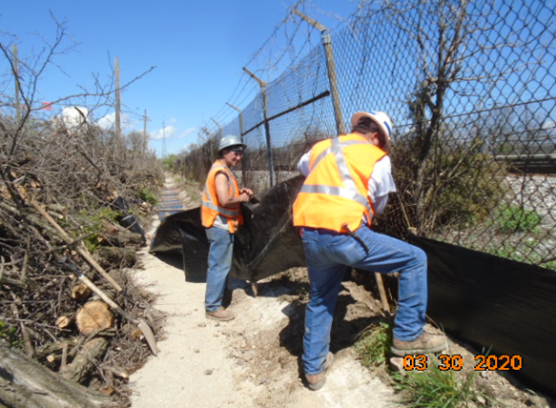

**Phase D – Crew installing silt fence**

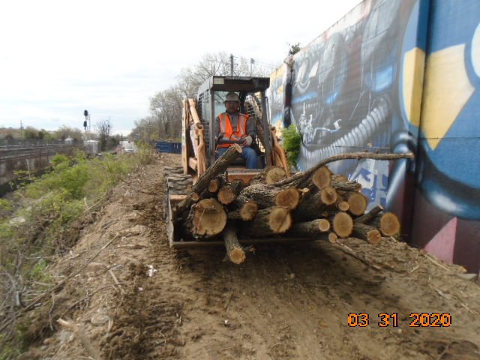

**Phase D – Crew clearing the cut trees**

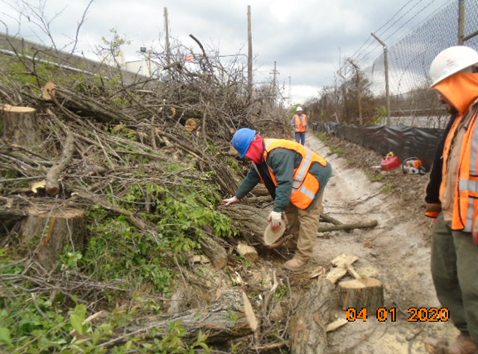

**Phase D – Crew clearing the cut trees**

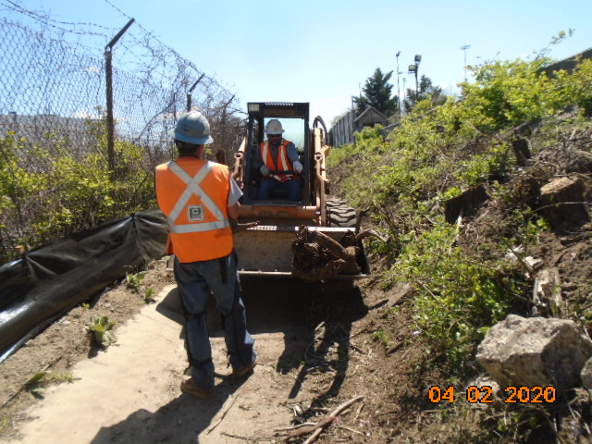**Phase D – Crew clearing the cut trees**