**Metropolitan Branch Trail Design Build, South Segment**

**DC CONTRACT NO. DCKA-2016-C-0044**

**FAP No.: STP-2016 (060)**

CONSTRUCTION MANAGER’S

WEEKLY PROGRESS REPORT

03/28/2021 – 04/03/2021

Project Website: [www.metbranchtrail-forttotten.com](http://www.metbranchtrail-forttotten.com)

For Additional Trail Information Please see [www.metbranchtrail.com](http://www.metbranchtrail.com)

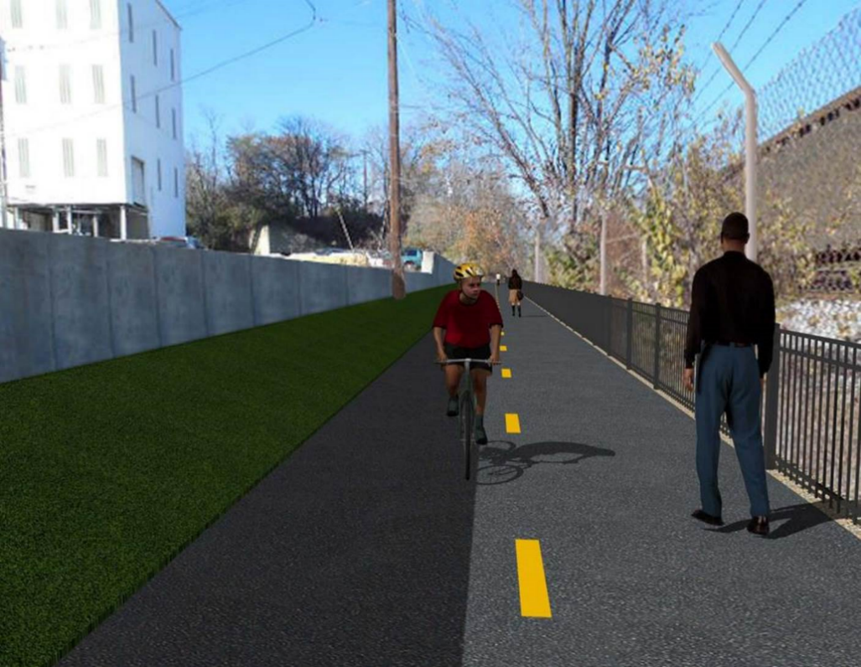

**Proposed Metropolitan Branch Trail**

**1. PROJECT DESCRIPTION**

The planned Metropolitan Branch Trail Project (“the Project”) consists of the design and construction of a new trail adjacent to CSX tracks and WMATA Red Line tracks along John McCormack Drive, adjacent to Fort Totten Metro Station, and on NPS property in NE, Washington D.C. The trail begins approximately 1500 feet south of Bates Road NE on the east side of John McCormack Drive NE, extending north along the WMATA and CSX tracks to the Fort Totten Metro Station tie in with First Place NE. An existing trail connection from Gallatin Road NE to the Fort Totten Metro Station will be reconstructed as a part of the Project.

The Project is 83.15% Federally-Funded and 16.85% District-Funded. Potomac Construction is the Design Build contractor.

Delon Hampton and Associates Chartered is providing Construction Management and Inspection services. Specific Construction Scope of Work includes:

* Provide mobilization and demobilization, provision and maintenance of Engineer’s field facilities, field layout, employee training, and other incidental work required for a quality, complete and finished product;
* Establishment and maintenance of vehicular and pedestrian traffic including signs, barricades and other transition devices; reconfiguring the devices in conjunction with changes in work areas; and their removal and disposal upon project completion, including restoration of disturbed areas;
* Clearing and grubbing, as required within the LOD;
* Removal of unsuitable material, excavation, and backfilling and pervious paving to construct a new trail;
* Protection of trees during construction;
* Provide ADA compliant trail connections and pedestrian ramps;
* Provide retaining walls as necessary to stay within the LOD and minimize property impacts following visual requirements specified for retaining walls on NPS property;
* Provide new permanent regulatory and wayfinding signs for the trail and all trail connection intersections;
* Provide road and trail pavement markings;
* Provide landscaping within the LOD for the Project including special requirements for landscaping on NPS property;
* Provide erosion and sediment control measures, storm water management facilities, including pervious asphalt pavement and bioretention facilities;
* Provide utility coordination, identification, locating, and protection of all utilities encountered during design and construction including relocation of Pepco poles along Aggregate Industries property; and
* Provide new WMATA security fencing between the trail and CSXT tracks.
* Remove existing sidewalk and widen sidewalk to 10’ along the west side of 1st place NE from Metropolitan Branch Trail to entrance to WMATA bus loop, on the west side.

**2. STATUS OF CONSTRUCTION / PROGRESS SUMMARY**

**Work performed this week:**

**Design**

* Revised PEPCO power feed plans for Phase D street lights under review with PEPCO and DDOT Electrical Division
* RFI No. 17 - Abandoned drainage pipe shown on Phase D Plans at Sta. 110+20 under review with Designer

**Construction:**

**Phase B**

* Glare Shields for Phase B at streetlight poles to be installed
* Security Cameras to be installed
* Punch List items to be addressed

**Phase D**

* Constructed retaining wall S2 footing formwork
* Installed retaining wall footing rebars
* Excavated 6” underdrain trench
* Installed 6” perforated underdrain pipe
* Placed concrete for retaining wall S2 footing
* Excavated electrical manhole trench
* Installed electrical manhole
* Backfilled and compacted electrical trench
* CSX flagger’s operation and safety tool box talk

**CM Consultant:**

* Monitored construction progress, make sure all applicable inspections and testing were

Performed

* Reviewed change order
* Reviewed contractor monthly payment estimate
* Prepared CM Weekly Report to post
* Prepared CM weekly report
* Attend MBT Project Progress Meeting
* Updated Project Files
* Updated Project Webpage
* Updated documents in DHA SharePoint sites
* Updated DDOT Sharepoint site
* Communication with the stakeholder in terms of submittals

**3. MEETINGS / PROJECT COORDINATION**

Tue 03/30/2021 MBT Progress Meeting Microsoft Teams meeting was held at 10:00 A.M.

**4. DAILY WORK PERFORMED**

Sun 03/28/21 No work performed.

Mon 03/29/21 Phase D – Constructed retaining wall S2 footing formwork. Installed retaining

wall footing rebars. Excavated 6” underdrain pipe trench.

Phase D – Electrical Work – Excavated electrical manhole trench

Tue 03/30/21 Phase D – Installed retaining wall S2 footing rebars. Performed backfilling

behind retaining wall S2. Excavated drainage trench for 6” underdrain pipe. Installed 6” perforated underdrain pipe.

Phase D – Electrical Work – Installed electrical manhole. Backfilled and compacted electrical trench.

Wed 03/31/21 Phase D – Work cancelled due to rain

Phase D – Electrical Work – Work cancelled due to rain.

Thurs 04/01/21 Phase D – Work cancelled due to rain.

Phase D – Electrical Work – No work performed

Fri 04/02/21 Phase D – PCCI cancelled work due to mandatory safety and COVID-19

refresher training.

Phase D – Electrical Work – No work performed

Sat 04/03/21 No work scheduled

**5. INSPECTION & MATERIAL TESTS PERFORMED**

|  |  |
| --- | --- |
| Jobsite Safety Inspection  Erosion and Sediment Control inspection  MOT Inspection  Compaction Test - Passed  Asphalt Material Testing  Concrete Material Testing – Pending results  **\*\* Note - Additional Material Test Results can be found on DDOT QA QC Material Division Tracking SharePoint website**. | Infiltration Tests  Dynamic Cone Penetration (DCP) Tests - Passed  Rebars Inspection - Passed |

**6. DBE PARTICIPATION SUMMARIES**

Potomac Construction (Contractor)

* DBE Goal for Contractor is 15%. To-date the Contractor has achieved 48.6% of their goal.

Delon Hampton & Associates (CM)

* DBE Goal for the CM is 10%. To-date the CM has achieved 82.7% of their Goal.

**7. ACCIDENTS / INCIDENTS**

None occurred on-site during this week.

**8. PHOTOS OF THE WORK PERFORMED**

**12. PHOTOS OF WORK PERFORMED THIS PERIOD**

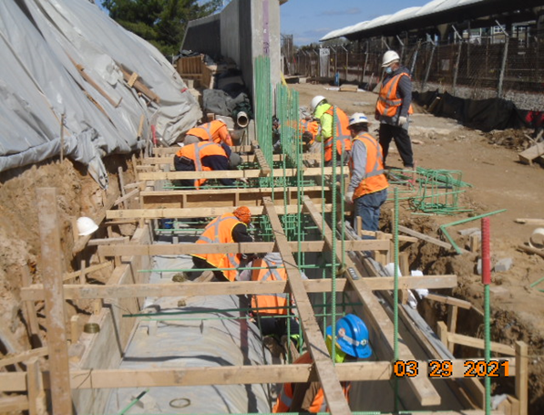

Phase D – Crew installing rebars retaining wall S2 footing

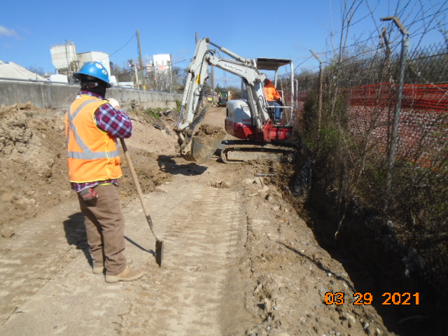

Phase D – Crew excavating for 6” underdrain

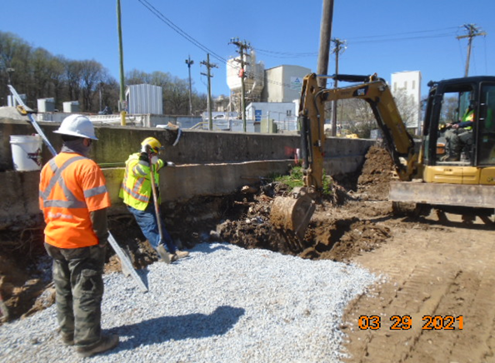

Phase D – Crew excavating electrical trench manhole

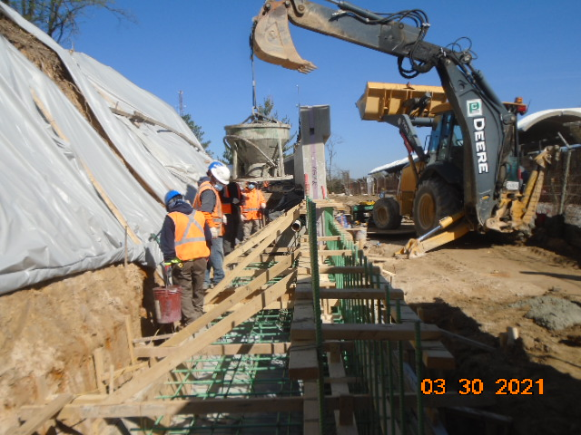

Phase D – Crew placing retaining wall footing concrete

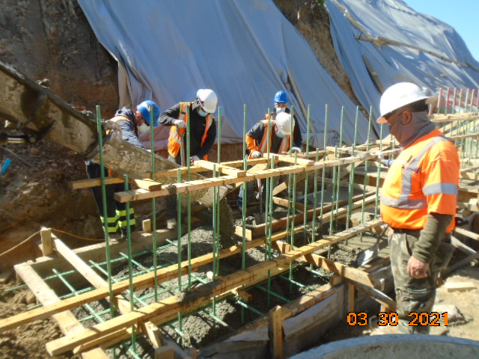

Phase D – Crew placing retaining wall S2 footing concrete

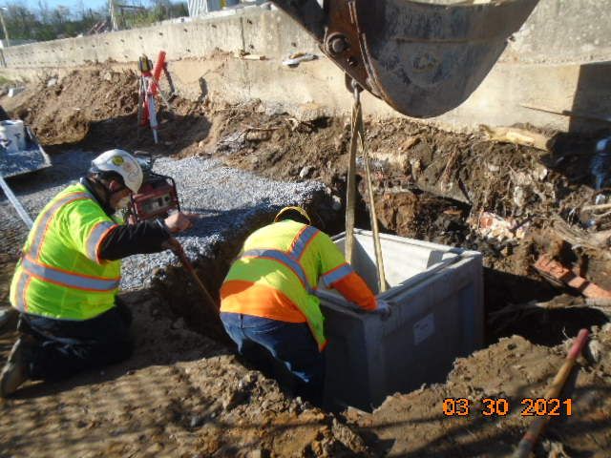

Phase D – Crew installing electrical manhole

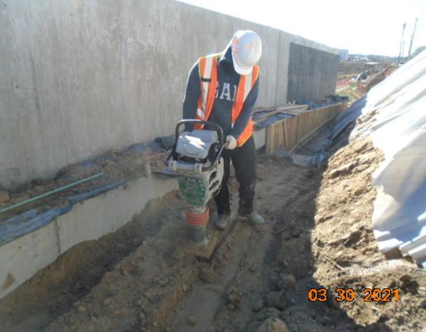

Phase D – Crew compacting backfill behind retaining wall S2

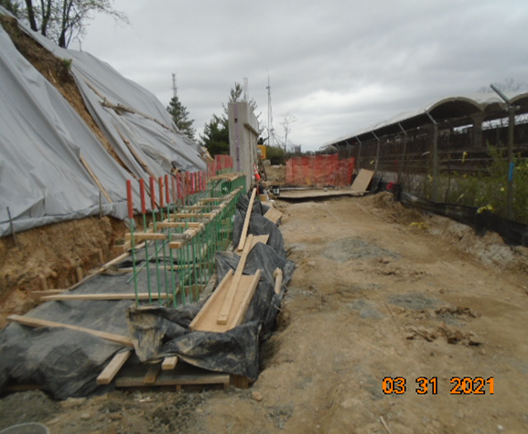

Phase D – Rain day. No work performed