**Metropolitan Branch Trail Design Build, South Segment**

**DC CONTRACT NO. DCKA-2016-C-0044**

**FAP No.: STP-2016 (060)**

CONSTRUCTION MANAGER’S

WEEKLY PROGRESS REPORT

03/21/2021 – 03/27/2021

Project Website: [www.metbranchtrail-forttotten.com](http://www.metbranchtrail-forttotten.com)

For Additional Trail Information Please see [www.metbranchtrail.com](http://www.metbranchtrail.com)

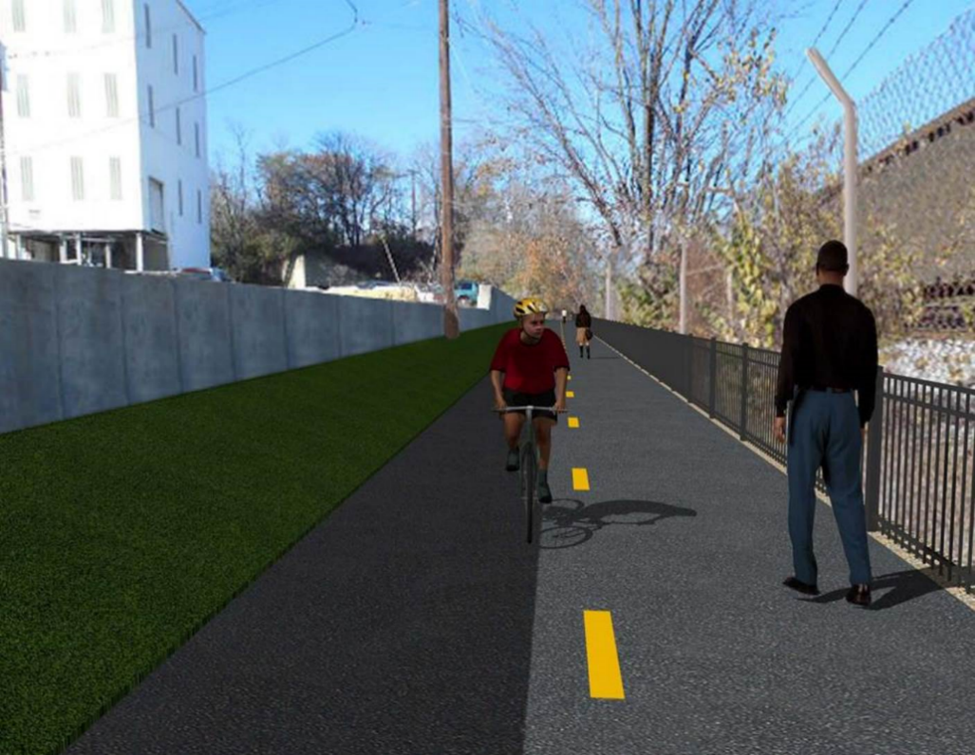

**Proposed Metropolitan Branch Trail**

**1. PROJECT DESCRIPTION**

The planned Metropolitan Branch Trail Project (“the Project”) consists of the design and construction of a new trail adjacent to CSX tracks and WMATA Red Line tracks along John McCormack Drive, adjacent to Fort Totten Metro Station, and on NPS property in NE, Washington D.C. The trail begins approximately 1500 feet south of Bates Road NE on the east side of John McCormack Drive NE, extending north along the WMATA and CSX tracks to the Fort Totten Metro Station tie in with First Place NE. An existing trail connection from Gallatin Road NE to the Fort Totten Metro Station will be reconstructed as a part of the Project.

The Project is 83.15% Federally-Funded and 16.85% District-Funded. Potomac Construction is the Design Build contractor.

Delon Hampton and Associates Chartered is providing Construction Management and Inspection services. Specific Construction Scope of Work includes:

* Provide mobilization and demobilization, provision and maintenance of Engineer’s field facilities, field layout, employee training, and other incidental work required for a quality, complete and finished product;
* Establishment and maintenance of vehicular and pedestrian traffic including signs, barricades and other transition devices; reconfiguring the devices in conjunction with changes in work areas; and their removal and disposal upon project completion, including restoration of disturbed areas;
* Clearing and grubbing, as required within the LOD;
* Removal of unsuitable material, excavation, and backfilling and pervious paving to construct a new trail;
* Protection of trees during construction;
* Provide ADA compliant trail connections and pedestrian ramps;
* Provide retaining walls as necessary to stay within the LOD and minimize property impacts following visual requirements specified for retaining walls on NPS property;
* Provide new permanent regulatory and wayfinding signs for the trail and all trail connection intersections;
* Provide road and trail pavement markings;
* Provide landscaping within the LOD for the Project including special requirements for landscaping on NPS property;
* Provide erosion and sediment control measures, storm water management facilities, including pervious asphalt pavement and bioretention facilities;
* Provide utility coordination, identification, locating, and protection of all utilities encountered during design and construction including relocation of Pepco poles along Aggregate Industries property; and
* Provide new WMATA security fencing between the trail and CSXT tracks.
* Remove existing sidewalk and widen sidewalk to 10’ along the west side of 1st place NE from Metropolitan Branch Trail to entrance to WMATA bus loop, on the west side.

**2. STATUS OF CONSTRUCTION / PROGRESS SUMMARY**

**Work performed this week:**

**Design**

* MBT Designer submitted Phase D 3-ring binder and 100% Plans to DDOT
* Stakeholders acceptance for Phase D Final Design Plans

**Construction:**

**Phase B**

* Glare Shields for Phase B trail lights to be installed

**Phase D**

* Perform rough grading
* Graded slope line along the trail
* Stripped retaining wall formwork
* Constructed wedge wall formwork
* Assembled 6” perforated drainage pipe
* Constructed retaining wall S2 formwork
* Placed concrete for retaining wall S2 wall section
* Stripped light pole foundations
* Demolished existing concrete foundation
* CSX flagger’s operation and safety tool box talk

**CM Consultant:**

* Monitored construction progress, make sure all applicable inspections and testing were

Performed

* Prepared CM Weekly Report to post
* Prepared CM weekly report
* Attend MBT DDOT CM PCCI Designer and AI Project Meeting
* Attended MBT QAQC Meeting
* Updated Project Files
* Updated Project Webpage
* Updated documents in DHA SharePoint sites
* Updated DDOT Sharepoint site
* Communication with the stakeholder in terms of submittals

**3. MEETINGS / PROJECT COORDINATION**

Wed 03/24/21 MBT DDOT DHA PCCI Designer and conference call was held at 10:00 A.M.

Fri 03/26/21 MBT QAQC Meeting conference call was held at 10:00 A.M.

**4. DAILY WORK PERFORMED**

Sun 03/21/21 No work performed.

Mon 03/22/21 Phase D – Performed rough grading. Graded slope line along the trail.

Backfilled and compacted trail path. Stripped retaining wall formwork.

Constructed wedge wall formwork. Assembled 6” perforated underdrain pipe.

Phase D – Electrical Work – Stripped light poles foundation. Demolished existing concrete foundation.

Tue 03/23/21 Phase D – Rough graded trail path. Graded slope line along the trail path.

Placed bedding stone and installed drainage pipe at retaining wall S2

wedge wall. Placed wedge wall concrete.

Phase D – Electrical Work – Shaft drilled electrical foundations. Installed pre-assembled rebars for light pole foundation. Installed light pole conduits and anchor bolts. Installed light pole foundation formwork.

Wed 03/24/21 Phase D – Work cancelled due to rain

Phase D – Electrical Work – Work cancelled due to rain.

Thurs 03/25/21 Phase D – Excavated retaining wall S2 footing and hauled away

Excavated material..

Phase D – Electrical Work – No work performed

Fri 03/26/21 Phase D – Excavated retaining wall footing. Construct formwork for

retaining wall footing.

Phase D – Electrical Work – No work performed

Sat 03/27/21 No work scheduled

**5. INSPECTION & MATERIAL TESTS PERFORMED**

|  |  |
| --- | --- |
| Jobsite Safety Inspection  Erosion and Sediment Control inspection  MOT Inspection  Compaction Test - Passed  Asphalt Material Testing  Concrete Material Testing – Pending results  **\*\* Note - Additional Material Test Results can be found on DDOT QA QC Material Division Tracking SharePoint website**. | Infiltration Tests  Dynamic Cone Penetration (DCP) Tests - Passed  Rebars Inspection - Ongoing |

**6. DBE PARTICIPATION SUMMARIES**

Potomac Construction (Contractor)

* DBE Goal for Contractor is 15%. To-date the Contractor has achieved 48.6% of their goal.

Delon Hampton & Associates (CM)

* DBE Goal for the CM is 10%. To-date the CM has achieved 82.7% of their Goal.

**7. ACCIDENTS / INCIDENTS**

None occurred on-site during this week.

**8. PHOTOS OF THE WORK PERFORMED**

**12. PHOTOS OF WORK PERFORMED THIS PERIOD**

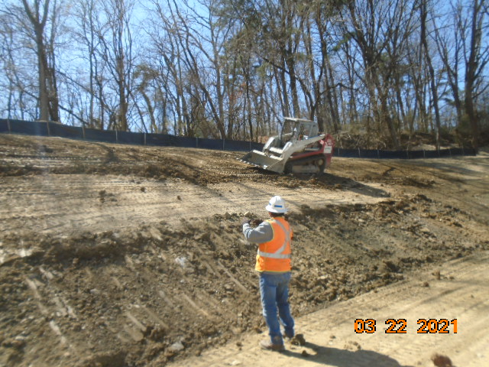

Phase D – Crew performing rough grading

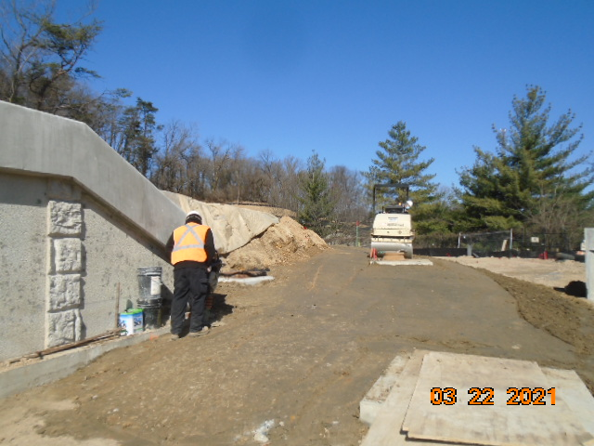

Phase D – Crew compacting the trail path

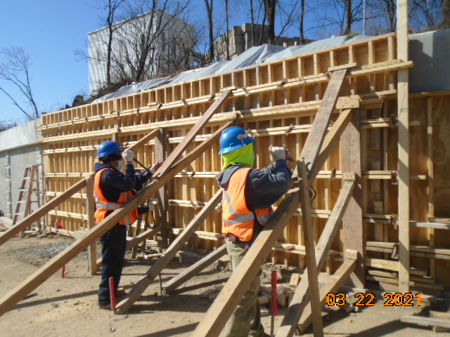

Phase D – Crew stripping retaining wall formwork

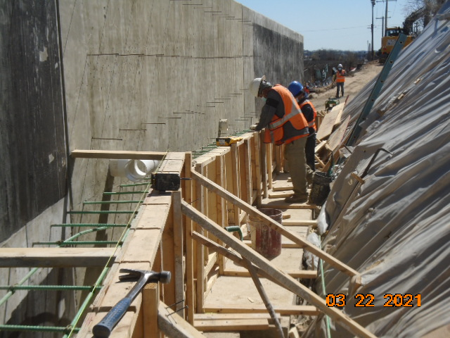

Phase D – Crew constructing wedge wall concrete

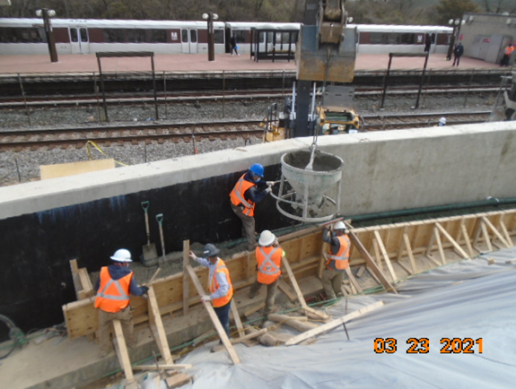

Phase D – Crew placing wedge wall concrete

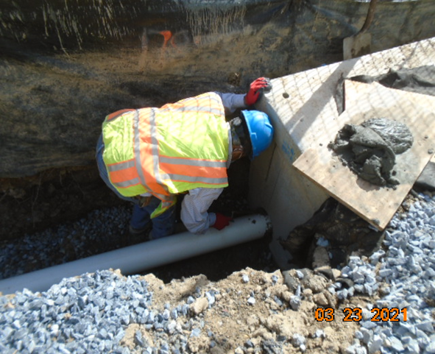

Phase D – Crew installing underdrain pipe

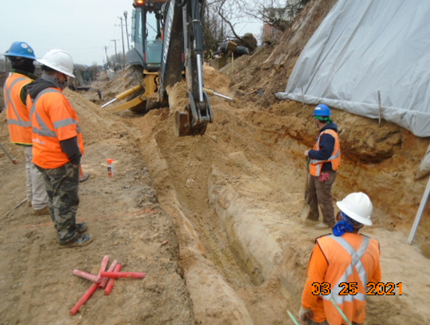

Phase D – Crew excavating retaining wall S2 footing

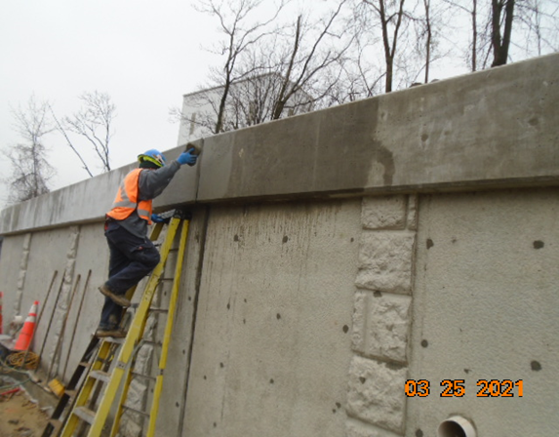

Phase D – Crew parging retaining wall S2 wall

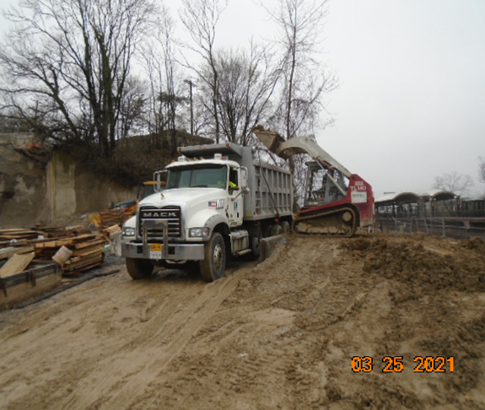

Phase D – Crew hauling away excavated material

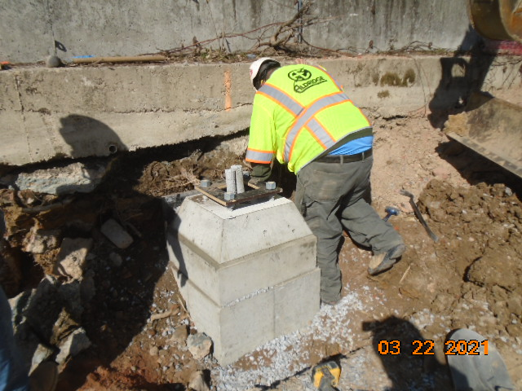

Phase D – Crew stripping light pole foundation formwork