Metropolitan Branch Trail Design Build, South Segment
DC CONTRACT NO. DCKA-2016-C-0044
FAP No.: STP-2016 (060)

CONSTRUCTION MANAGER’S
WEEKLY PROGRESS REPORT

03/14/2021 – 03/20/2021

Project Website: www.metbranchtrail-forttotten.com
For Additional Trail Information Please see www.metbranchtrail.com

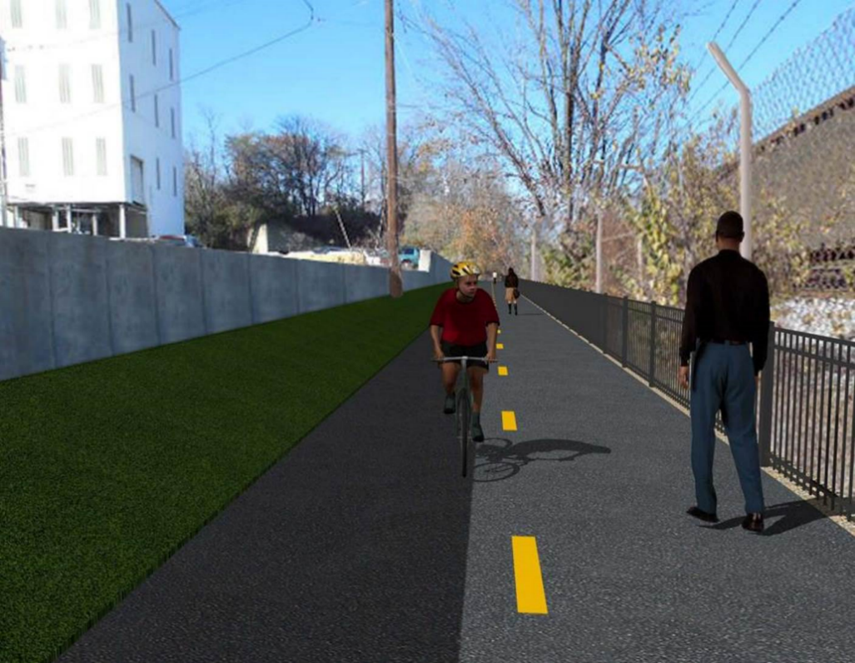

Proposed Metropolitan Branch Trail

1. PROJECT DESCRIPTION

The planned Metropolitan Branch Trail Project (“the Project”) consists of the design and construction of a new trail adjacent to CSX tracks and WMATA Red Line tracks along John McCormack Drive, adjacent to Fort Totten Metro Station, and on NPS property in NE, Washington D.C. The trail begins approximately 1500 feet south of Bates Road NE on the east side of John McCormack Drive NE, extending north along the WMATA and CSX tracks to the Fort Totten Metro Station tie in with First Place NE. An existing trail connection from Gallatin Road NE to the Fort Totten Metro Station will be reconstructed as a part of the Project.

The Project is 83.15% Federally-Funded and 16.85% District-Funded. Potomac Construction is the Design Build contractor.

Delon Hampton and Associates Chartered is providing Construction Management and Inspection services. Specific Construction Scope of Work includes:

- Provide mobilization and demobilization, provision and maintenance of Engineer’s field facilities, field layout, employee training, and other incidental work required for a quality, complete and finished product;
- Establishment and maintenance of vehicular and pedestrian traffic including signs, barricades and other transition devices; reconfiguring the devices in conjunction with changes in work areas; and their removal and disposal upon project completion, including restoration of disturbed areas;
- Clearing and grubbing, as required within the LOD;
- Removal of unsuitable material, excavation, and backfilling and pervious paving to construct a new trail;
- Protection of trees during construction;
- Provide ADA compliant trail connections and pedestrian ramps;
- Provide retaining walls as necessary to stay within the LOD and minimize property impacts following visual requirements specified for retaining walls on NPS property;
- Provide new permanent regulatory and wayfinding signs for the trail and all trail connection intersections;
- Provide road and trail pavement markings;
- Provide landscaping within the LOD for the Project including special requirements for landscaping on NPS property;
- Provide erosion and sediment control measures, storm water management facilities, including pervious asphalt pavement and bioretention facilities;
- Provide utility coordination, identification, locating, and protection of all utilities encountered during design and construction including relocation of Pepco poles along Aggregate Industries property; and
- Provide new WMATA security fencing between the trail and CSXT tracks.
- Remove existing sidewalk and widen sidewalk to 10’ along the west side of 1st place NE from Metropolitan Branch Trail to entrance to WMATA bus loop, on the west side.

2. STATUS OF CONSTRUCTION / PROGRESS SUMMARY

Work performed this week:

Design

- MBT Designer submitted Phase D 3-ring binder and 100% Plans to DDOT
- Stakeholders acceptance for Phase D Final Design Plans

Construction:

Phase B

- Installed MPD Security Cameras
- Glare Shields for Phase B trail lights to be installed

Phase D

- Perform rough grading
- Constructed retaining wall S2 formwork
- Placed concrete for retaining wall S2 wall section
- Excavated drainage trench
- Placed bedding material for inlet
- Installed precast drainage inlet
- Backfilled and compacted drainage trench
- Excavated 6” underdrain trench
- Shaft drilled light poles foundations
- Installed pre-assembled rebars in electrical manhole
- Installed electrical conduits light pole foundations
- Installed light pole foundations rebars
- Placed concrete for light pole foundations
- CSX flagger’s operation and safety tool box talk

CM Consultant:

- Monitored construction progress, make sure all applicable inspections and testing were
Performed
- Reviewed PCCI Monthly Payment Invoice
- Preparing Contract Modification package
- Reviewed Inspector Daily Reports
- Prepared CM Weekly Reports
- Attend MBT Progress Meeting
- Attended MBT QAQC Meeting
- Reviewed Project Schedule
- Prepared draft letter for S3 wall design change
- Prepare draft letter for Schedule concerns
- Updated Project Files
- Updated Project Webpage
- Updated documents in DHA SharePoint sites
- Updated DDOT Sharepoint site
- Communication with the stakeholder in terms of submittals

3. MEETINGS / PROJECT COORDINATION

Tue 03/16/21 MBT progress Meeting conference call was held at 10:00 A.M.
Fri 03/19/21 MBT QAQC Meeting conference call was held at 10:00 A.M.

4. DAILY WORK PERFORMED

Sun 03/14/21 No work performed.
Mon 03/15/21 Phase B – No work scheduled.
Phase B - Electrical Work – No work scheduled.
Phase D – Performed rough grading. Backfilled drainage trench. Backfilled trail path. Excavated drainage trench, placed bedding stone and install precast inlet. Made preparation for concrete stairs construction. Repaired silt fence.
Phase D – Electrical Work – Made preparation for light pole foundation excavation.
Tue 03/16/21 Phase B – No work scheduled.
Phase B – Electrical Work – No work scheduled.
Phase D – Rough graded trail path. Backfilled, compacted and proof rolled trail path. Excavated drainage trench, placed bedding stone and installed drainage pipe. Excavated drainage trench for 6” underdrain pipe
Phase D – Electrical Work – Shaft drilled electrical foundations. Installed pre-assembled rebars for light pole foundation. Installed light pole conduits and anchor bolts. Installed light pole foundation formwork.
Wed 03/17/21 Phase B – No work scheduled.
Phase B – Electrical Work – No work scheduled.
Phase D – Constructed retaining wall formwork including Ashlar pattern and green screen panel. Placed concrete for retaining wall S2 wall section. Backfilled and compacted drainage trench. Excavated trench for 6” under drain pipe.
Phase D – Electrical Work – Shaft drilled electrical foundations. Installed pre-assembled rebars for light pole foundation. Installed light pole conduits and anchor bolts. Installed light pole foundation formwork. Placed concrete for light pole foundations.
Thurs 03/18/21 Phase B – No work scheduled.
Phase B – Electrical Work – No work scheduled
Phase D – Electrical Work – Work cancelled due to rain
Fri 03/19/21 Phase B – No work scheduled.
Phase B – Electrical Work – No work scheduled.
Phase D – Work cancelled due to rain in weather forecast.
Phase D – Electrical Work – Work cancelled due to rain in weather forecast.
Sat 03/20/21 No work scheduled

5. INSPECTION & MATERIAL TESTS PERFORMED

Jobsite Safety Inspection  Erosion and Sediment Control inspection  MOT Inspection  Compaction Test - Passed  Asphalt Material Testing  Concrete Material Testing – Pending results  ** Note - Additional Material Test Results can be found on DDOT QA QC Material Division Tracking SharePoint website. | Infiltration Tests  Dynamic Cone Penetration (DCP) Tests - Passed  Rebars Inspection - Ongoing
6. DBE PARTICIPATION SUMMARIES

Potomac Construction (Contractor)
- DBE Goal for Contractor is 15%. To-date the Contractor has achieved 48.6% of their goal.

Delon Hampton & Associates (CM)
- DBE Goal for the CM is 10%. To-date the CM has achieved 82.7% of their Goal.

7. ACCIDENTS / INCIDENTS

None occurred on-site during this week.

8. PHOTOS OF THE WORK PERFORMED

12. PHOTOS OF WORK PERFORMED THIS PERIOD

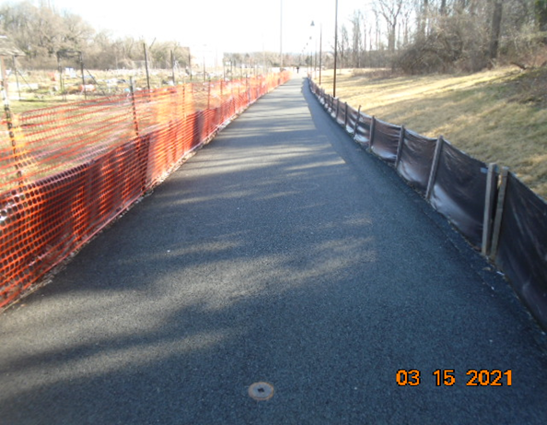
Phase B – No work performed

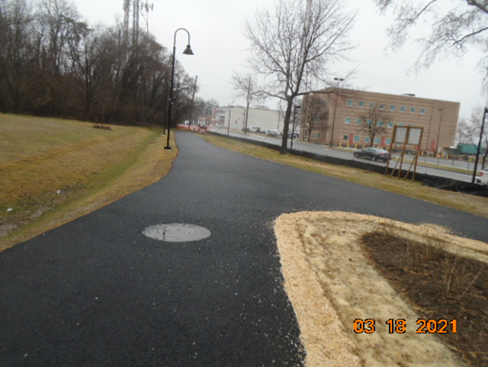
Phase B – No work performed
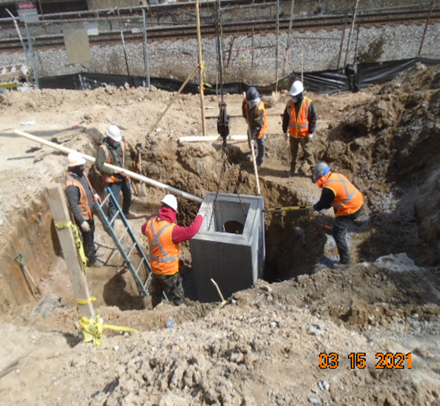
Phase D – Crew installing drainage inlet

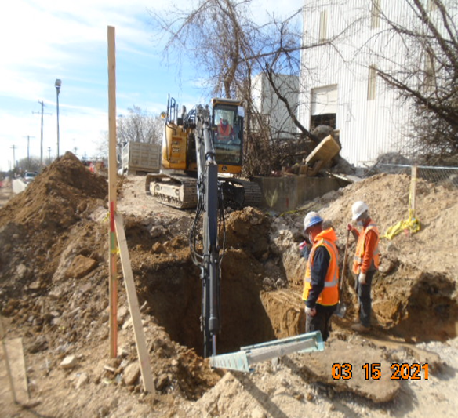
Phase D – Crew excavating drainage trench
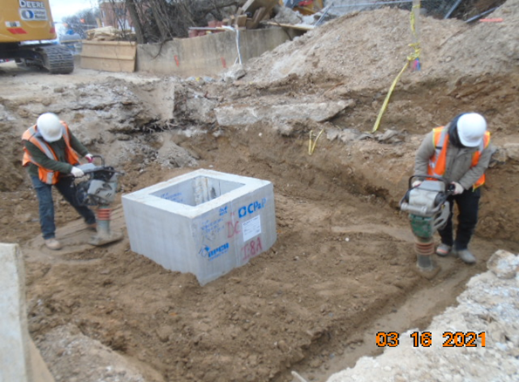
Phase D – Crew compacting drainage trench

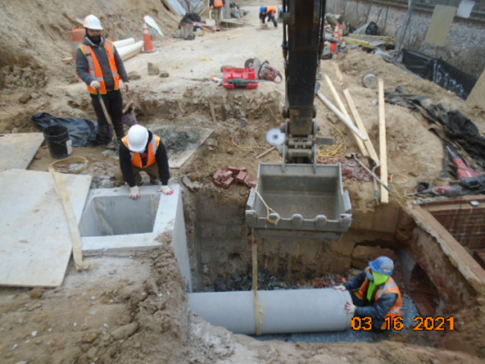
Phase D – Crew installing drainage pipe

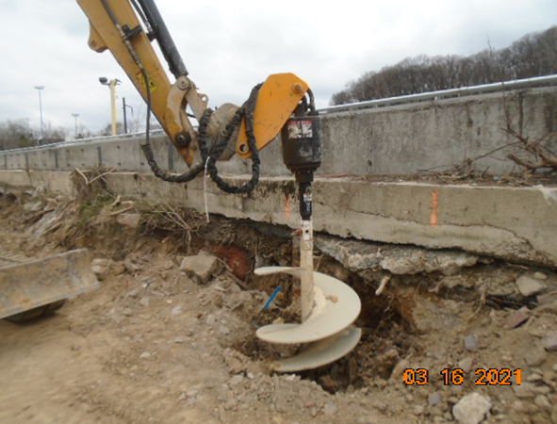
Phase D – Crew shaft drilling light pole foundation

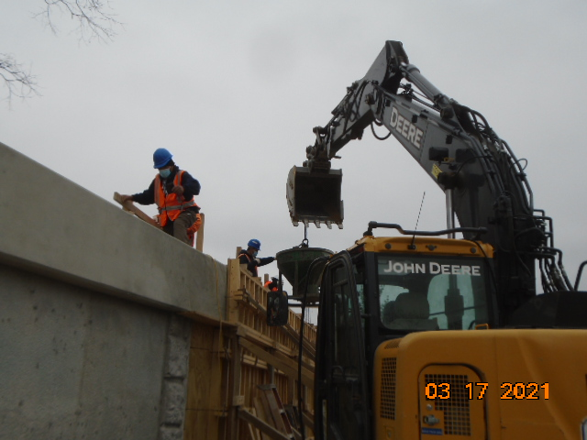
Phase D - Crew placing concrete for retaining wall S2 wall section

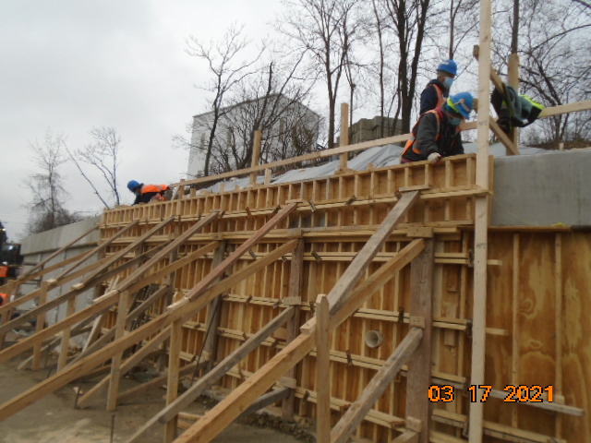
Phase D – Crew constructing retaining wall formwork

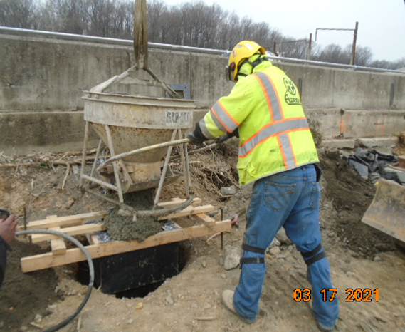
Phase D – Crew placing concrete for light pole foundation

