Metropolitan Branch Trail Design Build, South Segment
DC CONTRACT NO. DCKA-2016-C-0044
FAP No.: STP-2016 (060)

CONSTRUCTION MANAGER’S
WEEKLY PROGRESS REPORT

02/06/2022 – 02/12/2022

Project Website: www.metbranchtrail-forttotten.com
For Additional Trail Information Please see www.metbranchtrail.com

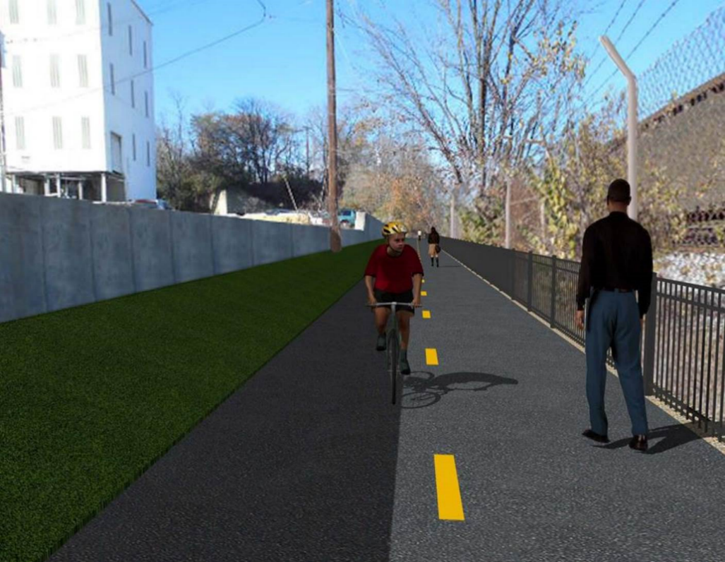

Proposed Metropolitan Branch Trail
1. PROJECT DESCRIPTION

The planned Metropolitan Branch Trail Project (“the Project”) consists of the design and construction of a new trail adjacent to CSX tracks and WMATA Red Line tracks along John McCormack Drive, adjacent to Fort Totten Metro Station, and on NPS property in NE, Washington D.C. The trail begins approximately 1500 feet south of Bates Road NE on the east side of John McCormack Drive NE, extending north along the WMATA and CSX tracks to the Fort Totten Metro Station tie in with First Place NE. An existing trail connection from Gallatin Road NE to the Fort Totten Metro Station will be reconstructed as a part of the Project.

This project is 83.15% Federally Funded and 16.85% Locally Funded. DDOT selected Potomac Construction Company, Inc. (PCCI) as the contractor and awarded the $8,555,000.00 contract on September 28, 2017. DDOT issued Notice to Proceed (NTP) with contract work to begin on October 31, 2017. A time extension approved on April 23, 2020 has set the substantial completion date to August 6, 2020. DDOT extended contract expiration date by 60 days from August 7, 2020 to October 6, 2020. A time extension approved on October 6, 2020 extended contract expiration date by 90 days from October 6, 2020 to January 5, 2021. A time extension approved on December 21, 2020 extended contract expiration date by 90 days from January 5, 2021 to April 5, 2021. A time extension approved on April 2, 2021 extended contract expiration date by 90 days from April 5, 2021 to July 4, 2021. A time extension approved on June 21, 2021 extended contract expiration date by ninety (90) days from July 6, 2021 to October 4, 2021.

Delon Hampton and Associates Chartered is providing Construction Management and Inspection services.

Specific Construction Scope of Work includes:

- Existing streetlights poles from the beginning point of the project south to Michigan Avenue shall have the existing luminaires replaced with new LED cobra head luminaires, see Section 16 of the Project Technical Provisions for details;
- Provide mobilization and demobilization, provision and maintenance of Engineer’s field facilities, field layout, employee training, and other incidental work required for a quality, complete and finished product;
- Establishment and maintenance of vehicular and pedestrian traffic including signs, barricades and other transition devices; reconfiguring the devices in conjunction with changes in work areas; and their removal and disposal upon project completion, including restoration of disturbed areas;
- Clearing and grubbing, as required within the LOD;
- Removal of unsuitable material, excavation, and backfilling and pervious paving to construct a new trail;
- Protection of trees during construction;
- Provide ADA compliant trail connections and pedestrian ramps;
- Provide retaining walls as necessary to stay within the LOD and minimize property impacts following visual requirements specified for retaining walls on NPS property;
- Provide new permanent regulatory and wayfinding signs for the trail and all trail connection intersections;
- Provide road and trail pavement markings;
- Provide landscaping within the LOD for the Project including special requirements for landscaping on NPS property;
- Provide erosion and sediment control measures, storm water management facilities, including pervious asphalt pavement and bioretention facilities;
- Provide utility coordination, identification, locating, and protection of all utilities encountered during design and construction including relocation of Pepco poles along Aggregate Industries property; and
- Provide new WMATA security fencing between the trail and CSXT tracks.
- Remove existing sidewalk and widen sidewalk to 10’ along the west, side of First Place NE from Metropolitan Branch Trail to entrance to WMATA bus loop, on the west side.

2. STATUS OF CONSTRUCTION / PROGRESS SUMMARY

Work performed this week:

Design

- 100 % Complete

Construction:

Phase D

- Excavated and graded the trail path
- Excavated and graded embankment slope in front of S3 wall
- Excavated and graded slope behind S3 wall
- Installed geotextile fabric at the trail path
- Installed trail perforated underdrain
- Placed and graded trail stone
- Removed electrical light pole foundation formwork
- Pulled conduit drag line.
- Cleaned and capped foundation conduit.
- Installed WMATA street light poles
- Contractor safety tool box talk

CM Consultant:

- Monitored construction progress, make sure all applicable inspections and testing were performed
- Reviewed Project Schedule
- Reviewed PCCI Monthly Payment Estimate
- Reviewed CSX Invoice
- Attended site meeting with NPS and DDOT
- Prepared CM Weekly Report to post
- Prepared CM Weekly report to DDOT
- Updated Project Files
- Updated Project Logs
- Updated Project Webpage
- Updated documents in DHA SharePoint site
- Updated DDOT Sharepoint site
- Coordination with contractor in terms of submittals

3. MEETINGS / PROJECT COORDINATION

Wed 02/09/2022 Onsite meeting was held between NPS DHA and DDOT at 8:00 A.M. to discuss
NPS items.

4. DAILY WORK PERFORMED

Sun 02/06/22 No work performed.
Mon 02/07/22 Phase D – Graded the trail path. Graded slope area in front of S3 wall. Repaired slit
fence along existing sidewalk.
Phase D – Removed light pole foundation formwork. Cleaned light pole conduits.
Tue 02/08/22 Phase D – Excavated and graded the trail path. Graded slope area in front of S3 wall.
Phase D – Electrical work – Removed light pole foundation formwork. Clean light pole foundation.
Wed 02/09/22 Phase D – Excavated and graded slope behind S3 wall. Excavated the trail path.
Phase D – Electrical work – Pulled dragline through light pole conduits.
Thurs 02/10/22 Phase D – Excavated the trail path. Graded the trail path.
Phase D – Electrical Work – Pulled dragline through light pole conduits.
Capped light pole foundation conduits.
Fri 02/11/22 Phase D – Installed geotextile fabric at the trail path. Installed perforated underdrain.
Phase D – Electrical Work – Installed WMATA light poles
Sat 02/12/22 Phase D – No work scheduled.

5. INSPECTION & MATERIAL TESTS PERFORMED

Jobsite Safety Inspection  Erosion and Sediment Control inspection  MOT Inspection  Compaction Test  Asphalt Material Testing  Concrete Material Testing – Pending results  ** Note - Additional Material Test Results can be found on DDOT QA QC Material Division Tracking SharePoint website. | Infiltration Tests  Dynamic Cone Penetration (DCP) Tests  Rebars Inspection - Passed
6. DBE PARTICIPATION SUMMARIES

Potomac Construction Inc. (Contractor)

- DBE Goal for Contractor is 15%. To-date the Contractor has achieved 55% of their goal.

Delon Hampton & Associates (CM)

- DBE Goal for the CM is 10%. To-date the CM has achieved 102 % of their goal.

7. ACCIDENTS / INCIDENTS

None occurred during this week.

8. PHOTOS OF THE WEEK

12. PHOTOS OF WORK PERFORMED THIS PERIOD

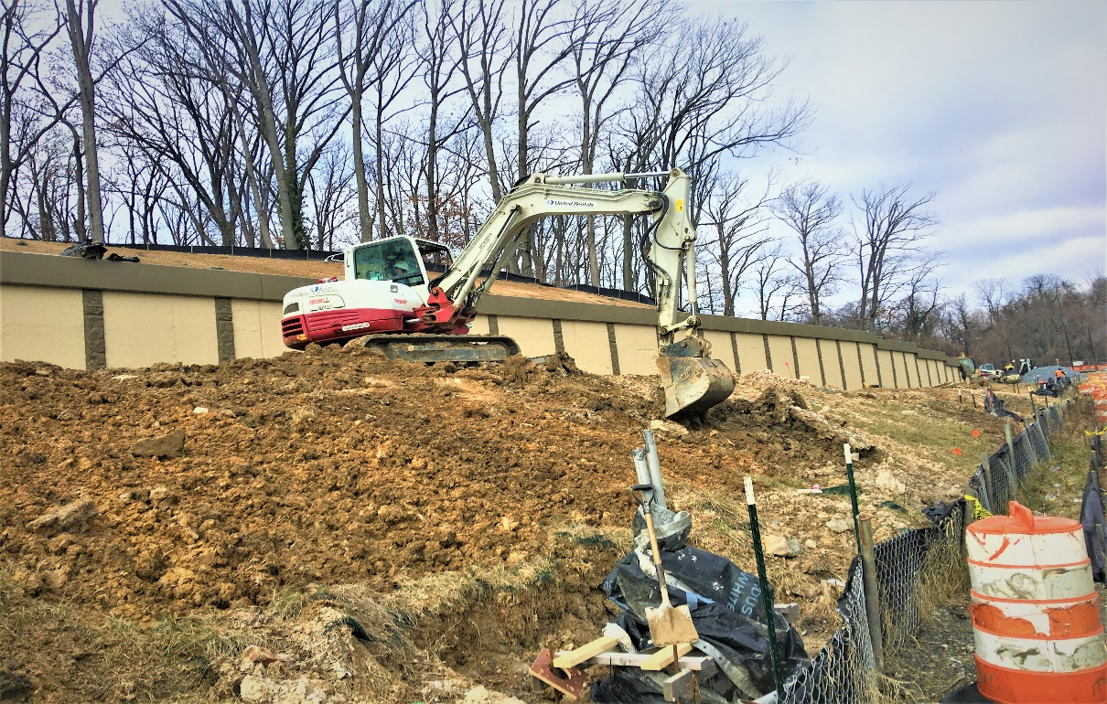
Phase D – Crew excavating slope area in front of S3 wall.

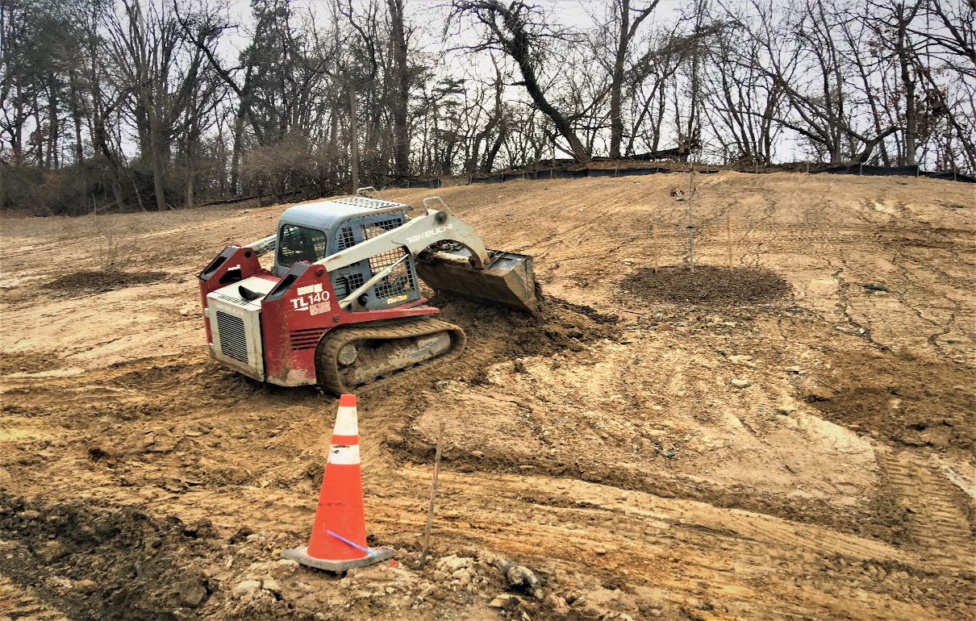
Phase D – Crew grading slope area along the trail

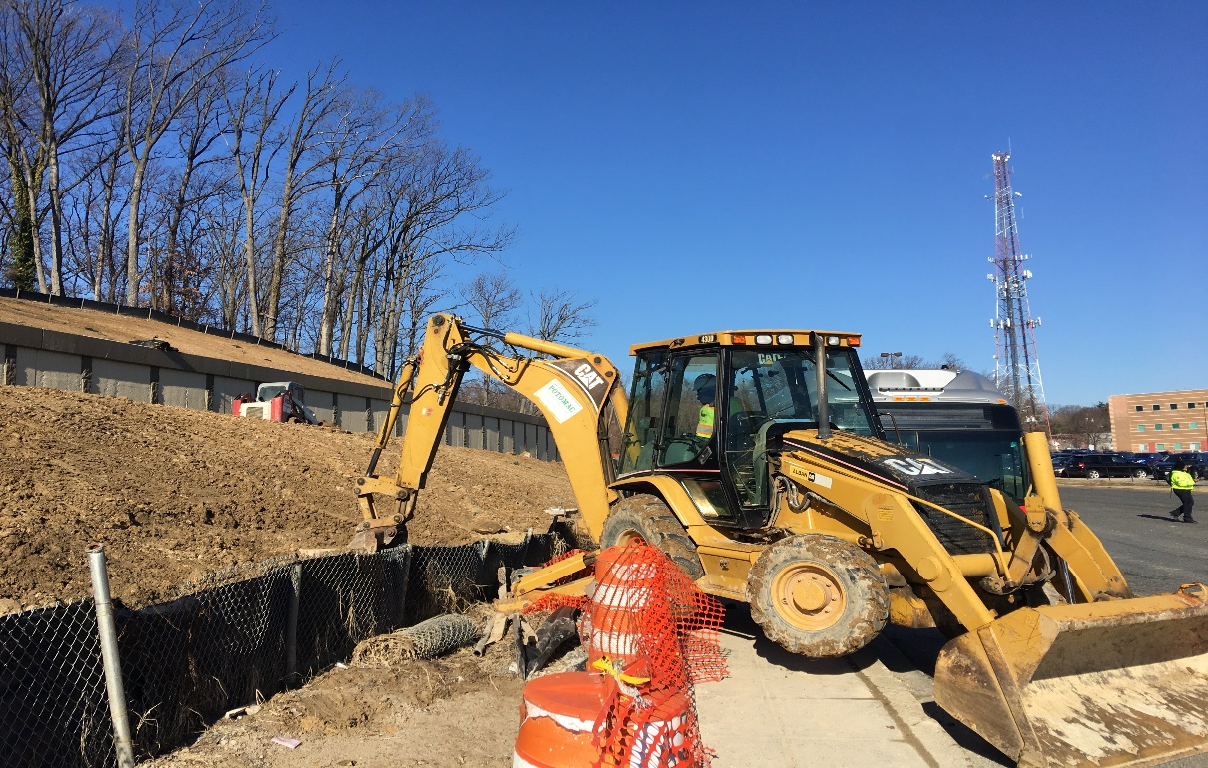
Phase D – Crew excavating around drainage inlet
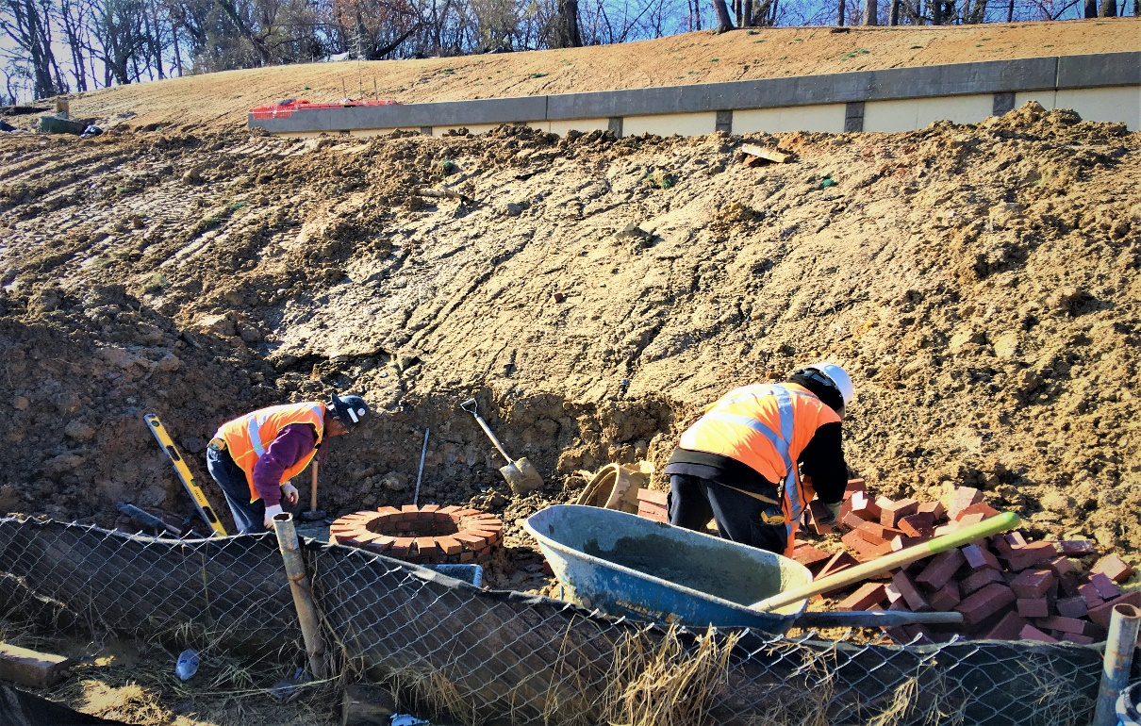
Phase D – Crew resetting brick manhole

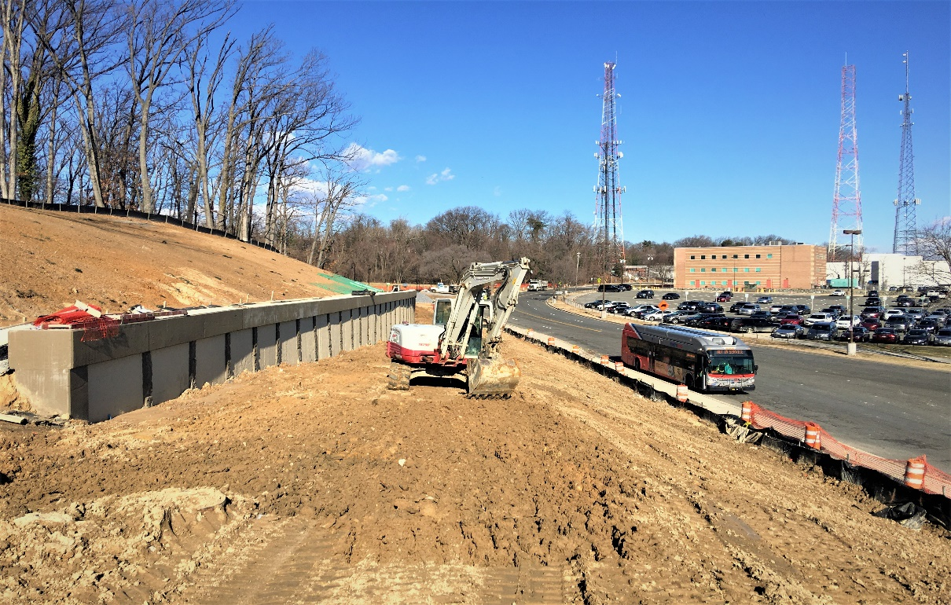
Phase D – Crew excvating the trail path

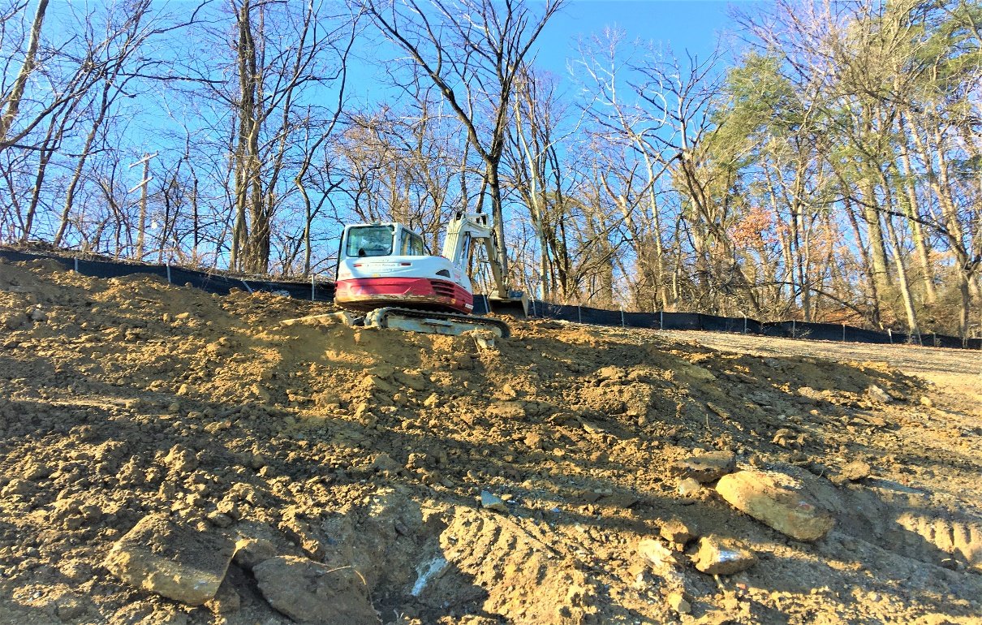
Phase D – Crew excavating slope area

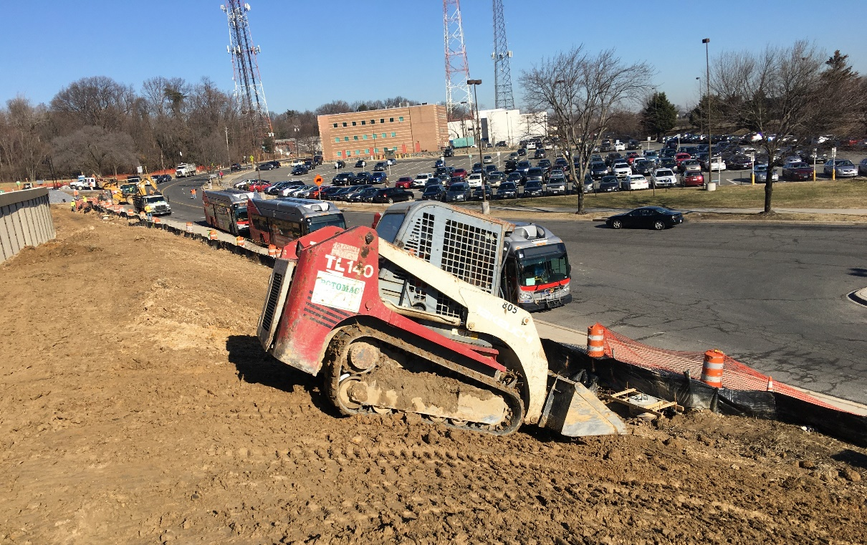
Phase D – Crew grading slope in front of S3 wall

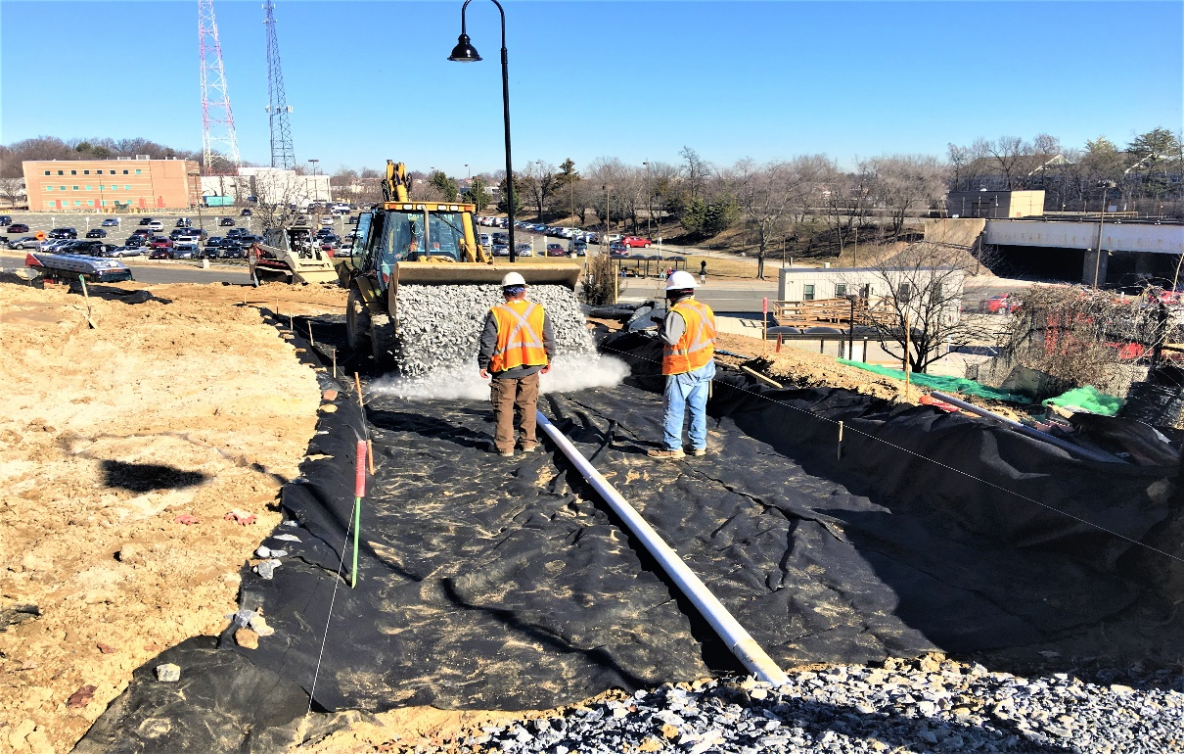
Phase D – Crew placing stone at the trail subgrade

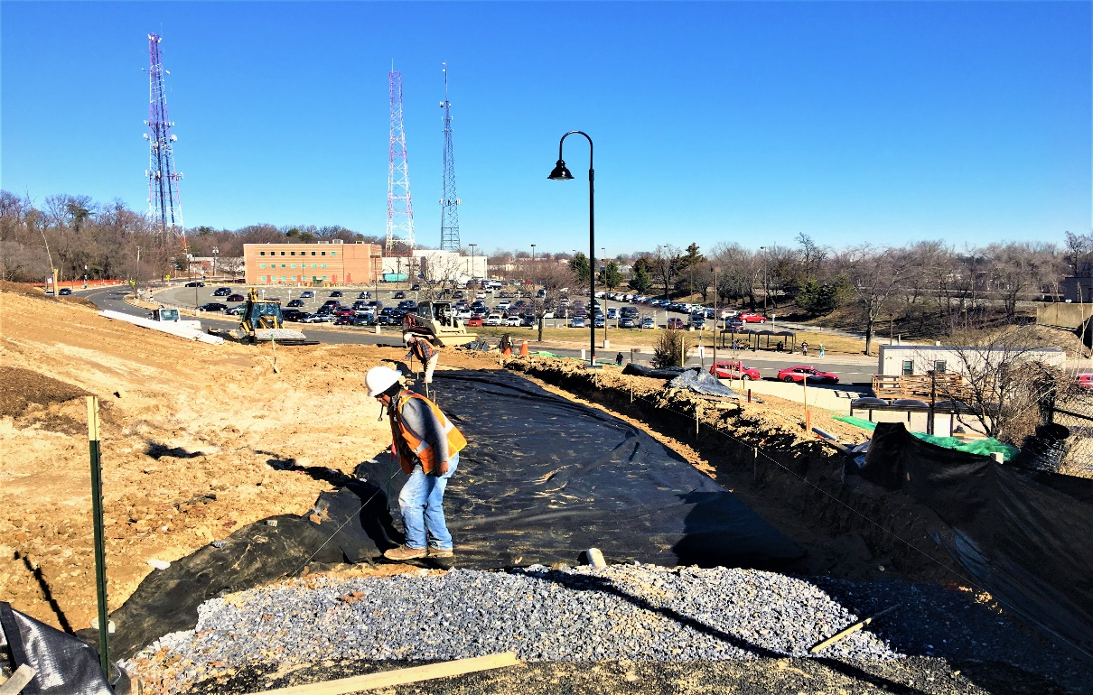
Phase D – Crew installing geotextile fabric at the trail subgrade

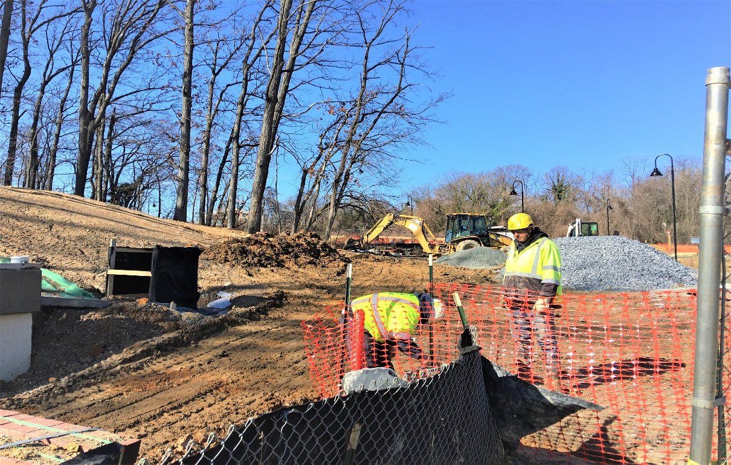
Phase D – Crew pulling conduit drag line

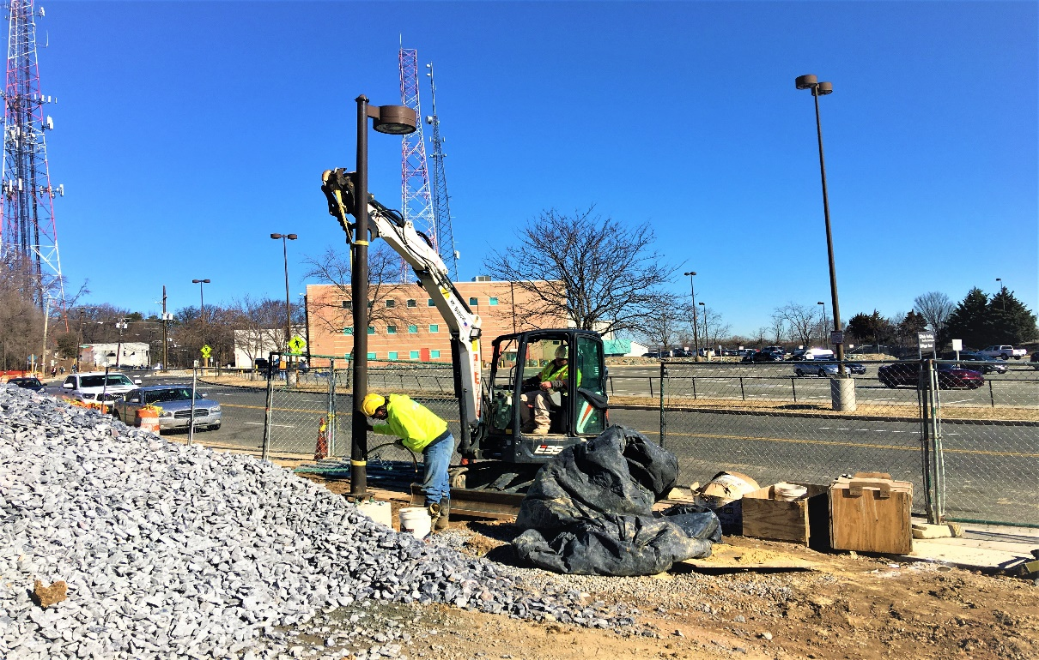
Phase D – Crew installing WMATA light pole

